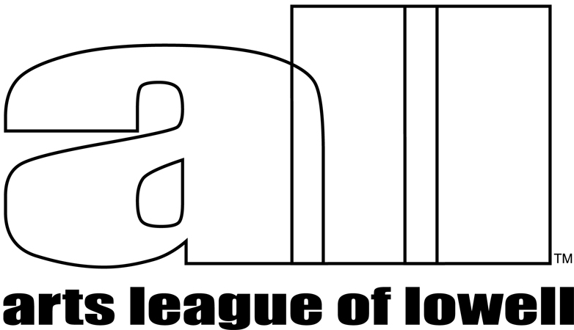 | Show Prospectus

The Arts League of Lowell (ALL) presents

JOURNEYS

A Juried Exhibition

September 28, 2018 Through November 11, 2018

Wednesdays-Saturdays, Noon-6pm, Sundays Noon-4pm
ARTIST RECEPTION – Saturday, October 13, 2018, 4:00p.m. – 6:00p.m.

ALL Arts Gallery, 307 Market St., Lowell, MA 01852

THEME
Works that explore Journeys: real and imagined, physical and spiritual, how we move through our world, the paths we choose, and the means we use to reach our destinations.

ELIGIBILITY
Open to all artists working in 2 dimensions or 3 dimensions and any medium, any technique. Submitted work must not have been shown previously at the Arts League of Lowell Gallery. Student work done under direct supervision is not eligible.

WORK REQUIREMENTS
This is a juried exhibition. Work will be juried using an online application and uploaded images. Artists may enter 1 to 3 works. Works chosen for this show must be securely and professionally presented. Hanging reliefs must be wired and ready to hang. No saw-tooth or keyhole hangers will be accepted. If your work is not properly prepared to hang, or otherwise install, it will be rejected, even if it was juried into the show. Several pedestals are available for artists’ use. Proposals will also be considered for installations, which must be set up by the artist, in a space agreed upon ahead of the installation schedule. There is one octagonal glass case available for small works – max. size per piece: approximately 8x8x8 inches. Please call or e-mail the curator if you have questions about the suitability of your entry, or if you have special installation requirements.

VOLUNTEERING REQUIREMENTS
ALL member artists, with work in this show, are required to gallery sit. Non-member artists are encouraged to gallery sit with a member partner. The Gallery depends upon the help of all participating artists to gallery sit.

ENTRY DEADLINE
All entries must be completed online before midnight, Saturday, September 8, 2018

ONLINE APPLICATION
Please apply for this show using an online application and complete by paying the entry fee. You may enter up to 3 works for the show with 1-3 images per work entered.
Images must be .jpg or .jpeg format and less than 2 Megabytes. File names should not include any spaces or special characters other than underscores or dashes. Please prepare your images before starting the application. The online application will be available on July 15.
Go to this location to access the application: www.artsleagueoflowell.org/gallery/showentry/Journeys2018
The application will be considered complete after you pay the entry fee online with credit/debit card or PayPal account (if you have one).

ENTRY FEE
Members - $30.00. Nonmembers $45.00. Entry fees are non-refundable and do not guarantee acceptance of your work in the exhibition. Entries will not be considered without accompanying entry fee. Non-member artists entering this show are welcome to join ALL ($45.00/year) and pay the members’ entry fee. Members who cannot gallery-sit are welcome to enter this show as a non-member and pay the associated fee and commission (40%).

You will be notified by Saturday, September 15 by the show curator to inform you of works accepted for this exhibition.

JUROR
Karl Stephan is a studio artist, art educator, curator and consultant based in Cambridge, MA. He has shown and sold work across the U.S. and on five continents and has curated two significant shows of the local street art scene. The Nave Gallery in Somerville named him “Gold Star Curator,” for these shows. He has a BFA in Painting and Printmaking, and a Master of Arts in Teaching from the School of the Museum of Fine Arts at Tufts University. He currently teaches teens and adults in his Cambridge studio, and at the Museum of Fine Arts, Boston. Karl supervises student teachers in the Tufts SMFA Masters program in art education. He has consulted with local museums and arts organizations on grant awards and exhibitions, and with individual artists on their work and practice as well.
http://karlstephanart.weebly.com/
http://karlstephanstudio.weebly.com/

DELIVERY OF WORK
Deliver accepted work to the ALL Arts Gallery, 307 Market St, in Lowell, on Sunday, September 23, 4:00p.m. – 6:00p.m. or Monday, September 24, 2018, 12:00p.m. – 2:00p.m. Other arrangements may be made IN ADVANCE if you cannot drop off your work at these times. Delivery of work that is different from that in the images submitted for the Juror’s consideration will be rejected. If you intend to ship your work, you must contact (your name) to arrange delivery location and receipt time/date.

SALES
ALL takes a 25% commission for ALL members’ artwork sold and 40% commission for non-members’ artwork sold. Artists are encouraged to show work that is for sale. Payment for work sold will be made no later than 15 days after the close of the exhibit.

INSURANCE AND LIABILITY
Every reasonable precaution will be taken to ensure the protection and careful handling of work. The Arts League of Lowell carries insurance to cover any damage to artwork while it is on the premises of the ALL Arts Gallery. If your work is in the show and you prefer to mark it “NFS” – Not For Sale – please include an insurance value for each piece, on the entry form.

PICK UP OF WORK
Work may be picked up after the show closes, Sunday, November 11, from 4:00p.m. – 6:00p.m.or Monday, November 12, 12:00p.m. – 2:00p.m.
Please make alternative arrangements IN ADVANCE if you cannot pick up at these times. We will try to accommodate you. We have no safe space to store work. Work left beyond the pickup date is subject to a $5.00 per day holding fee. Work left 30 days beyond the show closing date will be considered abandoned and will become the property of the Arts League of Lowell and will be used or disposed of as deemed appropriate by the curator.

QUESTIONS? - Contact the curator, Mark Hemenway at mhemenway1973@gmail.com.

CALENDAR

ENTRY APPLICATION available online Saturday, July 15, 2018

ENTRY DEADLINE Saturday, September 8, 2018

NOTIFICATION of accepted work Saturday, September 15, 2018

DELIVERY of accepted work Sunday, September 23, 4:00pm – 6:00pm
Monday, September 24, 12:00pm – 2:00pm

SHOW OPENS Friday, September 28, 2018(

ARTIST RECEPTION Saturday, October 13, 4:00pm. – 6:00pm.

SHOW CLOSES Sunday, November 11, 4:00pm

PICK UP of work Sunday, November, 11, 4:00pm - 6:00pm
Monday, November 12, 12:00pm – 2:00pm

ENTRY FORM JOURNEYS

Please fill out this form and include it if shipping or dropping off your work.

ARTIST’S NAME________________________________________________________
MAILING ADDRESS____________________________________________________
_________________________________________________________________________
PHONE___________________E-MAIL_______________________________________

******************************************
( ) ENTRY #1. TITLE______________________________________________________
MEDIUM/STYLE______________________________________________________
PRICE OR IF NFS, ins. value___________
FINISHED SIZE (including any fixed pedestal or frame, if applicable) _____________________
******************************************
( ) ENTRY #2. TITLE______________________________________________________
MEDIUM/STYLE______________________________________________________
PRICE OR IF NFS, ins. value___________
FINISHED SIZE (including any fixed pedestal or frame, if applicable) _____________________
******************************************
( ) ENTRY #3. TITLE______________________________________________________
MEDIUM/STYLE______________________________________________________
PRICE OR IF NFS, ins. value___________
FINISHED SIZE (including any fixed pedestal or frame, if applicable) _____________________
---------------------------------------------------------------------------------------------------------------
ARTIST AGREEMENT
With my submission of artwork to JOURNEYS, I agree to all terms set forth in the prospectus, and grant permission to photograph or otherwise reproduce images of any exhibited work to be used for publicity purposes.

Signed_______________________________________________ Date________________

---------------------------------------------------------------------------------------------------------------
** FOR GALLERY USE ONLY
Member? Yes No

Fee Paid ________ Cash Check Credit Card

Gallery sitting Date _____________
SHOW LABELS, PLEASE ATTACH TO WORK
CUT ALONG DOTTED LINES
======================================================
JOURNEYS
Artist Name_________________________________________________

Phone__________________________Email________________________________

Title ______________________________________Entry #_____________
======================================================
JOURNEYS
Artist Name_________________________________________________

Phone__________________________Email________________________________

Title ______________________________________Entry #_____________
======================================================
JOURNEYS
Artist Name_________________________________________________

Phone__________________________Email________________________________

Title ______________________________________Entry #_____________
=====================================================

