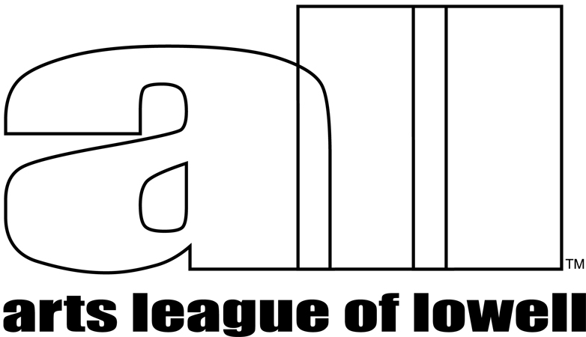  307 Market Street  Lowell, MA 01852 | Show Prospectus  VARIATIONS in SCALE
Call for Entry

Variations in Scale

August 10, 2018 to September 23, 2018

Reception: Saturday, August 18, 2018, 4-6 PM
sponsored by Netscout Systems

THEME
The size and scale of art works informs the content of the work and influences its viewing. By exhibiting LARGE scale 2D works and SMALL scale 3D works, this show will challenge the viewer's perspective.

LARGE SCALE 2 dimensional works:
Style: Any style (representational, abstract)
Size restrictions: finished measurements (with frame)
width: horizontal minimum: 24" - horizontal maximum: 48"
height: vertical minimum: 36" - vertical maximum: 72"
Work requirements:
Artists may enter works in any 2D medium (painting, drawing, photography, fiber, collage, mixed media, other).
Framed work must be securely and professionally presented, if applicable. No saw tooth or keyhole hangers accepted. Unframed works on paper may be entered if work can be hung securely with magnets.
Work over 40 pounds and work requiring special installation or handling must be installed by the artist with the Arts League of Lowell curatorial staff.
Failure to abide by these hanging requirements will result in the immediate rejection of your work for this exhibition.

SMALL SCALE 3 dimensional works:
Style: Any style (representational, abstract, functional, sculptural)
Size restrictions: per entry
width: maximum: 8", depth: maximum: 8", height: maximum: 8"
Work requirements:
Artists may enter works in any 3D medium (metal, ceramic, stone, wood, glass, paper, fiber, etc.) 3D works made from multiple parts can be entered as one submission if they are intended to be shown together as one work and are no larger than the maximum per-piece size. Example: a pair of earrings, a set of tea bowls etc.

ELIGIBILITY
You may enter up to 3 works, large and/or small for this show.
Open to all artists working in any medium and to active (dues up to date) ALL members. Submitted work must not have been shown previously at the Arts League of Lowell Gallery. Student work done under direct supervision is not eligible.

VOLUNTEERING REQUIREMENTS
Exhibiting ALL member artists are required to sign up to gallery sit for one shift at drop off.
NEW! Members who do not wish to honor their gallery sitting obligation for this show must pay the non-member entry fee of $40 and pay the 40% commission on any work sold.

SHOW APPLICATION PROCESS AND ENTRY FEE Online application available on June 1, 2018

ENTRY DEADLINE
All entries must be completed online before midnight, Saturday, July 28, 2018.

ONLINE APPLICATION
Please apply for this show using an online application, uploaded images and complete by paying the entry fee. You may enter up to 3 works for the show with 1-3 images per work entered. Images must be .jpg or .jpeg format and less than 2 Megabytes. File names should not include any spaces or special characters other than underscores or dashes. Please prepare your images before starting the application. The online application will be available on June 1, 2018. Go to this location to access the application:
http://www.artsleagueoflowell.org/gallery/showentry/variations2018.
The application will be considered complete after you pay the entry fee online with credit/debit card or PayPal account (if you have one). If you have a problem completing the application or uploading images, please contact Roberta Bloom (roberta@mediapersecond.com).

ENTRY FEE
Members - $25.00. Nonmembers $40.00. Entry fees are non-refundable and do not guarantee that all works entered will be accepted for this show. Space in the gallery is limited. Entries will not be considered without accompanying entry fee. Non-member artists entering this show are welcome to join ALL ($45.00/year) and pay the members’ entry fee. Members who cannot gallery-sit are welcome to enter this show as a non-member and pay the associated fee and commission (40%).

You will be notified by Wednesday, August 1 by the show curator to inform you of works accepted for this exhibition. Gallery size is limited. We may not be able to exhibit all entered works.
SALES
ALL takes a 25% commission on member work sold and a 40% commission on non-member work sold. Artists are encouraged to show work that is for sale. Payment for work sold will be made no later than 15 days after the close of the exhibit.

DELIVERY OF WORK
Deliver work at designated drop off times (calendar below) to ALL Arts Gallery, 307 Market St, Lowell, 01852. If you intend to ship your work, you must contact Roberta Bloom to arrange delivery location and receipt time/date. Please fill out labels for your work, sign the Artist Agreement (BELOW) and bring with you when you deliver your work.

INSURANCE AND LIABILITY
Every reasonable precaution will be taken to ensure protection and careful handling of work. The Arts League of Lowell carries insurance to cover any damage to artwork accepted into this show. If your work is accepted into the show and you prefer to mark it “NFS” – Not For Sale, please include an insurance value for each piece on the entry form.

PICK UP OF WORK
Work may be picked up after the show closes, Sunday, Sept. 23, from 4:00p.m. – 6:00p.m. or Monday, Sept. 24, 12:00p.m. – 2:00p.m. Please make alternative arrangements IN ADVANCE if you cannot pick up at these times. We will try to accommodate you. We have no safe space to store work. Work left beyond the pickup date is subject to a $5.00 per day holding fee. Work left 30 days beyond the show closing date will be considered abandoned and will become the property of the Arts League of Lowell and will be used or disposed of as deemed appropriate by the management.
WORK CANNOT BE PICKED UP BEFORE THE CLOSE OF THE SHOW AT 4:00PM, Sept. 23, 2018.

Questions? Please contact Roberta Bloom at email roberta@mediapersecond.com

CALENDAR Variations in Scale
ENTRY APPLICATION available online Friday, June 1, 2018
ENTRY DEADLINE Saturday, July 28, 2018.
Notification of accepted work Wednesday, August 1, 2018
DELIVERY of accepted work Sunday, August 5, 4:00p.m. – 6:00p.m.
Monday, August 6, 12:00p.m. – 2:00p.m.

SHOW OPENS Friday, August 10, 2018.
ARTIST RECEPTION Saturday, August 18, 4:00p.m. – 6:00p.m.
SHOW CLOSES Sunday, September 23, 4:00p.m.
PICK UP of work Sunday, September 23, 4:00p.m - 6:00p.m
Monday, September 24, 12:00p.m. – 2:00p.m.

PLEASE BRING WITH YOU WHEN YOU DROP OFF YOUR WORK.

ARTIST AGREEMENT
With the submission of artwork to the "VARIATIONS in SCALE" show, the artist agrees to all terms set forth in the prospectus, and grants permission to photograph and reproduce any accepted work for publicity purposes.

Signed______________________________________________ Date______________________

-------------------------------------------------------------------------------------------

* FOR GALLERY USE ONLY
Member? Yes No
Fee paid _____________ Cash Check Credit Card
Gallery Sit Date: ________________

SHOW LABELS - PLEASE PRINT IN BLOCK LETTERS
PLEASE ATTACH TO WORK
CUT ALONG DOTTED LINES

===============================================================

Artist Name ________________________________________ Phone __________________

Title________________________________________________ Price or NFS______________
===============================================================

Artist Name ________________________________________ Phone ___________________

Title_________________________________________________ Price or NFS____________
===============================================================

Artist Name __________________________________________ Phone _________________

Title__________________________________________________ Price or NFS____________
===============================================================

