# Sample Work:

### News App: <https://fantastic-gingersnap-1c87bb.netlify.app/>

Github link: <https://github.com/NSinhaDev18/NewsApp>

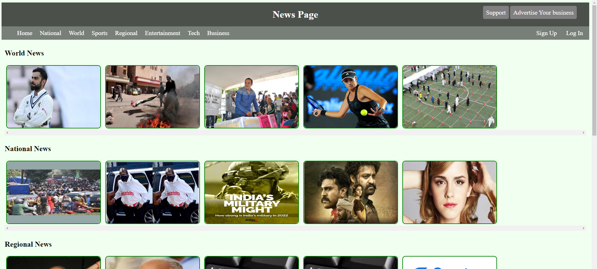

### Weather App: <https://lambent-manatee-147e02.netlify.app/>

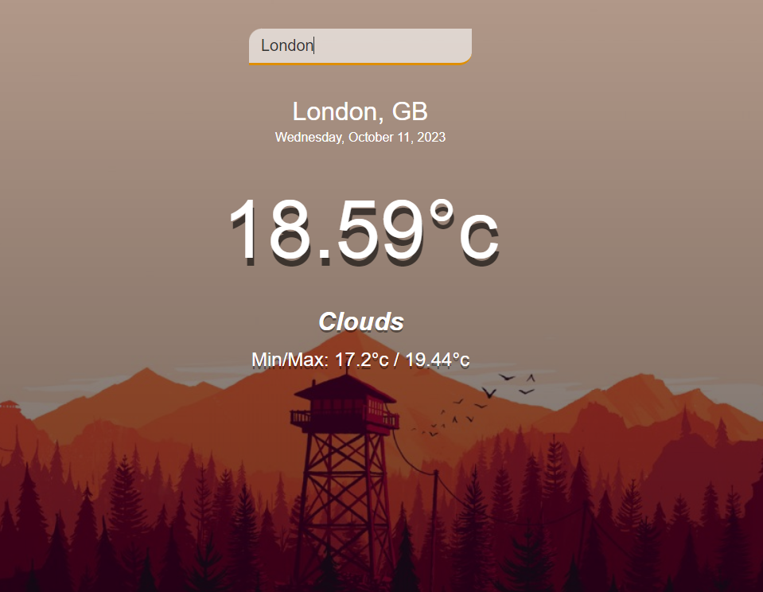

Github link: <https://github.com/NSinhaDev18/WeatherApp>

### Score-Board-App: <https://6523df331c4fcc008a46357d--glittery-beijinho-6765f2.netlify.app/>

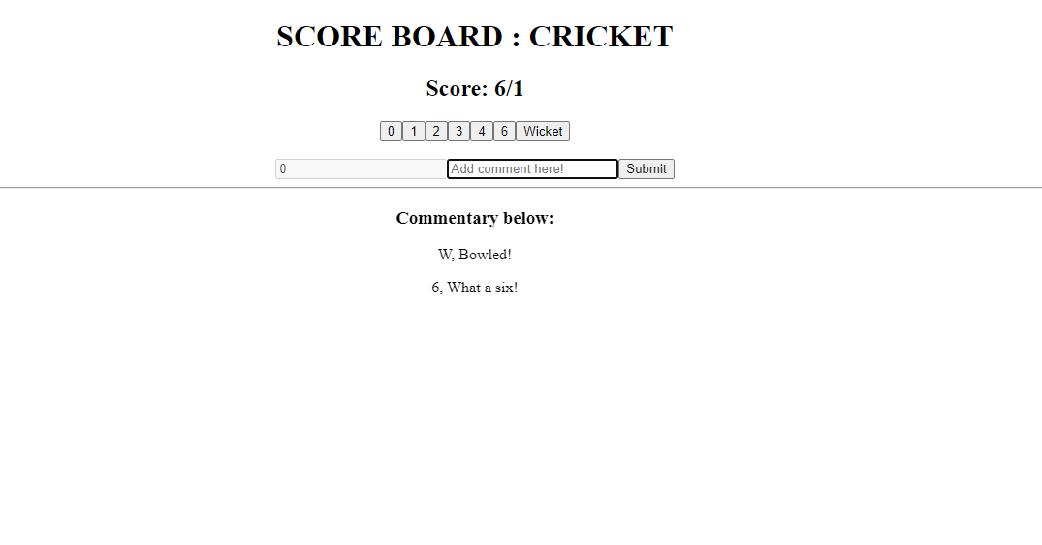

Github link: <https://github.com/NSinhaDev18/Score-Board-App>

### Customer-Record-App: [https://graceful-druid-1ba7b5.netlify.app](https://graceful-druid-1ba7b5.netlify.app/)

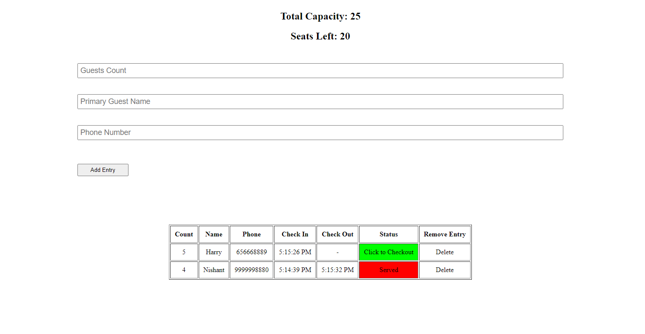

Github link: <https://github.com/NSinhaDev18/Customer-Record-App>

### Quotify App: <https://aquamarine-phoenix-a508b9.netlify.app/>

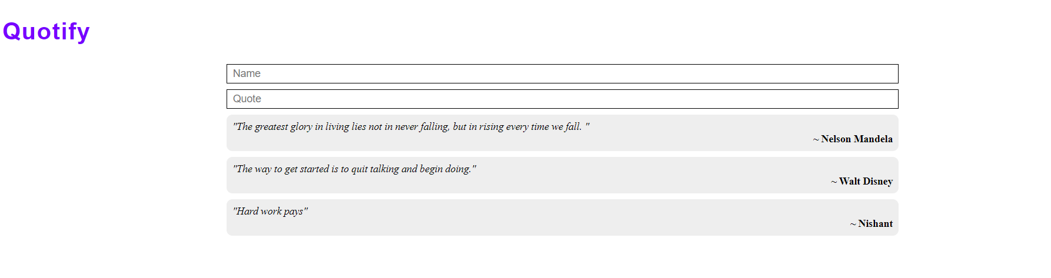

Github link: <https://github.com/NSinhaDev18/Quotify-React-app>

You can find some of my work here as well: <https://github.com/NSinhaDev18>