Changes in temperature, rainfall and snow cover during the reproductive season of Arctic-breeding birds

Running title: Arctic Warming and Bird Reproductive Windows

Keywords: Arctic tundra, Snowmelt, Phenology, Productive period, Climate projections, CMIP6, Extreme events, Migratory birds, EC-Earth

Abstract
Aim
To assess how large-scale changes in Arctic hydroclimatic regimes restructure the timing, reliability, and spatial organisation of the snow-free reproductive window, and how emerging climatic extremes increasingly constrain terrestrial breeding systems across space and time.
Location
Arctic lowland tundra (60–90°N).
Time period
ERA5 reanalysis (1940–2024), CMIP6 climate model projections (1850–2100), and multi-century equilibrium simulations (400-years).
Major taxa studied
Arctic tundra-breeding birds (waterfowl and shorebirds), used as a model terrestrial system.
Methods
We combined ERA5 reanalysis, daily output from ten CMIP6 Earth System Models, and long (400-year) steady-state EC-Earth3 simulations under fixed CO₂ forcing (1× and 2× present-day). Analyses were restricted to ecologically relevant lowland tundra using consistent spatial masking. We quantified changes in temperature, rainfall, snowfall, snow cover, productive period timing and duration, and the frequency, seasonality, and magnitude of extreme rainfall, including return periods derived from equilibrium simulations.
Results
CMIP6 projections show pronounced winter warming (up to +15 °C under SSP5-8.5 by 2100), widespread snowfall reductions, and strong declines in snow cover, with marked regional contrasts. Equilibrium experiments show that under doubled CO₂, the productive period lengthens due to earlier snowmelt (–28 days) and delayed snow return (+36 days). However, this expanded snow-free season coincides with a sharp intensification of rainfall extremes. During the PP, extremely wet days increase sixteen-fold on average, and in some regions nearly one-third of April–October days exceed present-day thresholds. Present-day 100-year rainfall events recur every 2–7 years under 2×CO₂, with the largest proportional increases in historically dry regions (e.g. Canada), indicating novel hydroclimatic regimes.
Main conclusions
Although Arctic warming lengthens the snow-free season, the ecological reliability of the reproductive window is increasingly constrained by intensifying and earlier-onset rainfall extremes. These results show that climate change is reorganising hydroclimatic regimes that act as large-scale ecological filters, highlighting the importance of extremes, variability, and regime emergence for understanding biogeographical responses to rapid climate change.

Introduction
Arctic migratory birds breed in one of the most challenging environments on Earth. Their entire reproductive cycle depends on a short summer window, the productive period (PP), between spring snowmelt and the return of snow cover (Meltofte et al. 2007). Within weeks, birds must arrive, lay eggs, rear their chicks, and prepare for migration. Any temporal variation in this window, whether from delayed snowmelt, early snow return, or extreme weather, can jeopardize reproductive success if not offset by the bird’s timing (Skinner et al., 1998; Schekkerman et al. 2003). As a result, many Arctic migrants exhibit some degree of flexibility in their migration and breeding phenology, adjusting in response to climatic conditions encountered throughout spring and summer (e.g. Liebezeit et al. 2014, Boom et al 2023b, Lameris et al 2018, Sauve et al 2019, Lameris et al 2025, Linssen et al 2025).
Climate change is posing challenges to Arctic-breeding birds, by destabilizing the timing of the PP, although current changes such as an earlier snowmelt may in fact be beneficial for these birds (Weiser et al. 2018). The Arctic is warming two to three times faster than the global average, with precipitation projected to increase by up to 60% over the 21st century (Serreze & Barry 2011; Bintanja 2018). These shifts are not uniform: maritime regions are trending toward rain-dominated winters, while continental interiors remain colder but highly variable. For birds adapted to specific local climates, such spatial and seasonal contrasts can be decisive.
Many climate studies, however, do not focus on the variables or spatiotemporal scales most relevant to Arctic–breeding birds. The Arctic is often analysed as a single unit, sometimes encompassing both land and ocean, or summarized in annual means (Sledd & L’Ecuyer 2021; Bintanja & Andry 2017; Screen & Deser 2019). Such approaches overlook the sharp regional and seasonal contrasts that shape ecological opportunities for the organisms that inhabit the Arctic, such as the differences between wet maritime and dry continental regions, or the transitional autumn months when snow cover retreats or returns. Moreover, most ecological studies focus on changes in mean conditions (Bozinovic et al. 2011; Vázquez et al. 2017), when weather extremes can also be important. Extreme climatic events, such as unusually persistent snow in spring or strong winds associated with heavy rain in summer, have been reported to trigger complete reproductive failures in Arctic bird species (Schmidt et al. 2019; Yannic et al. 2014). Yet despite their disproportionate impact, extremes and variability remain understudied in Arctic ecology.
Here, we analyse past and future projected climate conditions during the reproductive season of Arctic migratory birds, including the occurrence of precipitation extremes. We focus on terrestrial birds such as waterfowl and shorebirds inhabiting lowland tundra ecosystems, where season length is primarily governed by snow cover. This is in contrast to seabirds, which breed on cliffs and experience a different set of climatic constraints and are therefore outside the scope of this study. Our goal is to provide climate metrics directly relevant to ecology, such as snowmelt dates and extreme rainfall within the PP, and to assess how spatial and seasonal variability may shape future reproductive success of Arctic-breeding birds. We examine four key weather variables: surface temperature, rainfall, snowfall, and snow cover. We investigate how the PP and the occurrence of weather extremes inside that window may change by generating long, steady-state climate simulations with fixed CO₂ forcings (1× and 2× today’s level of 420 ppm). These experiments provide a clean comparison between present-day and a strongly perturbed climate by allowing us to sample numerous extreme events under stable conditions.
To generate our simulations, we combine available long-term weather forecasts from the ECMWF ERA5, an ensemble of CMIP6 (Eyring et al., 2016) Earth System Models (ESM), and long equilibrium experiments with the EC-Earth3 ESM (Döscher et al., 2022) to capture both historical trends and future projections. This approach allows us to evaluate and compare changes across the whole Arctic (60–90°N) as well as across ecologically significant subregions, and the different months of the year. In addition to transient scenarios that follow socio-economic pathways, the equilibrium experiments (1× and 2×CO₂) provide stable climates for assessing variability and extremes with high statistical confidence. Finally, we examine how these climatic shifts affect the biologically critical PP, with particular attention to the frequency, timing, and intensity of extreme events.
Together, these datasets give us a complete picture of Arctic climate change. ERA5 describes the recent climate that birds experience today and serves as a validation dataset for the performance of the CMIP6 ESMs. The CMIP6 models show how temperature, rainfall, and snow cover are expected to change in the coming decades. The EC-Earth equilibrium simulations add an essential component: they provide very long, stable climates that allow us to examine rare and extreme events with confidence. By combining these three sources, we can move from present conditions to future projections and then to long-term climate limits, and assess how these changes influence onset and end of the productive period and the weather conditions (terrestrial) birds will face during breeding.

Methods
In the following sections, we describe the three climate datasets used in the study and how they were combined to analyse recent conditions, future projections, and equilibrium responses. We then outline the steps used to derive seasonal and regional climate indicators, including PP timing and extreme events.

2.1 ERA5 reanalysis data
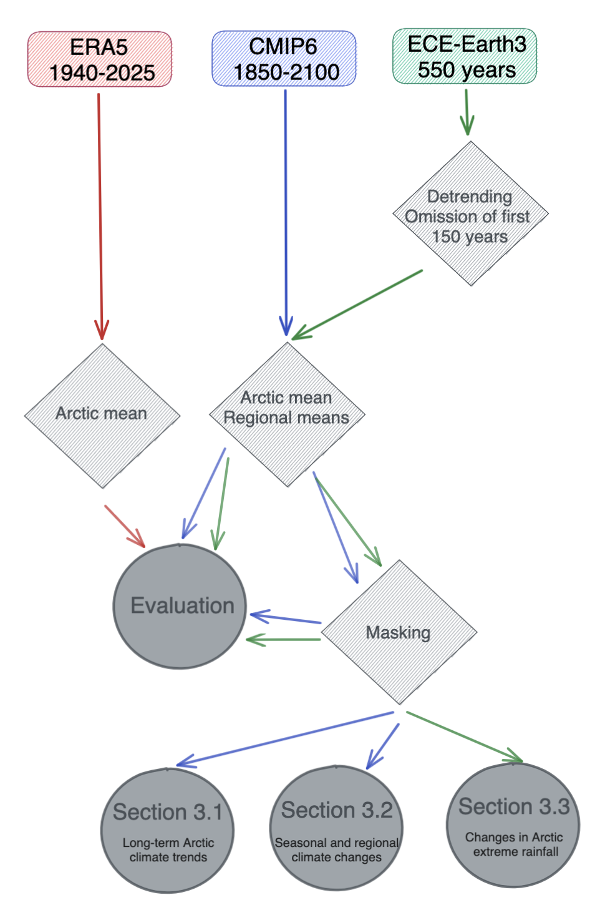

Figure 1: Data sources, processing steps, and analysis workflow. Three datasets were used: ERA5 reanalysis (1940–2024, red), CMIP6 simulations (1850–2100, blue), and EC-Earth3 long steady-state runs (550 years, green). EC-Earth3 data were detrended and the first 150 years omitted before use. For CMIP6 and EC-Earth3, Arctic and regional means were calculated; ERA5 was used for Arctic means only. Masking refers to the sequential application of three spatial masks to retain relevant Arctic land pixels (see section 2.4).

To characterise recent Arctic climate and provide a baseline for model evaluation (Fig. 1), we used surface air temperature (2 m), total precipitation, and snowfall from the ECMWF Reanalysis v5 (ERA5; Hersbach et al., 2020). Data were downloaded at ~25 km spatial resolution and monthly temporal resolution for the period 1940–2024, averaged annually, and regridded to a 1° × 1° grid. The Arctic was defined as the region between 60–90°N. Snow cover was obtained from ERA5-Land at ~10 km resolution for 1950–2024, as this variable is not available in ERA5. Snow cover data were processed following the same steps as the climate model output to allow direct comparison. ERA5 serves here as an observationally constrained reference dataset for validating Earth system model behaviour.

2.2 CMIP6 Earth System Model simulations

To assess future Arctic climate change (Fig. 1), we analysed daily output from ten CMIP6 Earth System Models (ESMs). We selected three Shared Socioeconomic Pathways (SSPs; O’Neill et al., 2016) to span a broad range of future forcing trajectories: SSP1-2.6 (low), SSP2-4.5 (intermediate), and SSP5-8.5 (high). These scenarios correspond to approximate radiative forcings of 2.6, 4.5, and 8.5 W m⁻² by 2100. Each SSP simulation was merged with its corresponding historical run (1850–2014), yielding continuous daily output from 1850 to 2100. One ensemble member per model was used. All data were regridded to a common 1° × 1° grid and aggregated to annual resolution for model evaluation. Model performance was assessed by comparing Arctic mean values (ensemble mean across models) to ERA5 over 1940–2024 for temperature, rainfall, and snowfall, and over 1950–2024 for snow cover. Comparisons were performed both with and without the tundra mask (Section 2.4) to ensure that masking did not bias model evaluation.
The ten CMIP6 models used were: CanESM5, CMCC-CM2-SR5, CMCC-ESM2, INM-CM4-8, INM-CM5-0, IPSL-CM6A-LR, MIROC6, MPI-ESM1-2-HR, MPI-ESM1-2-LR, and IITM-ESM.

2.3 EC-Earth3 equilibrium experiments

To quantify climate variability and robustly estimate rare extreme events (Fig. 1), we analysed long equilibrium simulations from the EC-Earth3-CC model configuration. Two fixed-CO₂ experiments were conducted: one at present-day CO₂ levels (1×CO₂, 420 ppm) and one at doubled CO₂ (2×CO₂, 840 ppm). Each experiment was integrated for 550 years under constant forcing.

Initial conditions were generated from a 100-year spin-up initialized from the SSP2-4.5 simulation. The first 150 years of each equilibrium run were discarded as spin-up, leaving 400 years for analysis. All variables were linearly detrended to remove residual model drift. Daily surface temperature, rainfall, snowfall, and snow cover were analysed, with all output interpolated to a 1° × 1° grid to ensure consistency with ERA5 and CMIP6.
These equilibrium simulations do not represent transient future projections but idealised end states, allowing comparison between a stable present-day climate and a stable doubled-CO₂ climate. This framework enables direct estimation of extreme-event statistics without assumptions about stationarity.
Transient SSP simulations and equilibrium experiments represent fundamentally different climate states. SSP simulations describe a continuously evolving climate system that has not fully equilibrated by 2100, whereas equilibrium simulations capture the committed climate response to fixed CO₂ concentrations. This distinction is particularly important when interpreting extremes and long-term seasonal changes.

2.4 Spatial masks and regional subdivision
Because the study focuses on migratory birds breeding in lowland tundra, all analyses were restricted to this habitat. Without masking, mixed land-cover types (e.g. ocean, mountains, forests) would bias estimates of snowmelt timing, precipitation, and extreme events.
Spatial masks were constructed from ERA5-Land fields and applied consistently to ERA5, CMIP6, and EC-Earth after regridding. ERA5-Land provided land–sea fraction, elevation (from geopotential height), and high-vegetation fraction. Source fields were interpolated to a 1° × 1° grid and cropped to the Arctic domain (60–90°N).
- Land–sea mask: grid cells with >50% land fraction were retained. This avoids including mixed coastal/ocean-dominated pixels, which would otherwise strongly influence precipitation and snow cover at this resolution.
- Elevation mask: Cells below 600 m were retained to capture lowland tundra. Most tundra-breeding shorebirds nest at low elevations, with Johnson et al. (2007) using 350 m as the upper limit for shorebird nesting, whereas for instance, white geese (genus Chen) generally occur below 200 m during the reproductive season (Hughes et al. 1994, Slattery & Alisauskas 2007). A strict 350 m cutoff would be too restrictive at the coarse 1° grid scale (~100 km), where many grid cells with mean elevations between 350 and 600 m might still be dominated by low-relief tundra and therefore function ecologically like lowland breeding habitat. The 600 m threshold therefore provides a practical upper limit that includes all low-elevation breeding environments while excluding high-elevation terrain with markedly different snow and precipitation regimes.
- Vegetation mask: Cells with >20% high-vegetation cover were excluded. This removes boreal forest and tall shrub zones, which have very different snow and moisture regimes. A 20% threshold retains open tundra including shrub–tundra mosaics, while preventing forest-dominated pixels from influencing climate averages. Lower values (e.g., 10%) would incorrectly exclude many tundra pixels; higher values (e.g., 30%) would allow forested areas to remain.
The combined mask was applied to all daily variables, ensuring that climate metrics reflect conditions relevant to tundra breeding habitats (Fig. 2).
For spatial analyses, the masked Arctic domain was subdivided into eight ecologically relevant regions: Norway, Svalbard, Novaya Zemlya, Taimyr, East Siberia, Alaska, Canada, Greenland, and Iceland (Supplementary Table 1). These regions represent major Arctic breeding areas and capture key longitudinal and climatic contrasts. Area-weighted regional means were computed for all datasets and scenarios.

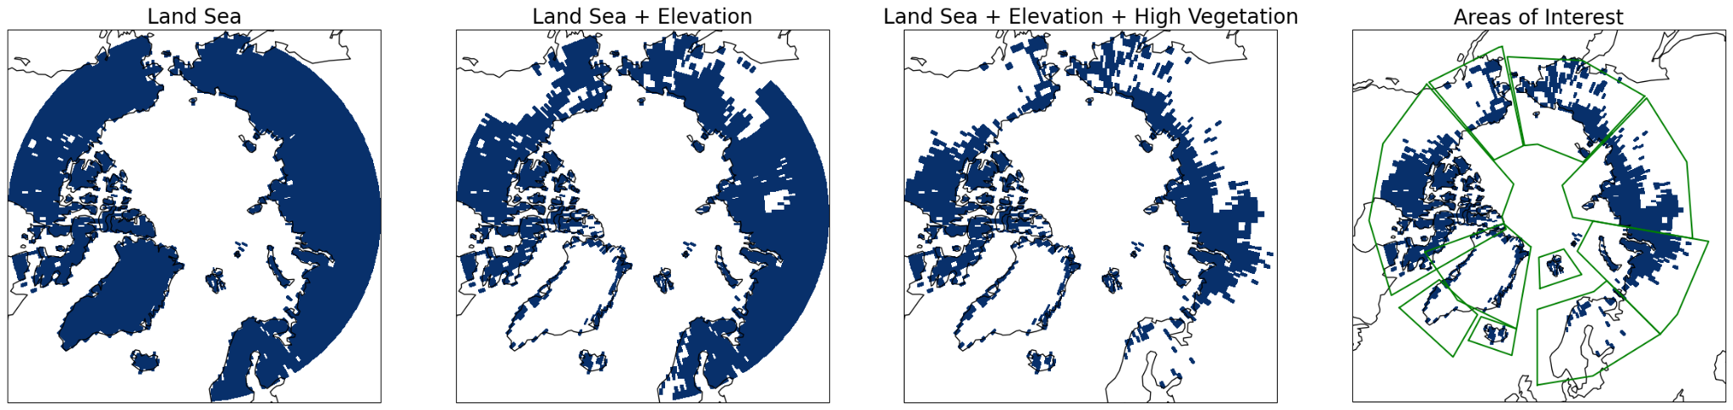

Figure 2. Spatial masks used in the analysis. Sequential application of three spatial masks to retain relevant Arctic land pixels: (left) land–sea mask, (middle) land–sea plus elevation mask (excluding areas >600 m), and (right) land–sea plus elevation plus high-vegetation mask (retaining tundra and other low-vegetation areas).

2.5 Seasonal timing and extreme event analysis

Productive Period Timing

We defined the Arctic PP as the annual window between spring snowmelt and autumn snow return, based on daily snow cover fraction. Melt onset was identified as the first day when regional mean snow cover dropped below 50%, and snow return as the first day when snow cover exceeded 30% again. PP length was calculated as the number of days between these two thresholds. All metrics were computed both for the whole Arctic (spatial mean) and for the different Arctic subregions. Interannual variability in PP timing and duration was quantified as the standard deviation across years.

Frequency, timing and magnitude of Extreme events

Extreme events were defined using fixed 99th-percentile thresholds derived from the present-day (1×CO₂) equilibrium simulation. For each month and region, all daily values across the 400-year 1×CO₂ run were pooled to estimate stable monthly thresholds. Thresholds were computed separately for each month to retain Arctic seasonality, and analyses were restricted to April–October.
Extreme-event metrics include frequency, intensity, and timing (day-of-year distribution). Return periods were estimated empirically from annual maximum daily rainfall by ranking values across the 400-year simulations. This approach avoids parametric assumptions and allows direct comparison of extreme-event magnitudes between 1× and 2×CO₂ climates. Throughout, “extreme events” refer to extreme daily events.

2.6 Software and data processing

All analyses were performed in Python using xarray (Hoyer & Hamman, 2017), numpy (Harris et al., 2020), pandas (McKinney, 2010), and piecewise-regression (Pilgrim, 2021), alongside Climate Data Operators (CDO; Schulzweida, 2020). Processing steps included regridding, spatial masking, temporal aggregation, detrending, percentile and return-period calculations, and regional averaging.

Results

3.1 Long-term Arctic climate trends (1850–2100, CMIP6)

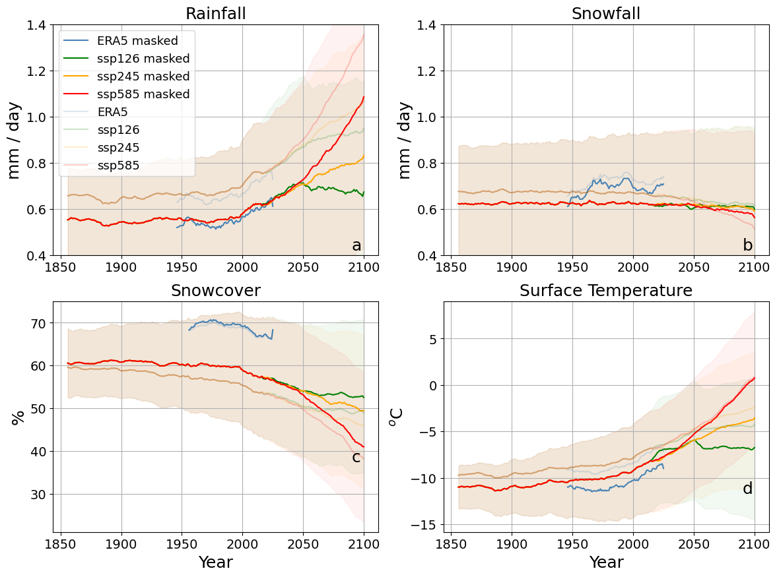
Figure 3. Long-term Arctic mean climate trends (1850–2100) from CMIP6 models (mean over 10 models) and ERA5/ERA5-Land reanalysis. Panels show annual mean a) rainfall (mm water equivalent per year), b) snowfall (mm water equivalent per year), c) snow cover fraction (%), and d) near-surface air temperature (°C). Values represent Arctic-wide averages with a 7-year rolling mean applied to improve visual clarity. Thick lines indicate masked means, while faint lines show unmasked Arctic-wide averages. Reanalysis data are taken from ERA5 for rainfall, snowfall, and air temperature (1940–2024) and from ERA5-Land for snow cover (1950–2024). CMIP6 simulations are shown for SSP1-2.6 (green), SSP2-4.5 (orange), and SSP5-8.5 (red). ERA5 and ERA5-Land are generally consistent with CMIP6 historical simulations up to the early 21st century, supporting the reliability of the model projections.

The Arctic climate remained relatively stable until the late 20th and early 21st century (Figure 3d; surface temperature breakpoint = 2007, rainfall breakpoint = 2020), providing predictable breeding conditions for migratory birds. Since then, rapid shifts in temperature, precipitation, and snow cover have emerged (Figure 3a–d), coinciding with intensified Arctic amplification (Gutiérrez et al. 2021; Rantanen et al. 2022). Arctic mean rainfall and surface temperature increased sharply in the early 21st century (trends: 10⁻² mm day⁻¹ yr⁻¹ and 1.1 × 10⁻¹ °C yr⁻¹, respectively), while snowfall remained relatively stable and snow cover declined steadily.

Future projections diverge after ~2050. Under SSP1-2.6 and SSP2-4.5, warming stabilizes, whereas under SSP5-8.5 it accelerates, reaching ~8.6 °C Arctic mean warming by 2081–2100 relative to 1995–2014, consistent with CMIP6 assessments (Gutiérrez et al. 2021). Even under SSP1-2.6, warming of ~2 °C is projected.
Arctic mean rainfall nearly doubles under SSP5-8.5 (0.6 → 1.02 mm day⁻¹; 2081–2100 mean compared to 1995–2014), while snowfall remains stable or declines slightly, shifting precipitation toward rain-dominated regimes (Figure 3a,b; Bintanja & Andry 2017). By the end of the century, rainfall exceeds snowfall by nearly 2:1, indicating a fundamental hydrological transition (Bintanja 2018). Snow cover declines from 58% to 42%, primarily due to reduced autumn and winter snow cover and, to a lesser extent, earlier spring melt (Figure 4c), shortening the snow season and altering PP timing.
Arctic-wide trends mask strong regional contrasts. In Norway, Iceland, and Svalbard, snowfall decreases year-round, driving pronounced winter and summer snow-cover loss and a shift toward rain-dominated precipitation. In contrast, Canada, East Siberia, and Taimyr retain stable or increasing winter snowfall but still experience summer and autumn snow-cover loss as precipitation shifts toward rain. Although total snow-cover decline is broadly similar across regions (50–60%), its seasonal timing and drivers differ markedly (Supplementary Figures 2–3).

3.2 Seasonal and regional climate changes across the Arctic (CMIP6)

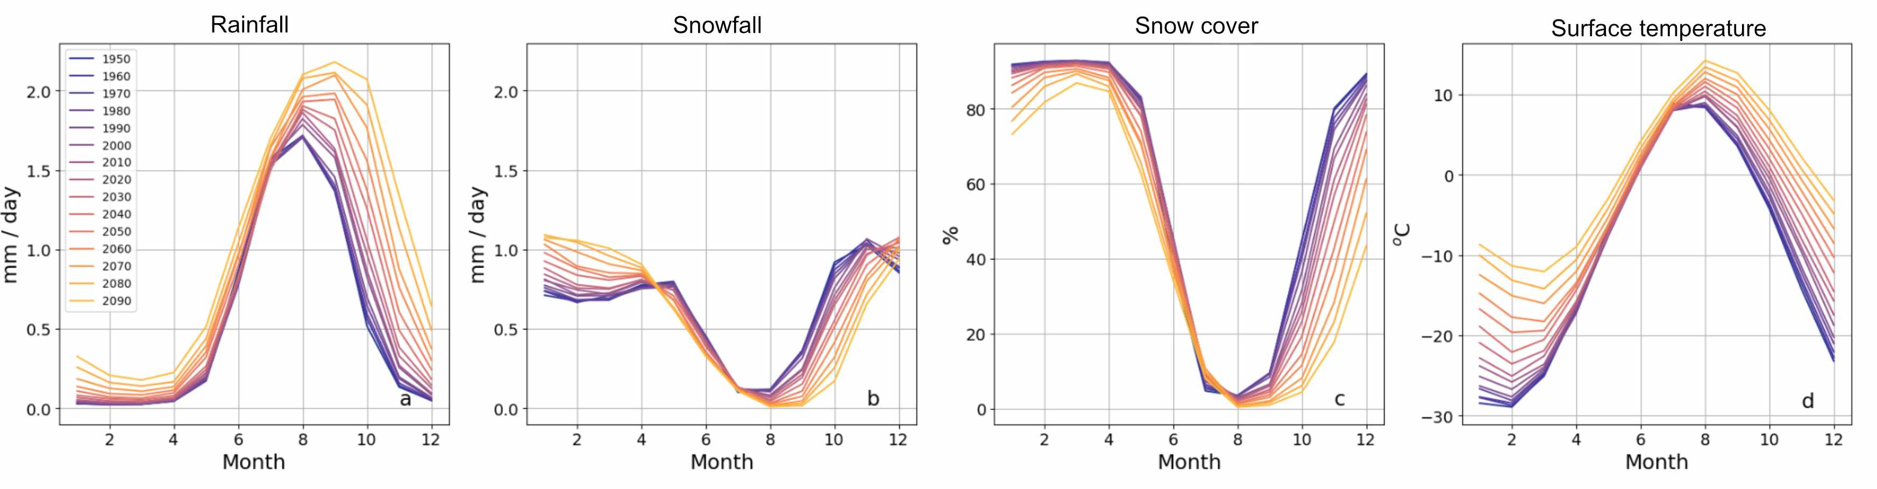

Figure 4: Monthly climatology of the CMIP6 ensemble mean for SSP5-8.5, shown per decade from 1950 to 2090 (line colour from dark blue to yellow). Variables are: a) rainfall (mm/day), b) snowfall (mm/day), c) snow cover fraction (%), and d) 2 m air temperature (°C). Each line represents the multi-model mean monthly values for a given decade, illustrating both long-term trends and shifts in the seasonal cycle. The results highlight a shift toward wetter winters, substantial reductions in snowfall and snow cover, and a pronounced winter warming signal over the 21st century.
Under SSP5-8.5, Arctic warming is strongest in winter (+15.3 °C in 2081–2100 relative to 1995–2014; Figure 4d), but temperatures remain sufficiently low for precipitation to fall mainly as snow. Spring and summer warming is more moderate (+8.2 °C and +4.0 °C), with spring precipitation still snow-dominated and limited effects on snow cover (Figure 4a–c).
In autumn, however, moderate warming (+8.4 °C) coincides with a strong rainfall increase (Figure 4a; August–December; 0.761 mm/day; same period comparison), delaying snowfall return and shortening the snow season. This shift reflects threshold behaviour: relatively small temperature increases around 0 °C produce abrupt changes in precipitation phase.
Regional patterns reinforce this contrast. Novaya Zemlya, Taimyr, East Siberia, Canada, and Greenland remain cold enough for winter precipitation to remain snow-dominated, partially compensating autumn losses. In contrast, Svalbard, Norway, and Iceland experience year-round snowfall declines, nearly halving annual snowfall and driving strong winter and spring snow-cover loss. In these regions, the onset of the PP occurs up to two months earlier (Supplementary Figure 3).

3.3 Changes in Arctic extreme rainfall: frequency, timing, and magnitude (EC-Earth steady-state experiments)
Snow defines the start and end of the PP, and hence extreme snowfall plays only a minor role during the PP itself in our 2×CO₂ run (Supplementary Figure 7). Our analysis shows that snowfall extremes occur almost exclusively outside the PP, when birds are absent. By contrast, the absolute occurrence of extreme rainfall events peaks during the PP.
To investigate how the PP window and (extreme) conditions inside that window may change, we used long, steady-state EC-Earth simulations with fixed CO₂ forcing (1× and 2×). These experiments provide a clean comparison between present-day and a strongly perturbed climate by allowing us to sample numerous extreme events under stable conditions. Our results show that under 2×CO₂ forcing, the PP becomes longer, with snow cover decreasing earlier and returning later. Across the Arctic, snowmelt advances by 28 days (from mean DOY ± standard deviation: 166 ± 4 to 138 ±3) on average, while snow return is delayed by 36 days (from 258 ± 5 to 294 ±3, see also vertical lines in Figure 5). While shifts in the timing and duration of the PP are important for migratory birds, the extreme events occurring within this window may be just as important.

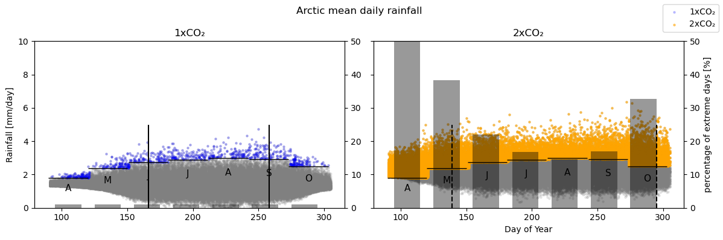

Figure 5: Changes in daily rainfall patterns and extremes in the Arctic under elevated CO₂ levels. Panels show precipitation distributions and extreme rainfall statistics for the Arctic region under present-day (1×CO₂ ≈ 420 ppm) and future (2×CO₂ ≈ 840 ppm) CO₂ levels, based on long-term steady-state simulations. All values are spatially averaged across the Arctic and computed over 400-year time slices per scenario. (a) Daily rainfall throughout the year under 1×CO₂, and (b) under 2×CO₂. Grey dots show all daily values; blue (a) and orange (b) dots mark extreme rainfall days, defined as exceeding the monthly 99th percentile from the 1×CO₂ data. Vertical black lines indicate the ecologically relevant productive period (PP), defined by snow cover thresholds: 50% in spring–summer (snowmelt) and 30% in autumn (snow return). Vertical black solid lines mark the PP under 1×CO₂, and vertical black dashed lines mark the PP under 2×CO₂. Overlaid grey bars (right axis) show the proportion of days per month exceeding the 1×CO₂ thresholds (always 1% on the left panel). Horizontal lines represent the monthly 1×CO₂ 99th percentile values. Extremes are defined relative to monthly percentiles to account for seasonal variation. The PP window was determined from modelled snow cover dynamics and applied consistently across both CO₂ scenarios. Under 2×CO₂, the frequency of rainfall extremes increases sharply both within and outside the PP, with particularly large increases in April–May and October.
During the PP_{1x} (mid-June to mid-September), the frequency of extremely wet days increases ~16-fold in the 2×CO₂ experiment compared to the 1× run (Table 1). Outside this window, however, the relative increase compared to present-day conditions is even more dramatic: In October, 32% of all days exceed the 1×CO₂ 99th-percentile threshold (i.e. days that would be classified as “extremely wet” under today’s climate), while in April and May they are even 96% and 38%, respectively. These pre-PP_{1x} months show the most pronounced shifts, reflecting unprecedented extreme rainfall levels and occurrences, driven mainly by higher mean daily precipitation (compared to 1×CO₂, Supplementary Figure 4). Thus, while the PP_{1x} concentrates the largest absolute number of extreme rainfall days, the strongest relative shifts toward unprecedented wet conditions occur outside the PP_{1x}.
Because the Arctic is generally dry compared to most other regions of the world, the threshold for defining an “extremely wet” day is very low. As a result, even modest absolute increases in rainfall translate into large relative changes. This effect is most pronounced outside the PP_{1x}: although rainfall also increases during the PP_{1x}, the much larger ratios in April–May and October indicate that the climate state itself is shifting, with previously relatively dry months experiencing unprecedented extreme rainfall rates. Across all regions, the ratio of extreme wet days for 2×CO₂ compared to 1×CO₂ during the PP_{1x} still averages 3.7 ± 1.2 (Table 1).
Regional differences sharpen this contrast. In relatively wet regions such as Norway, Svalbard, and Iceland, the ratio remains modest (4.7 ± 1.6) even when extended to the April-October period, implying that heavier rainfall largely amplifies familiar seasonal patterns. In contrast, relatively dry regions such as East Siberia, Canada, and Greenland show much sharper increases, with ratios reaching 17.4 ± 0.9. Here, modest absolute changes produce disproportionately large relative shifts, creating rainfall regimes with no modern analogue. For migratory Arctic-breeding birds, this means that those species that are accustomed to “wet” regions will encounter stronger rainfall within familiar patterns, whereas birds in historically dry regions will be confronted with a transition toward wetter climates, exposing them to novel and potentially disruptive conditions.

Table 1. Increase in extreme rainfall events under doubled CO₂ (2×CO₂) conditions across Arctic regions. Values represent the ratio of days with extreme precipitation (above the monthly 99th percentile of the 1×CO₂ climate) in the 2×CO₂ scenario compared to 1×CO₂. For the PP_{1x} (Productive Period under 1xCO₂ climate) column, extreme days were only counted within each region’s reproductive season, defined by the region-specific snowmelt and snow return dates (days of year when snow cover drops below 50% and rises above 30%, respectively). The 7-month column includes all region-specific extreme events from April to October. High ratios indicate strong intensification of extreme rainfall. More detailed information is presented in Supplementary Figure 5

Region | 2x/1x Ratio during PP_{1x} | 2x/1x Ratio during Apr-Oct
Arctic | 15.9 | 33.7
Norway | 3.0 | 4.1
Svalbard | 3.2 | 7.0
Novaya Zemlya | 3.1 | 5.9
Taimyr | 4.3 | 11.1
East Siberia | 4.0 | 9.6
Alaska | 3.1 | 4.2
Canada | 4.7 | 19.7
Greenland | 5.9 | 17.1
Iceland | 2.1 | 2.5

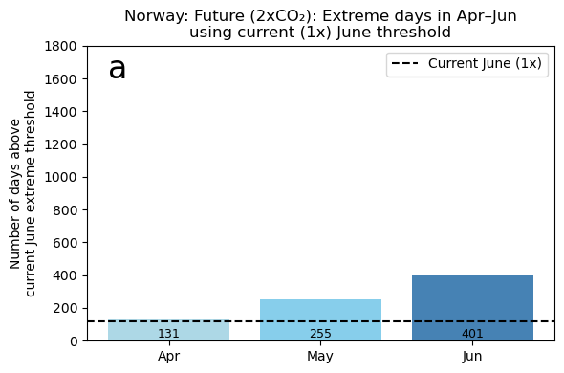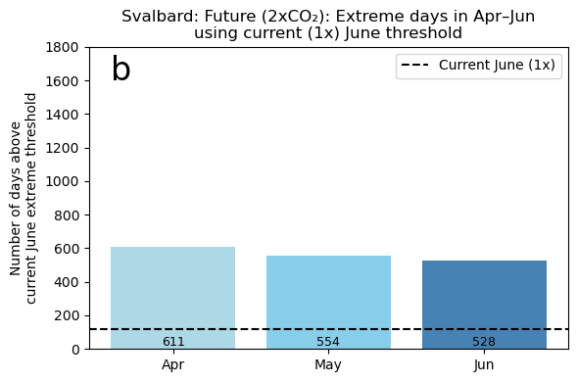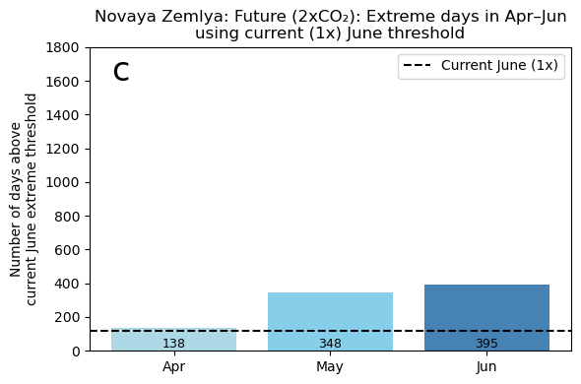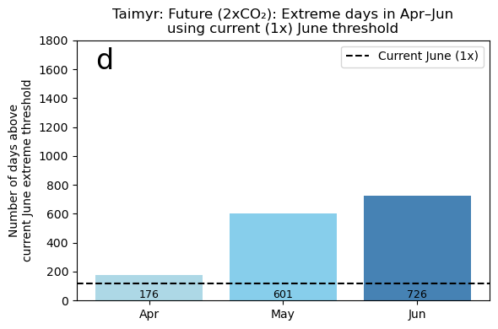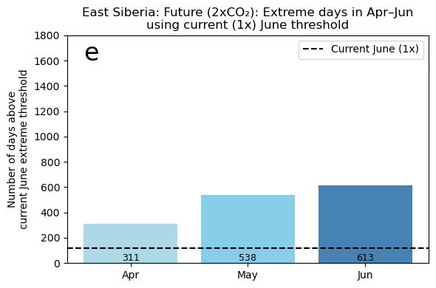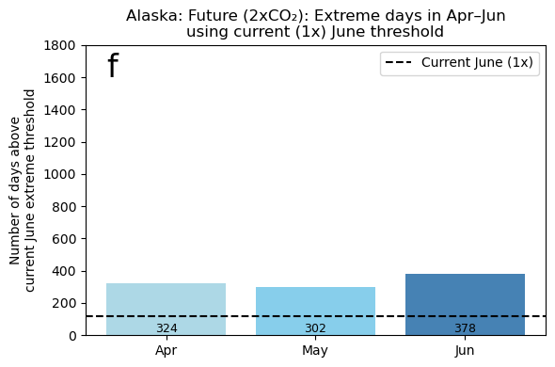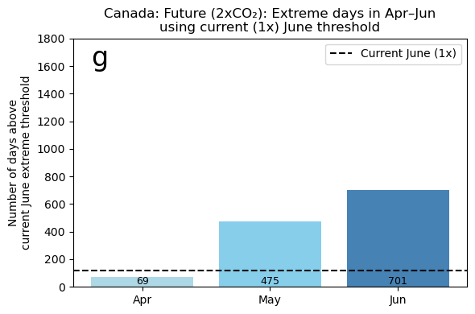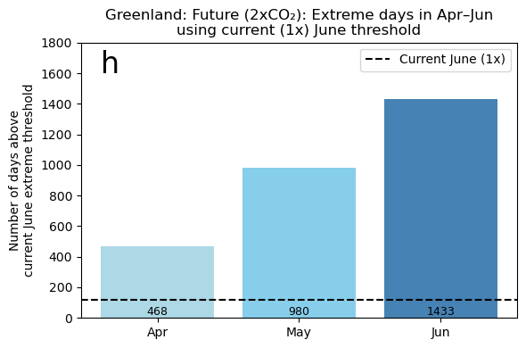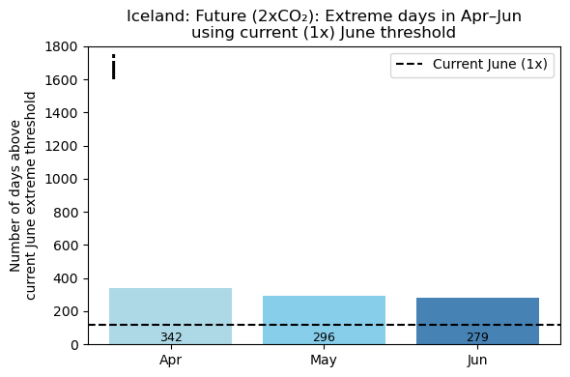

Figure 6. Number of days exceeding the present-day (1×CO₂) June extreme rainfall threshold under future 2×CO₂ conditions, shown for April–June across nine Arctic regions. Bars indicate monthly counts over 400 year simulations, while the dashed line marks the present-day June baseline. This illustrates how rainfall extremes spread into earlier months under warming, reducing the potential for migratory birds to avoid extreme conditions by arriving earlier in the season. April is shown to illustrate climatic spillover relative to present-day June, not direct bird exposure.
Using June as a reference month, as this marks the period when most Arctic-breeding tundra birds are nesting, we find that under doubled CO₂, there are clear regional differences in how present-day June rainfall extremes change and redistribute seasonally (Figure 6). Regions such as Greenland and Canada, which have relatively low present-day thresholds, show a strong amplification of June extremes, but limited spillover into May. By contrast, regions where thresholds are already high, such as Iceland and Norway, show smaller relative increases in June itself, but a more even redistribution of June-like extremes into May, and to a lesser extent April. While April primarily reflects a shift in the climatic regime rather than direct exposure of breeding birds, it illustrates how present-day June conditions emerge progressively earlier in the calendar year.
Svalbard shows a mixed response, combining a strong increase in June extremes with pronounced seasonal spillover. Together, these patterns indicate that regions differ in whether climate change primarily intensifies extremes during the core breeding period or redistributes them toward earlier parts of the season once snow-free conditions are reached. This balance between amplification and seasonal redistribution likely reflects differences in local climate drivers and background precipitation regimes.

Table 2. Change in rainfall magnitude of rare and extreme events between 1×CO₂ (420 ppm) and 2×CO₂ (840 ppm) climates across 10 Arctic regions. Each cell shows the transition from 1× to 2× values (in mm/day × 10⁻⁴), followed by the percentage increase in parentheses. Values were derived directly from 400-year simulations per scenario (no parametric fits, i.e. return levels taken directly from the data rather than by fitting a statistical distribution). The first three columns report changes in (1) the annual maximum daily rainfall, (2) the 10-year return level (i.e. the 40th highest value), and (3) the 100-year return level (i.e. the 4th highest value). The final column indicates how often a current (1×) 100-year event is expected to occur under 2× conditions (i.e. its new return period). Cell colors indicate relative change: Green: moderate increase (0–35%), Yellow: strong increase (35–75%), Red: extreme increase (>75%). Greenland 1, a typically dry region, shows a 400% increase in annual maximum rainfall due to a very low baseline. Overall, most regions experience a 25–50% increase in the intensity of rare events, and current 100-year events become decadal or even more frequent in a 2×CO₂ world.

Region | 1-yr return event (mm/day) | 10-yr return event (mm/day) | 100-yr return event (mm/day) | Return Period (1x_100yr) in 2x world  (years)
Norway | 6.2 -> 8.4 (35%) | 13.4 -> 17.1 (28%) | 16.5 -> 21.7 (32%) | 7
Svalbard | 4.3 ->9.2 (114%) | 15.8 -> 25.5 (61%) | 21.3 -> 34.9 (64%) | 4
Novaya Zemlya | 5.1 -> 6.2 (22%) | 10.0 -> 13.2 (32%) | 12.3 -> 15.6 (27%) | 6
Taimyr | 3.5 -> 5.3 (66%) | 6.9 -> 9.2 (33%) | 9.0 -> 10.8 (20%) | 8
East Siberia | 3.2 -> 5.1 (59%) | 8.8 -> 12.5 (42%) | 12.1 -> 17.2 (42%) | 9
Alaska | 5.4 -> 7.2 (33%) | 14.7 -> 19.7 (34%) | 18.1 -> 26.3 (45%) | 6
Canada | 2.6 -> 3.7 (42%) | 5.9 -> 8.4 (42%) | 7.3 -> 11.2 (53%) | 4
Greenland | 2.5 -> 5.3 (112%) | 6.4 -> 10.4 (62.5%) | 8.0 -> 13.4 (67.5%) | 2
Iceland | 12.9 -> 15.6 (21%) | 27.6 -> 35.3 (28%) | 33.8 -> 51.5 (52%) | 7

Even if birds were to arrive earlier to avoid the higher frequency of extremes, they would still face more intense downpours than in the past, meaning that months with fewer exceedances may still expose them to intense rainfall levels (Table 2). All regions are projected to experience substantial increases in extreme rainfall events, though the magnitude differs: some, such as Iceland and Norway, show relatively moderate growth, while others, including Canada and East Siberia, face much stronger intensification.
Two regions stand out as extreme cases. Greenland shows the most dramatic change, with the 1-year return event (an event expected roughly once per year) increasing by +112% and reducing the recurrence time of a present-day 100-year event to only two years. Svalbard displays similarly large proportional increases (+114% at the 1-year level and +64% at the 100-year level), but with absolute rainfall amounts nearly double those projected for Greenland. Taken together, these results imply that rainfall events that are currently rare even within a bird’s whole lifetime, may in the future occur multiple times in a single reproductive season (Supplementary Figure 10).

Discussion

4.1 Steady-state runs as a tool for extreme event analysis
We used long steady-state (equilibrium) simulations, run under fixed CO₂ concentrations (EC-Earth dataset), to analyse how increasing weather extremes may affect the breeding season of Arctic migratory birds. Unlike transient CMIP6 scenarios, which combine long-term trends with evolving variability (Figure 3), our simulations hold the background climate constant and allow hundreds or even thousands of years of variability to be sampled under both present-day and perturbed conditions. This design enabled us to separate internal variability from long-term change (van der Linden et al., 2017) and to characterize extreme events with greater statistical confidence than transient simulations permit (Rugenstein et al., 2019).
For our purposes, the steady-state framework was crucial. It provided a simple contrast between present-day conditions (1×CO₂, 420 ppm) and a strongly perturbed climate (2×CO₂, 840 ppm). In the 2×CO₂ experiment, the Arctic warms by 3.9 °C (masked, detrended dataset, average of the last 400 years), which is about 4 °C warmer than the late-century SSP5-8.5 projection (masked dataset, 2081–2100 mean; Figure 3d). This difference reflects the contrast between transient and fully equilibrated climate states rather than an inconsistency between scenarios. This allowed us to ask not only whether extremes intensify, but how their frequency, timing, and seasonal distribution shift when the background climate is held fixed. We find that rainfall extremes (Figure 5 and Supplementary Figure 5), snowfall (Supplementary Figure 7) and snowmelt timing all change substantially between 1× and 2× CO₂. These responses show that extremes can evolve in ways that are not directly proportional to mean climate trends, with shifts in frequency and timing that reshape the conditions birds experience during the productive period. It is important to note that these experiments are not literal scenarios: the 1× run equilibrates at a temperature level slightly higher than today because the system requires centuries to balance, and the 2× run is a theoretical end-state rather than a socio-economic trajectory (Fabiano et al., 2024). Nonetheless, they provide a powerful tool for probing the mechanisms behind our results.

4.2 Spatial and seasonal variability in Arctic futures
Warming patterns across the Arctic are not uniform. Traditionally cold regions with mean annual surface temperature below 0 °C show the strongest increases (8–12 °C by the end of the century), whereas Norway and Iceland, which were already above freezing, warm more moderately (~5 °C). Yet even these smaller increases are sufficient to push them beyond critical thresholds, leading to sharp snowfall declines and large reductions in snow cover (~30%). This illustrates that even modest warming in already mild regions can trigger disproportionate impacts on the snow regime.
Svalbard represents an important outlier. Situated at the historical edge of sea-ice extent, it combines features of both colder and milder regions. While its mean annual TAS remains below 0 °C despite warming of 8–12 °C, it shows a strong year-round shift in precipitation, with summer and autumn snowfall nearly halved and no compensation by increasing winter snowfall. At the same time, rainfall rises across all seasons, driving marked snow cover loss throughout the year. The case of Svalbard highlights the role of sea ice in Arctic climate: once protected by the seasonal ice edge, it is now transitioning toward a regime more comparable to Norway and Iceland, with rain increasingly replacing snow and snow cover progressively diminishing. In this sense, Svalbard may offer a glimpse of the future trajectory of traditionally colder Arctic regions. Although snow cover is declining, the overlap of persistent snow with rising rainfall means that rain-on-snow events are expected to become more frequent and severe, creating ice crusts that limit food access for herbivores (Rennert et al., 2009) and decrease the insulating effect of snow for animals wintering under the snow (Kausrud et al. 2008). Such events may have knock-on effects on the whole food web, including breeding birds (Layton-Matthews et al. 2023; Nolet et al. 2013).
Seasonal differences are equally important. Winter exhibits the strongest warming signal across the Arctic, reflecting the retreat of sea ice at its maximum seasonal extent and the full force of Arctic Amplification. Despite this, most regions remain cold enough to sustain snowfall, and enhanced atmospheric moisture can even produce the paradox of increasing winter snowfall. In areas such as Greenland, this thicker snowpack may delay snow cover loss, thereby sustaining the traditional timing of the PP. Spring and summer warming is more moderate, but in regions without winter snowfall increases (e.g. Svalbard), snow cover reduction accelerates, advancing the PP onset.
Autumn is found to be the most critical season of change. Even relatively modest warming pushes temperatures above freezing, reduces snowfall, increases rainfall, and delays the establishment of snow cover. At the same time, sea ice is at its seasonal minimum, and delayed snowfall coupled with warmer conditions postpones freeze-up, enhancing ocean–atmosphere heat fluxes and further amplifying Arctic warming and wetting. Although migratory birds typically depart during this season, autumn processes set the stage for the subsequent winter and spring. Later snow onset and delayed sea-ice formation can cascade into warmer winters and earlier spring melt, shortening the snow season.
Taken together, these results show that both spring advances and autumn delays shape the timing of the PP, but the balance between them differs regionally. Relatively cold regions are projected to remain snow-dominated in winter, preserving a relatively short but still snow-governed reproductive window. By contrast, regions near the sea-ice edge, such as Svalbard, are shifting toward longer yet wetter seasons, where snow cover is reduced and rainfall plays a growing role. For birds, this implies divergent risks: some populations will continue to face narrow windows constrained by snow, while others will contend with longer seasons increasingly dominated by rain. Ultimately, while some regions currently show winter snowfall increases, this resilience has limits: continued warming is likely to erode it, pushing even the most stable regions toward trajectories resembling Svalbard, with year-round snow loss and rain-dominated precipitation regimes.

4.3 Implications of intensifying extremes for bird reproduction and migration strategies
A longer PP will generally benefit birds by providing more time for reproduction. In waterfowl, earlier and warmer springs can increase the proportion of individuals attempting to breed and improve nesting success (Boom et al. 2023b). Increased rainfall may also have positive effects by enhancing vegetation growth, particularly graminoids, thereby increasing food availability for Arctic-nesting waterfowl (van der Kolk et al. 2016). However, rainfall can also have negative effects on reproduction, especially during early life stages. Young chicks have limited insulation, and prolonged wet conditions can increase brooding time at the expense of foraging, reducing growth rates and survival (Oortwijn, 2025). At the nest level, heavy rainfall has been linked to nest failure (Skinner et al. 1998) and chick mortality (Anctil et al. 2014). Moreover, rainfall effects may be indirect and context-dependent: for example, higher summer precipitation in Svalbard barnacle geese was associated with increased fledgling mortality, potentially through increased cloud cover reducing plant productivity (Layton-Matthews et al. 2019). Finally, a later end of the PP may again benefit some waterfowl species, which typically depart the Arctic only as cold conditions set in and day length decreases, whereas many shorebirds depart breeding grounds shortly after brood-rearing, often as early as mid-July (Boom et al. 2023a).
The results of our EC-Earth steady-state simulations indicate strong regional differences in the extent to which earlier breeding could help Arctic birds reduce their exposure to extreme rainfall during the snow-free period. In regions such as Svalbard and Iceland, rainfall extremes that are characteristic of present-day June (1×CO₂) increasingly occur as soon as snow cover retreats under future 2×CO₂ conditions (Figure 6). As a result, extreme rainfall is no longer confined to the peak reproductive month but extends into the earliest part of the PP, effectively narrowing the scope for birds to avoid extremes by advancing arrival or breeding. In theory, earlier arrival could reduce exposure to the most intense rainfall events (Figure 6), but our results suggest that, on average, shifts of several weeks to months relative to present-day timing would be required. Such advances may not be biologically realistic for long-distance migrants. Although many Arctic-breeding herbivores can advance arrival and egg-laying by days or weeks through faster migration (Lameris et al. 2025; Linssen et al. 2025), further advances are constrained by snowmelt timing (Liebezeit et al. 2014; Lameris et al. 2018; Boom et al. 2023). Consequently, earlier breeding would only be feasible if snowmelt advanced sufficiently to permit nesting (Supplementary Figure 5). Moreover, once limits to faster migration are reached, additional advances would require earlier fuelling and departure from non-breeding areas (Linssen et al. 2025). Given that Arctic amplification proceeds much faster than climate change at temperate latitudes, it remains uncertain whether birds can adjust the timing of their migration when cues to initiate migration are shifting less than the optimal breeding window (McNamara et al. 2011; Burnside et al. 2021).
The ecological consequences of these changes are likely to depend on baseline conditions, defined here as the present-day rainfall regimes to which each population is adapted. Birds breeding in historically wetter regions (with high extreme rainfall magnitude), such as Norway or Svalbard, already experience frequent rainfall under 1×CO₂ and may tolerate moderate increases under 2×CO₂. In contrast, birds breeding in historically drier regions (with low extreme rainfall magnitude), such as Canada and Greenland, face much larger proportional increases in extreme rainfall frequency and intensity when moving from 1× to 2×CO₂, even though absolute magnitudes remain lower than in wetter regions (Table 2; Supplementary Figure 5). Whether these newly emerging extremes will have comparable ecological impacts remains uncertain: they may overwhelm populations adapted to low-rainfall environments, or alternatively be less damaging than smaller proportional changes in already wet regions. An additional possibility is that species adapted to wetter conditions may expand into regions that become increasingly suitable. Together, these contrasting responses highlight that both the timing of extreme rainfall within the snow-free period and the ecological context of local adaptation are critical for understanding climate-change impacts on Arctic-breeding birds.

Data Availability Statement
The data supporting the results of this study are available via Zenodo at:
https://doi.org/10.5281/zenodo.18282287. Raw CMIP6 climate model data used in this study are publicly available through the Earth System Grid Federation (ESGF) portal (https://esgf-node.llnl.gov/). Raw ERA5 reanalysis data are publicly available from the Copernicus Climate Data Store (https://cds.climate.copernicus.eu/datasets). The raw ALEVA data (550-year steady-state EC-Earth3 climate model simulations) are not publicly available, as they are stored on ECMWF’s High Performance Storage System, which is accessible only to ECMWF member states. The processed ALEVA-derived data products used in this study are provided via Zenodo.

Code Availability Statement
The scripts supporting the results in this paper are available at Zenodo: https://doi.org/10.5281/zenodo.18281938

References

- Anctil, A., Franke, A., & Bêty, J. (2014). Heavy rainfall increases nestling mortality of an Arctic top predator: Experimental evidence and long-term trend in peregrine falcons. Oecologia, 174(3), 1033–1043. https://doi.org/10.1007/s00442-013-2800-y
- Beintema, A. J., & Visser, G. H. (1989). The effect of weather on time budgets and development of chicks of meadow birds. Ardea, 77(2), 181–192.
- Bintanja, R. (2018). The impact of Arctic warming on increased rainfall. Scientific Reports, 8(1), Article 16001. https://doi.org/10.1038/s41598-018-34450-3
- Bintanja, R., & Andry, O. (2017). Towards a rain-dominated Arctic. Nature Climate Change, 7(4), 263–267. https://doi.org/10.1038/nclimate3240
- Boom, M. P., Lameris, T. K., Schreven, K. H. T., Buitendijk, N. H., Moonen, S., de Vries, P. P., Zaynagutdinova, E., Nolet, B. A., van der Jeugd, H. P., & Eichhorn, G. (2023). Year-round activity levels reveal diurnal foraging constraints in the annual cycle of migratory and non-migratory barnacle geese. Oecologia, 202, 287–298. https://doi.org/10.1007/s00442-023-05386-x
- Boom, M. P., Schreven, K. H. T., Buitendijk, N. H., Moonen, S., Nolet, B. A., Eichhorn, G., van der Jeugd, H. P., & Lameris, T. K. (2023). Earlier springs increase goose breeding propensity and nesting success at Arctic but not at temperate latitudes. Journal of Animal Ecology, 92, 2399–2411. https://doi.org/10.1111/1365-2656.14020
- Bozinovic, F., Bastías, D. A., Boher, F., Clavijo-Baquet, S., Estay, S. A., & Angilletta, M. J. (2011). The mean and variance of environmental temperature interact to determine physiological tolerance and fitness. Physiological and Biochemical Zoology, 84(6), 543–552. https://doi.org/10.1086/662551
- Burnside, R. J., Salliss, D., Collar, N. J., & Dolman, P. M. (2021). Birds use individually consistent temperature cues to time their migration departure. Proceedings of the National Academy of Sciences, 118(28), e2026378118. https://doi.org/10.1073/pnas.2026378118
- Döscher, R., Acosta, M., Alessandri, A., Anthoni, P., Arsouze, T., Bergman, T., … Zhang, Q. (2022). The EC-Earth3 Earth system model for the Coupled Model Intercomparison Project 6. Geoscientific Model Development, 15(7), 2973–3020. https://doi.org/10.5194/gmd-15-2973-2022
- Eyring, V., Bony, S., Meehl, G. A., Senior, C. A., Stevens, B., Stouffer, R. J., & Taylor, K. E. (2016). Overview of the Coupled Model Intercomparison Project Phase 6 (CMIP6) experimental design and organization. Geoscientific Model Development, 9(5), 1937–1958. https://doi.org/10.5194/gmd-9-1937-2016
- Fabiano, F., Davini, P., Meccia, V. L., Zappa, G., Bellucci, A., Lembo, V., Bellomo, K., & Corti, S. (2024). Multi-centennial evolution of the climate response and deep-ocean heat uptake in a set of abrupt stabilization scenarios with EC-Earth3. Earth System Dynamics, 15(2), 527–546. https://doi.org/10.5194/esd-15-527-2024
- Gutiérrez, J. M., Jones, R. G., Narisma, G. T., Alves, L. M., Amjad, M., Gorodetskaya, I. V., … Yoon, J.-H. (2021). Atlas. In V. Masson-Delmotte et al. (Eds.), Climate change 2021: The physical science basis (pp. 1927–2058). Cambridge University Press. https://doi.org/10.1017/9781009157896.021
- Harris, C. R., Millman, K. J., van der Walt, S. J., Gommers, R., Virtanen, P., Cournapeau, D., … Oliphant, T. E. (2020). Array programming with NumPy. Nature, 585(7825), 357–362. https://doi.org/10.1038/s41586-020-2649-2
- Hersbach, H., Bell, B., Berrisford, P., Hirahara, S., Horányi, A., Muñoz-Sabater, J., … Thépaut, J.-N. (2020). The ERA5 global reanalysis. Quarterly Journal of the Royal Meteorological Society, 146(730), 1999–2049. https://doi.org/10.1002/qj.3803
- Hoyer, S., & Hamman, J. (2017). xarray: N-D labeled arrays and datasets in Python. Journal of Open Research Software, 5(1), Article 10. https://doi.org/10.5334/jors.148
- Hughes, R. J., Gauthier, G., & Reed, A. (1994). Summer habitat use and behaviour of greater snow geese (Anser caerulescens). Wildfowl, 45, 49–64.
- Johnson, J. A., Lanctot, R. B., Andres, B. A., Bart, J. R., Brown, S. C., Kendall, S. J., & Payer, D. C. (2007). Distribution of breeding shorebirds on the Arctic Coastal Plain of Alaska. Arctic, 60(3), 277–293.
- Kausrud, K. L., Mysterud, A., Steen, H., Vik, J. O., Østbye, E., Cazelles, B., … Stenseth, N. C. (2008). Linking climate change to lemming cycles. Nature, 456, 93–98. https://doi.org/10.1038/nature07442
- Lameris, T. K., Boom, M. P., Nuijten, R. J. M., Buitendijk, N. H., Eichhorn, G., Ens, B. J., et al. (2025). Migratory birds advance spring arrival and egg-laying in the Arctic, mostly by travelling faster. Global Change Biology, 31(4), e70158. https://doi.org/10.1111/gcb.70158
- Lameris, T. K., van der Jeugd, H. P., Eichhorn, G., Dokter, A. M., Bouten, W., Boom, M. P., … Nolet, B. A. (2018). Arctic geese tune migration to a warming climate but still suffer from a phenological mismatch. Current Biology, 28(15), 2467–2473.e4. https://doi.org/10.1016/j.cub.2018.05.077
- Layton-Matthews, K., Vriend, S. J. G., Grøtan, V., Loonen, M. J. J. E., Sæther, B.-E., Fuglei, E., & Hansen, B. B. (2023). Extreme events, trophic chain reactions, and shifts in phenotypic selection. Scientific Reports, 13(1), Article 15181. https://doi.org/10.1038/s41598-023-41940-6
- Liebezeit, J. R., Gurney, K. E. B., Budde, M., Zack, S., & Ward, D. (2014). Phenological advancement in Arctic bird species: Relative importance of snowmelt and ecological factors. Polar Biology, 37, 1309–1320. https://doi.org/10.1007/s00300-014-1522-x
- Linssen, H., Lameris, T. K., Boom, M. P., Nuijten, R. J. M., Buitendijk, N. H., Dokter, A. M., … Nolet, B. A. (2025). Scope for waterfowl to speed up migration to a warming Arctic. Nature Climate Change. https://doi.org/10.1038/s41558-025-02419-6
- McKinney, W. (2010). Data structures for statistical computing in Python. In Proceedings of the 9th Python in Science Conference (pp. 56–61). https://doi.org/10.25080/majora-92bf1922-00a
- McNamara, J. M., Barta, Z., Klaassen, M., & Bauer, S. (2011). Cues and the optimal timing of activities under environmental changes. Ecology Letters, 14, 1183–1190. https://doi.org/10.1111/j.1461-0248.2011.01686.x
- Meltofte, H., Piersma, T., Boyd, H., McCaffery, B., Ganter, B., Golovnyuk, V. V., … Wennerberg, L. (2007). Effects of climate variation on the breeding ecology of Arctic shorebirds. Meddelelser om Grønland, Bioscience 59. https://doi.org/10.7146/mogbiosci.v59.142631
- Nolet, B. A., Bauer, S., Feige, N., Kokorev, Y. I., Popov, I. Y., & Ebbinge, B. S. (2013). Faltering lemming cycles reduce productivity and population size of a migratory Arctic goose species. Journal of Animal Ecology, 82, 804–813. https://doi.org/10.1111/1365-2656.12060
- Nye, P. A. (1964). Heat loss in wet ducklings and chicks. Ibis, 106(2), 189–197. https://doi.org/10.1111/j.1474-919X.1964.tb03695.x
- O’Neill, B. C., Tebaldi, C., van Vuuren, D. P., Eyring, V., Friedlingstein, P., Hurtt, G., … Sanderson, B. M. (2016). The Scenario Model Intercomparison Project (ScenarioMIP) for CMIP6. Geoscientific Model Development, 9(9), 3461–3482. https://doi.org/10.5194/gmd-9-3461-2016
- Oortwijn, T. (2025). Flyway connections: Isotopic insights in the changing conditions faced by red knots (Doctoral dissertation, University of Groningen). https://doi.org/10.33612/diss.1384465642
- Pilgrim, C. (2021). piecewise-regression (aka segmented regression) in Python. Journal of Open Source Software, 6(68), 3859. https://doi.org/10.21105/joss.03859
- Rantanen, M., Karpechko, A. Y., Lipponen, A., Nordling, K., Hyvärinen, O., Ruosteenoja, K., … Laaksonen, A. (2022). The Arctic has warmed nearly four times faster than the globe since 1979. Communications Earth & Environment, 3(1), Article 168. https://doi.org/10.1038/s43247-022-00498-3
- Rennert, K. J., Roe, G., Putkonen, J., & Bitz, C. M. (2009). Soil thermal and ecological impacts of rain-on-snow events in the circumpolar Arctic. Journal of Climate, 22(9), 2302–2315. https://doi.org/10.1175/2008JCLI2117.1
- Rugenstein, M., Bloch-Johnson, J., Abe-Ouchi, A., Andrews, T., Beyerle, U., Cao, L., … Yang, S. (2019). LongRunMIP motivation and design for a large collection of millennial-length AOGCM simulations. Bulletin of the American Meteorological Society, 100(12), 2551–2569. https://doi.org/10.1175/BAMS-D-19-0068.1
- Sauve, D., Divoky, G., & Friesen, V. L. (2019). Phenotypic plasticity or evolutionary change? An examination of the phenological response of an Arctic seabird to climate change. Functional Ecology, 33(11), 2180–2190. https://doi.org/10.1111/1365-2435.13400
- Schekkerman, H., Tulp, I., Piersma, T., & Visser, G. H. (2003). Mechanisms promoting higher growth rate in Arctic than in temperate shorebirds. Oecologia, 134, 332–342. https://doi.org/10.1007/s00442-002-1124-0
- Schmaljohann, H., & Both, C. (2017). The limits of modifying migration speed to adjust to climate change. Nature Climate Change, 7, 573–576. https://doi.org/10.1038/nclimate3336
- Schmidt, N. M., Reneerkens, J., Christensen, J. H., Olesen, M., & Roslin, T. (2019). An ecosystem-wide reproductive failure with more snow in the Arctic. PLoS Biology, 17(10), e3000392. https://doi.org/10.1371/journal.pbio.3000392
- Schulzweida, U. (2021). CDO user guide (Version 2.0.0) [Software manual]. Zenodo. https://doi.org/10.5281/zenodo.5614769
- Screen, J. A., & Deser, C. (2019). Pacific Ocean variability influences the time of emergence of a seasonally ice-free Arctic Ocean. Geophysical Research Letters, 46(4), 2222–2231. https://doi.org/10.1029/2018GL081393
- Serreze, M. C., & Barry, R. G. (2011). Processes and impacts of Arctic amplification: A research synthesis. Global and Planetary Change, 77(1–2), 85–96. https://doi.org/10.1016/j.gloplacha.2011.03.004
- Skinner, W. R., Jefferies, R. L., Carleton, T. J., & Abraham, K. F. (1998). Prediction of reproductive success and failure in lesser snow geese based on early season climatic variables. Global Change Biology, 4(1), 3–16. https://doi.org/10.1046/j.1365-2486.1998.00097.x
- Slattery, S. M., & Alisauskas, R. T. (2007). Distribution and habitat use of Ross’s and lesser snow geese during late brood rearing. The Journal of Wildlife Management, 71(7), 2230–2237. https://doi.org/10.2193/2005-502
- Sledd, A., & L’Ecuyer, T. S. (2021). Emerging trends in Arctic solar absorption. Geophysical Research Letters, 48(18), e2021GL095813. https://doi.org/10.1029/2021GL095813
- van der Kolk, H.-J., Heijmans, M. M. P. D., van Huissteden, J., Pullens, J. W. M., & Berendse, F. (2016). Potential Arctic tundra vegetation shifts in response to changing temperature, precipitation and permafrost thaw. Biogeosciences, 13, 6229–6245. https://doi.org/10.5194/bg-13-6229-2016
- van der Linden, E. C., Bintanja, R., & Hazeleger, W. (2017). Arctic decadal variability in a warming world. Journal of Geophysical Research: Atmospheres, 122(11), 5677–5696. https://doi.org/10.1002/2016JD026058
- Vázquez, D. P., Gianoli, E., Morris, W. F., & Bozinovic, F. (2017). Ecological and evolutionary impacts of changing climatic variability. Biological Reviews, 92(1), 22–42. https://doi.org/10.1111/brv.12216
- Weiser, E. L., Brown, S. C., Lanctot, R. B., Gates, H. R., Abraham, K. F., Bentzen, R. L., … Sandercock, B. K. (2018). Effects of environmental conditions on reproductive effort and nest success of Arctic-breeding shorebirds. Ibis, 160(3), 608–623. https://doi.org/10.1111/ibi.12571
- Yannic, G., Aebischer, A., Sabard, B., & Gilg, O. (2014). Complete breeding failures in ivory gull following unusual rainy storms in North Greenland. Polar Research, 33(1), 22749. https://doi.org/10.3402/polar.v33.22749

