**NEURAL NETWORK & DEEP LEARNING**

**ASSIGNMENT 1**

**Name : SAI SNUSHA NAKKA**

**Student ID : 700746287**

**Git hub Link:** [**https://github.com/NSnusha/NNDL_Assignment1**](https://github.com/NSnusha/NNDL_Assignment1)

**Video link:**[**https://drive.google.com/file/d/1wJmux74mvybSU_aqybMryYf0XUzIlwr0/view?usp=sharing**](https://drive.google.com/file/d/1wJmux74mvybSU_aqybMryYf0XUzIlwr0/view?usp=sharing)

1. Write a python program for the following: – Input the string “Python” as a list of characters from console, delete at least 2 characters, reverse the resultant string and print it. Sample input: •python

•Sample output: •ntyp – Take two numbers from user and perform at least 4 arithmetic operations on them.

2. .Write a program that accepts a sentence and replace each occurrence of ‘python’ with ‘pythons’. •Sample input: •I love playing with python •Sample output: •I love playing with pythons

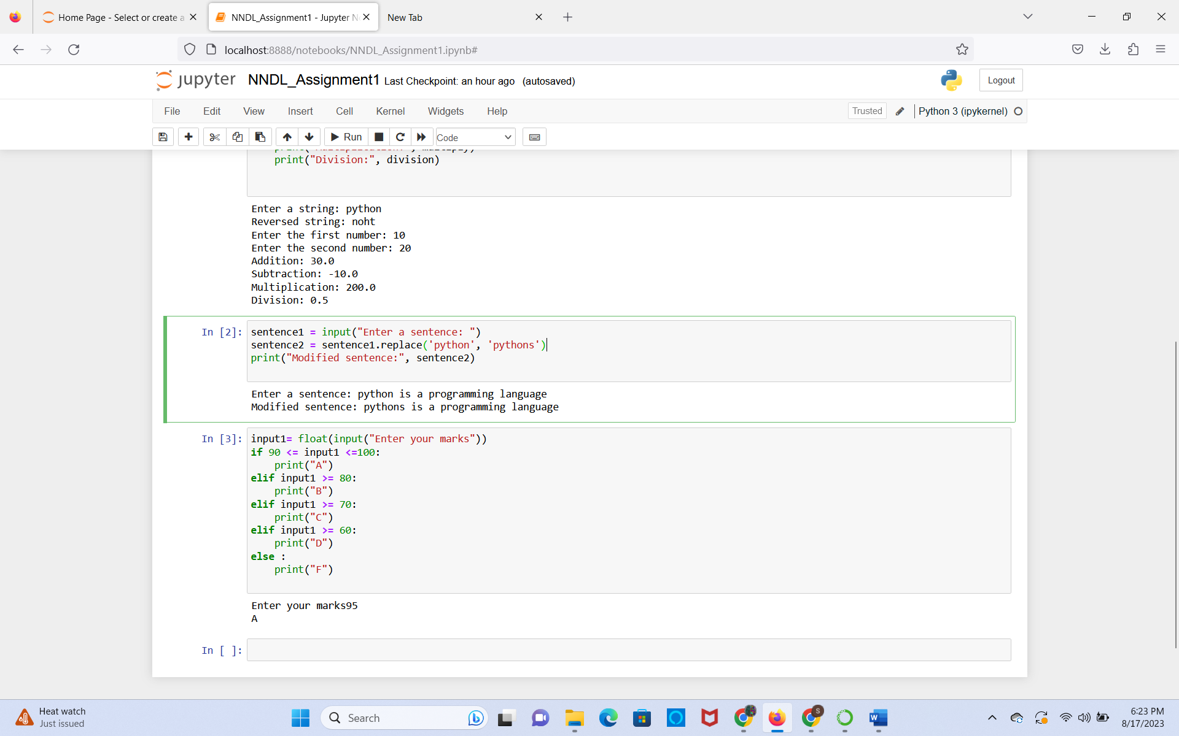

3.Use the if statement conditions to write a program to print the letter grade based on an input class score. Use the grading scheme we are using in this class.

