**NEURAL NETWORK & DEEP LEARNING**

**ASSIGNMENT 2**

**Name : SAI SNUSHA NAKKA**

**Student ID : 700746287**

**Git hub Link:** [**https://github.com/NSnusha/NNDL_Assignment2**](https://github.com/NSnusha/NNDL_Assignment2)

**Video link:** [**https://drive.google.com/file/d/1dDQS0FwpEpztfeKr_HUNMAnzC7Oa6hbd/view?usp=sharing**](https://drive.google.com/file/d/1dDQS0FwpEpztfeKr_HUNMAnzC7Oa6hbd/view?usp=sharing)

1. Write a program that takes two strings from the user: first_name, last_name. Pass these variables to fullname function that should return the (full name). o For example: ▪ First_name = “your first name”, last_name = “your last name” ▪ Full_name = “your full name” o Write function named “string_alternative” that returns every other char in the full_name string. Str = “Good evening” Output: Go vnn Note: You need to create a function named “string_alternative” for this program and call it from main function.

2. . Write a python program to find the wordcount in a file (input.txt) for each line and then print the output. o Finally store the output in output.txt file. Example: Input: a file includes two lines: Python Course Deep Learning Course Output: Python Course Deep Learning Course Word_Count: Python: 1 Course: 2 Deep: 1 Learning: 1

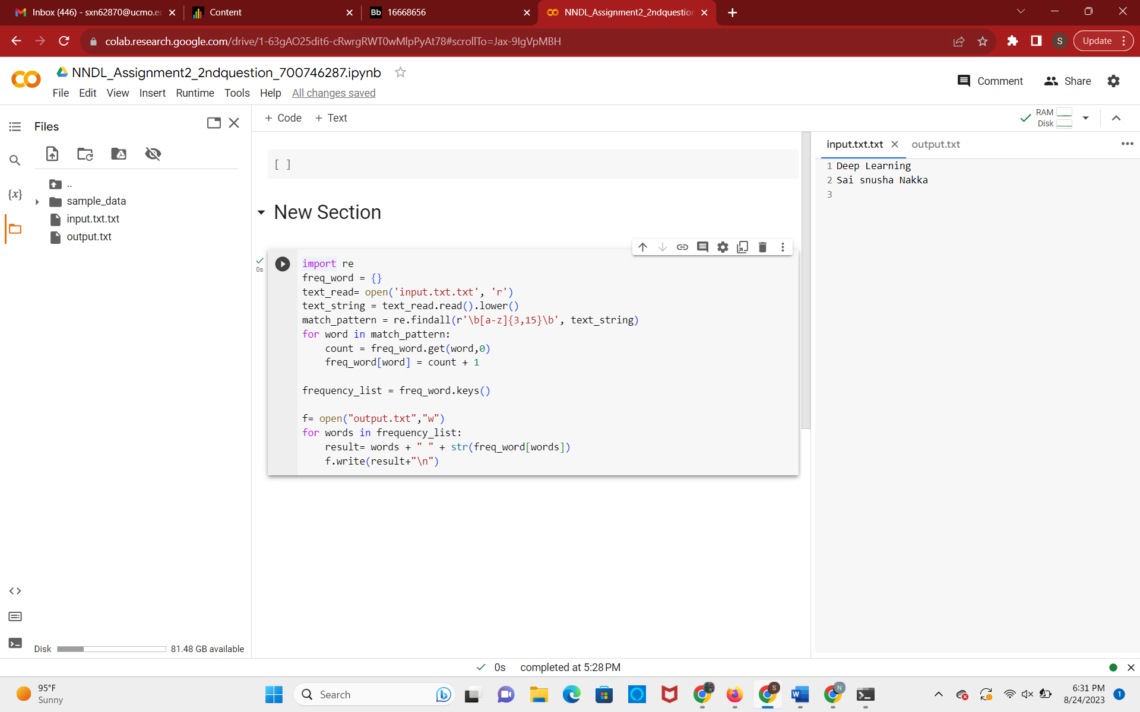

3. Write a program, which reads heights (inches.) of customers into a list and convert these heights to centimeters in a separate list using: 1) Nested Interactive loop. 2) List comprehensions

Example: L1: [150,155, 145, 148] Output: [68.03, 70.3, 65.77, 67.13]

