TERRAFORM APPLY – DYNAMO_DB:

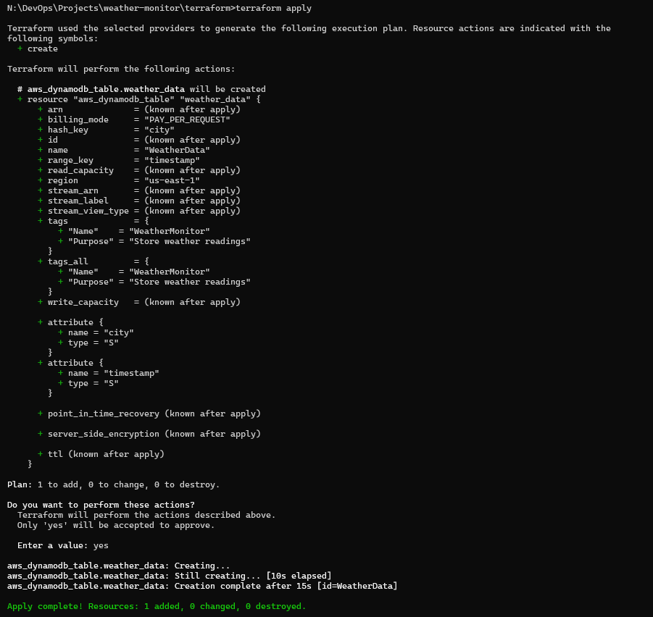

TERRAFORM APPLY – LAMBDA FUNCTION: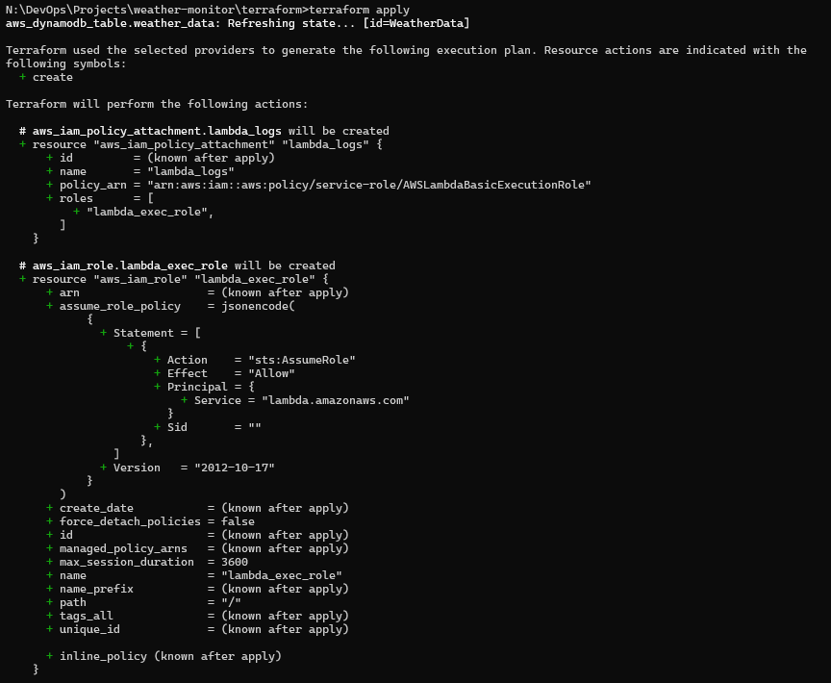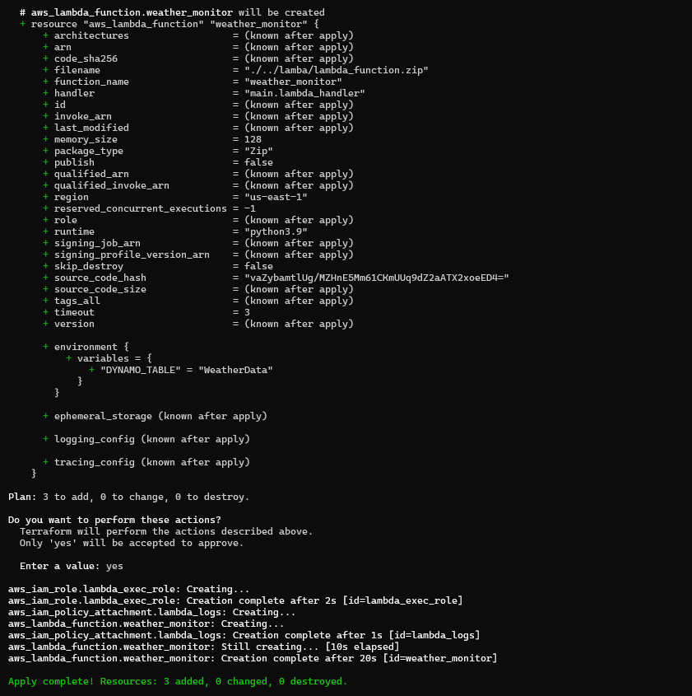

LAMBDA EXECUTION:

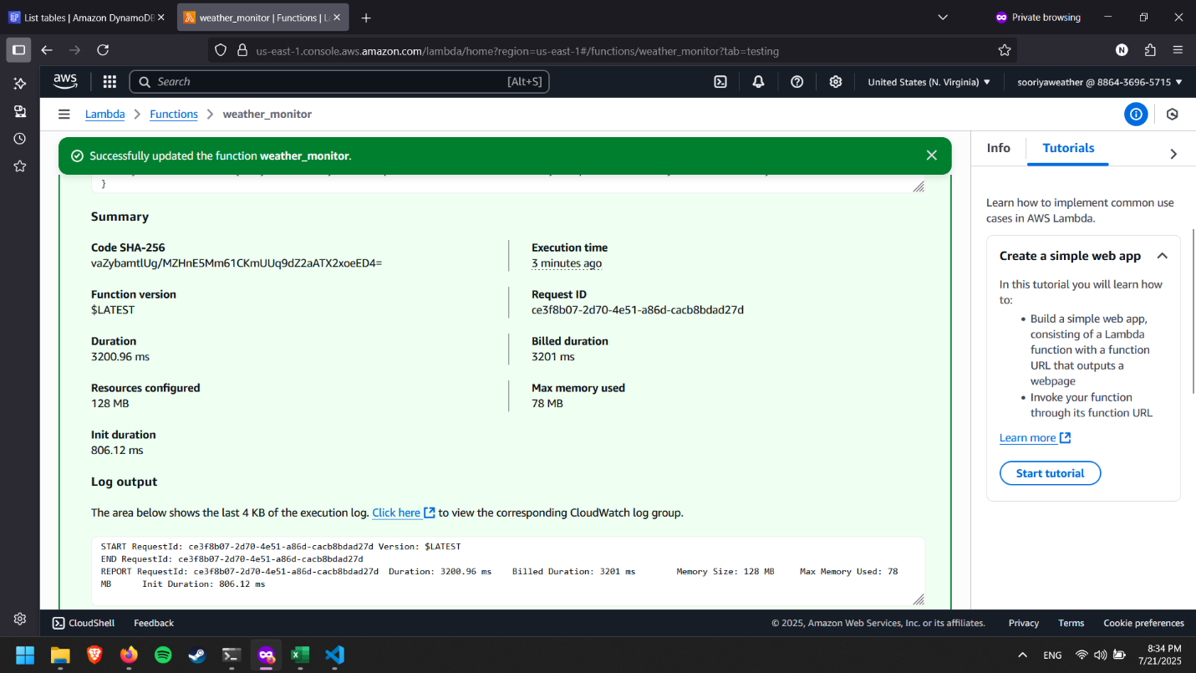

DYNAMO DB TABLE:

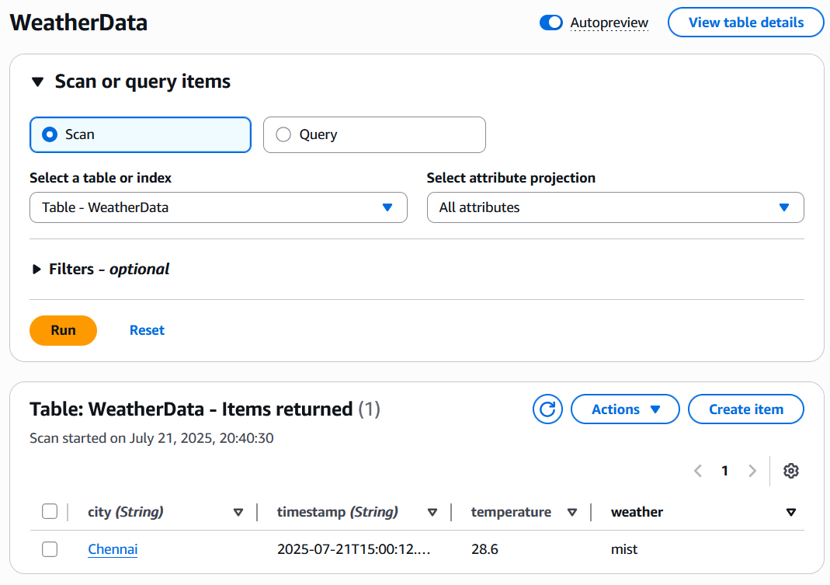

TERRAFORM DESTROY:

