QAP 2 – SQL and PostgreSQL Mastery

By: Nicole Sparkes

Problem #1 – University Course Enrollment System

1. Write SQL Queries:

Retrieve full names of students enrolled.

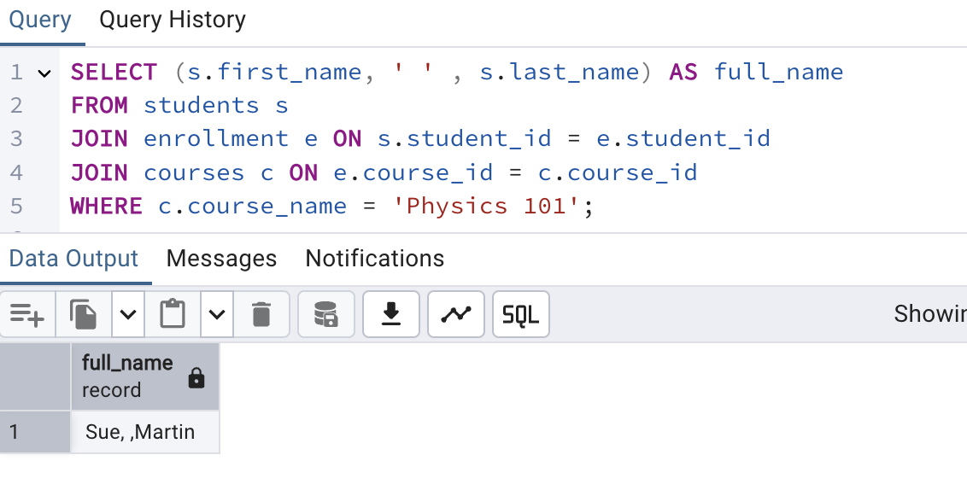

Retrieve all courses and Professors full name.

Courses with students enrolled.

Total of students enrolled in course.

1. Update Data:

Update student email.



1. Delete Data:

DELETE FROM enrollment

WHERE student_id = 2203 AND course_id = 9;

Problem #2 – Online Store Inventory and Order system:

1. Write SQL Queries:

Retrieve product names and stock quantity.

Retrieve the products names and quantities for one order placed.

Retrieve all orders placed by one customer.

1. Update Data:

1. Delete Data:

