**Evolutionary Trees**

**Learning Objectives:**

* Understand evolutionary trees and how they show change over time.
* Recognise that fossils provide information about organisms that inhabited the Earth millions of years ago.

**Prep Required:**

* Print out the **Evolutionary Tree Worksheet** for each child.
* Print out the **Bones Worksheet** for each child.
* Print out the **Snap Cards Worksheet** for each pair of children and cut out the cards.

**Starter (15 minutes) – Evolutionary Tree**

*Aim: to understand that change over long periods of time can lead to the formation of new animals due to natural selection and that this can be shown using an evolutionary tree.*

**Common Ancestor** an organism that is the ancestor of two living species

1. Ask the class if they are familiar with the concept of a ***family tree***. Ask the pupils to draw the Simpson family tree. Explain the term ***common ancestor*** and ask who Bart and Lisa’s common ***ancestors*** are. Then ask who the descendants of Grandpa Simpson are. Explain the term ***descendants***.
2. Explain how, in the same way we display the relationship between family members, we can display the relationship between different ***species*** using an evolutionary tree.

**Descendant**

an organism that is related to you and lives after you (e.g. grandchildren!)

1. Hand out the **[Evolutionary Tree Worksheet]**. They are going to create an evolutionary tree for: two domestic cats (Persian and Siamese), a panther, a lion and a dog. Ask the children which animal they think the Siamese domestic cat is most related to. Prompt the children to match this with the Persian domestic cat and join them together using a “v” shape. Explain that the “v” shows that they are related.
2. Who is the panther most related to? Prompt them to match with the lion and draw another “v”. Next ask the class who they think the panther and lion are most closely related to, the domestic cats or the dog? They should notice that they have more ***characteristics in common*** with the cat than with the dog. Join the domestic cats and big cats with a bigger “v”. They are all related but less related than the domestic cats are to each other. Then finally add on the dog in an extended “v” shape.
3. Expected result:

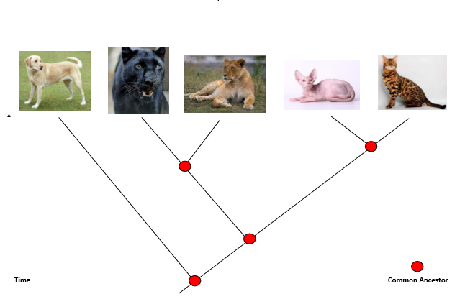

1. Outline how it shows time, with the most recent animals (that we can still see today) at the top of the tree; and the older animals which are now extinct at the bottom. Get the children to draw an arrow onto their evolutionary tree to show the direction of time.
2. ***Common ancestors:*** the last ancestor of a group of animals we see today which shares common characteristics with all the animals within the group. Explain how there are lots of different common ancestors on an evolutionary tree. It is important to reiterate to the children how an evolutionary tree shows change over time on a large time scale of millions of years and it shows the divergence of different animals and helps us understand the changes that have occurred since the first animals walked the earth.

**Class Activity (30 minutes) – Pentadactyl Limbs**

*Aim: to reiterate the fact that change over long periods of time can lead to the formation of new animals due to natural selection and that this can be shown using an evolutionary tree. To understand that an evolutionary tree can be drawn based on a certain characteristic such as the pentadactyl limb.*

1. Show the class images of a reptile (lizard), a bird, a human and a bat on a PowerPoint slide. Discuss with the class how different the four animals are. Then ask if they can see any similarities. They all have bones. They also all have a back bone – that is why all these animals are known as ***vertebrates***. Do they think the bone structures in these animals are similar or different? Explain how you are now going to look at the bones in each animal’s arm so that you can answer this question.
2. Hand out the **[Bones Worksheet]**. Discuss with the class how the images show the forearm limb from the four different animals – the human, the reptile, the bird and the bat. This limb is named the ***pentadactyl limb***. It is important that the children realise you are only looking at bone structure. First get them to determine which limb matches which animal.
3. Next, ask the children to colour in the bones that look similar with the same colour (i.e. colour all the humorous bones pink). Make sure that the children notice that on the bird the longer bones at the end are fingers, not a copy of the ulna and radius or extended wrist bones (as shown below). Prompt the children to look for similarities between the bone size and shapes and encourage them to start thinking about which animals are more related than others.

**Teachers Notes: Pentadactyl limb**

The pentadactyl limb has 5 digits on the hand and foot. It also has a specific pattern of bones. This structure consists of the humerus, the radius and the ulna, metacarpals and then the 5-digit fingers and toes. The pentadactyl limb is common to humans, other mammals (although whales and dolphins have lost their hind limbs), birds, dinosaurs, and other reptiles and amphibians. The pentadactyl limb is common to most tetrapods (4-limbed creatures). It is evidence of humans’ common ancestry with amphibians, reptiles and other mammals. Every pentadactyl limb has the same base structure of five digits but they all look very different and also do very different things. This is all because of evolution.

Expected Result:

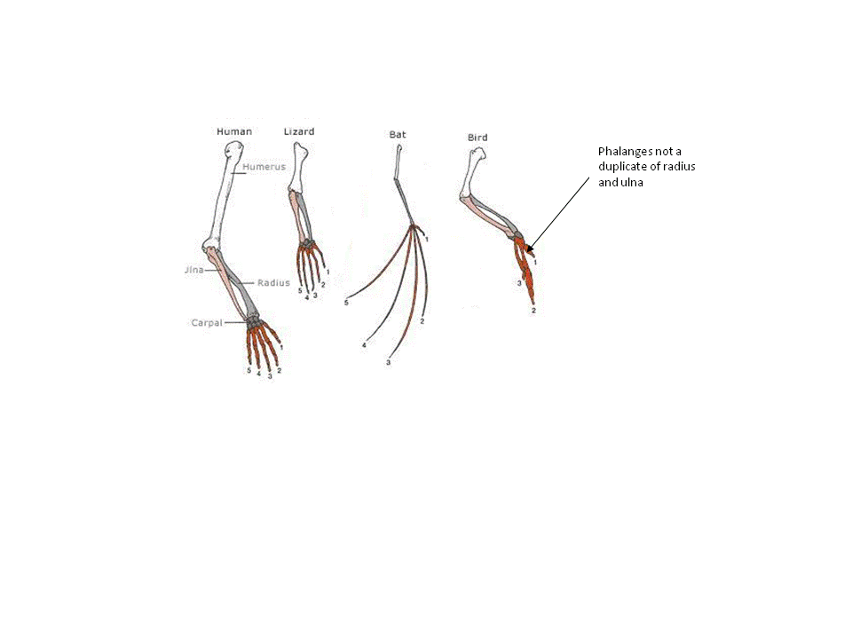

1. Rather than looking at the animals directly, you are going to build an evolutionary tree based on the pentadactyl limb.
   * Which bone structure is most closely related to the human bone structure? Look at the shape of the bones (whether they are long and narrow as in the bat and the human or fat and shorter as in the bird and reptile) and the gap in between the ulna and radius which is smaller in the human and the bat in comparison to the bird and the reptile. Once they have determined it is the bat then draw a “v” shape between the bat and the human.
   * Is the reptile more closely related to the bird or the human? Once they have determined it is the bird then draw another “v”.
   * Join the two v’s together emphasising how they are all related due to the presence of the pentadactyl limb. Congratulate the class on completing their second evolutionary tree.
2. *Note: the fingers are the latest thing to evolve. Therefore, when looking at how the four animals are related you need to* ***focus on the bones in the arm****. Also be careful as some characteristics can look the same but not be derived from a common ancestor. For example, the wings of a bird and a bat have the same function and might be considered similar. However, a look at the bone structure reveals their distinct evolutionary paths. This indicates that they do not come from a common ancestor who had wings, but that both* ***evolved wings for flight independently****.*

**Misconception!**

Humans share a common ancestor with modern day monkeys but did not evolve from modern day monkeys.

1. As before ask the children to draw a time arrow onto their evolutionary tree. Also remind the class that the ***common ancestor***is the last ancestor of a group of animals which shares common characteristics with all the animals within the group. Ask them to draw circles where the common ancestors are found on the tree (red circles above).

Expected Result:

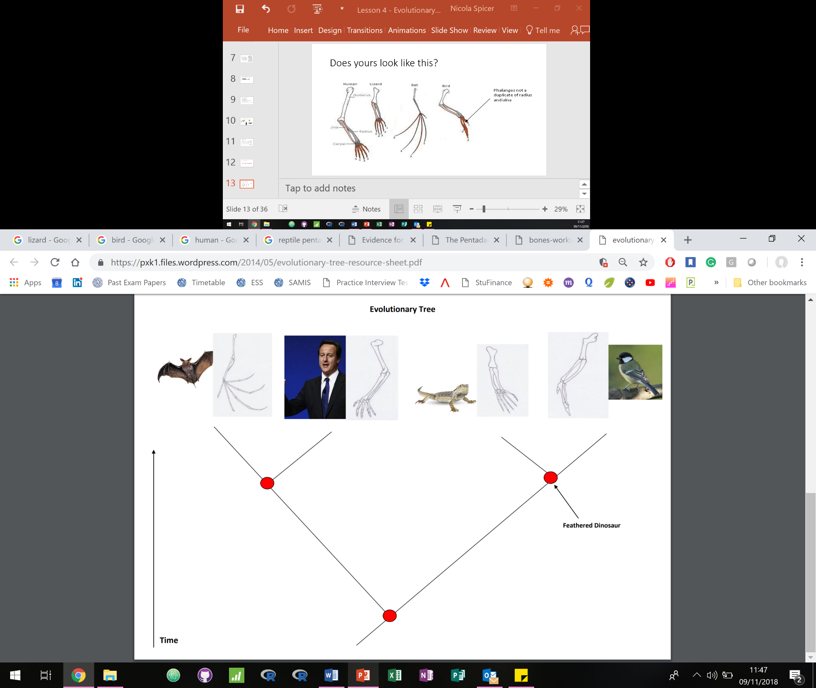

Archaeopteryx

**Misconception!**

Emphasise that evolution is a well-supported scientific theory with evidence – not just a ‘theory’ how the word is commonly used.

**Teacher-led discussion: fossils**

1. What would the common ancestor between the bird and the lizard look like? How can we know this? ***Fossils!*** If the children say this, then ask them what they know about fossils encouraging them to lead the discussion. If not, then start the discussion yourself. Make sure to talk about:
   1. Fossils are the remains of ancient animals and plants, the traces or impressions of living things from past ages, or the traces of their activities.
   2. Fossils can be bones, whole animals (such as insects in amber or frozen mammals) or footprints. Fossils have been found on every continent on Earth.
   3. Fossils found deeper in the ground are older. Explain how fossils are found in the ground by *palaeontologists*. That fossils provide evidence for animals that are not here today and help us determine what those animals may have looked like.

**Archaeopteryx**

Common ancestor of bird and reptile

1. Where in the tree they just built, should the ***archaeopteryx*** go? Prompt the children by asking them what characteristics it has. What creature does it remind you off? Hopefully they will tell you that it looks like a bird (feathers, wings) and a reptile (face and feet/claws).
2. You can discuss how it is the ***common ancestor*** of the birds and the reptiles. Ask them to draw an arrow and label to show where this common ancestor is on their evolutionary tree (shown above). If you have time, discuss why it may not have survived leading to the evolution of the reptile and bird. For example, it looks too heavy to fly easily and to run/scurry around the forest ground so therefore it was more advantageous to evolve to be a specialist at one or the other rather than both.

**Plenary (10 minutes)**

*Aim: to reinforce the understanding of fossils and how they are the remains/traces or impressions of living things.*

Hand out the **[Snap Cards]** and in pairs, the children should turn all the cards face down and then take it in turns to turn over two cards. If the fossil and the image of the animal matches, then the child wins those cards otherwise they are turned back and it is their partners turn. If the children can state what the animal is they get a bonus point.

Big thought question: how long would it take you to become a fossil? Prompt them to think about how Egyptian mummies are not even old enough to be fossils. Answer: it takes over **10,000 years** for a fossil to form!

**Extra Material for a creative activity:**

This is a really nice activity which describes how to make fossils for the children to see in the classroom: <http://www.nps.gov/brca/forteachers/paleoact4.htm>