**PROJECT-NAME: LENSKART**

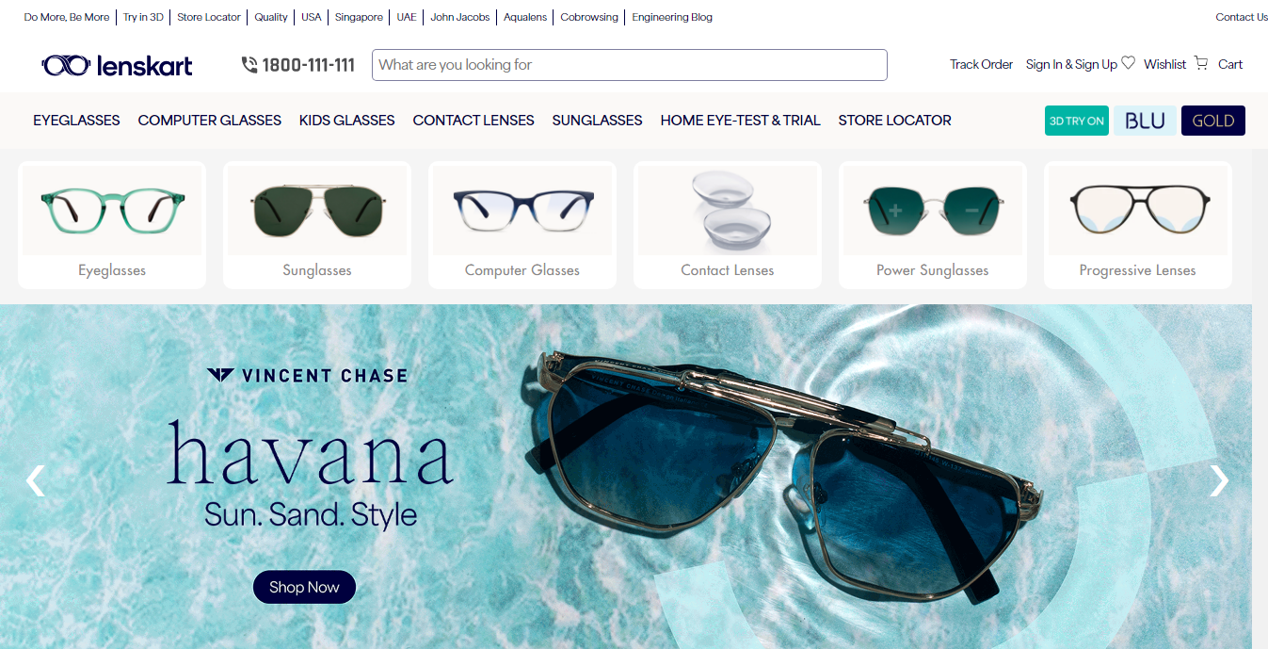

* **OVERVIEW:** Lenskart is a leading e-commerce company that creates an online optical store that sells a variety of eyewear. Customers will get the new eye-wear collections with free home delivery through the company's marketplace, which offers prescription eyewear, branded contact lenses, sunglasses, and accessories.

1. **HOME PAGE:**
   * + - LOGO
       - ICONS - (WISHLIST, ADD TO CART)
       - SEARCH BAR
       - DEALS - (IMAGES)
       - FEATURED - (IMAGES)
       - TRENDING - (IMAGES)
       - SLIDERS WITH ARROWS - (IMAGES)
       - FOOTER –(CONTACT US , HELPLINES , BRIEF DESCRIPTION ABOUT THE COMPANY , SOCIAL-MEDIA HANDLE ICONS , DOWNLOAD MOBILE APP)
2. **REGISTRATION (sign up/ sign in)**

SIGN UP:

* + - * + First name
        + Last name
        + Mobile Number
        + E-Mail
        + Password

SIGN IN:

* Mobile/ E-mail

**3. MAIN PAGE:**

* FILTERS -( FRAME SHAPE, FRAME TYPE, FRAME SIZE, PRICE, GENDER, BRAND, MATERIAL, FRAME COLOR, WEIGHT GROUP, PRESCRIPTION TYPE)
* IMAGES OF THE CHOSEN PRODUCT WITH DETAILS LIKE -

( IMAGE, BRAND NAME , PRICE , DISCOUNT%(IFANY))

* ON CLICKING THE IMAGE -(MULTIPLE IMAGES OF THE

PRODUCT WILL APPEAR FROM DIFFERENT ANGLES ,ZOOM IN , ZOOM OUT)

* LOWER HALF OF THE PAGE - RELATED PRODUCTS

1. **CHECKOUT PAGE AND PAYMENT PAGE**

* ADDRESS SELECTION
* PAYMENT METHOD - (PHONEPE , GOOGLE PAY , COD , CREDIT/DEBIT CARD , NET - BANKING , EMI , PAYTM)

1. **TECHNOLOGIES USED:**

MARKUP LANGUAGE:

* HTML5

SITE ELEMENTS:

* [External CSS](https://w3techs.com/technologies/details/ce-externalcss)
* [Embedded CSS](https://w3techs.com/technologies/details/ce-embeddedcss)
* [Inline CSS](https://w3techs.com/technologies/details/ce-inlinecss)

CSS FRAMEWORK:

* [Animate](https://w3techs.com/technologies/details/cs-animate)

CLIENT-SIDE PROGRAMMING LANGUAGE:

* JavaScript

SERVER-SIDE PROGRAMMING LANGUAGES:

* JavaScript
* PHP

WEB SERVER:

* [Node.js](https://w3techs.com/technologies/details/ws-nodejs)

JAVASCRIPT LIBRARIES:

* [jQuery](https://w3techs.com/technologies/details/js-jquery)
* [Bootstrap](https://w3techs.com/technologies/details/js-bootstrap)

CODE COMPILER:

* Visual Studio Code