Lumina RFID — Smart Jewellery Store Handling System
Phase-1 Smart Store Handling & Monitoring Prototype — Technical Architecture & Audit Report
Project Status | Phase-1 Prototype Complete & Fully Validated
Date | October 7, 2026
Deployment Target | Single Windows Laptop / Commercial USB Tabletop RFID Reader
Document Audience | Executive Leadership, Project Sponsors & Technical Review Board

1. Executive Summary
In high-value retail environments like jewellery stores, inventory shrink, handling ambiguities, lack of custodial accountability, and inefficient manual counts present substantial operational and financial risks.
Lumina RFID (Phase 1) provides an enterprise-grade proof of concept demonstrating how Radio Frequency Identification (RFID) can automate custodian tracking, inventory handling, point-of-sale transitions, and physical tag reuse on a standard Windows PC using one commercial USB RFID reader.
The Phase-1 system successfully proves:
1. Strict Custodial Accountability: Jewellery cannot leave a case without an authenticated salesperson linked to the active handling session.
2. Context-Aware RFID Reader Modes: The software dynamically contextualizes raw card scans based on user session and operational view.
3. Rigid Product State Machine: Jewellery strictly enforces lifecycle transitions: `AVAILABLE` ⇄ `IN_HANDLING` ⇄ `BILLING` → `SOLD`.
4. Physical RFID Tag Reusability: Physical RFID tags are released upon sale completion and can be rebound to new products while preserving historical assignments without data loss.
5. Permanent Immutable Audit Trail: All case allocations, item scans, billing events, and tag reassignments are timestamped on the server.
2. Problem Statement & Business Motivation
Traditional jewellery store operations face distinct challenges:
Operational Challenge | Traditional Approach | Lumina RFID Solution
Handling Custody | Salespersons manually pull items; no real-time record of who holds which tray item. | Salesperson badge allocates case; scanning an item marks them as `current_handler` instantly.
Shrink & Item Misplacement | Discrepancies discovered hours later during end-of-day manual ledger counts. | Salespersons are blocked from clocking out if items remain `IN_HANDLING` or `BILLING`.
Tag Reusability & Cost | RFID tags are often discarded or their old metadata is overwritten in crude databases. | Strict relational separation: product records are permanent; tags transition to `RELEASED` and can be rebound with full audit history.
Capital Expenditure | Enterprise RFID deployments often demand multi-antenna readers and edge controllers per cabinet before software validation. | Phase 1 validates the complete operational logic on a single USB tabletop reader before hardware investment.

3. Prototype Scope & Single-Reader Architectural Innovation
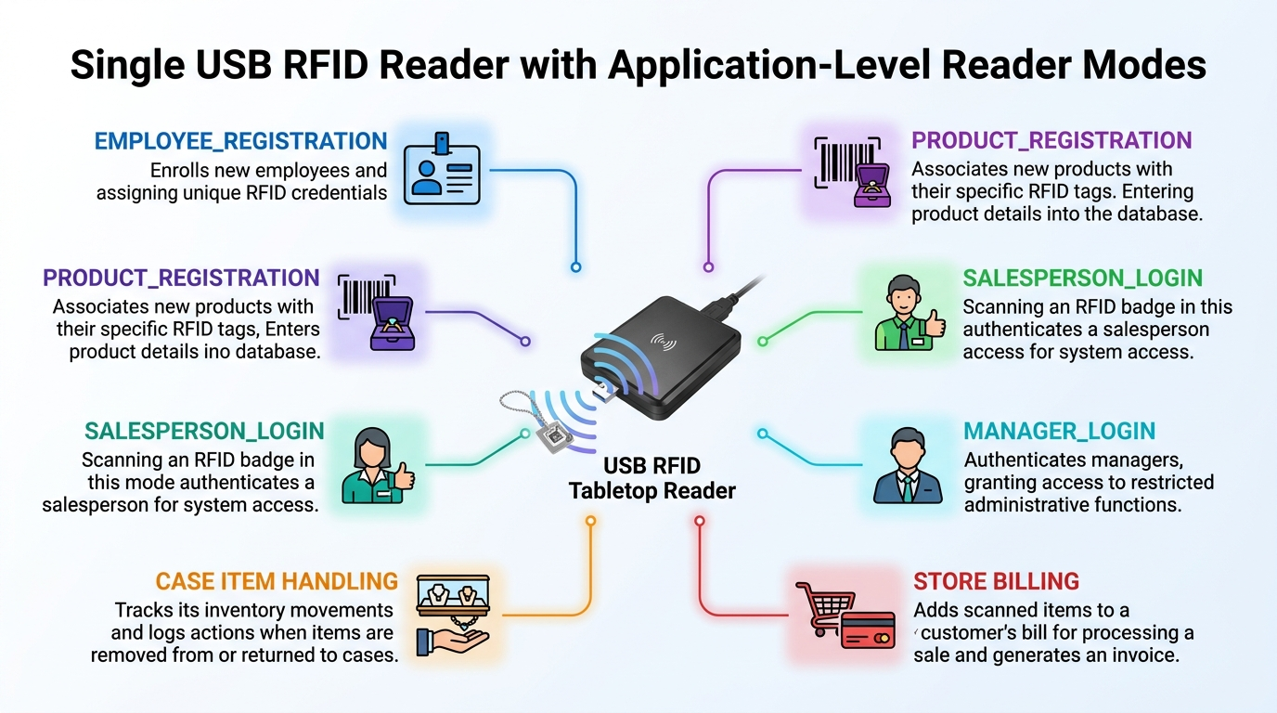
Figure: Single USB Tabletop RFID Reader with 6 Application-Level Reader Modes
The Single-Reader Constraint
Phase 1 was architected around a single tabletop USB RFID reader that emulates a USB HID (Human Interface Device / Keyboard). It outputs an RFID Card Unique Identifier (UID) followed by a carriage return.
[ Physical RFID Tag / Badge ]
│
▼
[ USB RFID Tabletop Reader ] (HID Emulation)
│
▼ (Keystroke UID)
[ Application Reader Mode Engine ]
│
┌─────────┴─────────────────────────────────────────┐
▼ ▼
Employee Card Scan Jewellery Tag Scan
Context: SALESPERSON_LOGIN / MANAGER_LOGIN Context: ITEM_HANDLING / BILLING / REGISTRATION

Context-Aware Reader Modes
To prevent erroneous cross-operations with one reader, the UI/UX maintains an Application-Level RFID Reader Mode Engine:
- `EMPLOYEE_REGISTRATION`: Scans are validated as staff badges.
- `PRODUCT_REGISTRATION`: Scans register jewellery tags.
- `SALESPERSON_LOGIN`: Authenticates staff and allocates cases.
- `MANAGER_LOGIN`: Unlocks store oversight.
- `ITEM_HANDLING`: Determines item removal/return based on active salesperson case.
- `BILLING`: Initiates invoice generation.
4. System Architecture
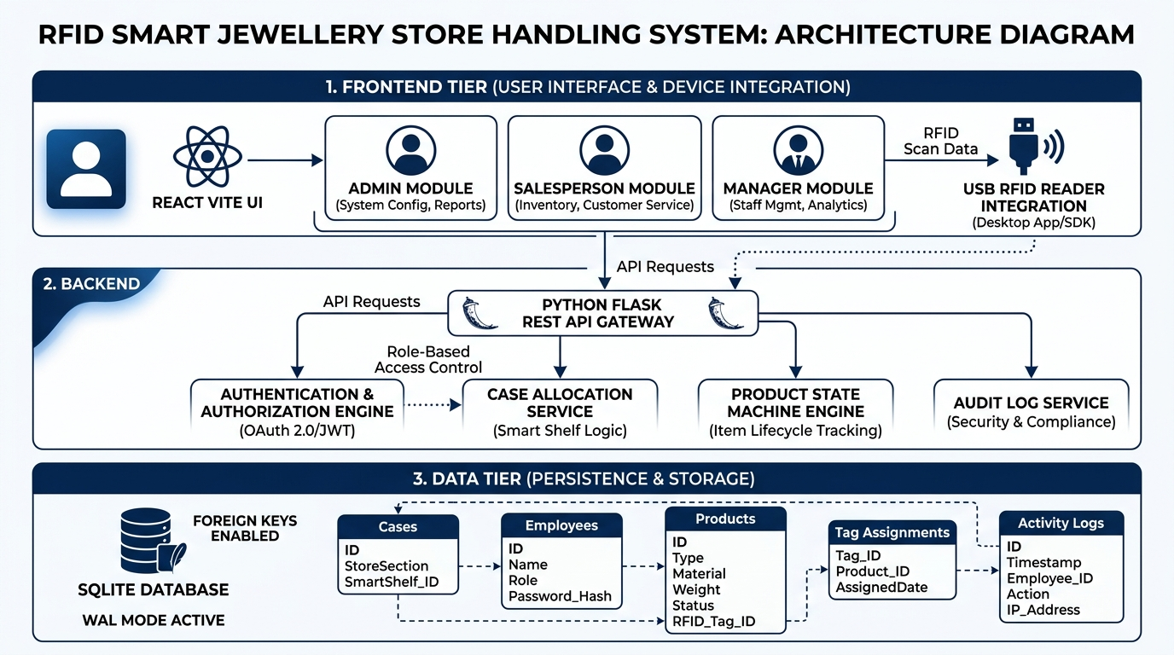
Figure: Three-Tier System Architecture: React Vite Frontend, Flask REST API & SQLite Database
4.1 High-Level Architecture Diagram
graph TD
subgraph Client ["Client Presentation Tier (Browser)"]
UI["React.js 18 Application (Vite)"]
Router["React Router (Role Modules)"]
RFIDComp["RFIDInput Component (Autofocus & 2s Debounce)"]
UI --> Router
Router --> RFIDComp
end
subgraph Proxy ["Development Proxy Tier"]
ViteProxy["Vite Reverse Proxy (:5173 -> :5000)"]
RFIDComp -->|JSON REST API| ViteProxy
end
subgraph Server ["Application Logic Tier (Python / Flask)"]
Flask["Flask REST Controller (:5000)"]
AuthSvc["Auth & Session Service"]
CaseSvc["Case Allocation Service"]
ProdSvc["Product State Machine Engine"]
BillSvc["Atomic Billing Service"]
AuditSvc["Audit & Log Service"]
ViteProxy --> Flask
Flask --> AuthSvc
Flask --> CaseSvc
Flask --> ProdSvc
Flask --> BillSvc
Flask --> AuditSvc
end
subgraph Data ["Persistence Tier (SQLite)"]
DB[("jewellery.db (WAL Mode, Foreign Keys On)")]
AuthSvc --> DB
CaseSvc --> DB
ProdSvc --> DB
BillSvc --> DB
AuditSvc --> DB
end

4.2 Frontend Architecture (React.js & Vite)
- Role Isolation:
- `/admin/*`: Staff onboarding, product registration, case overview, billing counter, RFID registry.
- `/salesperson/*`: Fast badge login, automatic case allocation, single-reader item removal/return desk.
- `/manager/*`: Store oversight, case allocations, product movement logs, sales records, RFID reuse chains.
- RFID Input Component (`RFIDInput.jsx`):
- Automatically captures hardware keystrokes from USB HID readers.
- Features software debounce (2 seconds) to avoid duplicate physical reads.
- Supports manual text entry for environments testing without physical tags.
4.3 Backend Architecture (Python & Flask)
- Blueprint architecture (`auth_routes.py`, `admin_routes.py`, `salesperson_routes.py`, `billing_routes.py`, `manager_routes.py`).
- Stateless REST endpoints returning JSON data payloads.
- Native Python 3.14 datetime management (`datetime.now().strftime('%Y-%m-%d %H:%M:%S')`).
4.4 Data Layer Architecture (SQLite, WAL Mode, ACID Guarantees)
- Embedded SQLite with `PRAGMA foreign_keys = ON;` and `PRAGMA journal_mode = WAL;`.
- Operations modifying multiple tables (e.g., Complete Sale) run in atomic transactions:
- Product updated to `SOLD`.
- Sale row created.
- Active `tag_assignments` closed with `released_at`.
- RFID registry updated to `RELEASED`.
- Audit trail and state transition history inserted.
5. Core Business Entities & Database Schema
erDiagram
cases ||--o{ case_assignments : "allocated via"
cases ||--o{ products : "contains"
employees ||--o{ case_assignments : "assigned to"
employees ||--o{ products : "currently handles"
employees ||--o{ sales : "processes"
rfid_registry ||--o{ employees : "identifies"
rfid_registry ||--o{ tag_assignments : "bound in"
products ||--o{ tag_assignments : "tagged by"
products ||--o{ product_state_history : "transitions"
products ||--o{ sales : "sold in"
cases {
int id PK
string case_id UK "CASE-01 to CASE-05"
string name
int functional "1=Functional, 0=Future"
string current_status "AVAILABLE / ASSIGNED"
}
employees {
int id PK
string employee_id UK
string name
string role "ADMIN / MANAGER / SALESPERSON"
string rfid_uid UK
int active
}
products {
int id PK
string product_id UK
string product_name
float price
string case_id FK
string current_status "AVAILABLE / IN_HANDLING / BILLING / SOLD"
string current_handler_employee_id FK
}
rfid_registry {
int id PK
string uid UK
string rfid_type "EMPLOYEE / ITEM_TAG"
string status "ACTIVE / ASSIGNED / RELEASED"
}
tag_assignments {
int id PK
string rfid_uid FK
string product_id FK
string assigned_at
string released_at
string status "ACTIVE / RELEASED"
}
product_state_history {
int id PK
string product_id FK
string old_state
string new_state
string employee_id FK
string timestamp
string reason
}
sales {
int id PK
string bill_number UK "BILL-0001..."
string product_id FK
string customer_name
float amount
string created_at
}
activity_logs {
int id PK
string timestamp
string employee_id
string role
string action
string details
}

6. Operational User Roles & Access Boundaries
┌───────────────────────────┐
│ LUMINA RFID PORTAL │
└─────────────┬─────────────┘
│
┌──────────────────────────┼──────────────────────────┐
▼ ▼ ▼
┌──────────────┐ ┌──────────────┐ ┌──────────────┐
│ ADMIN MODULE │ │ SALESPERSON │ │ MANAGER │
└──────┬───────┘ └──────┬───────┘ └──────┬───────┘
│ │ │
• Employee Reg. • Badge Login • Store Metrics
• Product Reg. • Auto Case Alloc. • Case Status
• Case Config • Item Removal • State History
• Billing Counter • Item Return • Tag Chains
• RFID Registry • Activity Log • Audit Logs

7. Comprehensive Workflow Diagrams
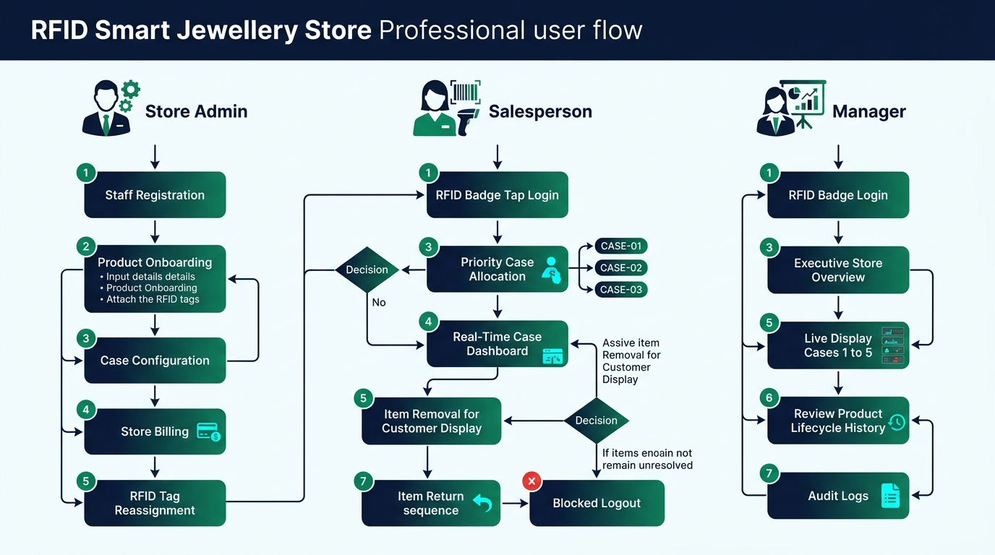
Figure: Operational User Flow Diagram across Store Admin, Salesperson, and Manager Roles
7.1 End-to-End System Lifecycle Flow
sequenceDiagram
autonumber
actor Admin
actor Salesperson
actor Customer
participant App as Lumina RFID App
participant DB as SQLite DB
Admin->>App: Register Staff (EMP001) & Product (JWL001 in CASE-01 with TAG001)
App->>DB: Persist in employees, products, rfid_registry, tag_assignments
Salesperson->>App: Scan Badge EMP_RFID_001
App->>DB: Check availability; allocate CASE-01
App-->>Salesperson: Open Salesperson Dashboard (CASE-01 Active)
Salesperson->>App: Scan Item TAG001
App->>DB: State Transition: AVAILABLE -> IN_HANDLING (Handler: EMP001)
Customer->>Salesperson: Inspects item and decides to buy
Salesperson->>Admin: Escorts customer with item to Billing
Admin->>App: Scan TAG001 at Billing Counter
App->>DB: State Transition: IN_HANDLING -> BILLING
Admin->>App: Enter Customer details & Complete Sale
App->>DB: Atomically mark SOLD, generate BILL-0001, release TAG001
Admin->>App: Register new product JWL002 using TAG001
App->>Admin: Detects RELEASED tag -> Prompts for Reassignment
Admin->>App: Confirms Reassignment
App->>DB: Bind TAG001 to JWL002 (Old history for JWL001 preserved!)

7.2 Salesperson Authentication & Automatic Priority Case Allocation
flowchart TD
Start([Salesperson Scans Badge]) --> Lookup[Query rfid_registry & employees]
Lookup --> Found{Valid & Active?}
Found -- No --> Err1[Access Denied: Unrecognized Badge]
Found -- Yes --> CheckRole{Role == SALESPERSON?}
CheckRole -- No --> Err2[Access Denied: Role Mismatch]
CheckRole -- Yes --> CheckActive{Already Assigned a Case?}
CheckActive -- Yes --> Resume[Resume Existing Active Case Session]
CheckActive -- No --> CheckCase1{Is CASE-01 Free?}
CheckCase1 -- Yes --> Alloc1[Allocate CASE-01]
CheckCase1 -- No --> CheckCase2{Is CASE-02 Free?}
CheckCase2 -- Yes --> Alloc2[Allocate CASE-02]
CheckCase2 -- No --> CheckCase3{Is CASE-03 Free?}
CheckCase3 -- Yes --> Alloc3[Allocate CASE-03]
CheckCase3 -- No --> AllBusy[NO CASE CURRENTLY AVAILABLE: Contact Admin]
Alloc1 --> Commit[Insert case_assignments, Update cases, Log Activity]
Alloc2 --> Commit
Alloc3 --> Commit
Resume --> Dashboard([Open Salesperson Dashboard])
Commit --> Dashboard

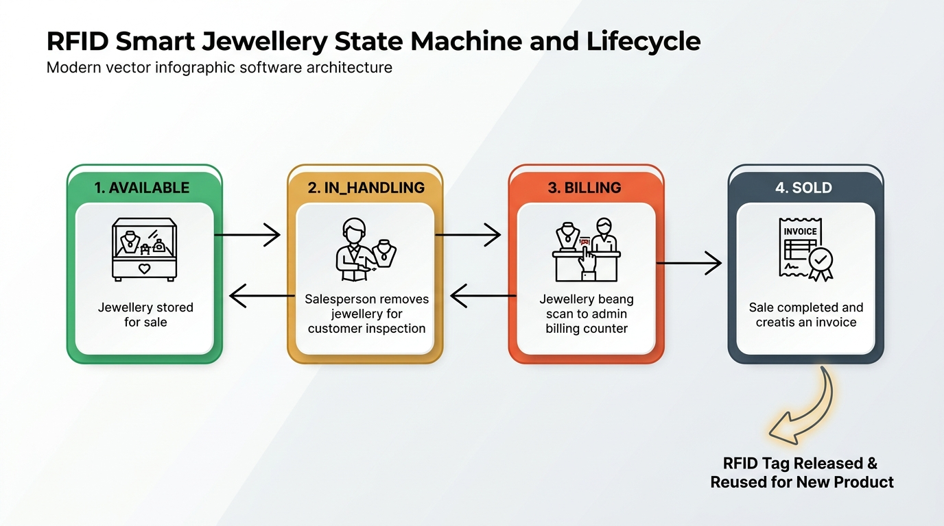
Figure: Mandatory Product State Machine & RFID Tag Reusability Loop
7.3 Single-Reader Item Handling State Machine
stateDiagram-v2
[*] --> AVAILABLE : Product Registered
AVAILABLE --> IN_HANDLING : Scan 1 (Item Removed by Salesperson)
IN_HANDLING --> AVAILABLE : Scan 2 (Item Returned Safely)
IN_HANDLING --> BILLING : Admin Billing Scan
BILLING --> IN_HANDLING : Admin Cancels Billing
BILLING --> SOLD : Complete Sale & Invoice Generated
SOLD --> [*] : Tag Released to Registry

7.4 Physical RFID Tag Reassignment & Lifecycle Chain
========================================================================================
PHYSICAL RFID TAG LIFECYCLE CHAIN
========================================================================================
TIMELINE 1:
Physical Tag UID : TAG001
Assigned Product : JWL001 (22K Gold Ring)
Status : ACTIVE
Case : CASE-01
TIMELINE 2 (Sale Completed):
Product State : JWL001 -> SOLD (Timestamp: 2026-10-07 12:03:06)
Sale Invoice : BILL-0001
Physical Tag UID : TAG001 -> RELEASED (Available in Registry)
TIMELINE 3 (Tag Reassignment):
Admin registers new product : JWL007 (Diamond Bracelet) in CASE-02
Scans same physical tag : TAG001
System Action : Flags tag as RELEASED from JWL001
Confirmation : Admin clicks "Confirm Reassign"
New Association : TAG001 -> JWL007 (Status: ACTIVE)
DATABASE AUDIT PRESERVATION:
tag_assignments Row 1: TAG001 | JWL001 | Assigned: 10:00 | Released: 12:03 | RELEASED
tag_assignments Row 2: TAG001 | JWL007 | Assigned: 12:05 | Released: NULL | ACTIVE
(Row 1 is NEVER updated or overwritten. Complete chain is preserved permanently!)
========================================================================================

8. Failure Prevention & Preventative Validations
Failure Scenario | Threat / Risk | Enforced System Protection
Duplicate Employee RFID | Card cloned or assigned to multiple staff members. | Blocked with HTTP 409 and error referencing existing employee.
Cross-Entity RFID Collision | Staff badge used as jewellery tag, or vice versa. | Central `rfid_registry` enforces separation.
Wrong Case Item Scan | Salesperson accidentally handles jewellery from another case. | System validates `product.case_id == salesperson.case_id`. Blocked if mismatch.
Unauthorized Handling Transfer | Staff member scans an item already in another salesperson's hands. | Blocked with alert: `ITEM ALREADY IN HANDLING by [Handler Name]`.
Premature Logout with Active Items | Staff clocks out while holding jewellery. | Logout API rejects request with HTTP 409 if active items remain.
Invalid State Transitions | Item moved from `AVAILABLE` directly to `SOLD` or `BILLING`. | State machine validates old state before allowing transition.
Double-Billing / Double-Click | Network lag causes double complete sale click. | Backend verifies sale record existence before committing.
Inactive Case Allocation | System assigns unequipped future cases (`CASE-04`, `CASE-05`). | Allocation engine strictly restricted to functional cases (`01`–`03`).

9. Physical Hardware Integration & Reader Debounce Model
USB HID Hardware Behavior
Standard USB RFID readers operate without proprietary drivers:
1. Card enters antenna RF field (13.56MHz or 125KHz).
2. Reader reads UID and sends it as keyboard strokes followed by `Enter`.
3. If held in field, some readers send repeat keystrokes every 200–500ms.
Software Debounce Layer
To prevent accidental state toggling, `RFIDInput.jsx` enforces a 2-second debounce:
const now = Date.now();
if (trimmed === lastScan.uid && now - lastScan.time < 2000) {
setFeedback({ type: 'warning', text: 'Duplicate scan ignored (debounce).' });
return;
}

10. Auditability, Traceability & Management Oversight
The Store Manager Dashboard gives executive visibility into:
1. Case Status View: Real-time occupation of all 5 store cases.
2. Case Allocation History: Preserved logs of every shift allocation and case release.
3. Product State History: Every state change logged with actor, case, timestamp, and reason.
4. Sales Records: Sequential bills with customer, item, handler, and price.
5. RFID Reuse History: Complete audit chain of physical tags across products.
6. Full System Audit Trail: Central audit log capturing logins, removals, returns, cancellations, and sales.
11. Scalability & Roadmap (Phase-2 Smart Case Vision)
Phase 1 provides the business and logic foundation for Phase-2 physical hardware deployment:
graph TD
subgraph Phase1 ["Phase 1 (Complete)"]
P1_Reader["1 Tabletop USB RFID Reader"]
P1_Logic["Application Reader Modes & Allocation Engine"]
P1_DB["SQLite Audit & Reusability DB"]
end
subgraph Phase2 ["Phase 2 (Production Vision)"]
P2_Antenna["Dedicated Antennas inside Smart Cases 01-05"]
P2_Lock["Electronic Solenoid Locks on Trays"]
P2_Sensors["Door Reed Switches & Tamper Sensors"]
P2_Edge["Raspberry Pi / ESP32 Edge Controllers (MQTT/WebSockets)"]
P2_Central["Centralized Store Server & Remote Executive Dashboard"]
end
Phase1 -.->|Logic & Schema Ready| Phase2

12. Conclusion & Recommendations
The Lumina RFID Phase-1 Prototype successfully proves the core business logic, user flow, custodial security model, and physical tag reuse workflow.
It satisfies all prototype criteria:
- Zero unnecessary enterprise complexity: Self-contained React + Flask + SQLite stack.
- Single-Reader Viability: Contextual RFID modes enable complete lifecycle testing with one tabletop device.
- Reliable Audit Trail: Never overwrites historical records.
Recommendation: Proceed with executive live demonstration using the manual testing guide, followed by planning Phase-2 hardware integration for smart-case enclosures.

