1. Choose 2 objects.  What are their affordances?

Affordance is the relationship between a physical object and a person. To be effective an affordance has to be discoverable and perceivable. A bed has an affordance for support and comfort. This allows the user to sit/lay and be comfortable while sleeping. A box has an affordance for security, transportation, and organization. This allows the user to be sure the objects stay in the box (security), carry items (transportation), and know where objects are (organization)

1. Suppose you were creating a smart water bottle with a hidden menu that would turn on when the user held the bottle.  What kind of signifier could you add to communicate this possible action to the user?

A signifier is a way of signaling an affordance or anti-affordance that can’t be easily perceived. They communicate where an action should take place. They are any mark, sound, or perceivable indicator that communicates appropriate behavior to a person. A signifier I would add to the water bottle is a hand print colored green (or another contrasting color that is associated with positive actions). This makes the user see where they should take the action of holding the water bottle and the positive color let’s them know the action will result in something good.

1. Suppose you were creating a smart water bottle.  The user has the ability to enter a desired goal for drinking water.  What are some options for providing feedback to them about their progress towards their drinking goal?

Feedback is communicating the results of an action. Some options for providing feedback to them about their progress towards their drinking goal are:

* An indicator on the screen of the water bottle for each milestone.
* The nozzle (where the water comes out) turns green when goal is finishes.
* A ring around the water bottle top, that shows less as you drink water and get closer to goal.
* A ring around the water bottle top, that shows more as you drink water and get closer to goal.
* Whole water bottle changes color from red to orange to green as you get closer to goal.

1. Mappings: If you own a car, look at its dashboard controls.  If you do not, find a photo of a car dashboard on the internet.  Do the heat/cooling controls use effective mappings?  Why or why not?

Mapping is the relationship between the elements of two sets of things. Below is an image from the internet of the heat controls in my car. I would say that it uses effective mappings. I believe this because it takes advantage of natural mapping, which mean it takes advantages of special analogies. You can see this both the temperature dials and the fan buttons. I believe humans see that clockwise, right, and up are related, while counterclockwise, left, and down are related. So, it makes sense that the dial turns the temperature up when turned clockwise. Also, that the fan is turned up when you click the button on the right.

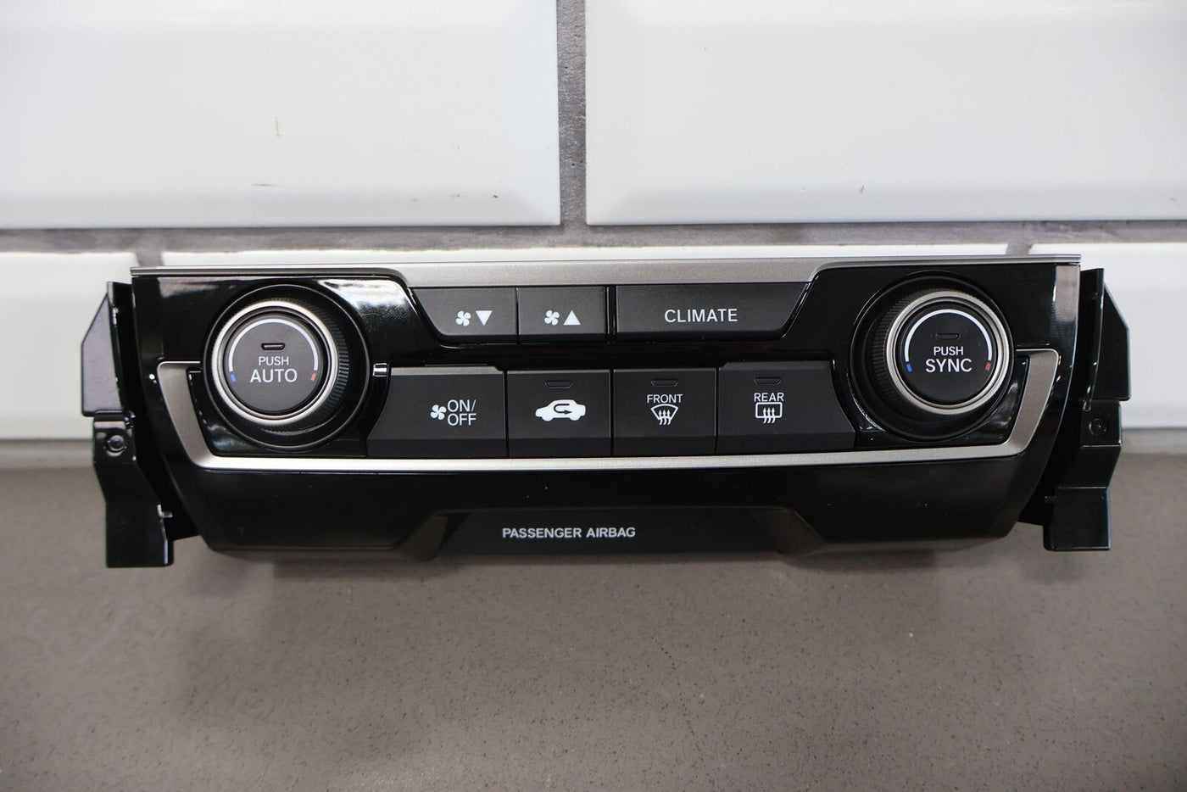

1. Conceptual model: Imagine you have solar panels on your roof.  You know that when the sun is out, the panels converts the energy from the sun into energy that can be used for running electric devices.   You think the energy from the panels flows into a battery, and then energy from the battery flows into your home (Your conceptual model).  But it turns out that the panels convert the energy from the sun into energy that goes 'into the grid'.  The grid is the system that powers the entire community, including your home.
   1. If it is a sunny day, and the power goes out, why might you be confused?

You might be confused because your simplified conceptual model did not hold true. It was inferred from the device itself. You believed and understood that the solar panels provided power, the power came from harvesting sunlight, and that your house required power. However, the conceptual model was erroneous, and you did not know that your house didn’t have a battery and was instead going directly to the grid and not a battery in your house. This conceptual model also likely took hold because you were probably having a highly discounted or $0.00 power bill every month, because you were providing a lot of power to the grid. You probably didn’t see that it was cheaper because you paid it back with the power you gave and not because you weren’t using the grid at all.

* 1. In general terms, in what ways could a solar panels user interface communicate this system model?

A solar panels user interface could communicate this system model in the flowing ways:

* Including a diagram that shows the power going to grid and coming from grid.
* Having an ingoing and outgoing meter, to show that the power created and used are different.
* Having a no battery sign.