Nguyễn Văn Thống

Clear Datas

set sql_safe_updates = 0

ALTER TABLE coffee_shop_sales

MODIFY COLUMN transaction_date DATE;

UPDATE coffee_shop_sales

SET transaction_date = STR_TO_DATE(transaction_date, '%d-%m-%Y');

ALTER TABLE coffee_shop_sales

MODIFY COLUMN transaction_time TIME;

DESCRIBE coffee_shop_sales;

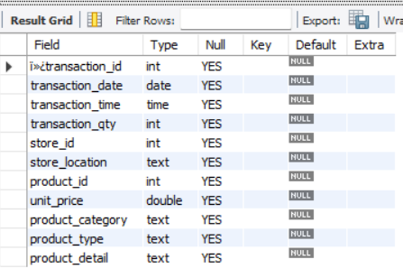

ALTER TABLE coffee_shop_sales

CHANGE COLUMN `ï»¿transaction_id` transaction_id INT;

requestments

1. Tổng doanh thu

SELECT ROUND(SUM(unit_price * transaction_qty)) as Total_Sales

FROM coffee_shop_sales

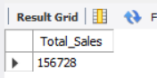

1. Tỷ trọng doanh thu so với tháng trước(tăng giảm bao nhiêu %)

SELECT

MONTH(transaction_date) AS month,

ROUND(SUM(unit_price * transaction_qty)) AS total_sales,

(SUM(unit_price * transaction_qty) - LAG(SUM(unit_price * transaction_qty), 1)

OVER (ORDER BY MONTH(transaction_date))) / LAG(SUM(unit_price * transaction_qty), 1)

OVER (ORDER BY MONTH(transaction_date)) * 100 AS mom_increase_percentage

FROM

coffee_shop_sales

WHERE

MONTH(transaction_date) IN (4, 5) -- for months of April and May

GROUP BY

MONTH(transaction_date)

ORDER BY

MONTH(transaction_date);

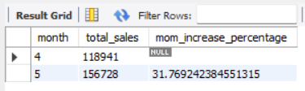

3. Tổng số lượng order

SELECT COUNT(transaction_id) as Total_Orders

FROM coffee_shop_sales

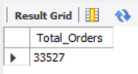

4. Tỷ trọng tổng số order so với tháng trước

SELECT

MONTH(transaction_date) AS month,

ROUND(COUNT(transaction_id)) AS total_orders,

(COUNT(transaction_id) - LAG(COUNT(transaction_id), 1)

OVER (ORDER BY MONTH(transaction_date))) / LAG(COUNT(transaction_id), 1)

OVER (ORDER BY MONTH(transaction_date)) * 100 AS mom_increase_percentage

FROM

coffee_shop_sales

WHERE

MONTH(transaction_date) IN (4, 5) -- for April and May

GROUP BY

MONTH(transaction_date)

ORDER BY

MONTH(transaction_date);

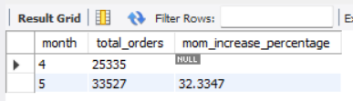

5. Tổng số lượng sản phẩm đã bán

SELECT SUM(transaction_qty) as Total_Quantity_Sold

FROM coffee_shop_sales

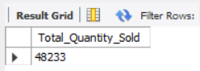

6. Tỷ trọng tổng số bán so vơi tháng trước

SELECT

MONTH(transaction_date) AS month,

ROUND(SUM(transaction_qty)) AS total_quantity_sold,

(SUM(transaction_qty) - LAG(SUM(transaction_qty), 1)

OVER (ORDER BY MONTH(transaction_date))) / LAG(SUM(transaction_qty), 1)

OVER (ORDER BY MONTH(transaction_date)) * 100 AS mom_increase_percentage

FROM

coffee_shop_sales

WHERE

MONTH(transaction_date) IN (4, 5) -- for April and May

GROUP BY

MONTH(transaction_date)

ORDER BY

MONTH(transaction_date);

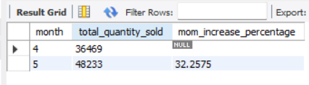

7. Bảng tổng doanh thu, tống số lượng bán, tổng đơn order

SELECT

SUM(unit_price * transaction_qty) AS total_sales,

SUM(transaction_qty) AS total_quantity_sold,

COUNT(transaction_id) AS total_orders

FROM

coffee_shop_sales

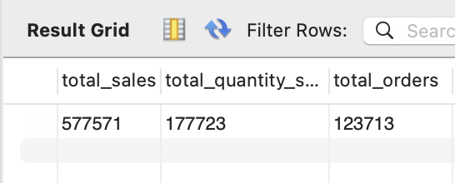

**(Hoặc)**

SELECT

CONCAT(ROUND(SUM(price * qty) / 1000, 1),'K') AS total_sales,

CONCAT(ROUND(COUNT(id) / 1000, 1),'K') AS total_orders,

CONCAT(ROUND(SUM(qty) / 1000, 1),'K') AS total_quantity_sold

FROM

cff

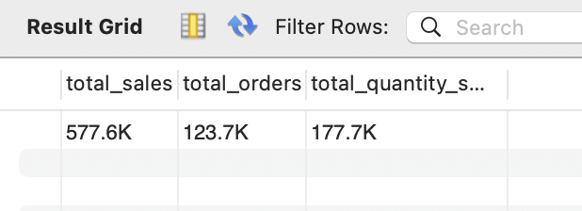

8. Doanh thu trung bình theo ngày

SELECT AVG(total_sales) AS average_sales

FROM (

SELECT

SUM(unit_price * transaction_qty) AS total_sales

FROM

coffee_shop_sales

WHERE

MONTH(transaction_date) = 5 -- Filter for May

GROUP BY

transaction_date

) AS internal_query;

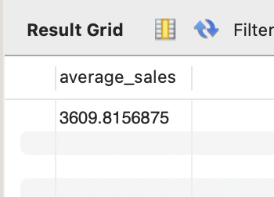

9. Doanh thu từng ngày trong tháng (ví dụ tháng 5)

SELECT

DAY(transaction_date) AS day_of_month,

ROUND(SUM(unit_price * transaction_qty),1) AS total_sales

FROM

coffee_shop_sales

WHERE

MONTH(transaction_date) = 5

GROUP BY

DAY(transaction_date)

ORDER BY

DAY(transaction_date);

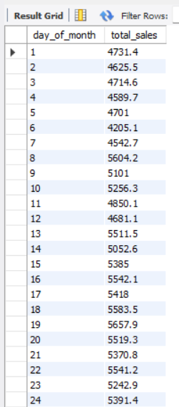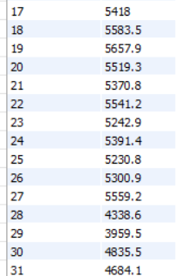

10. Truy vấn tháng để xem ngày nào trên hoặc dưới mức trung bình (ví dụ tháng 5)

SELECT

day_of_month,

CASE

WHEN total_sales > avg_sales THEN 'Above Average'

WHEN total_sales < avg_sales THEN 'Below Average'

ELSE 'Average'

END AS sales_status,

total_sales

FROM (

SELECT

DAY(transaction_date) AS day_of_month,

SUM(unit_price * transaction_qty) AS total_sales,

AVG(SUM(unit_price * transaction_qty)) OVER () AS avg_sales

FROM

coffee_shop_sales

WHERE

MONTH(transaction_date) = 5 -- Filter for May

GROUP BY

DAY(transaction_date)

) AS sales_data

ORDER BY

day_of_month;

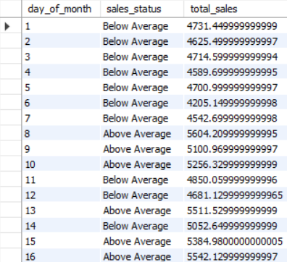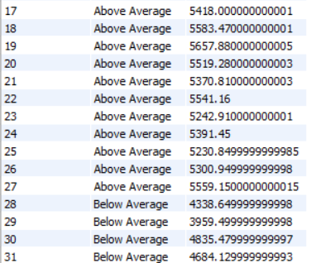

11. Tổng doanh thu các ngày trong tuần và cuối tuần (cuối tuần gồm thứ 7 và CN)

SELECT

CASE

WHEN DAYOFWEEK(transaction_date) IN (1, 7) THEN 'Weekends'

ELSE 'Weekdays'

END AS day_type,

ROUND(SUM(unit_price * transaction_qty),2) AS total_sales

FROM

coffee_shop_sales

GROUP BY

CASE

WHEN DAYOFWEEK(transaction_date) IN (1, 7) THEN 'Weekends'

ELSE 'Weekdays'

END;

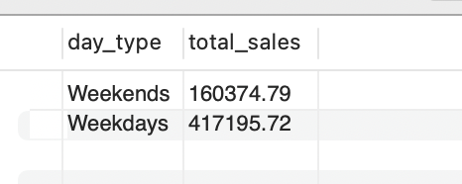

12. Tổng doanh thu của các cửa hàng khác nhau

SELECT

store_location,

SUM(unit_price * transaction_qty) as Total_Sales

FROM coffee_shop_sales

GROUP BY store_location

ORDER BY SUM(unit_price * transaction_qty) DESC

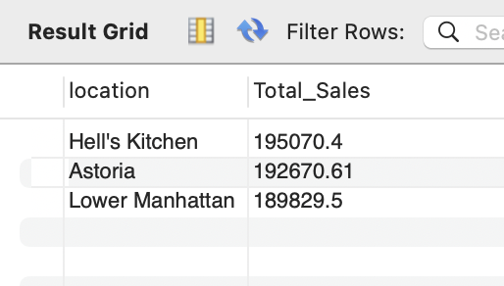

13. Tổng doanh thu theo từng sản phẩm

SELECT

product_category,

ROUND(SUM(unit_price * transaction_qty),1) as Total_Sales

FROM coffee_shop_sales

GROUP BY product_category

ORDER BY SUM(unit_price * transaction_qty) DESC

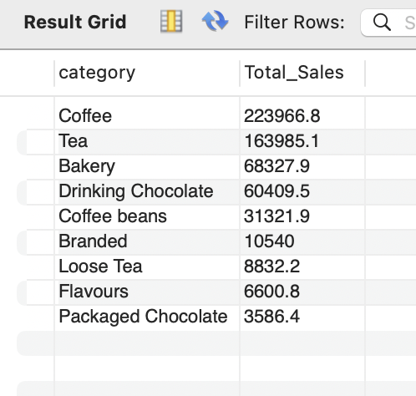

14. Liệt kê TOP 10 loại sản phẩm có doanh thu cao nhất

SELECT

product_type,

ROUND(SUM(unit_price * transaction_qty),1) as Total_Sales

FROM coffee_shop_sales

GROUP BY product_type

ORDER BY SUM(unit_price * transaction_qty) DESC

LIMIT 10

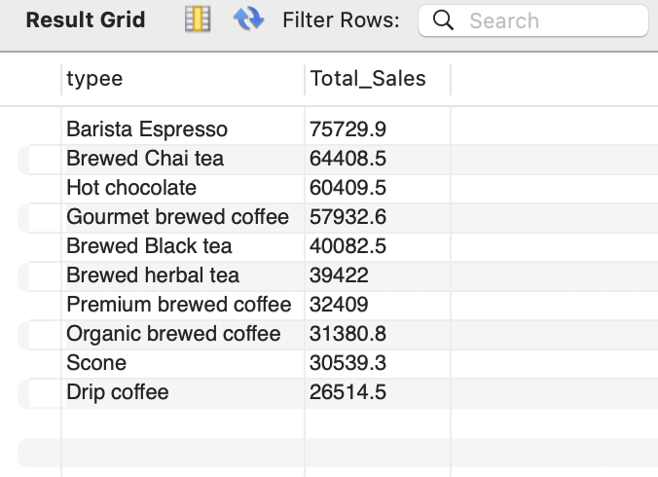

15. Truy vấn chi tiết doanh thu theo ngày, tháng, giờ cụ thể

SELECT

ROUND(SUM(unit_price * transaction_qty)) AS Total_Sales,

SUM(transaction_qty) AS Total_Quantity,

COUNT(*) AS Total_Orders

FROM

coffee_shop_sales

WHERE

DAYOFWEEK(transaction_date) = 3 -- Thu 3

AND HOUR(transaction_time) = 8 -- 8 Gio

AND MONTH(transaction_date) = 5; -- Thang 5

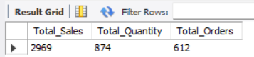

16. Doanh thu các ngày trong tuần

SELECT

DAYNAME(datee) AS Day,

ROUND(SUM(price * qty), 2) AS total_sales

FROM

cff

GROUP BY Day

ORDER BY

FIELD(Day, 'Monday', 'Tuesday', 'Wednesday', 'Thursday', 'Friday', 'Saturday', 'Sunday');

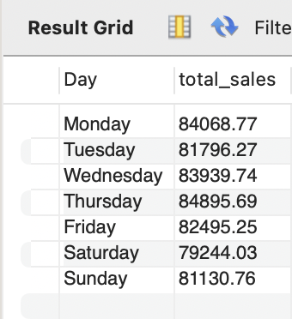

17. Doanh thu các giờ trong ngày

SELECT

HOUR(timee) AS Hour_of_Day,

ROUND(SUM(price * qty)) AS Total_Sales

FROM

cff

GROUP BY

HOUR(timee)

ORDER BY

HOUR(timee);

