Nguyễn Văn Thống

**1. Tổng doanh thu**

SELECT SUM(total_price)

AS Total_Revenue

FROM pizza_sales;

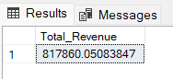

**2. Trung bình giá trên mỗi đơn đặt**

SELECT (SUM(total_price) / COUNT(DISTINCT order_id)) AS Avg_order_Value

FROM pizza_sales

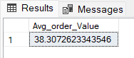

**3. tổng pizza bán được**

SELECT SUM(quantity) AS Total_pizza_sold

FROM pizza_sales

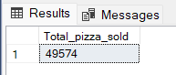

**4. tổng đơn đặt**

SELECT COUNT(DISTINCT order_id) AS Total_Orders

FROM pizza_sales

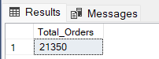

**5. Trung bình số lượng pizza trên mỗi lần đặt**

SELECT CAST(CAST(SUM(quantity) AS DECIMAL(10,2)) /

CAST(COUNT(DISTINCT order_id) AS DECIMAL(10,2)) AS DECIMAL(10,2))

AS Avg_Pizzas_per_order

FROM pizza_sales

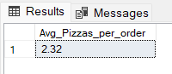

6.Tổng đơn order mỗi ngàySELECT DAYNAME(order_date) AS order_day, COUNT(DISTINCT order_id) AS total_orders

FROM pizza_sales

GROUP BY 1;

***Output:***

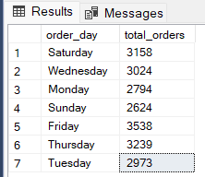

7.Tổng đơn order mỗi tháng

select MONTHNAME(order_date) as Month_Name,

COUNT(DISTINCT order_id) as Total_Orders

from pizza_sales

GROUP BY DATENAME(MONTH, order_date)***;***

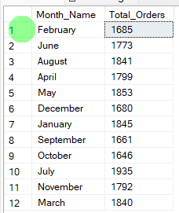

**8. Tổng doanh thu và tỷ trọng của từng loại pizza**

SELECT pizza_category, CAST(SUM(total_price) AS DECIMAL(10,2)) as total_revenue,

CAST(SUM(total_price) * 100 / (SELECT SUM(total_price) from pizza_sales) AS DECIMAL(10,2)) AS PCT

FROM pizza_sales

GROUP BY pizza_category

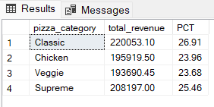

**9. Tổng doanh thu và tỷ trọng của từng loại kích cỡ pizza**

SELECT pizza_size, CAST(SUM(total_price) AS DECIMAL(10,2)) as total_revenue,

CAST(SUM(total_price) * 100 / (SELECT SUM(total_price) from pizza_sales) AS DECIMAL(10,2)) AS PCT

FROM pizza_sales

GROUP BY pizza_size

ORDER BY pizza_size

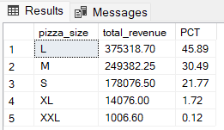

**10. Tổng số lượng bán ra của từng loại pizza**

SELECT pizza_category, SUM(quantity) as Total_Quantity_Sold

FROM pizza_sales

GROUP BY pizza_category

ORDER BY Total_Quantity_Sold DESC

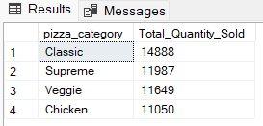

**11. TOP 5 loại pizza có doanh thu cao nhất**

SELECT Top 5 pizza_name, SUM(total_price) AS Total_Revenue

FROM pizza_sales

GROUP BY pizza_name

ORDER BY Total_Revenue DESC

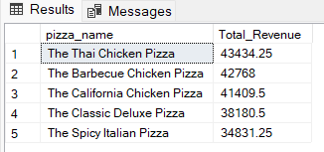

**12. TOP 5 loại pizza có doanh thu thấp nhất**

SELECT Top 5 pizza_name, SUM(total_price) AS Total_Revenue

FROM pizza_sales

GROUP BY pizza_name

ORDER BY Total_Revenue ASC

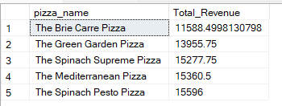

**13. TOP 5 loại pizza có số lượng bán cao nhất**

SELECT Top 5 pizza_name, SUM(quantity) AS Total_Pizza_Sold

FROM pizza_sales

GROUP BY pizza_name

ORDER BY Total_Pizza_Sold DESC

***Output***

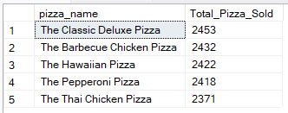

**14. TOP 5 loại pizza có số lượng bán thấp nhất**

SELECT TOP 5 pizza_name, SUM(quantity) AS Total_Pizza_Sold

FROM pizza_sales

GROUP BY pizza_name

ORDER BY Total_Pizza_Sold ASC

***Output***

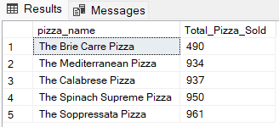

**15. TOP 5 loại pizza được order nhiều nhất**

SELECT Top 5 pizza_name, COUNT(DISTINCT order_id) AS Total_Orders

FROM pizza_sales

GROUP BY pizza_name

ORDER BY Total_Orders DESC

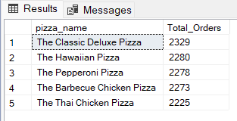

**16. TOP 5 loại pizza được order ít nhất**

SELECT Top 5 pizza_name, COUNT(DISTINCT order_id) AS Total_Orders

FROM pizza_sales

GROUP BY pizza_name

ORDER BY Total_Orders ASC

