Nguyễn Văn Thống

Clear Datas

set sql_safe_updates = 0

ALTER TABLE coffee_shop_sales
MODIFY COLUMN transaction_date DATE;

UPDATE coffee_shop_sales
SET transaction_date = STR_TO_DATE(transaction_date, '%d-%m-%Y');

ALTER TABLE coffee_shop_sales
MODIFY COLUMN transaction_time TIME;

DESCRIBE coffee_shop_sales;
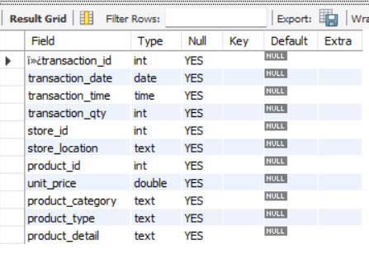

ALTER TABLE coffee_shop_sales
CHANGE COLUMN `ï»¿transaction_id` transaction_id INT;

requestments
- Tổng doanh thu
SELECT ROUND(SUM(unit_price * transaction_qty)) as Total_Sales
FROM coffee_shop_sales
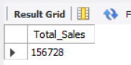
- Tỷ trọng doanh thu so với tháng trước(tăng giảm bao nhiêu %)

SELECT
MONTH(transaction_date) AS month,
ROUND(SUM(unit_price * transaction_qty)) AS total_sales,
(SUM(unit_price * transaction_qty) - LAG(SUM(unit_price * transaction_qty), 1)
OVER (ORDER BY MONTH(transaction_date))) / LAG(SUM(unit_price * transaction_qty), 1)
OVER (ORDER BY MONTH(transaction_date)) * 100 AS mom_increase_percentage
FROM
coffee_shop_sales
WHERE
MONTH(transaction_date) IN (4, 5) -- for months of April and May
GROUP BY
MONTH(transaction_date)
ORDER BY
MONTH(transaction_date);
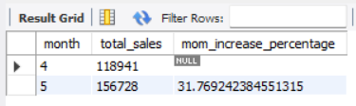
3. Tổng số lượng order
SELECT COUNT(transaction_id) as Total_Orders
FROM coffee_shop_sales
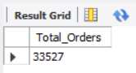

4. Tỷ trọng tổng số order so với tháng trước
SELECT
MONTH(transaction_date) AS month,
ROUND(COUNT(transaction_id)) AS total_orders,
(COUNT(transaction_id) - LAG(COUNT(transaction_id), 1)
OVER (ORDER BY MONTH(transaction_date))) / LAG(COUNT(transaction_id), 1)
OVER (ORDER BY MONTH(transaction_date)) * 100 AS mom_increase_percentage
FROM
coffee_shop_sales
WHERE
MONTH(transaction_date) IN (4, 5) -- for April and May
GROUP BY
MONTH(transaction_date)
ORDER BY
MONTH(transaction_date);
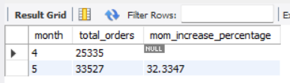
5. Tổng số lượng sản phẩm đã bán
SELECT SUM(transaction_qty) as Total_Quantity_Sold
FROM coffee_shop_sales
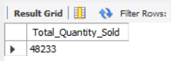
6. Tỷ trọng tổng số bán so vơi tháng trước
SELECT
MONTH(transaction_date) AS month,
ROUND(SUM(transaction_qty)) AS total_quantity_sold,
(SUM(transaction_qty) - LAG(SUM(transaction_qty), 1)
OVER (ORDER BY MONTH(transaction_date))) / LAG(SUM(transaction_qty), 1)
OVER (ORDER BY MONTH(transaction_date)) * 100 AS mom_increase_percentage
FROM
coffee_shop_sales
WHERE
MONTH(transaction_date) IN (4, 5) -- for April and May
GROUP BY
MONTH(transaction_date)
ORDER BY
MONTH(transaction_date);
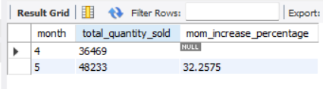
7. Bảng tổng doanh thu, tống số lượng bán, tổng đơn order
SELECT
SUM(unit_price * transaction_qty) AS total_sales,
SUM(transaction_qty) AS total_quantity_sold,
COUNT(transaction_id) AS total_orders
FROM
coffee_shop_sales
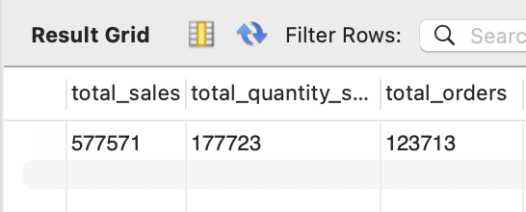
(Hoặc)
SELECT
CONCAT(ROUND(SUM(price * qty) / 1000, 1),'K') AS total_sales,
CONCAT(ROUND(COUNT(id) / 1000, 1),'K') AS total_orders,
CONCAT(ROUND(SUM(qty) / 1000, 1),'K') AS total_quantity_sold
FROM
cff

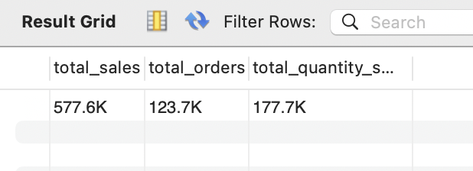
8. Doanh thu trung bình theo ngày
SELECT AVG(total_sales) AS average_sales
FROM (
SELECT
SUM(unit_price * transaction_qty) AS total_sales
FROM
coffee_shop_sales
WHERE
MONTH(transaction_date) = 5 -- Filter for May
GROUP BY
transaction_date
) AS internal_query;
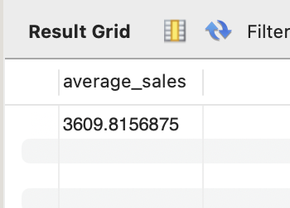
9. Doanh thu từng ngày trong tháng (ví dụ tháng 5)
SELECT
DAY(transaction_date) AS day_of_month,
ROUND(SUM(unit_price * transaction_qty),1) AS total_sales
FROM
coffee_shop_sales
WHERE
MONTH(transaction_date) = 5
GROUP BY
DAY(transaction_date)
ORDER BY
DAY(transaction_date);

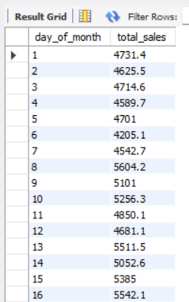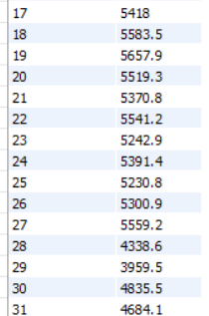
10. Truy vấn tháng để xem ngày nào trên hoặc dưới mức trung bình (ví dụ tháng 5)
SELECT
day_of_month,
CASE
WHEN total_sales > avg_sales THEN 'Above Average'
WHEN total_sales < avg_sales THEN 'Below Average'
ELSE 'Average'
END AS sales_status,
total_sales
FROM (
SELECT
DAY(transaction_date) AS day_of_month,
SUM(unit_price * transaction_qty) AS total_sales,
AVG(SUM(unit_price * transaction_qty)) OVER () AS avg_sales
FROM
coffee_shop_sales
WHERE
MONTH(transaction_date) = 5 -- Filter for May
GROUP BY
DAY(transaction_date)
) AS sales_data
ORDER BY
day_of_month;
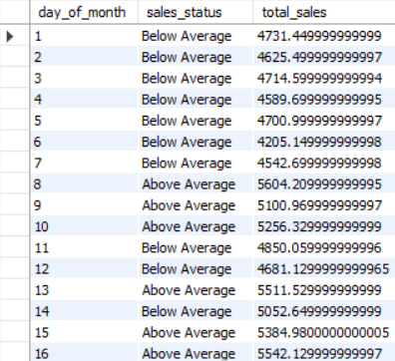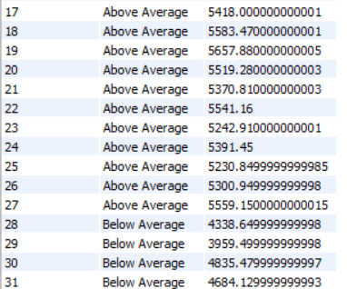
11. Tổng doanh thu các ngày trong tuần và cuối tuần (cuối tuần gồm thứ 7 và CN)

SELECT
CASE
WHEN DAYOFWEEK(transaction_date) IN (1, 7) THEN 'Weekends'
ELSE 'Weekdays'
END AS day_type,
ROUND(SUM(unit_price * transaction_qty),2) AS total_sales
FROM
coffee_shop_sales
GROUP BY
CASE
WHEN DAYOFWEEK(transaction_date) IN (1, 7) THEN 'Weekends'
ELSE 'Weekdays'
END;
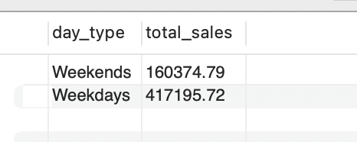
12. Tổng doanh thu của các cửa hàng khác nhau
SELECT
store_location,
SUM(unit_price * transaction_qty) as Total_Sales
FROM coffee_shop_sales
GROUP BY store_location
ORDER BY SUM(unit_price * transaction_qty) DESC
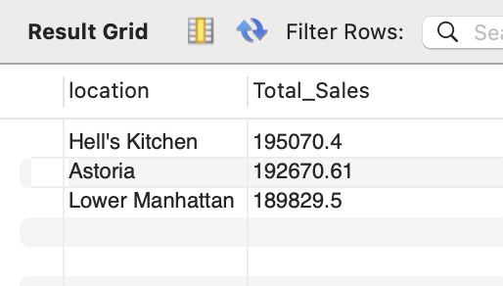
13. Tổng doanh thu theo từng sản phẩm
SELECT
product_category,
ROUND(SUM(unit_price * transaction_qty),1) as Total_Sales
FROM coffee_shop_sales
GROUP BY product_category
ORDER BY SUM(unit_price * transaction_qty) DESC
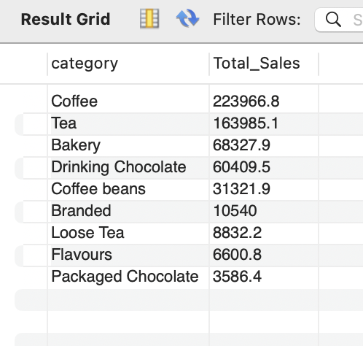
14. Liệt kê TOP 10 loại sản phẩm có doanh thu cao nhất
SELECT
product_type,
ROUND(SUM(unit_price * transaction_qty),1) as Total_Sales
FROM coffee_shop_sales
GROUP BY product_type
ORDER BY SUM(unit_price * transaction_qty) DESC
LIMIT 10
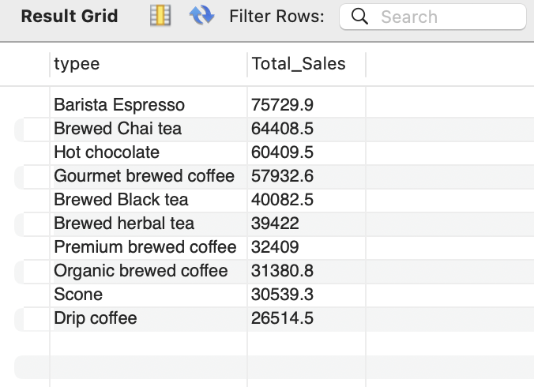
15. Truy vấn chi tiết doanh thu theo ngày, tháng, giờ cụ thể
SELECT
ROUND(SUM(unit_price * transaction_qty)) AS Total_Sales,
SUM(transaction_qty) AS Total_Quantity,
COUNT(*) AS Total_Orders
FROM
coffee_shop_sales
WHERE
DAYOFWEEK(transaction_date) = 3 -- Thu 3
AND HOUR(transaction_time) = 8 -- 8 Gio
AND MONTH(transaction_date) = 5; -- Thang 5
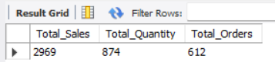
16. Doanh thu các ngày trong tuần
SELECT
DAYNAME(datee) AS Day,
ROUND(SUM(price * qty), 2) AS total_sales
FROM
cff
GROUP BY Day
ORDER BY
FIELD(Day, 'Monday', 'Tuesday', 'Wednesday', 'Thursday', 'Friday', 'Saturday', 'Sunday');

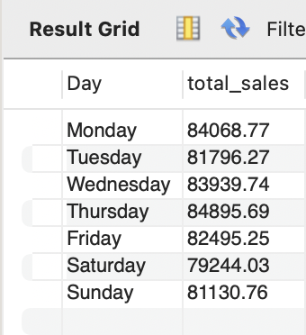

17. Doanh thu các giờ trong ngày
SELECT
HOUR(timee) AS Hour_of_Day,
ROUND(SUM(price * qty)) AS Total_Sales
FROM
cff
GROUP BY
HOUR(timee)
ORDER BY
HOUR(timee);
