Ecom Public Catalog

Đánh giá GET Product List và Product Detail

STATUS | Source review | OWNER | Catalog API / BE | LAST UPDATED: 2026-08-09

Authors | Codex - source-first review
Reviewers | Catalog FE, API/Commerce reviewers
Related docs | ProductsController; PublicCatalogReadStore; Catalog DTO/handlers/tests
Scope | Anonymous GET /api/v1/products and GET /api/v1/products/{slug}

1. Abstract
Hai endpoint public đã có biên giới đúng: controller mỏng, list dùng read store PostgreSQL, detail dùng query no-tracking, giá hiệu lực do server chọn và media chỉ trả Clean + Public. Không có giá vốn, tồn kho thô hay dữ liệu payment trong DTO.
Đây là đánh giá source hiện tại, không phải chứng minh PostgreSQL/staging. Rủi ro chính cho khách hàng là list/detail không cùng visibility rule, phân trang có thể overflow, CTA không phản ánh khả năng mua và link slug cũ 404.

2. Goals and Non-Goals
Goals | Non-goals
Đồng nhất dữ liệu product khách nhìn thấy ở list và detail. | Không thay public API, schema, migration hoặc config trong tài liệu này.
Giữ giá, category, producer và media là server-authoritative. | Không suy ra số lượng tồn hoặc tổng checkout từ browser.
Loại bỏ lỗi 500 do input paging và dữ liệu hierarchy bất thường. | Không đặt ngưỡng traffic/SLO khi source không có telemetry.
Tạo checklist FE/BE và test gate có thể triển khai theo batch. | Không gọi build/test local là bằng chứng production readiness.

3. Background and Problem Statement
`ProductsController` cho anonymous access. List ủy quyền cho `PublicCatalogReadStore`, dùng SQL parameterized để lọc Product Published, Producer Published+Verified, primary category có toàn bộ ancestor Published, active Variant có effective Sale/Public VND price, và primary media Clean+Public nếu có.
Detail đọc Product/Producer/primary Category bằng EF no-tracking, sau đó đọc category, variant, option mapping, effective price và media. Điều này giữ DTO public gọn, nhưng predicate visibility và truy vấn bị tách thành hai implementation nên đã phát sinh divergence.

4. Proposed Architecture

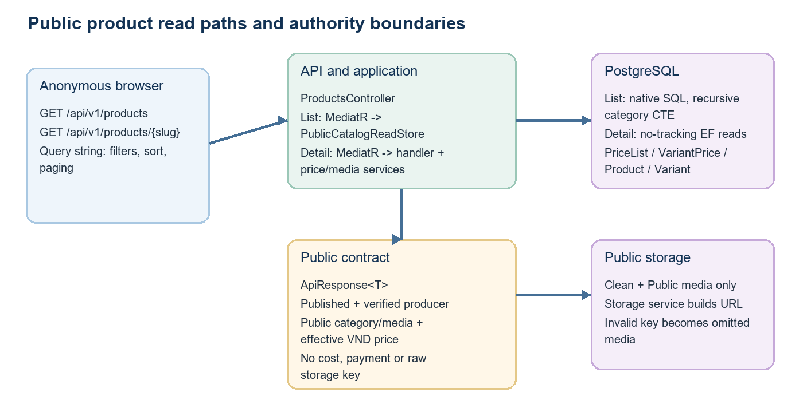
Figure 1. Current public product read paths and source-of-truth boundaries.

Core components

Component | Responsibility | Primary storage | Failure behavior
ProductsController | Versioned anonymous routes; binds query/slug and sends MediatR. | ASP.NET Core | Validation returns ApiResponse 400; unhandled failures map generic 500.
PublicCatalogReadStore | List projection, filter, order whitelist, count and paging. | PostgreSQL via ApplicationDbContext connection | DB/SQL failure stops browsing; no output cache or route rate limit.
GetProductBySlug handler | Detail projection, category/variant/options orchestration. | UnitOfWork no-tracking queries | Missing base row returns 404; duplicate/corrupt joins can become 500.
EffectivePriceResolver | Chooses active VND min-quantity-1 Sale before Public price. | VariantPrice and PriceList | No effective price removes a variant; detail becomes 404 when none remain.
ProductMediaReader / storage | Returns only public clean media and creates URL from storage key. | MediaAsset and public storage | Invalid key is logged and media is omitted; card may have no image.

5. Request Lifecycle
- List entry: browser sends filters (`q`, categorySlug, producerId, price range, sort, page, pageSize) to GET /api/v1/products. Detail entry: browser sends only the current slug to GET /api/v1/products/{slug}.
- Model validation checks text lengths, sort whitelist, positive price bounds and page/pageSize minimums. Current validator has no maximum Page, so offset multiplication can overflow an int.
- List uses one SQL `asOfUtc`; detail loads Published Product, Published+Verified Producer and a Published primary Category before reading dependent facts.
- List calculates effective price in SQL with Sale priority then latest effective date. Detail batches price resolution for active variants and excludes variants without a current effective price.
- List requires Published ancestors via recursive CTE. Detail currently checks only direct primary Category status; a product can therefore be hidden in list but still returned by detail after an ancestor is paused.
- Media readers return public, clean files only; invalid storage keys are omitted with a warning. Responses use ApiResponse and UTC JSON serialization; no response cache or public-read rate limiter is attached.
- The browser receives discovery/card data or variant detail. Checkout remains authoritative for current stock and price, but current browse DTO has no availability signal, so the CTA can be misleading.

6. API and Data Contracts

Primary data contract

Field | Type | Required | Description
slug (detail) | path string | Yes | Exact current Product slug, max 350. Current read does not resolve ProductSlugHistory or canonical redirect.
q | query string | No | Max 200; parameterized ILIKE over product name and short description.
categorySlug | query string | No | Max 250; matches any assigned public category with a fully Published ancestor chain.
producerId | query UUID | No | Filters only Producer Published and Verified in the public read model.
minPrice / maxPrice | decimal query | No | Non-negative; filter effective product fromPrice, not client-computed discount.
sort | query enum | No | newest, name-asc, price-asc, price-desc. SQL order is a closed whitelist.
page / pageSize | int query | No | Page starts at 1; pageSize 1-50. Add bounded/cursor pagination before large public traffic.

Contract guarantees

- Visibility guarantee must be identical in both routes: Product Published; Producer Published+Verified; primary and filtered categories with all ancestors Published; active variant plus a currently effective public price.
- List order is stable inside each sort (`Id` tie-breaker). Detail variant order is not explicitly ordered by DisplayOrder/Name, so the client must not treat array position as a stable default-selection contract.
- The public DTO publishes Id, slug, producer/category summaries, media URL metadata and price. It omits inventory quantities, payment state and management stamp; confirm whether SKU and Producer.Code are intended for public disclosure.
- Product browse data is discovery information, not an inventory reservation or checkout quote. Cart/checkout must re-evaluate product status, availability and price on the server.
Current implementation references are source-controlled in `ProductsController`, Catalog DTOs, list store and detail handler.
Related FE analysis: document/architecture/COMMERCE-ENTITY-DATABASE-FE-PAGE-REPORT-2026-08-09.md

7. Consistency, Idempotency, and Replay

The two GET routes are read-only and do not require client idempotency. Their critical guarantee is deterministic and equal public visibility. Current code is safe from SQL injection in list filters and sort, but is not yet parity-safe across list/detail and has no cache/rate-limit boundary for the expensive public query.
Scenario | Expected behavior | Reasoning
Ancestor category becomes Paused/Hidden | List hides the product; detail can still return it because it checks only direct primary category status. | Direct links, search index or browser history can show content absent from catalog navigation.
Very large `page` | `Skip()` multiplies two int values; overflow can send a negative OFFSET and surface as server error. | Anonymous invalid input should return a stable 400, not consume DB/error budget.
Stock/price changes while browsing | Price is recomputed for browse; inventory is not projected. AddCart checks active status, while reserve happens later. | User can add/select an item that fails at preview/create-order with no earlier availability cue.
Slug is changed | Update handler changes Product.Slug but does not write ProductSlugHistory; detail only matches current slug. | Existing links and indexed URLs 404 despite a history table existing in the model.

8. Security and Privacy Considerations

- Anonymous access is intentional and the controller does not require a policy. DTOs avoid cost, reservation, payment and raw storage keys; public media is filtered to Clean + Public.
- List SQL uses command parameters for values and a closed switch for ORDER BY, which protects the query from filter/sort injection. Detail uses typed EF no-tracking queries.
- Review public exposure of `ProductVariant.Sku` and `Producer.Code`. They may be harmless catalog identifiers, but source has no explicit public-safe classification or redaction rule.
- The costly public list has neither `EnableRateLimiting` nor Response/Output Cache while other sensitive or mutating endpoints do use named rate policies. Add a public-read policy and CDN/application cache policy with clear invalidation boundaries.
- Logs must keep excluding query PII and storage internals. Continue treating checkout as the authority for sellability, price and quantity; never add client-controlled availability to the public contract.

9. Operational Readiness
Signal | SLO or alert | Owner | Launch gate
List/detail visibility parity | No current metric source. Add synthetic pair tests and alert on a product visible by one route only. | Catalog API | Required
Public GET 4xx/5xx | Track validation errorCode, 404, SQL exceptions and paging overflow separately; targets TBD from traffic baseline. | Catalog API | Required
List query latency and plan | Capture p50/p95/p99, rows scanned and EXPLAIN ANALYZE on representative PostgreSQL data; no current threshold proven. | Data/API | Required
Rate/cache effectiveness | Measure cache hit ratio and 429s after a documented public-read budget; avoid cache of stale sellability claims. | Platform/API | Required
Browse-to-checkout availability rejection | Count preview/create-order failures caused by unavailable variants after browse; use it to validate availability projection. | Commerce | Recommended
Rollout constraint: no database migration is implied. Ship logic changes behind focused PostgreSQL integration tests, benchmark the list SQL, run API smoke tests, then canary/cache-rate controls with rollback to current read path.

10. Alternatives Considered

Alternative | Why it was considered | Why it was not selected
Keep separate list SQL and detail EF predicates | Minimal code change and each endpoint remains locally simple. | Not selected as-is: current ancestor visibility divergence proves parity can drift.
Shared public visibility read model/view | One defined rule for Product, Producer, category ancestry, price and media eligibility. | Recommended direction; design must retain efficient list projection and detail composition.
Only cache in browser/CDN | Fastest perceived browsing speed. | Insufficient alone: cannot fix correctness, abuse, invalidation or source-of-truth gaps.
Full-text search immediately | Better discovery than `%ILIKE%` at scale. | Defer until Vietnamese search semantics, ranking, indexes and traffic evidence are agreed.

11. Open Questions
- Open question 1: Should a product with an out-of-stock tracked variant be visible, purchasable with backorder, or visible but disabled? Define a server-computed availability vocabulary.
- Open question 2: Is ProductSlugHistory intended to create HTTP 301 redirects, return canonical slug metadata, or remain an unused audit table? Decide before more public slug edits.
- Open question 3: What maximum depth/page/cursor policy and category hierarchy integrity guard are acceptable for public traffic? Current recursive CTE assumes valid acyclic data.
- Open question 4: Which cache TTL, invalidation events and public-read rate budget balance browsing speed with price/category lifecycle correctness?

12. Decision and Next Steps
Decision: retain the current server-owned price/media design, but do not treat the public Product read surface as complete. First fix visibility parity and page overflow, then define availability and slug-history contracts; follow with PostgreSQL/API tests and a controlled rate/cache rollout. No migration, deployment or API change is made by this review.
Milestone | Deliverable | Exit criteria
M1 | Parity hardening | GET list/detail share or prove equivalent ancestor visibility; add tests for pause/hide/producer/media/price boundary.
M2 | Input and UX contract | Bound or cursor-page list; deterministic variant order; decide safe availability projection and slug-history behavior.
M3 | PostgreSQL and API proof | Run dedicated PostgreSQL query/constraint/API tests and realistic list EXPLAIN/latency evidence.
M4 | Controlled public rollout | Rate/cache policy, dashboards and synthetic parity probes are live; canary has no unexplained visibility/5xx regression.

Use footnotes for definitions, assumptions, or terms that need precision without interrupting the main narrative.

