**You have looked at the website of an information center, you are interested in *IT course*. Write an email 80-100 words to the center to request information about: *How many hours a week for a class*; *How to get material for the course*; *the discounts for the students***

Dear Sir or Madam,

I am writing to request more information about the *IT course*, this course that I have read on your website. I have some questions about the course: Firstly, How many hours a week are the classes? Secondly, How do students get course materials? And finally, do you offer any discounts for students? I am particularly interested in learning more about the following topics: Programming language, web development

Thank you in advance for providing this information.

I look forward to hearing from you.

Best regards,

Nguyen Thai Bao

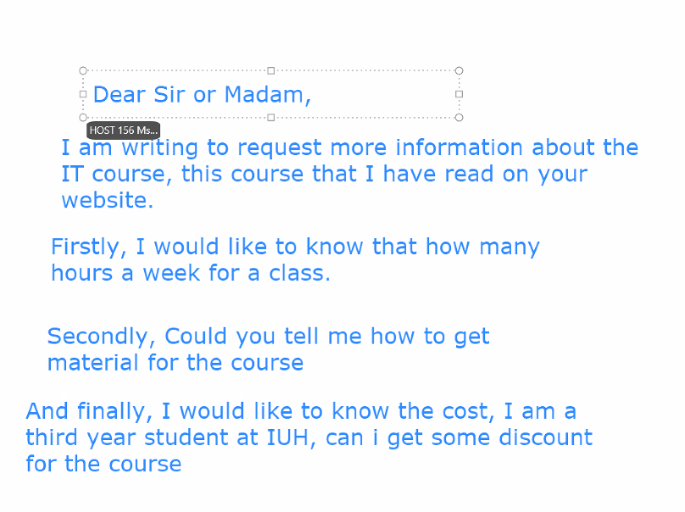

**Write four paragraph about a coffe shop that you usually hang out with your family**

1. **What is the name of this coffee shop ? Where is it?**
2. **What are the good points about this coffee shop?**
3. **Are there any problems with coffee shop?**
4. **On the whole, would you recommend this coffee shop to others? Why not?**

Paragraph 1:

My favorite coffee shop to hang out with my family is called Coffee Bean & Tea Leaf. It is located in the heart of Ho Chi Minh City, Vietnam.

Paragraph 2:

There are many good things about this coffee shop. First, the coffee and food are great. The coffee is made with freshly roasted beans, and the food is made with fresh, seasonal ingredients. Second, the atmosphere is family-friendly. The coffee shop has a warm and inviting atmosphere, making it a great place to relax and spend time with family and friends. Third, the location is convenient. The coffee shop is located in a convenient location, making it easy to get to. It is also close to several other attractions.

Paragraph 3:

There are a few problems with the coffee shop. First, the prices can be high. The prices at Coffee Bean & Tea Leaf are higher than at some other coffee shops in Vietnam. Second, the coffee shop can be crowded during peak hours. This can make it difficult to find a seat.

Paragraph 4:

Overall, I would highly recommend Coffee Bean & Tea Leaf to others. It is a great place to enjoy a delicious cup of coffee and a bite to eat with family and friends. The atmosphere is warm and inviting, and the staff is always friendly and helpful. While the prices can be high, I believe that the quality of the coffee and food is worth it.

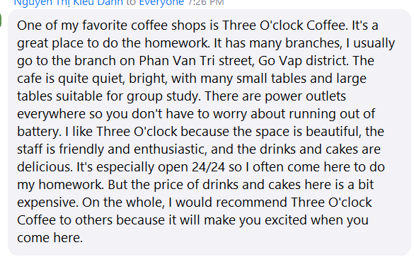

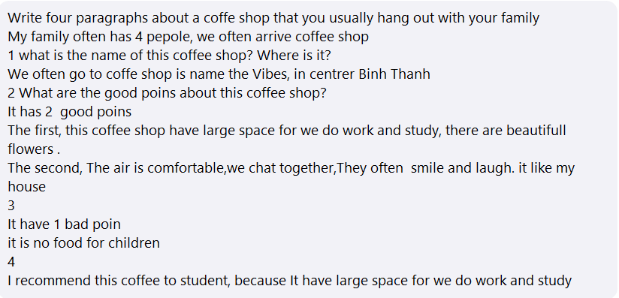

My family has 4 people. We often go to a coffee shop called Vibes, in the center of Binh Thanh. It has 2 good points. First, this cafe has spacious space for us to work and study, and has very beautiful flowers. Second, the atmosphere is comfortable, we chat together. It's like my home. It has 1 bad point. It is not a drink for children. I recommend this coffee to students because it has spacious space for us to work and study

