# Components Diagram

Components are what live inside containers , and are often logical in nature; for instance a collection of classes that are used for a use case (authentication, data access). This structure of a components diagram can vary from class/uml, to n-tier, or even a CQRS workflow.

**Purpose**

* Validate the high-level design
* Identify problems early
* Show relationships and dependencies between components

**Features**

* Whatever you feel the best way to identify components and their interactions
* Technology choices, possibly

**Example**

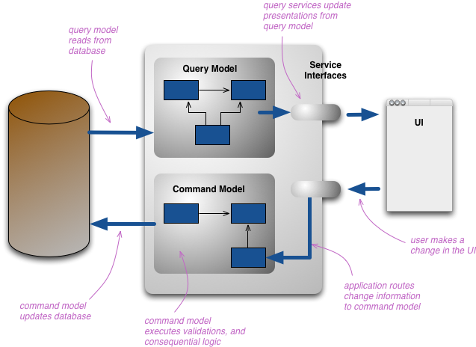

(courtesy of Martin Fowler’s website)