***SCREENSHOT***

API ROOT

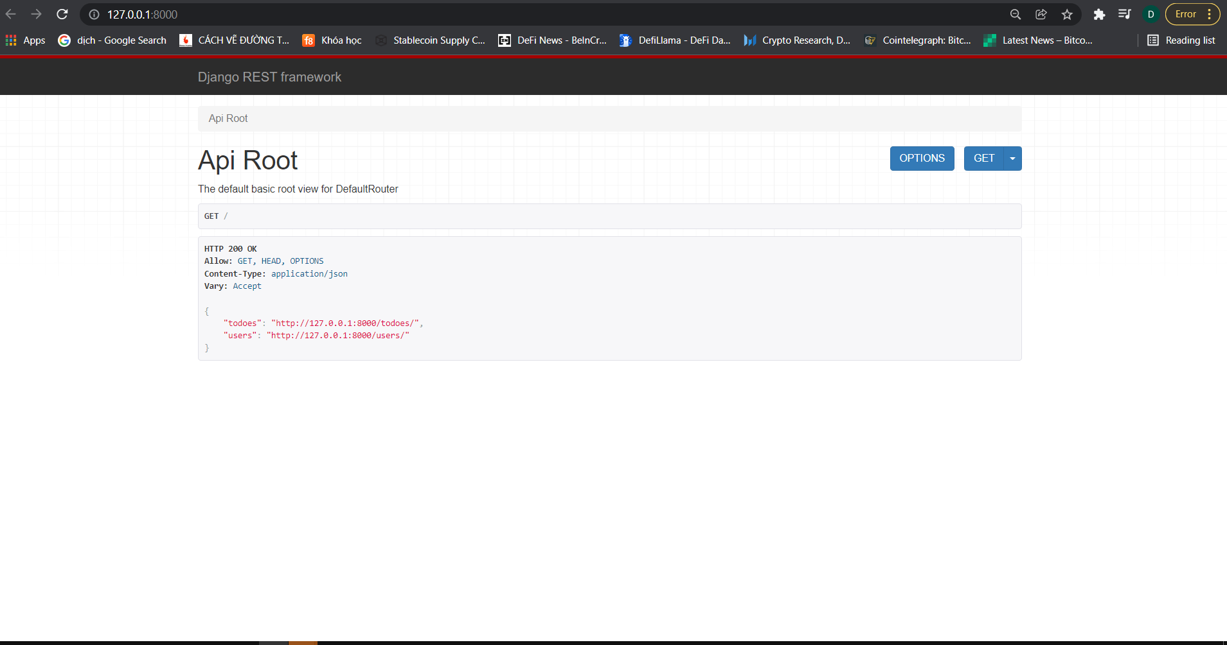

API TODOES

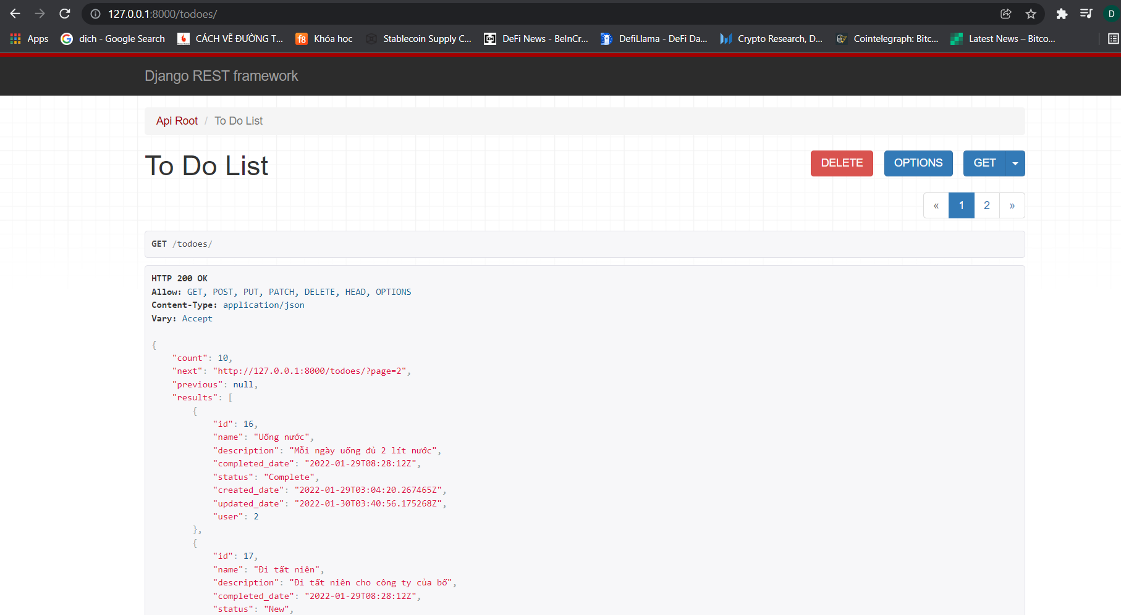

API USERS

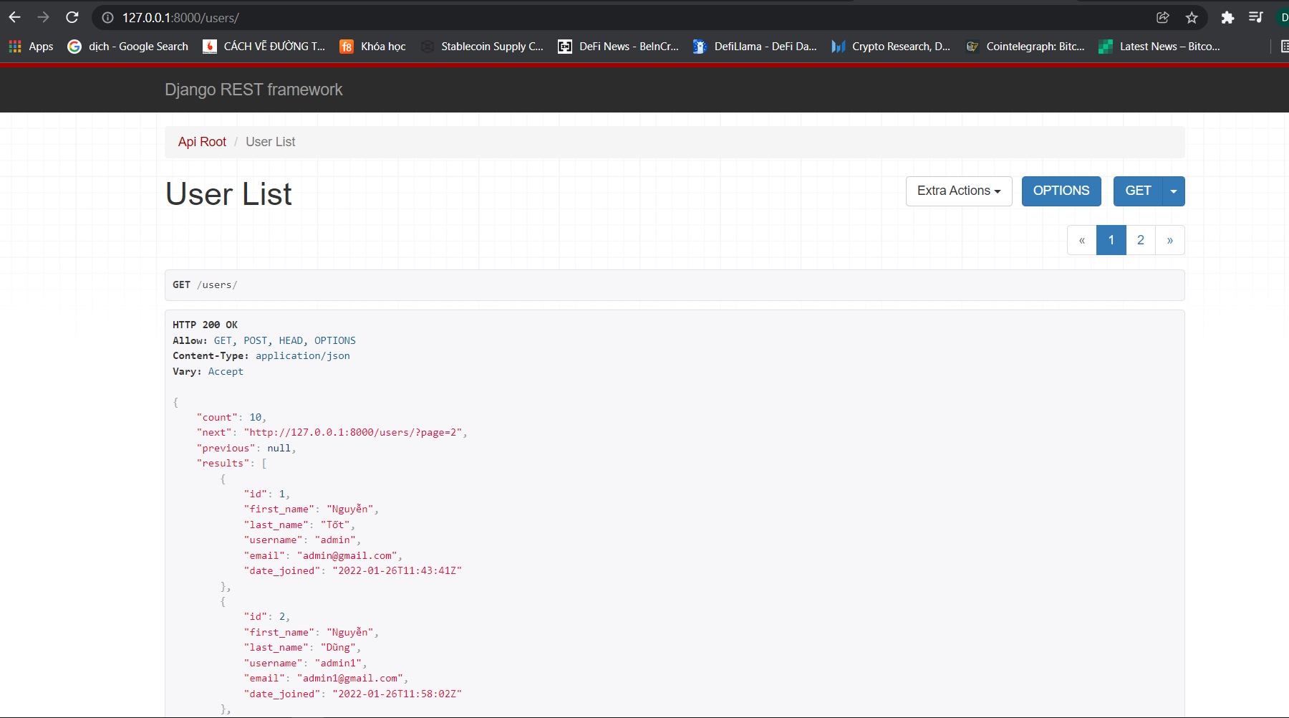

SWAGGER

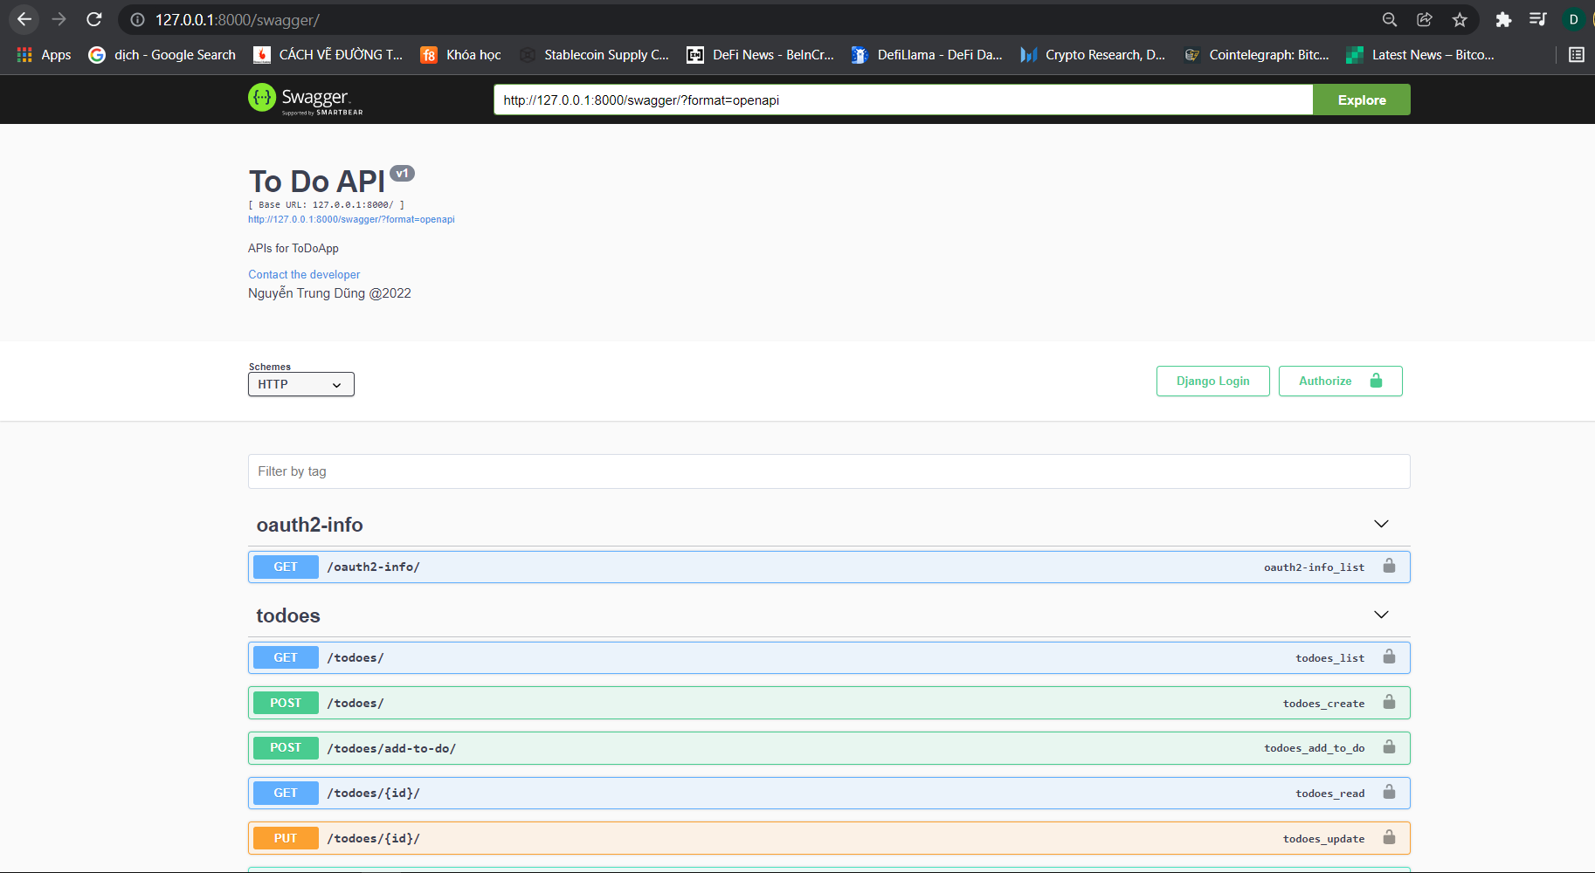

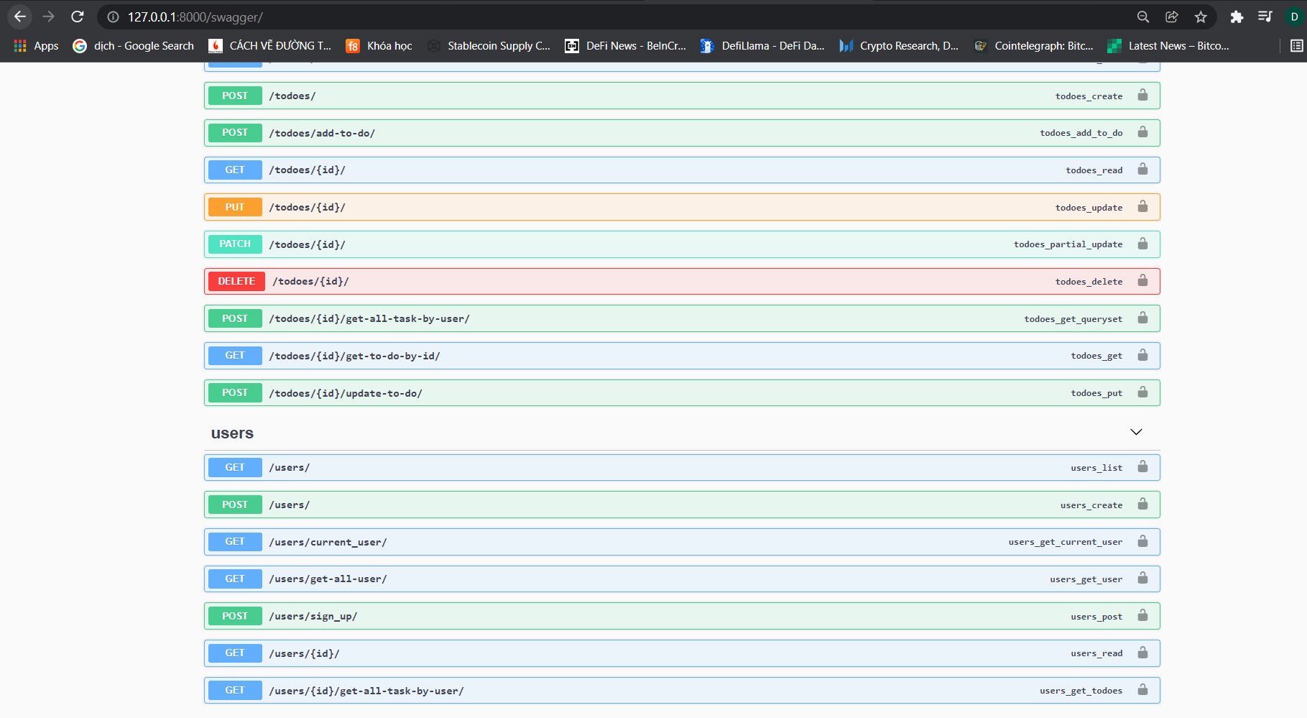

API GET CLIENT-ID, CLIENT-SECRET

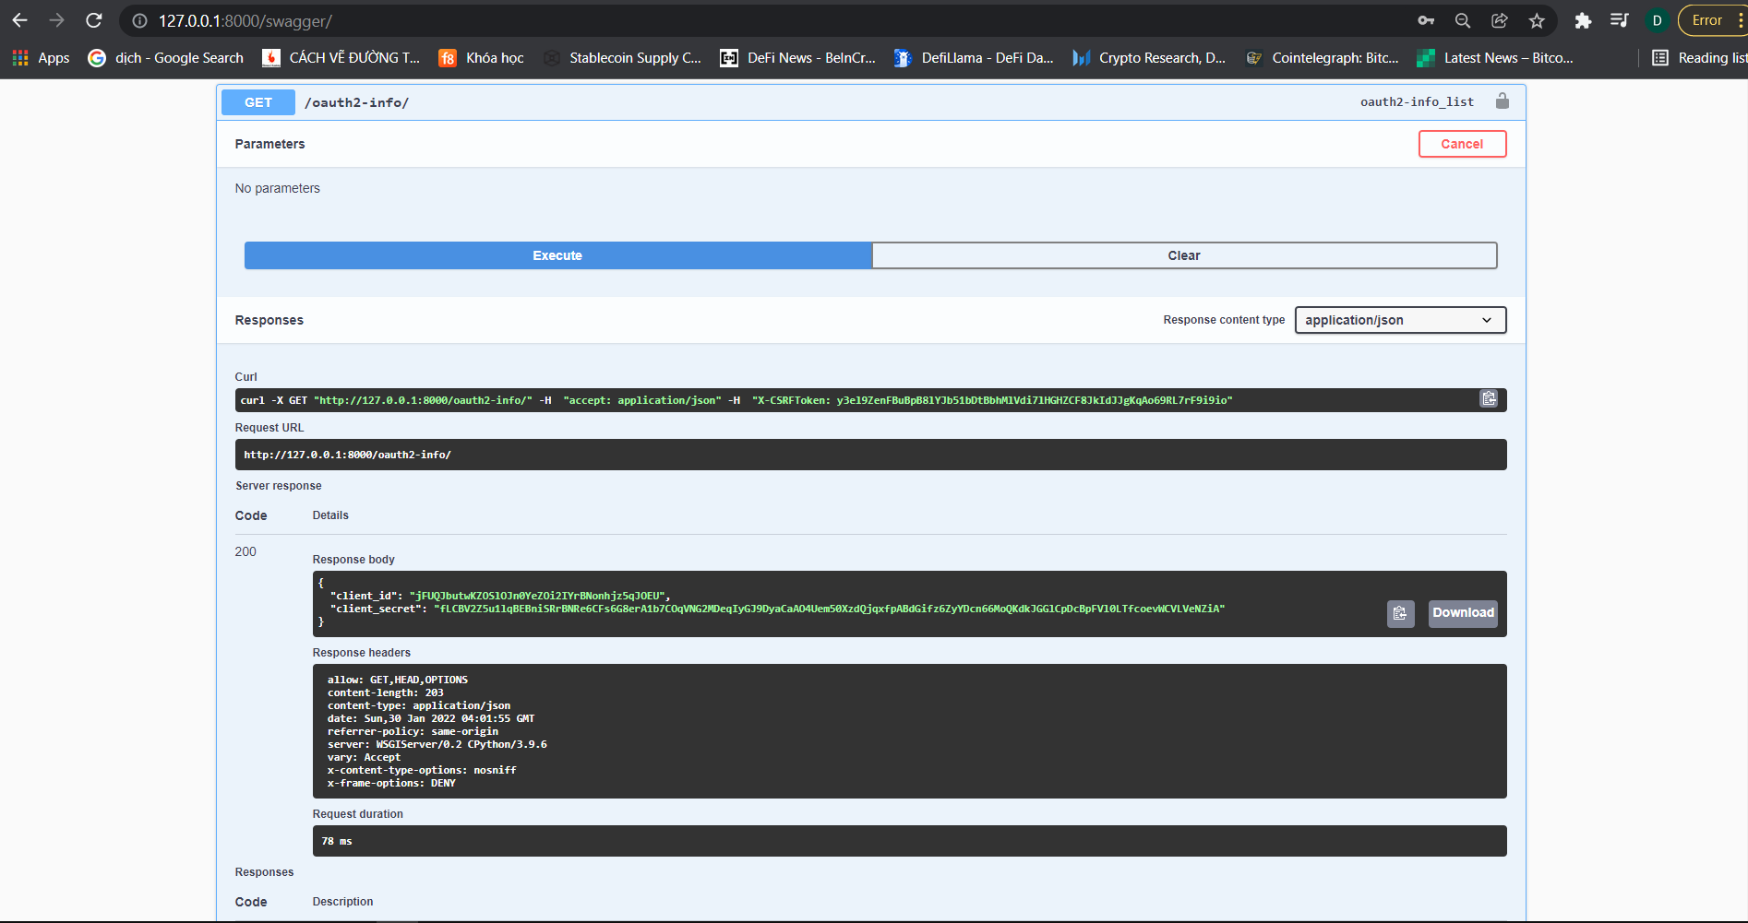

API1_SIGN-UP

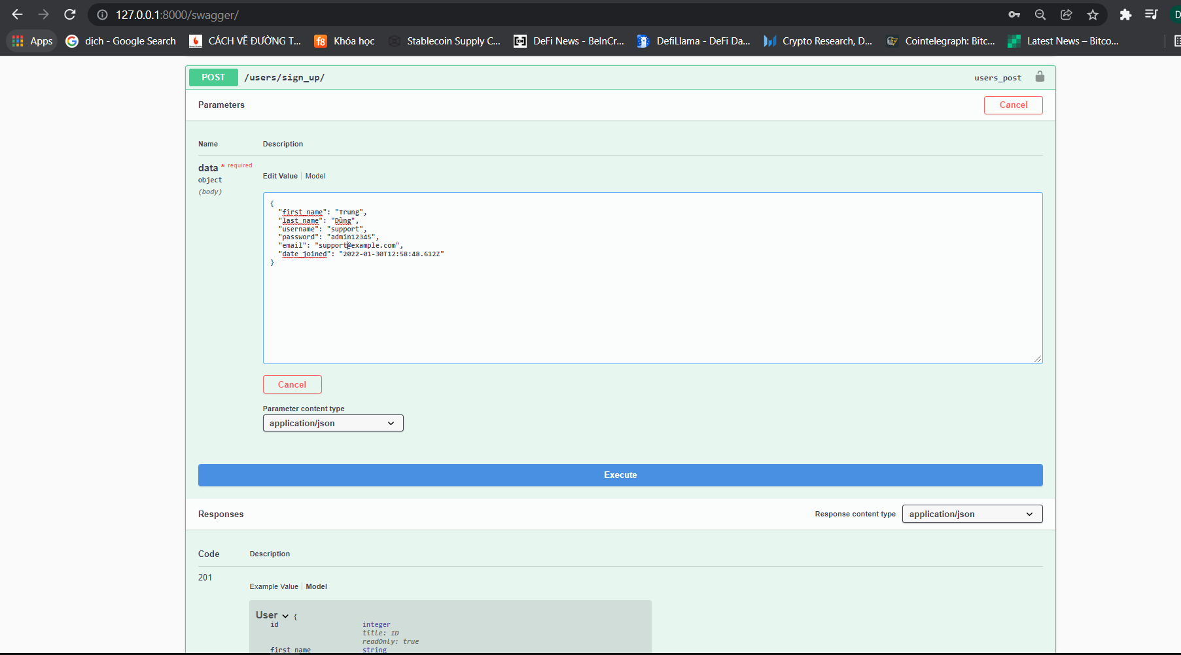

RESPONSE API1_SIGN-UP

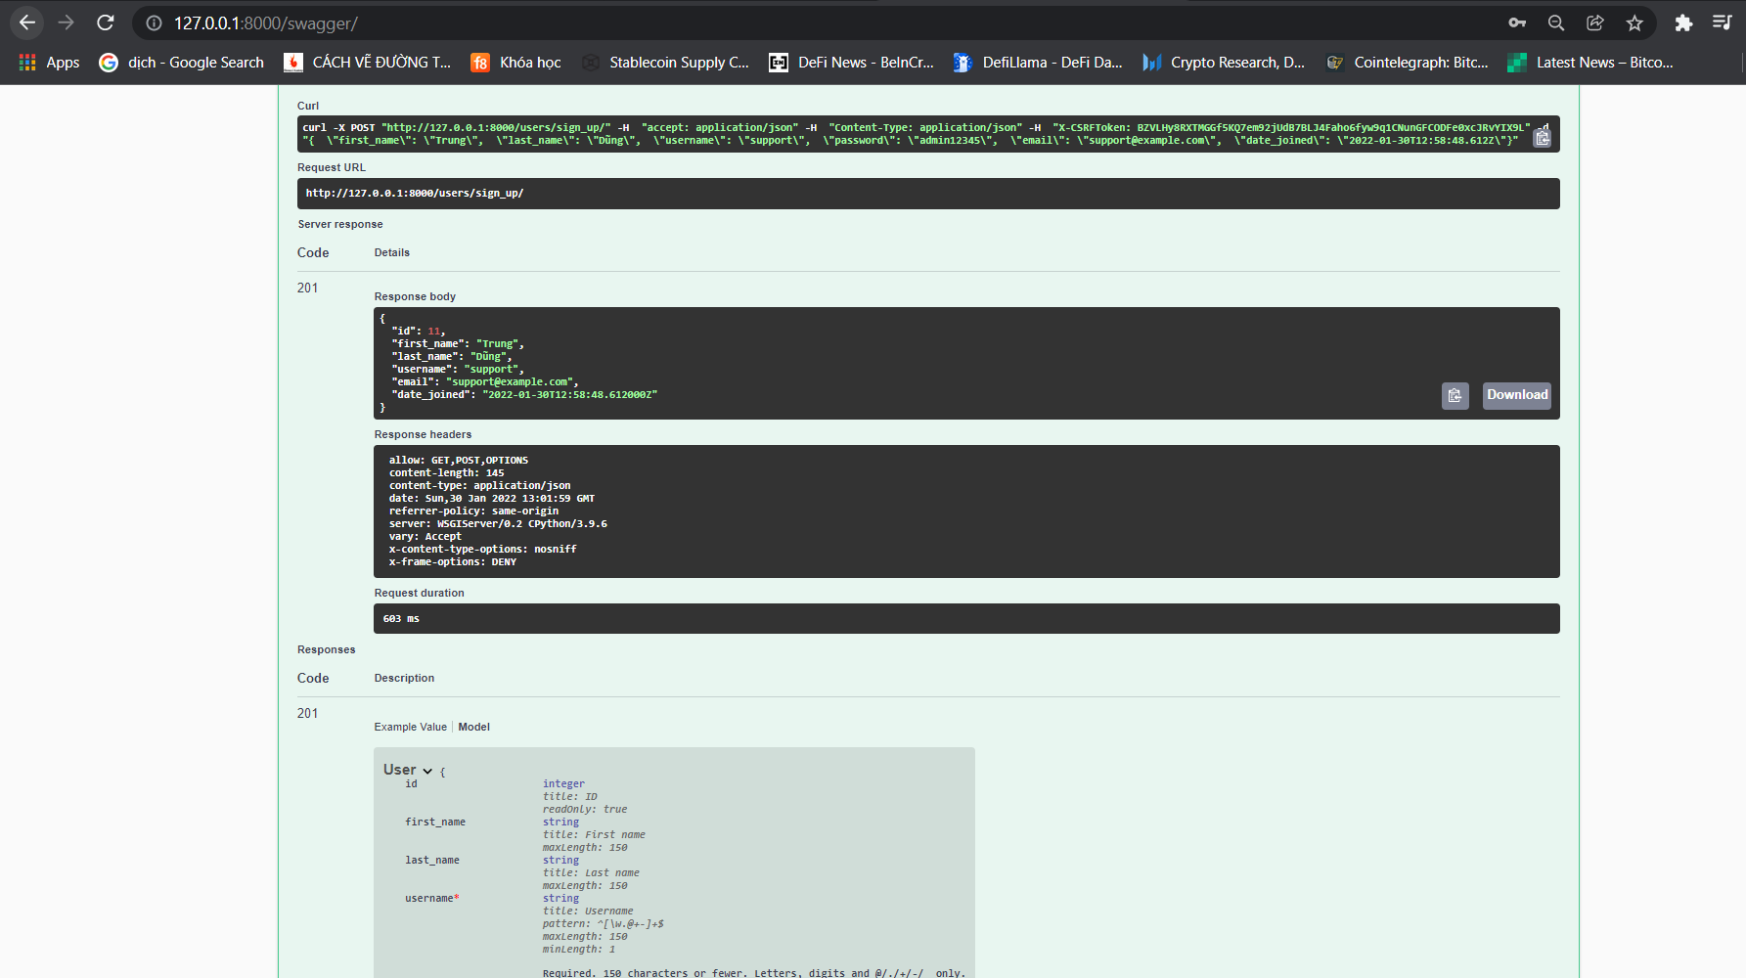

API2_SIGN-IN

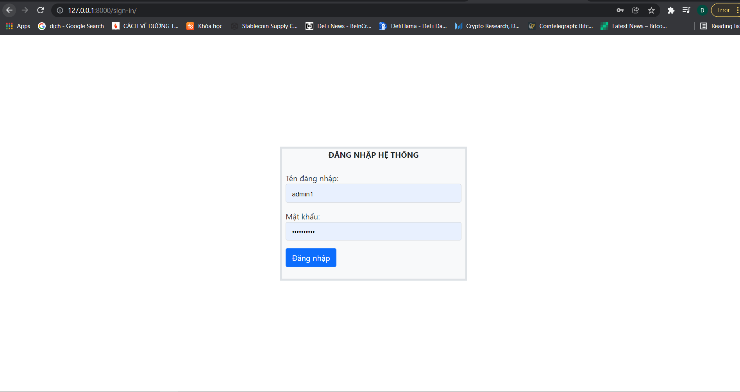

API 3 ADD TO DO

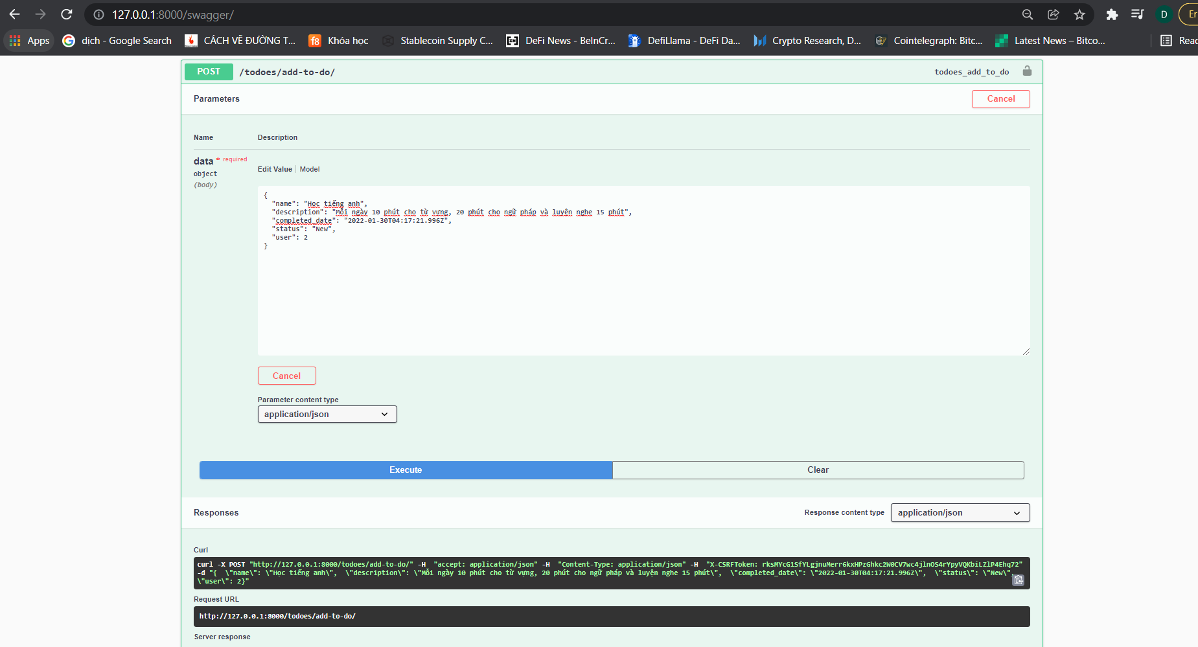

RESPONSE API3_ADD-TO-DO

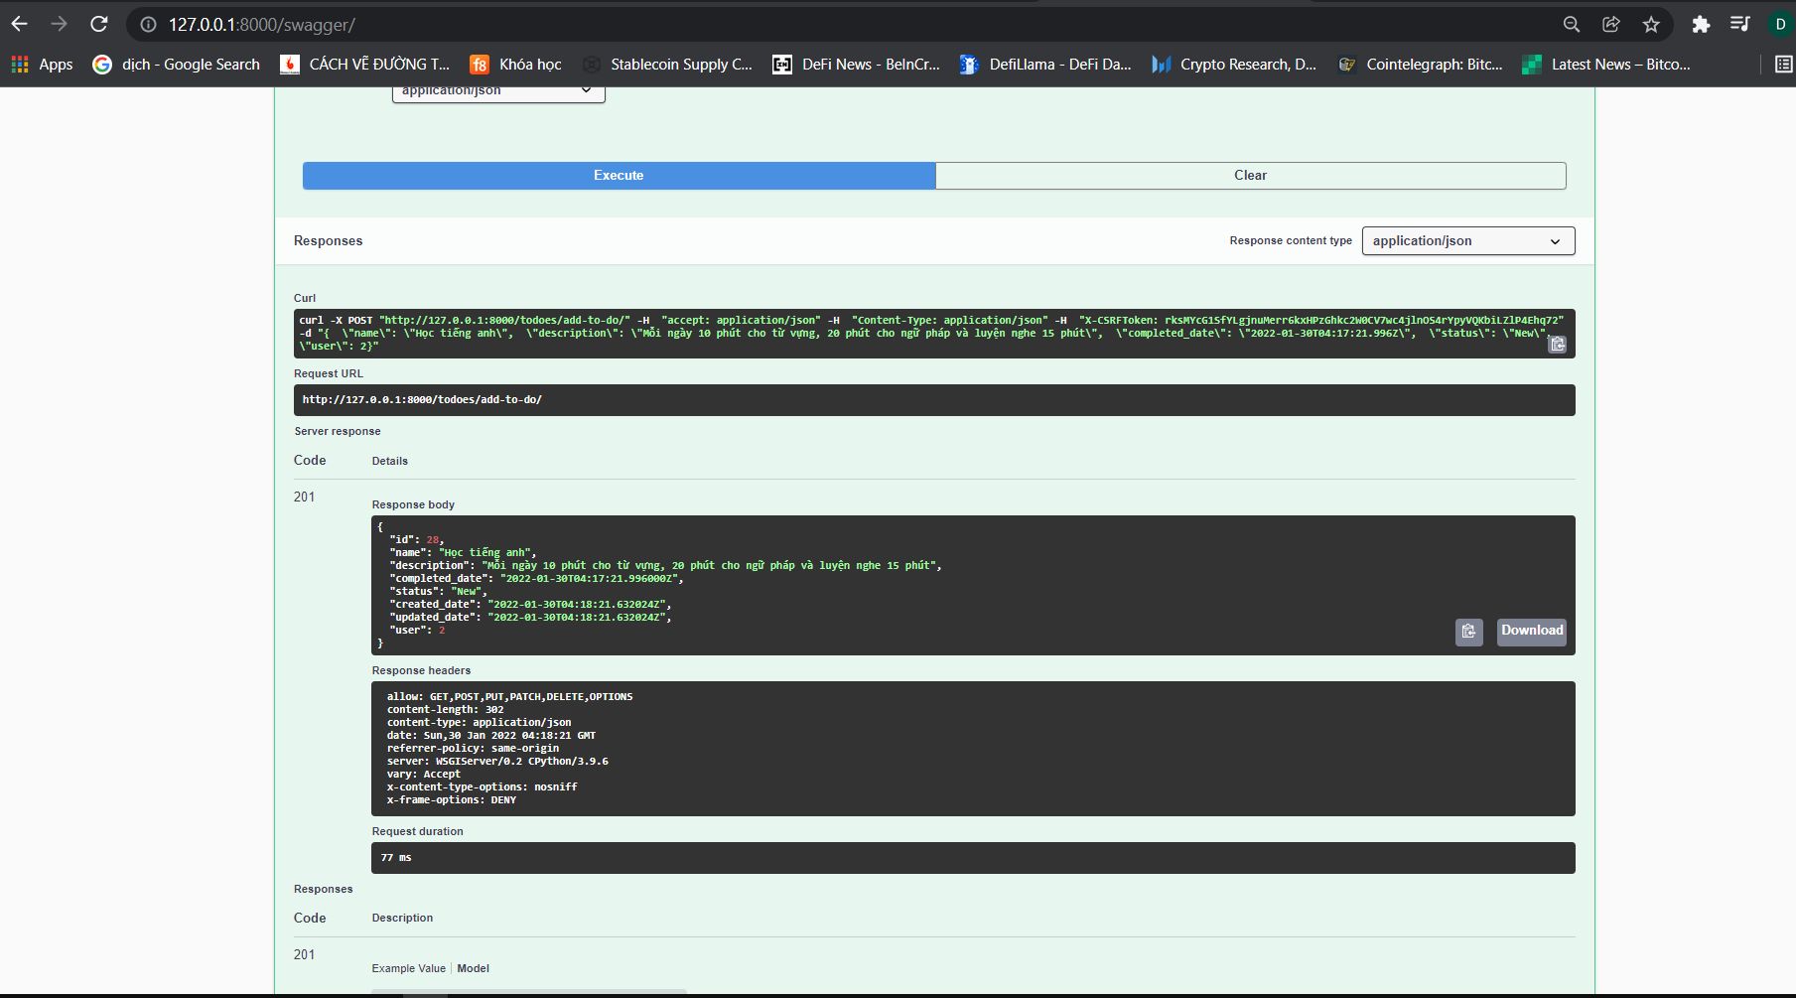

API4 UPDATE-TO-DO

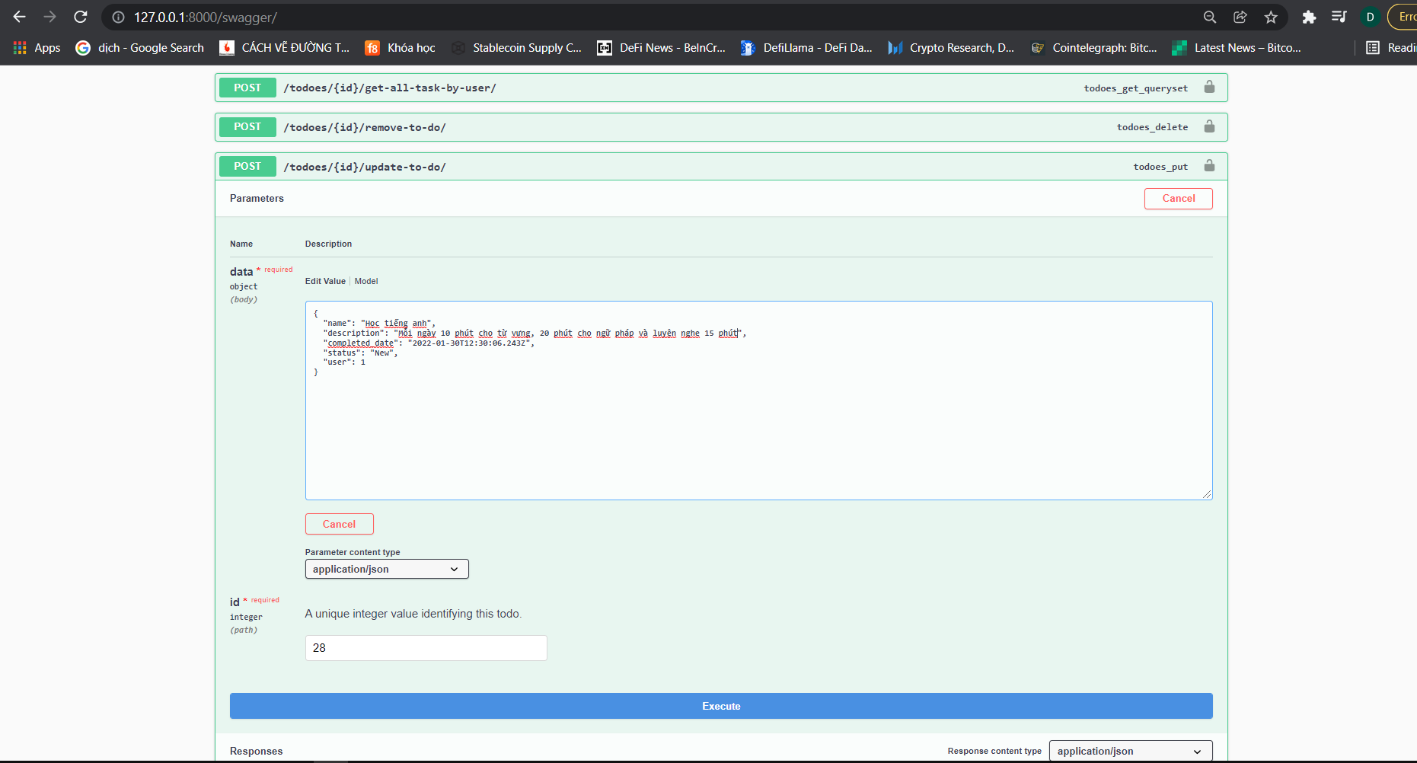

RESPONSE API4_UPDATE-TO-DO

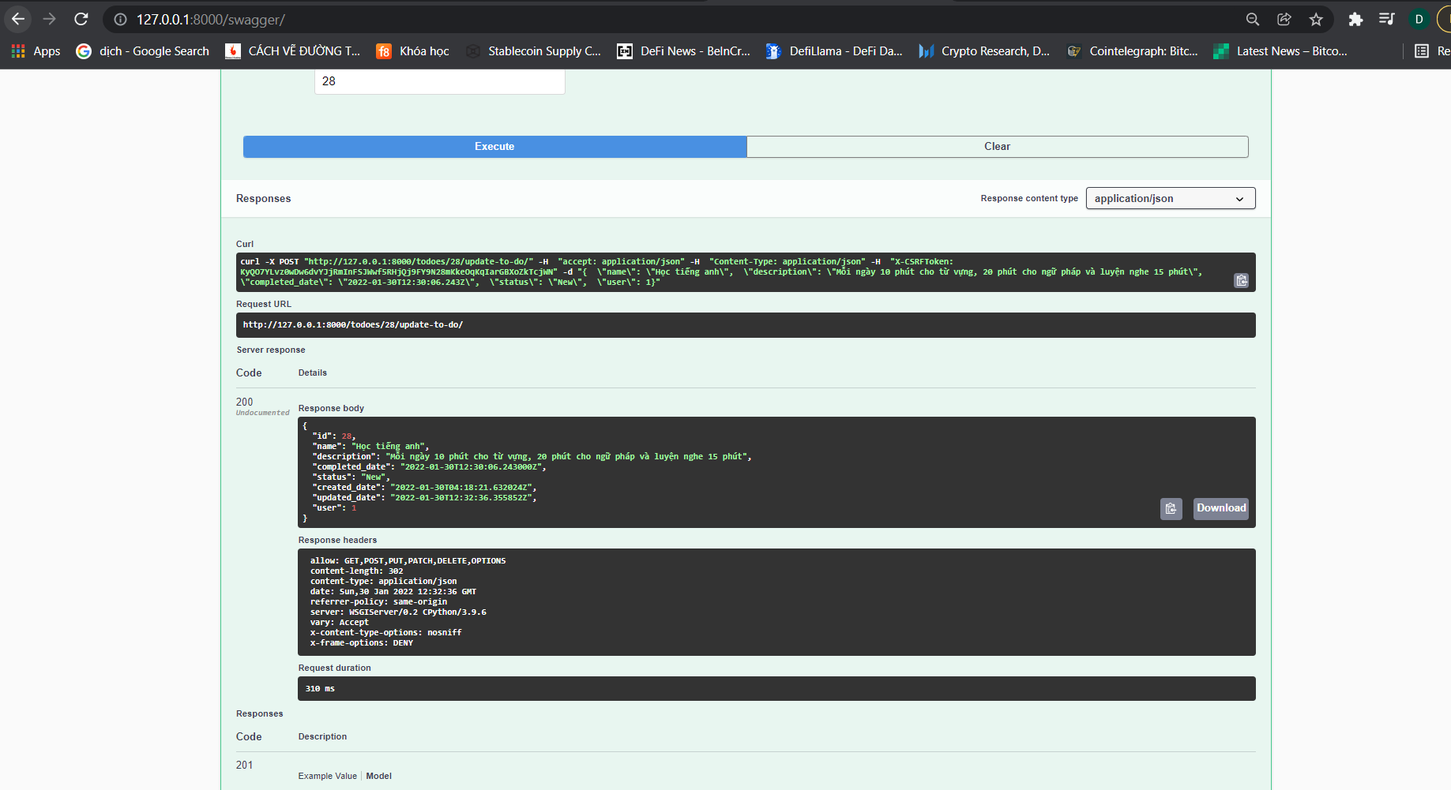

API5_REMOVE-TO-DO

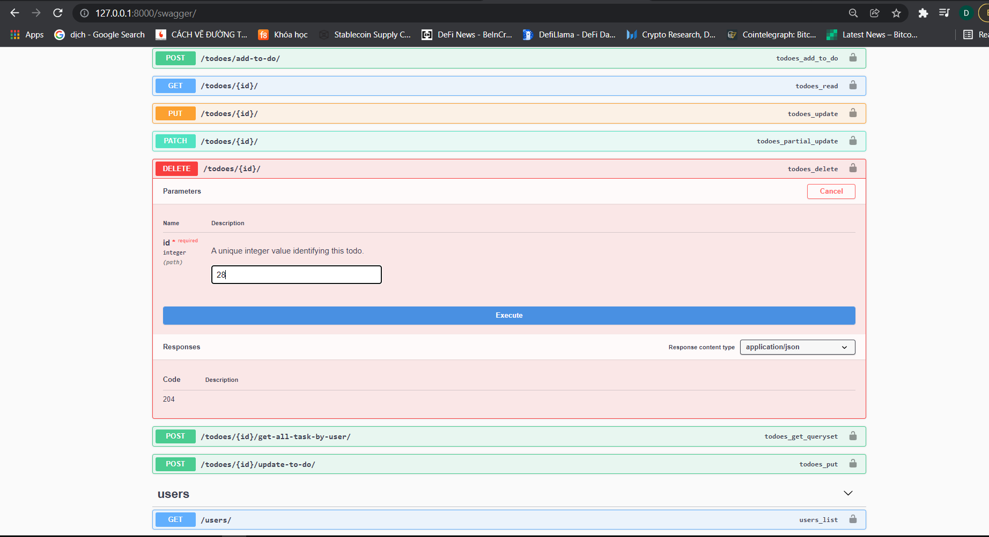

RESPONSE API5_REMOVE-TO-DO

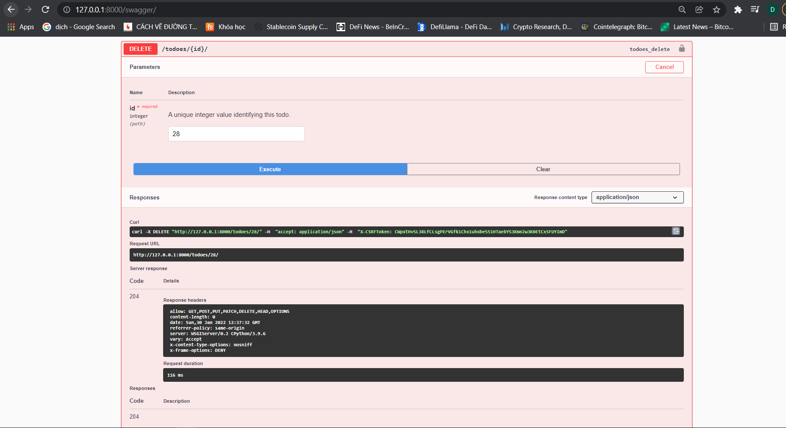

API6_GET-ALL-TO-DO

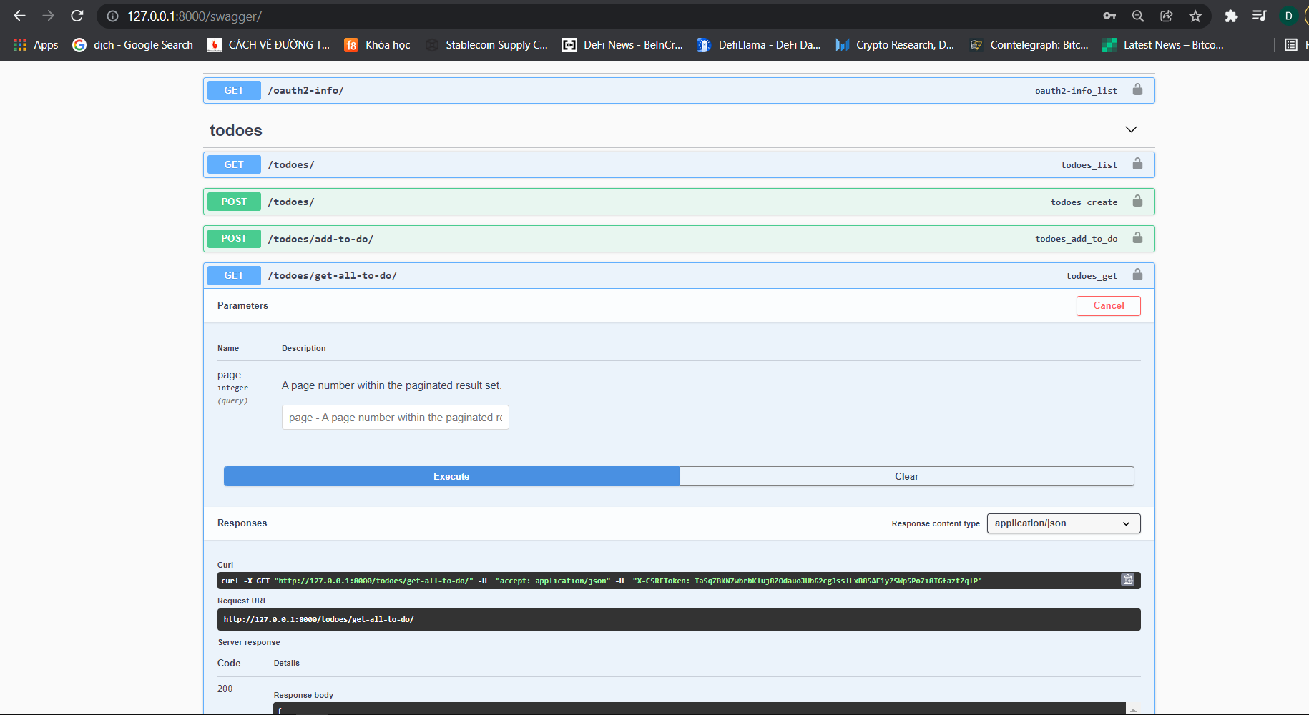

RESPONSE _API6_GET-ALL-TO-DO

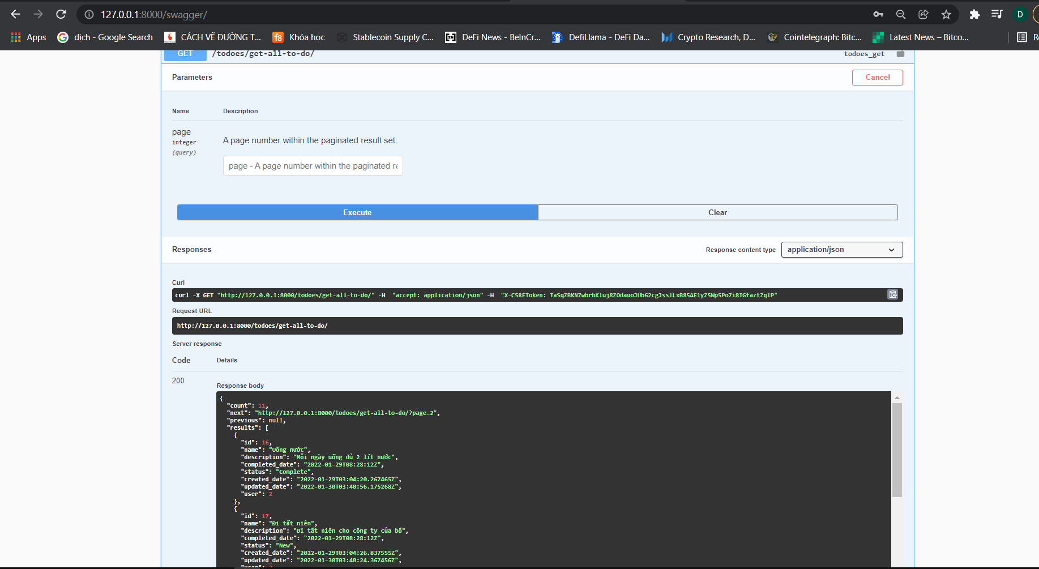

API7_GET-TO-DO-BY-ID

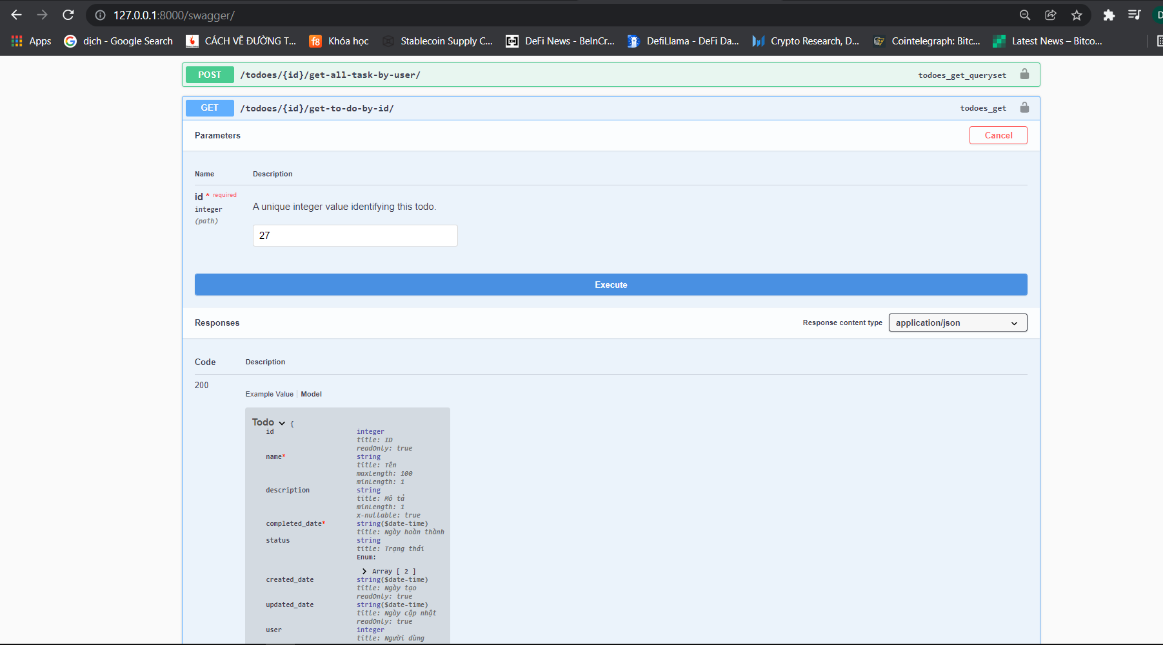

RESPONSE API7_GET-TO-DO-BY-ID

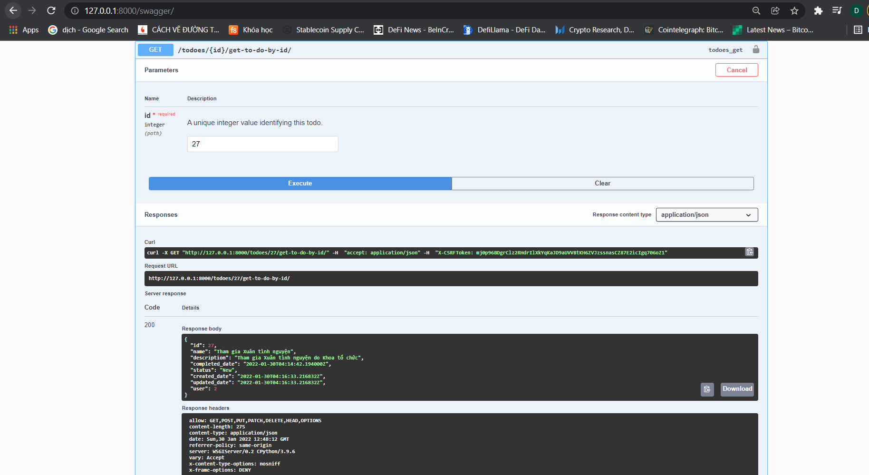

API8_GET-ALL_USER

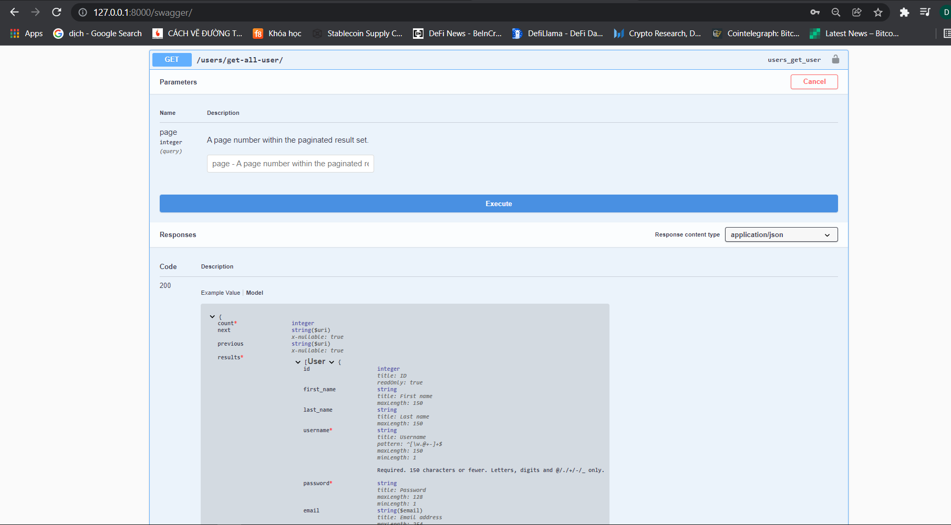

RESPONSE_API8_GET-ALL-USER

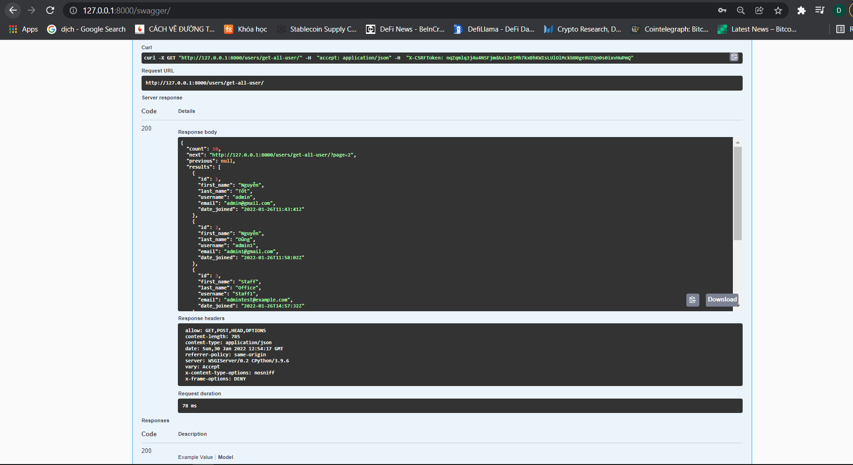

API10_GET-ALL-TASK-BY-USER

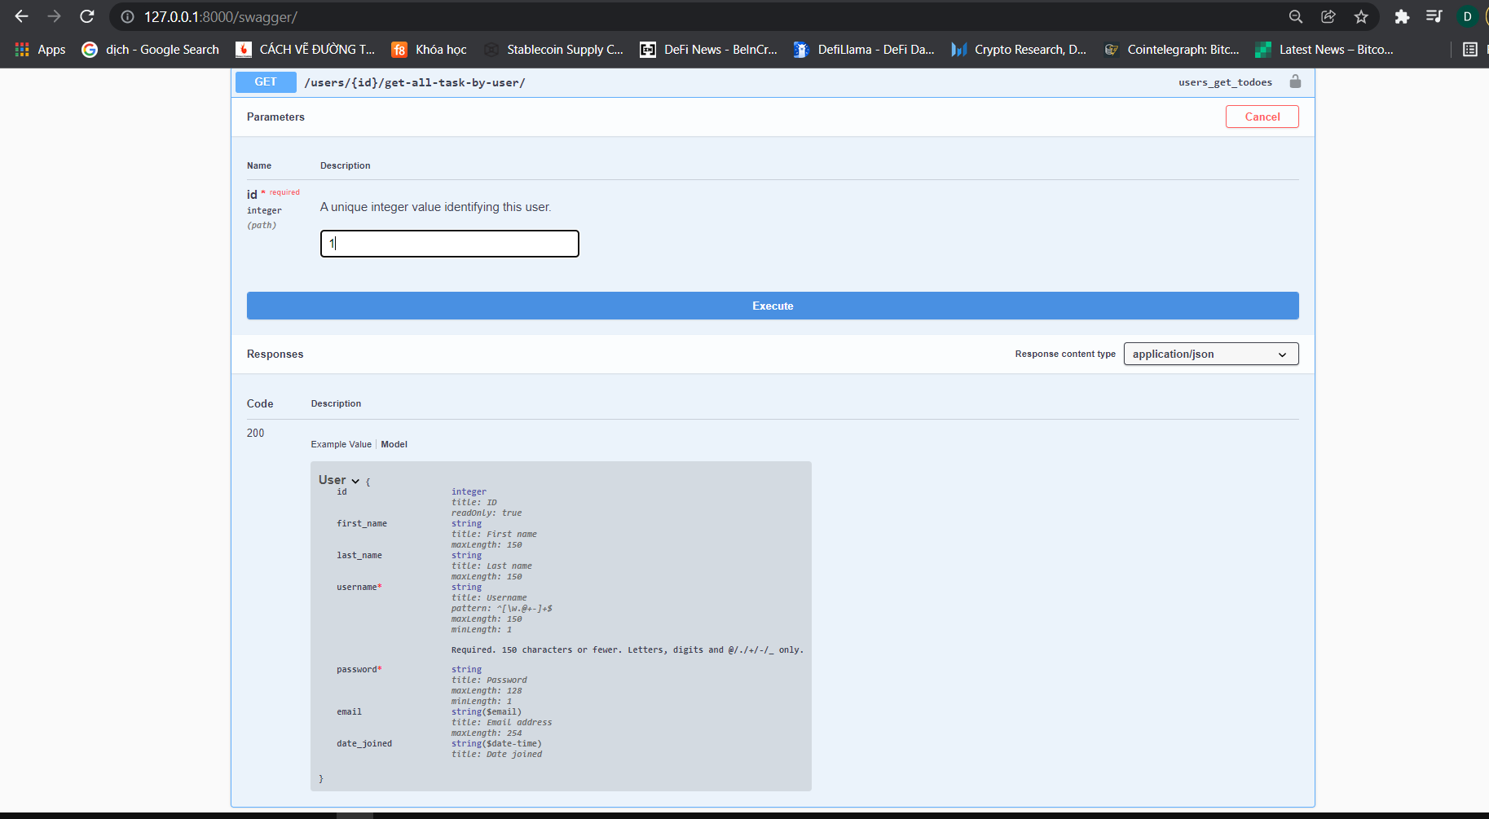

RESPONSE_API10_GET-ALL-TASK-BY-USER

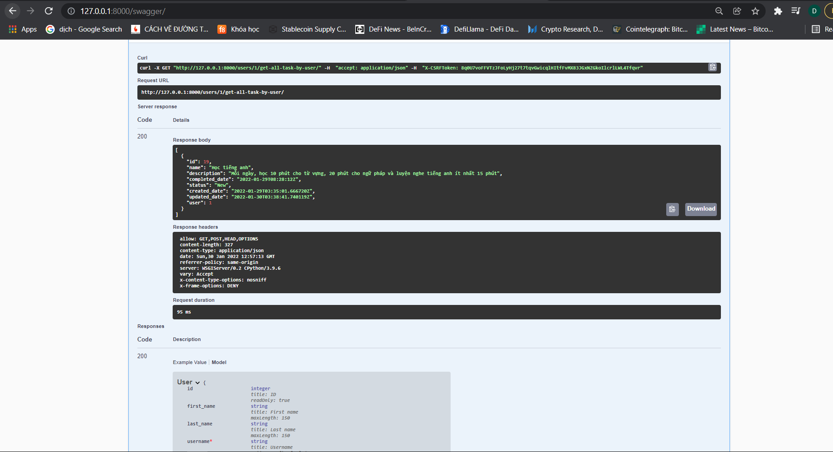

POSTMAN

GET CLIENT_ID, CLIENT-SECRET

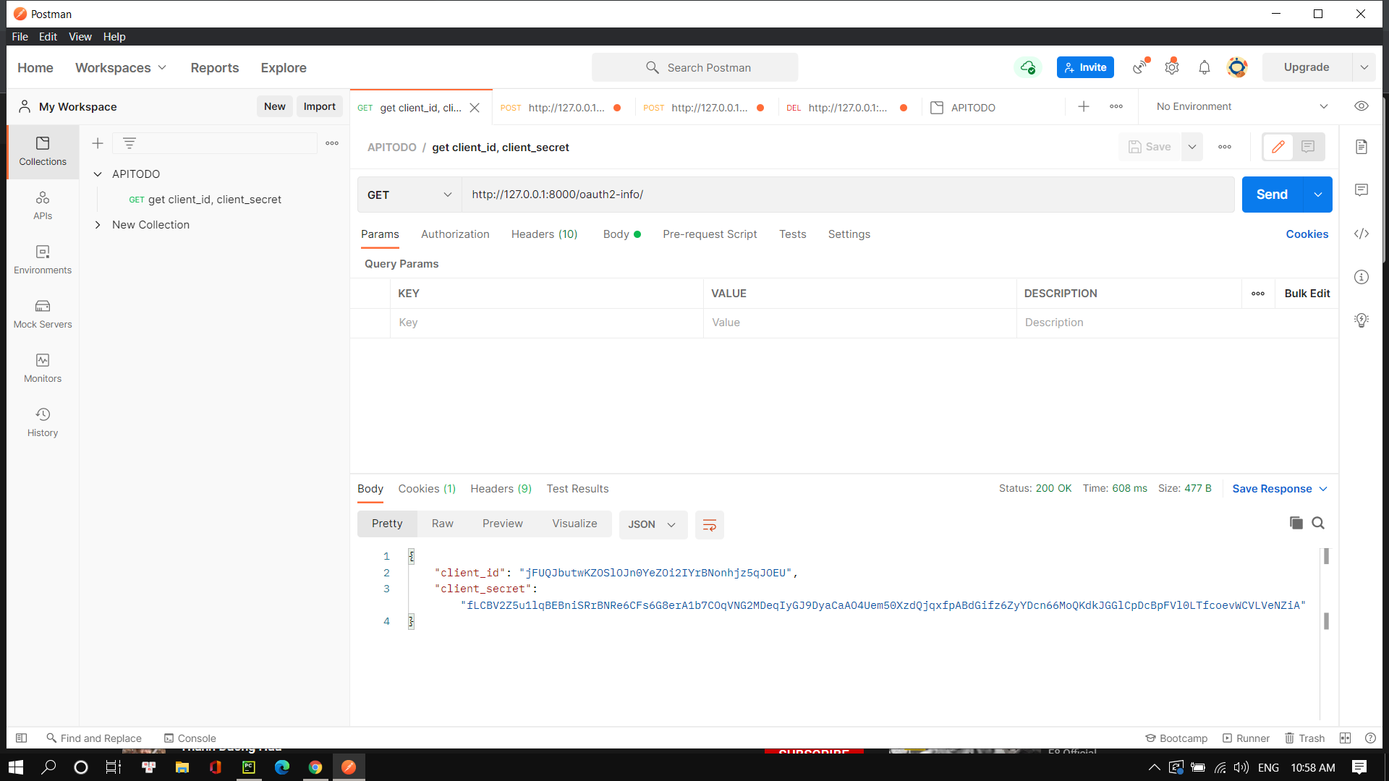

API SIGN-IN GET ACCESS TOKEN

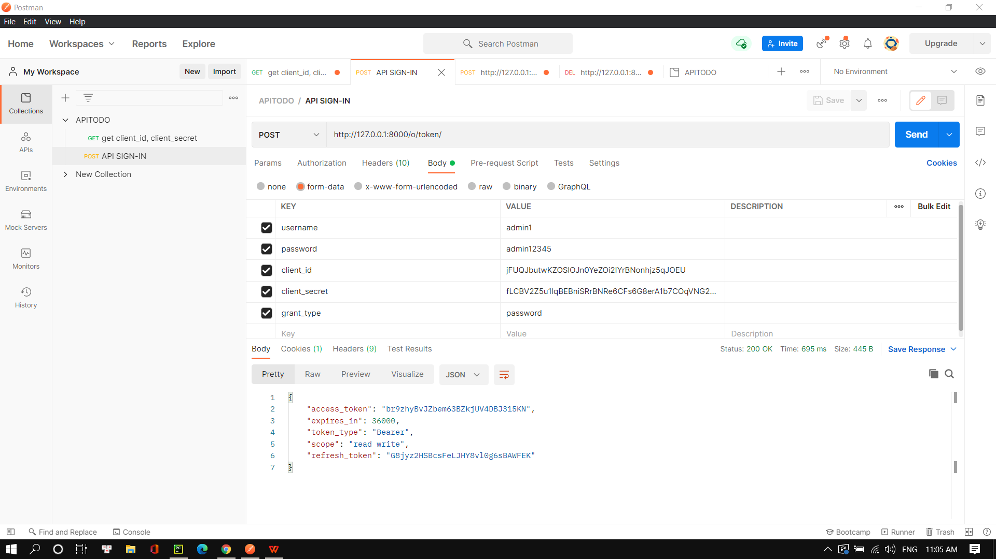

API SIGN_UP

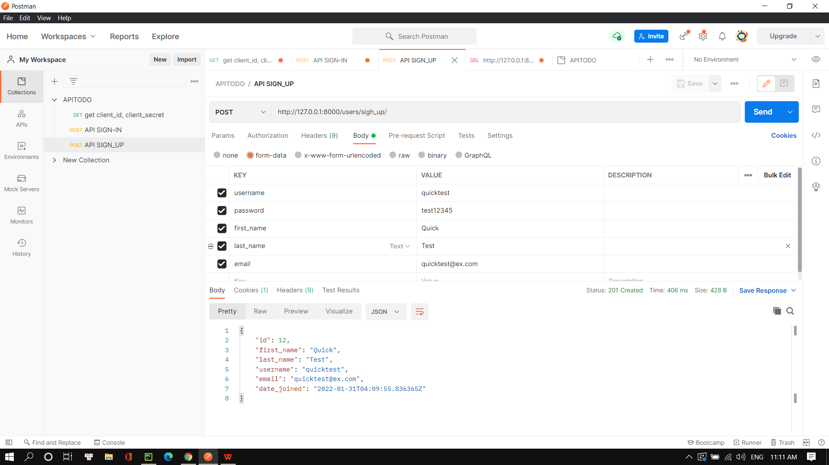

Với các API còn lại thêm vào Headers Authorization là access_token để chứng thực JWT

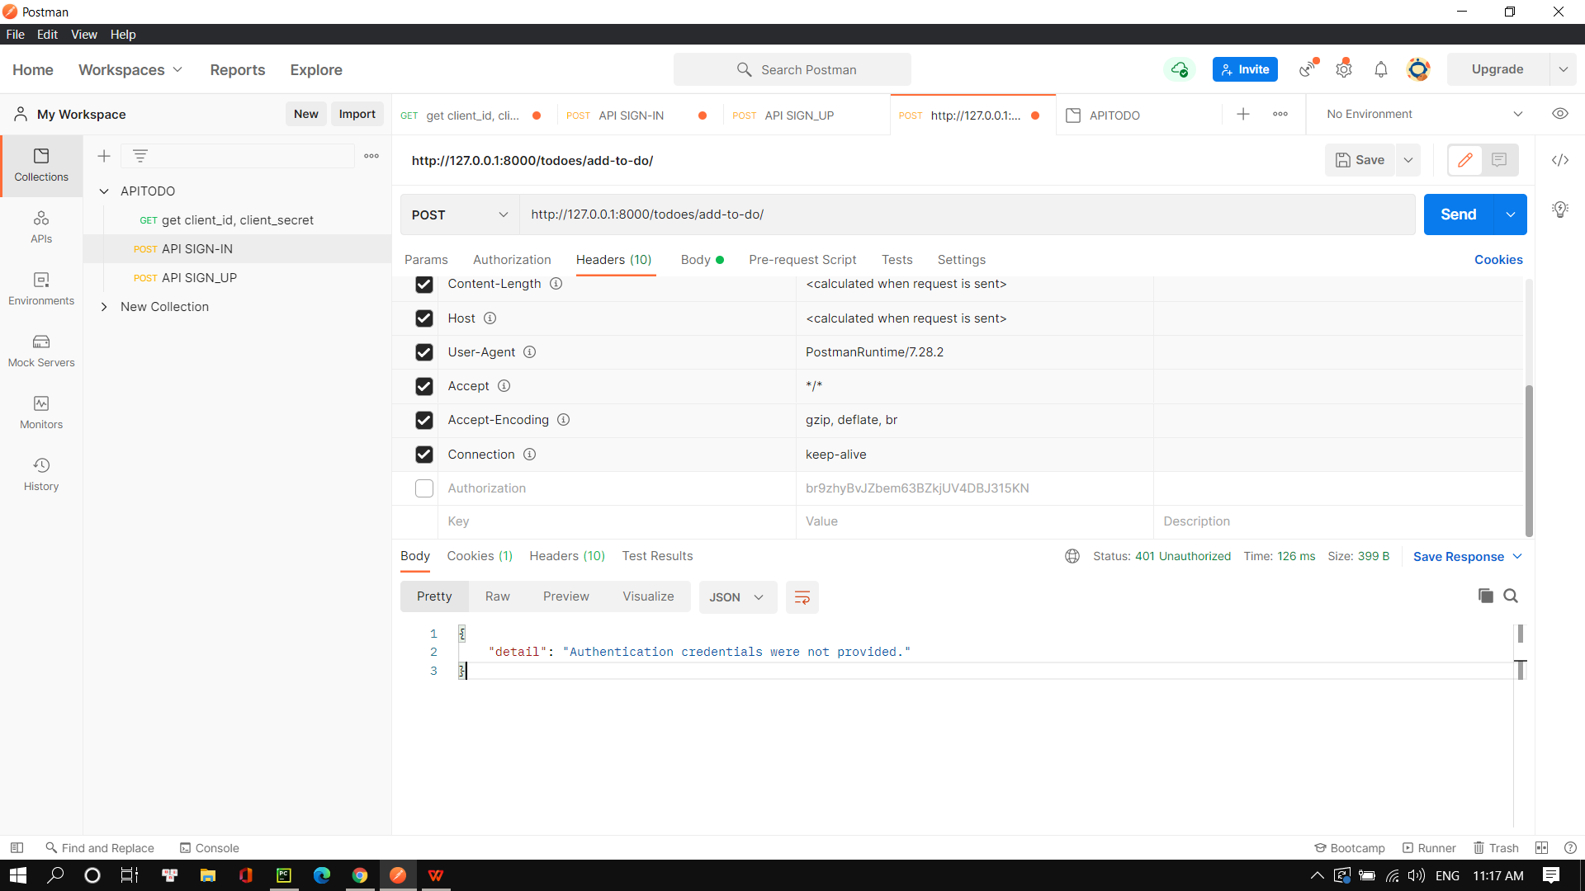

API3 ADD_TO_DO

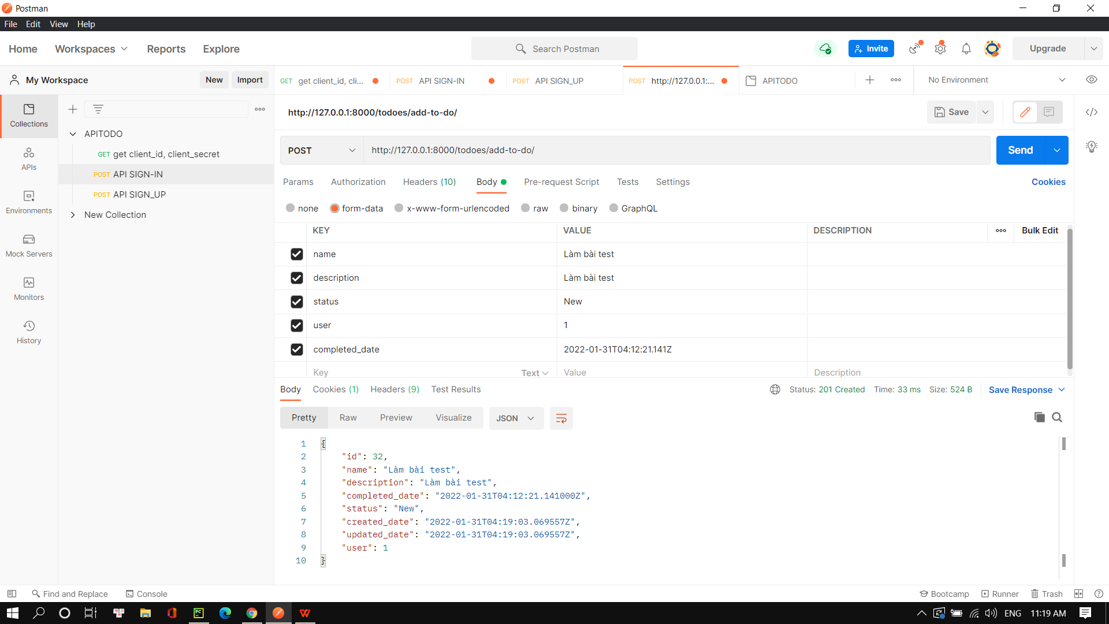

API4 UPDATE_TO_DO

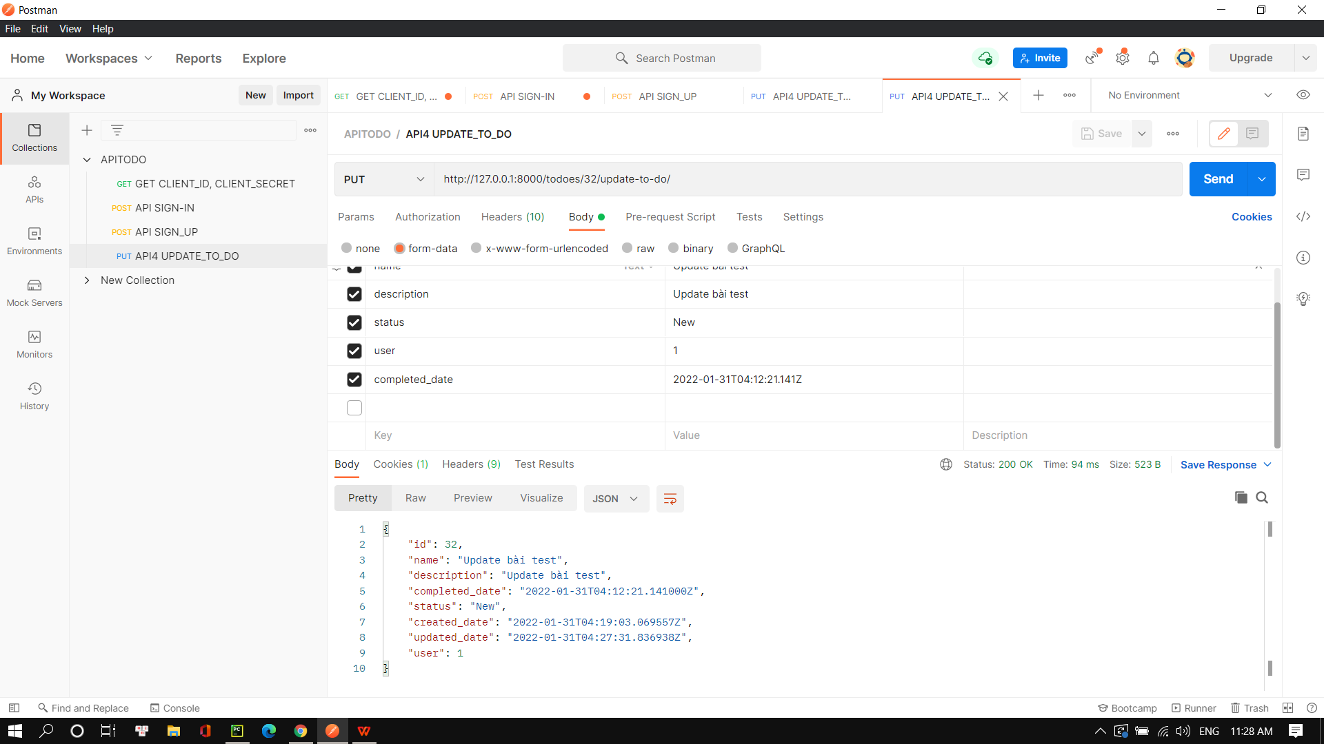

API5 REMOVE_TO_DO

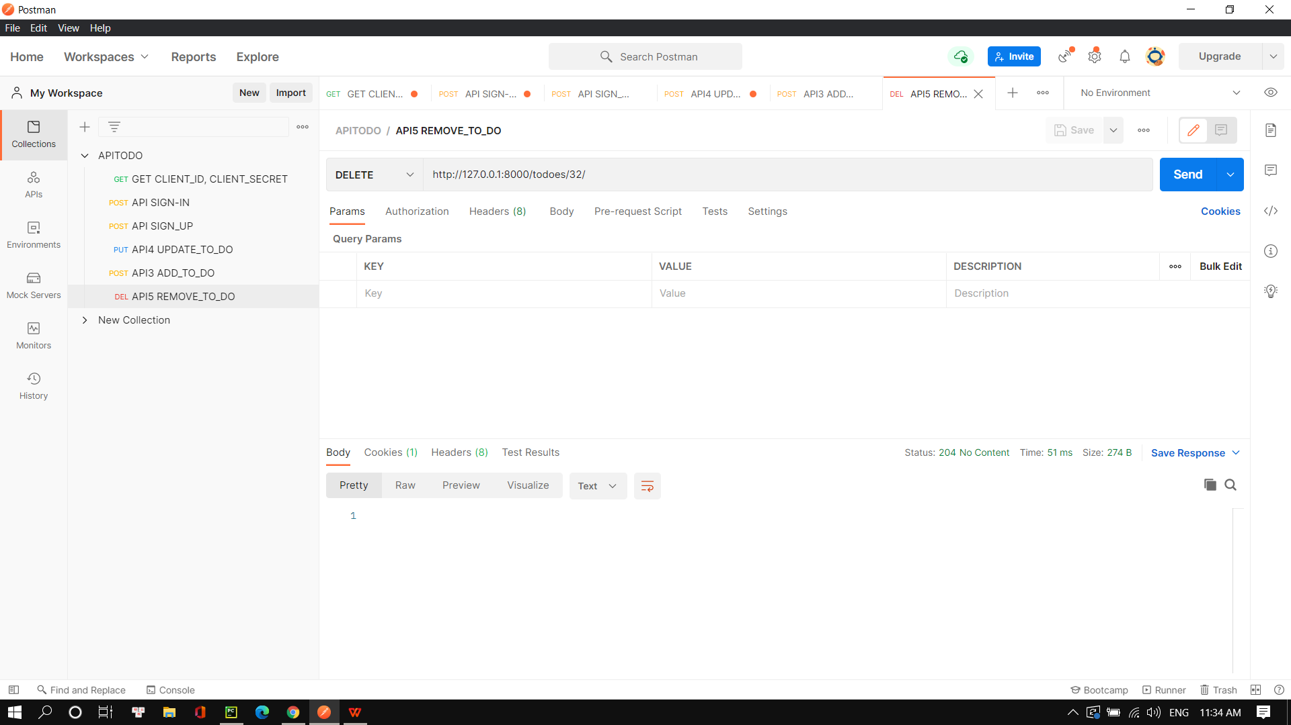

API6 GET_ALL_TO_DO

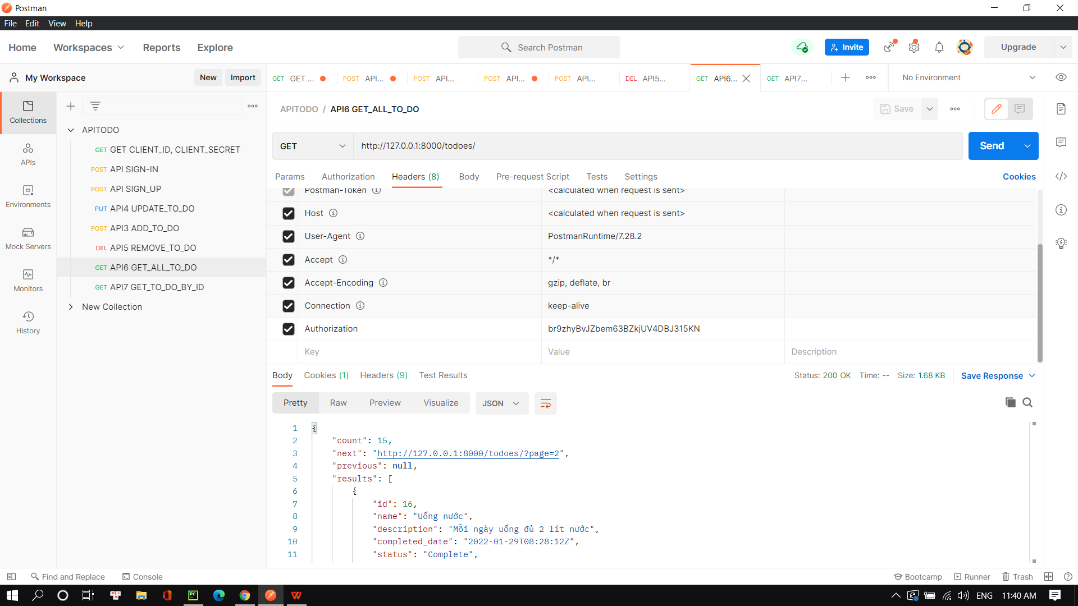

API7 GET_TO_DO_BY_ID

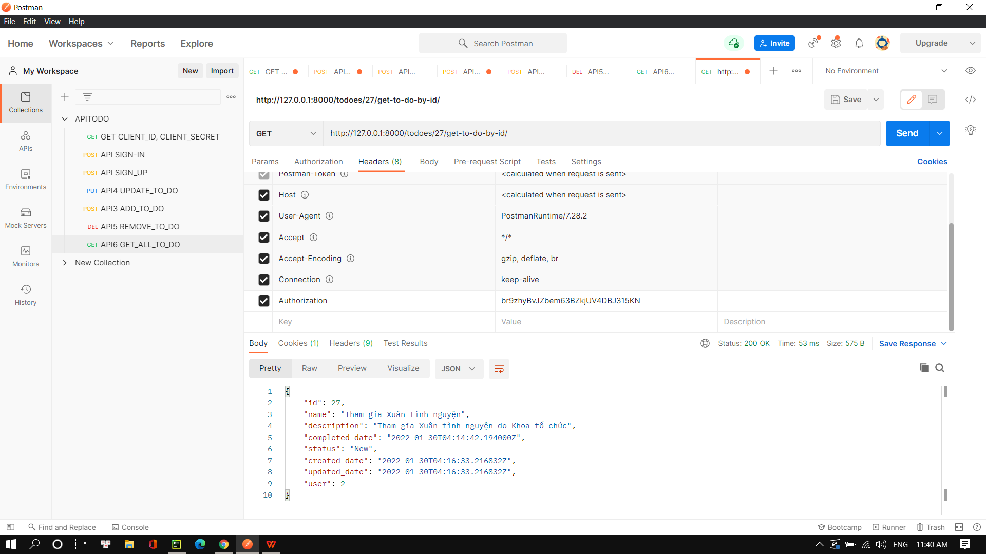

API8 GET_ALL_USER  
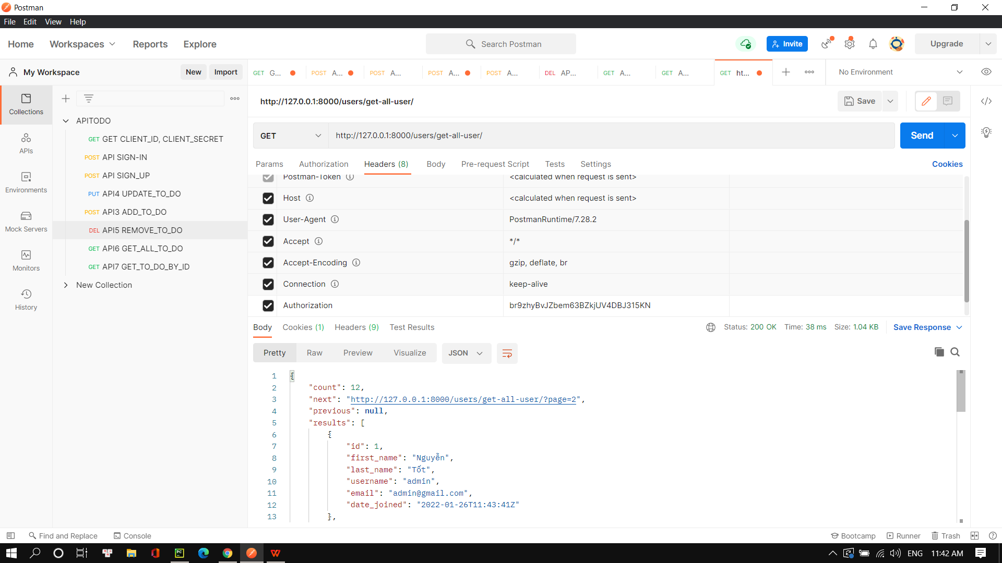

API10 GET-ALL-TASK-BY-USER

