Git exercises

1. create an account in GitHub
2. create a repository in github
3. choose your source code, change, and push to the repository
4. create new branch -> change something -> push to new branch
5. merge the branch to master branch
6. Set private/public for your repository
7. Remove your source code in local
8. clone source code from your repo in GitHub
9. Practice git command on local machine (add, commit, push, checkout, branch)  
     
   Note: screenshot your action and write them to MS Word
10. Create an account in GitHub

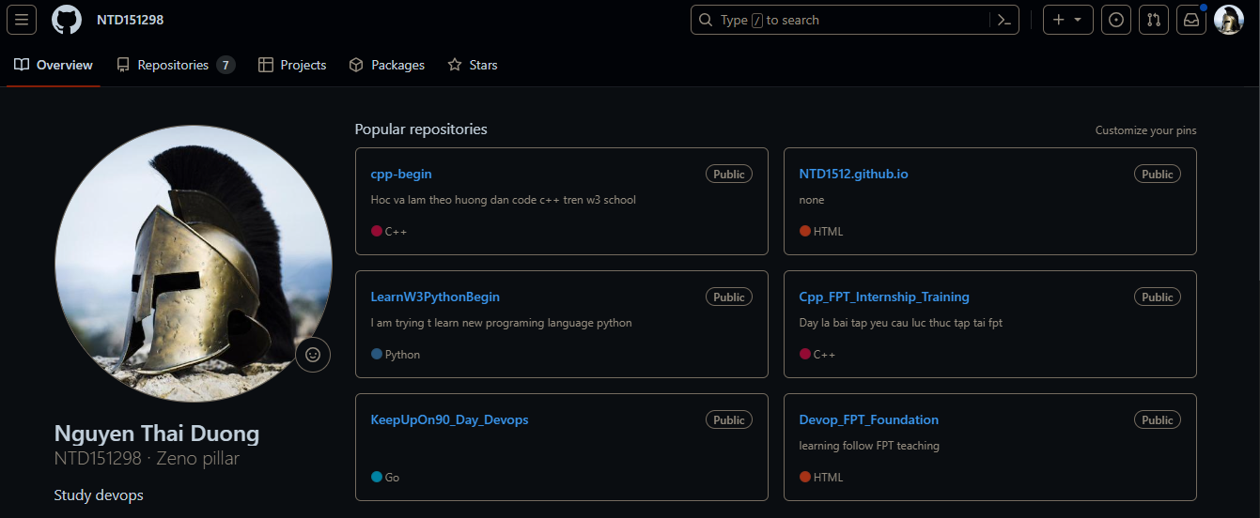

1. create a repository in github

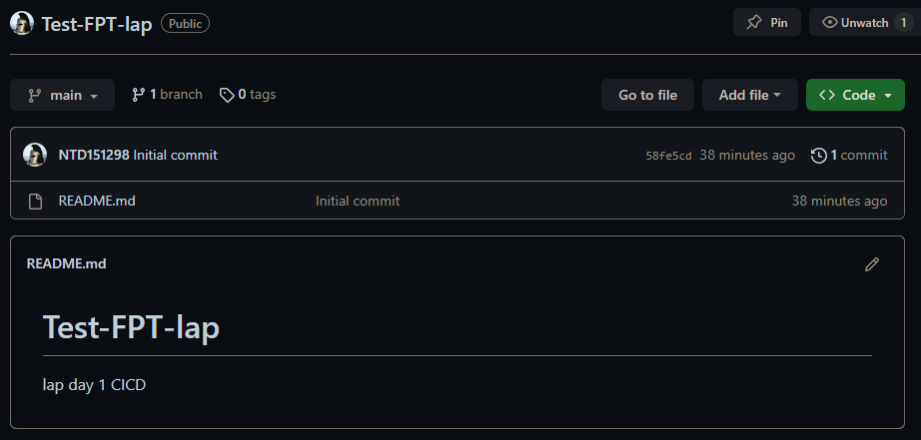

1. choose your source code, change, and push to the repository



1. create new branch -> change something -> push to new branch

create a new file (main.cpp)

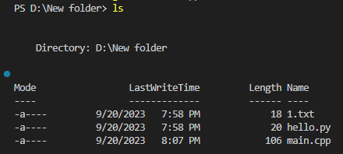 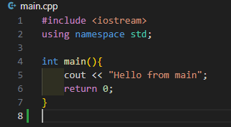

Create new branch main, add file to main, commit

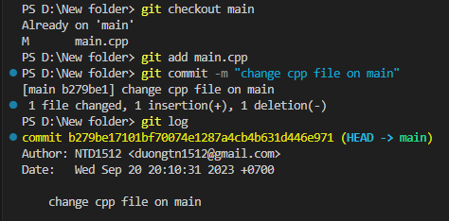

1. merge the branch to master branch

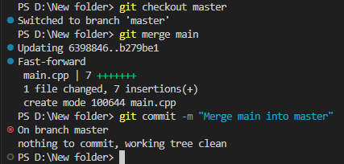

1. Set private/public for your repository

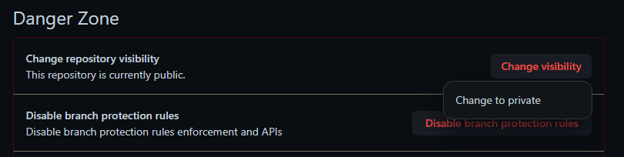

We pick public (at setting repo github) at the end of the setting page

1. Remove your source code in local

Fist we push all of our current file to our newest created github repo



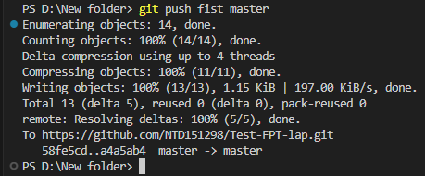

Then we delete every thing we created



1. clone source code from your repo in GitHub

At our master branch on github repo

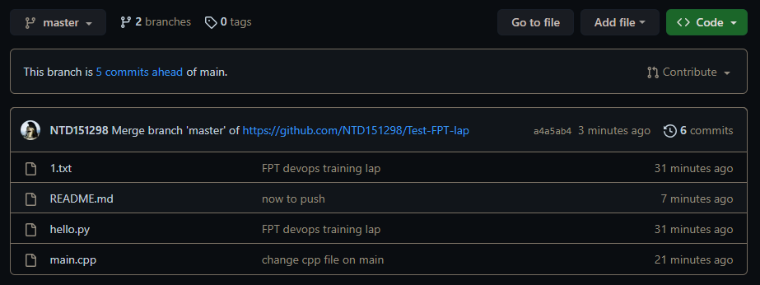

We do command git clone (github repo url)

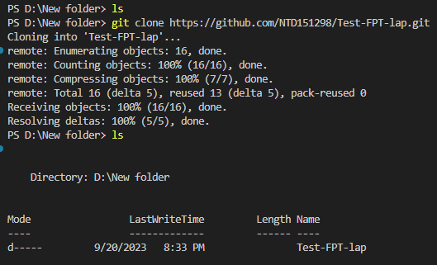

Check file on master

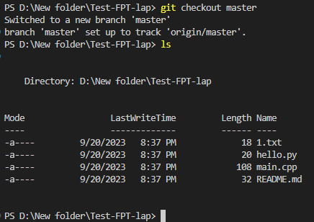

Check file on main

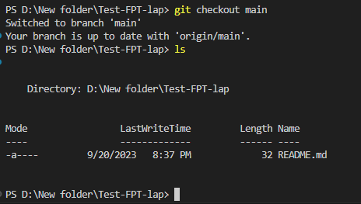

Practice git command on local machine (add, commit, push, checkout, branch)