Nguyễn Thái Dương Day 2 exerise:

Task 1: Create a Dockerfile for a Python application that prints a message.
Build the image and run a container from it.
Task 2: Build an image with multiple tags and push it to Docker Hub.
( I do fist 2 task in 1 run )
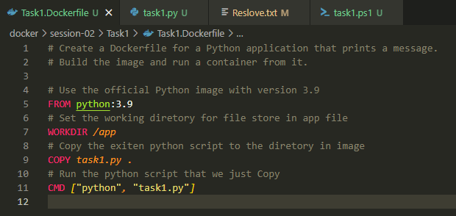
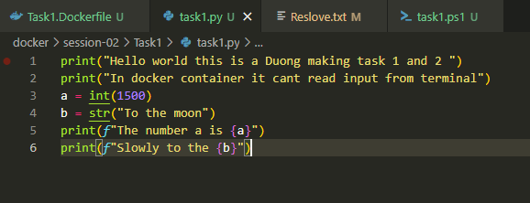
Powershell script to auto muti tag, build, push, run and login Docker
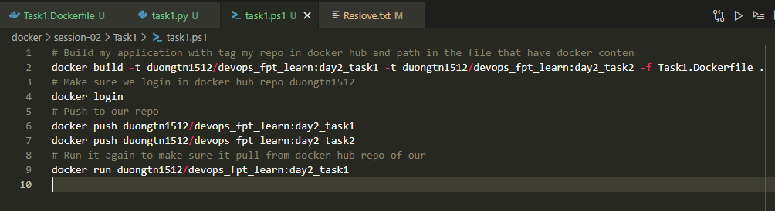

Run the script and get result printed on terminal
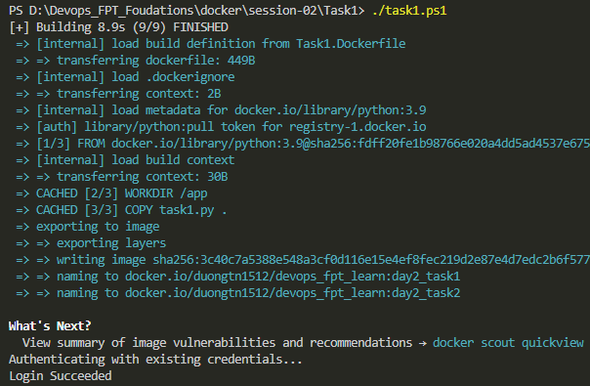
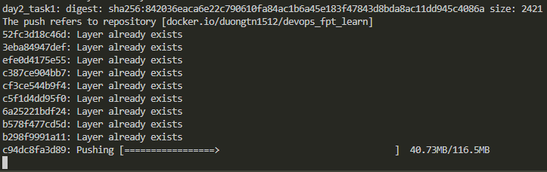
Success login docker hub, build many tag docker images, push it to repo and run a image
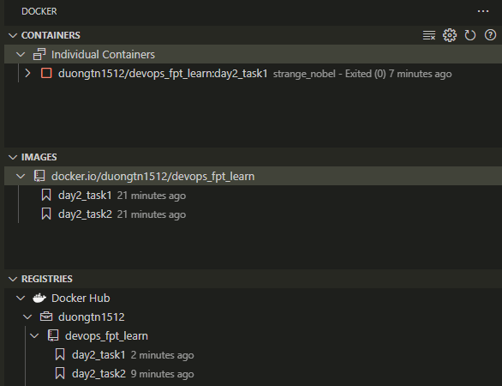
Log from container
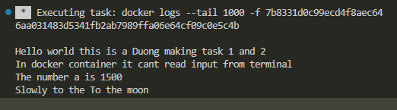
Output of python code I make it into a docker image then run it in a container day2_task1
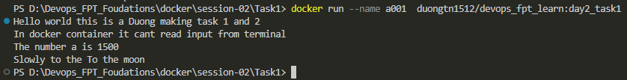

Task 3: Create a multi-stage Dockerfile for a Node.js app. Build the app and copy only the necessary files to the final image.
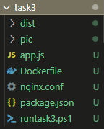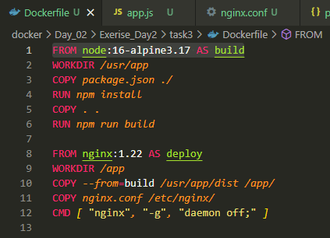
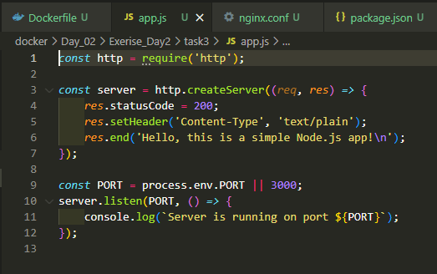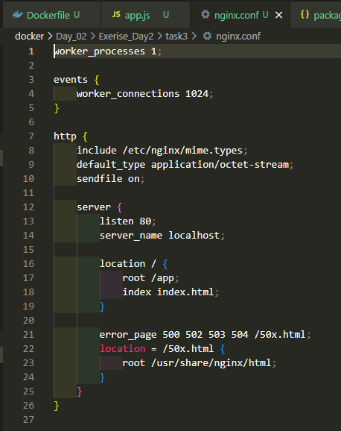
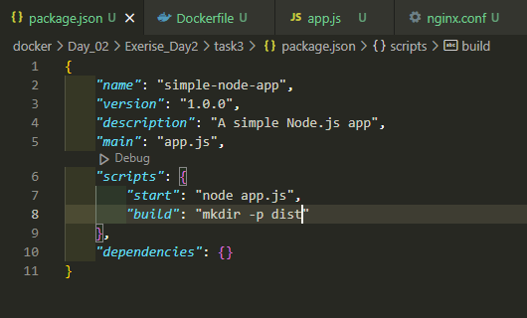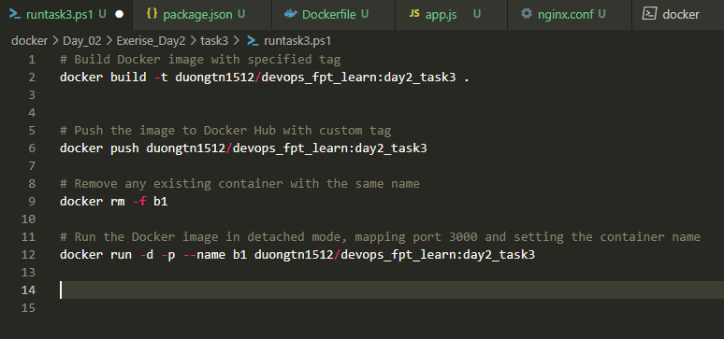
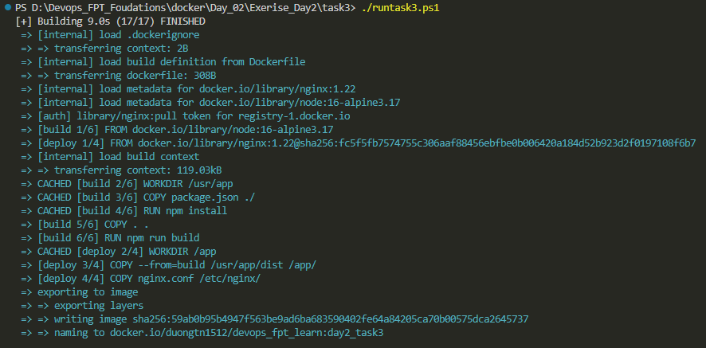
End result we enter the container, list the files in app and curl localhost:80
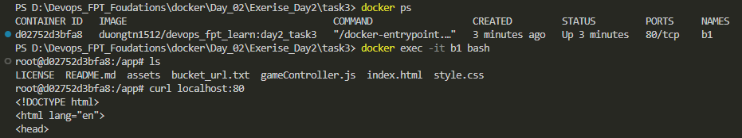

Task 4: Push an image you've created to your Docker Hub repository. Then, pull it to a different machine and run a container.
Create an ec2 aws instance
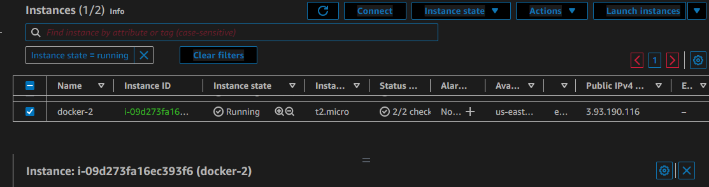
Connect to ec2 via SSH from vs code
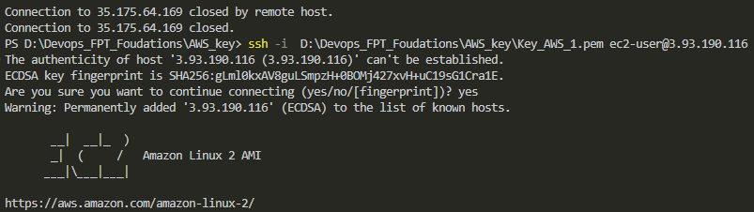
Check images on docker hub repo
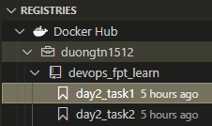
Install docker on cenos and check for status
sudo yum update -y
sudo amazon-linux-extras install docker
sudo service docker start
sudo systemctl enable docker
sudo usermod -a -G docker ec2-user
docker info

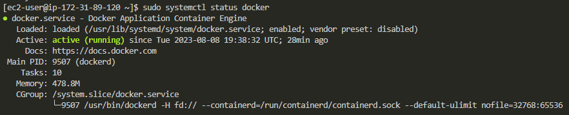
Docker login to docker hub repo
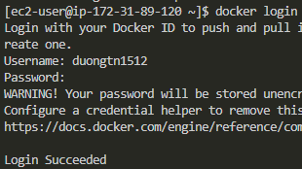
Pull a image and run ( Docker Image is Python base image with code wirted on Task 1 )
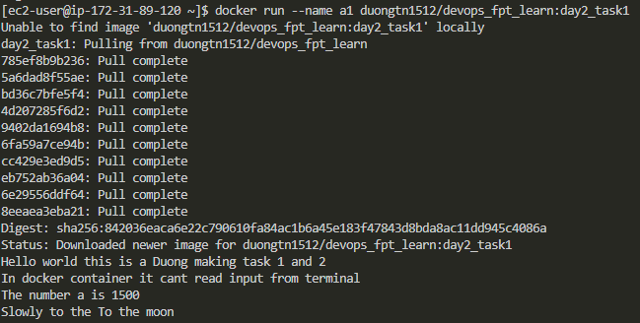
Check docker contaner on this EC2 machine

