Nguyễn Thái Dương – duongtn1512@gmail.com
Exerise day 4

Task 1: Create a named volume called "data_volume" and mount it to a container. Verify that data is persisted even after the container is removed.
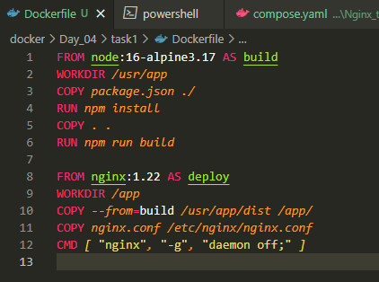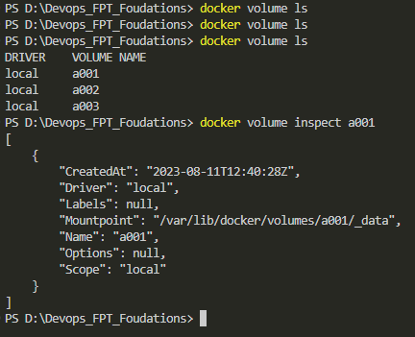
Using dockerfile we create image duongtn1512/devops_fpt_learn:day2_task3 and use volume a001
From docker compose we mount a001 to new image we created and name container bb1
The file in dist folder will get put into folder app in container bb1 folow docker file in deploy stage
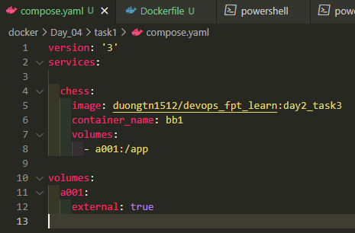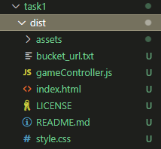
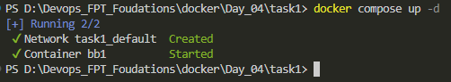 The file in app folder will get mount to storage a001
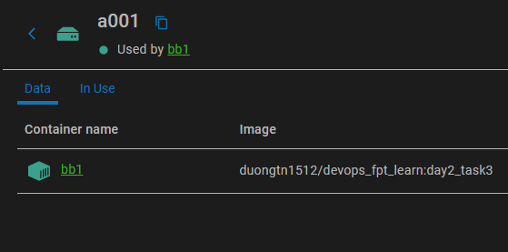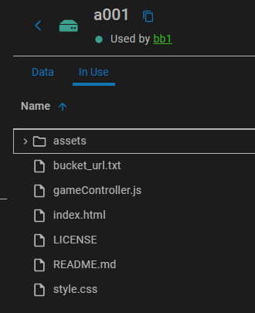
We delete container bb1
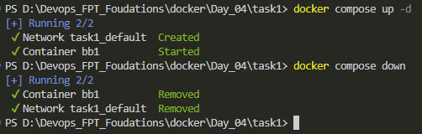
And then we check data in storage a001 when not in use by any docker containers
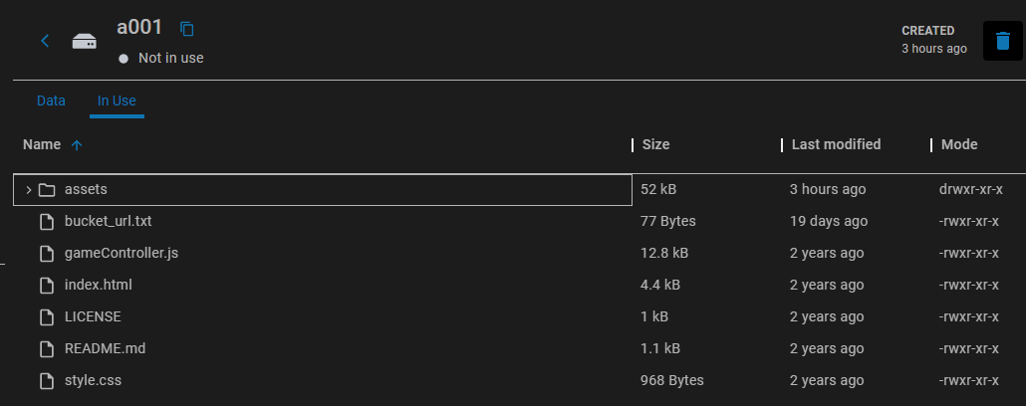
Its still here.

Task 2: Mount a directory from your host machine to a container using a bind mount. Modify files from both the host and the container to observe changes.
Prepare Directory and Files:
With host folder is task2_host_floder and host file is host_file.txt
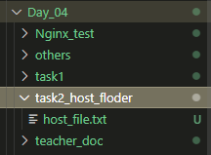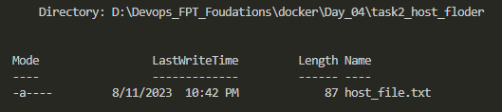
Data in file host_file.txt
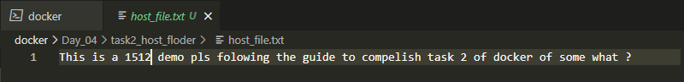
Create an contaner name cc1 with bind mount task2_host_floder to it contaner path /app:
docker run -it --name cc1 -v D:\Devops_FPT_Foudations\docker\Day_04\task2_host_floder:/app nginx bash
We then enter container and check for the file host_file.txt
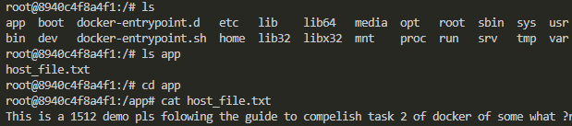
We had success bring file from windows host to docker nginx container
Modify from Host
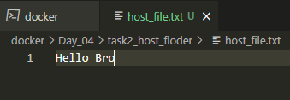
And then we enter container to see if it change the txt file
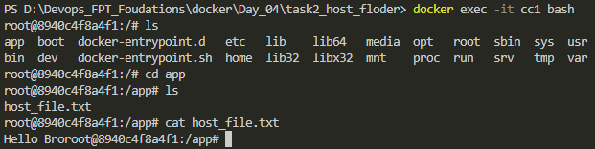
Yes it dose change the data in host_file.txt
Modify from Container
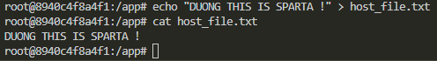
And in the host is changed
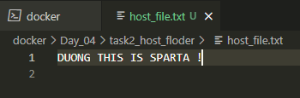
So both ways are ok and can make change to the file its bind mouth
Task 3: Use the docker volume inspect command to view metadata and configuration details of a volume.
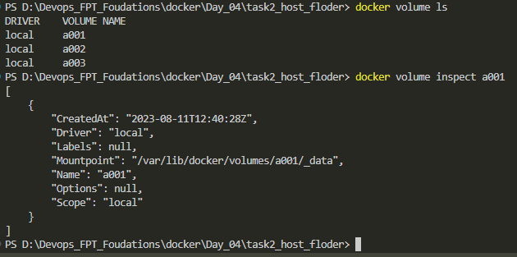
Task 4: Identify and remove volumes that are no longer in use to free up storage space.
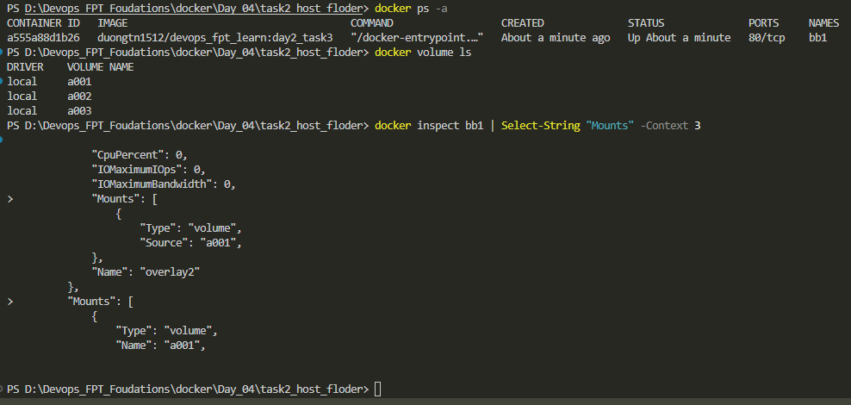
So from the image I get, I belive that only volume a001 in used with container bb1
We rm volume a002 and a003 because it not in use
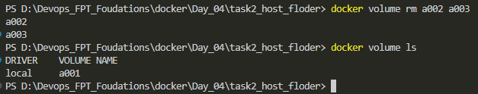

Task 5: Backup the contents of a volume to your local machine and then restore it to a new volume.
Fist we use volume a001 created before in task 1
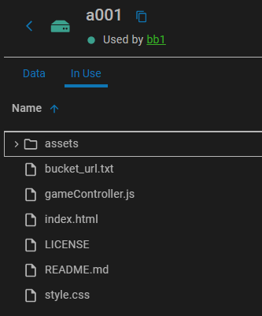We use this comand too backup at host windows
docker run --rm -v a001:/data -v C:\local\backup\path:/backup nginx tar cvf /backup/backup.tar /data
Check path we backup data C:\local\backup\path using ls command
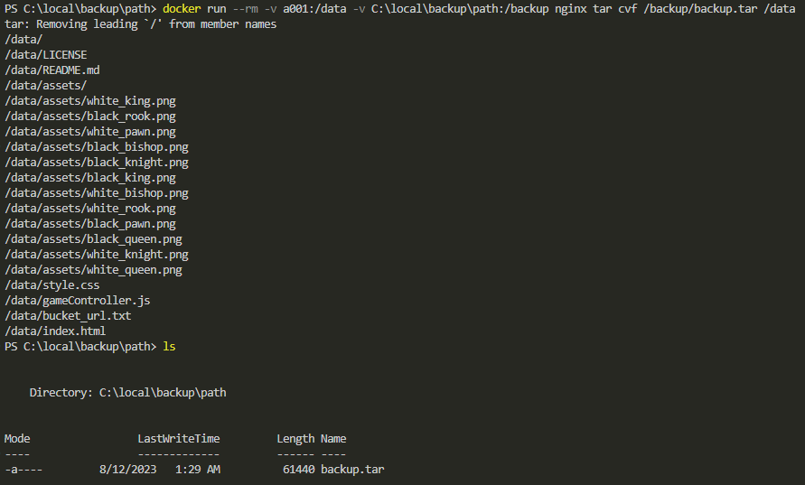
As we can see we have store volume a001 data to file backup.tar at C:\local\backup\path
For the restore the data to another volume, we create a new volume and bring data to that volume
docker volume create a002
docker run --rm -v a002:/data -v C:\local\backup\path:/backup nginx tar xvf /backup/backup.tar -C /data
We inspect the data from docker desktop
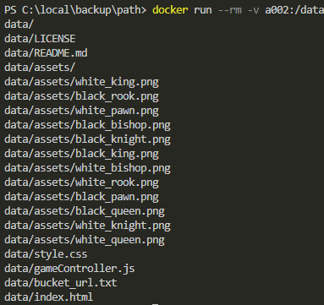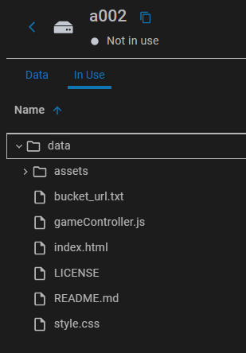

Task 6: Create a container with a tmpfs mount to store temporary data in memory. Observe how the data is lost when the container stops.
We create a nginx container temporary mount it at path /data inside container using this command
docker run -itd --mount type=tmpfs,target=/data nginx
We make a test.txt file echo in it “Hello, temporary data!” and save file within peaceful_kalam
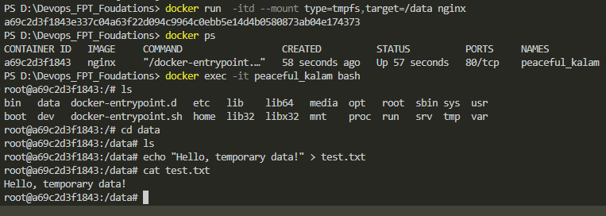
Using same command we create another container with docker name it thirsty_nightingale
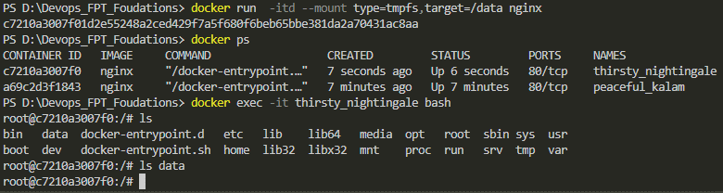
As you see we enter container with same type of tmpfs mount and in data folder there is no test.txt
We stop container peaceful_kalam and restart it again
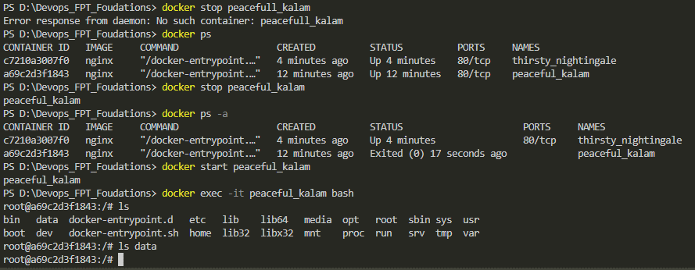
And then enter container, the file test.txt we make has alredy gone. This is how tmpfs mount work

Task 7: Write a docker-compose.yml file that defines a service using volumes, then launch multiple containers to share data.
Fist off we will use volume a001 to use with multiple container that will share eachother same data

Here is a docker compose file that will make 3 nginx container with it data will be take from volume a001 and then store in /usr/share/nginx/html folder inside container to make an frontend web
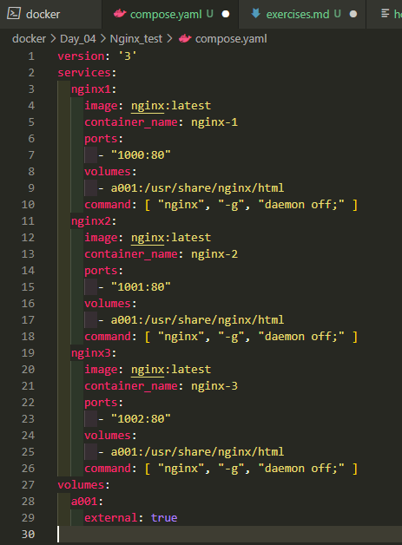
We docker compose up -d to make them run and curl each of nginx port to see result
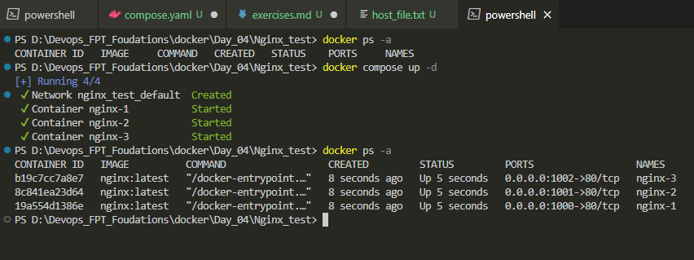
So all 3 port take same resource from volume a001 to make web chess game and expose to port
Localhost: 1000, 1001, 1002
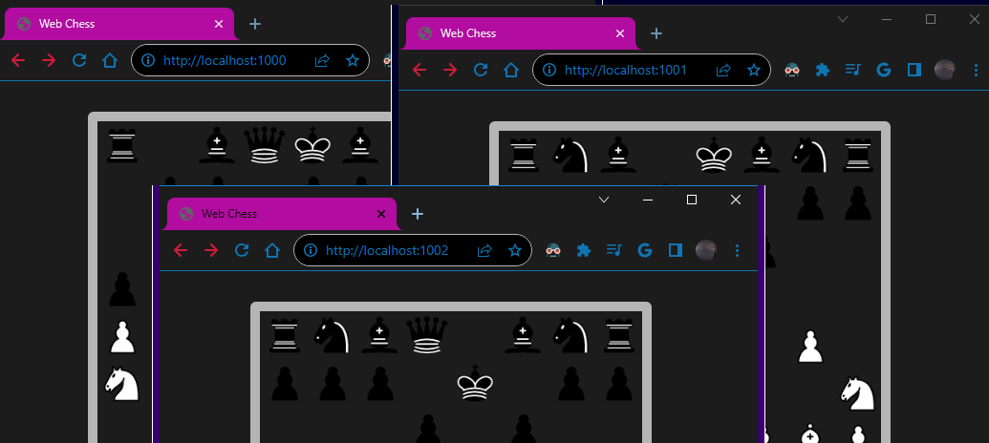

Task 8: Launch a container that uses multiple volumes for different parts of its filesystem.
We will use 2 volume a001 and a002 with them own distinctive data
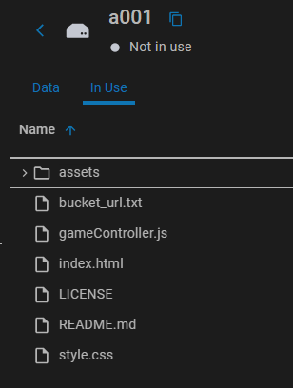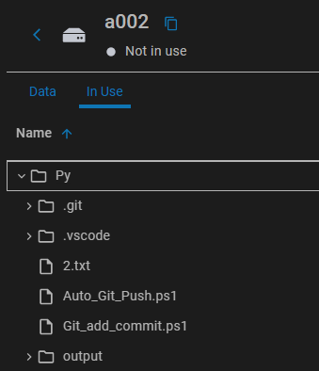We then run
docker run -d --name multi_nginx -v a001:/app1 -v a002:/app2 nginx
This command line will fist pull and run image nginx:latest to a container name multi_nginx and attach data from volume a001 to app1 folder in container, so on with data from a002 to app2 floder
We then enter container and check if the data from volume a001 and a002 has successfully deploy inside container multi_nginx folder app1, app2.
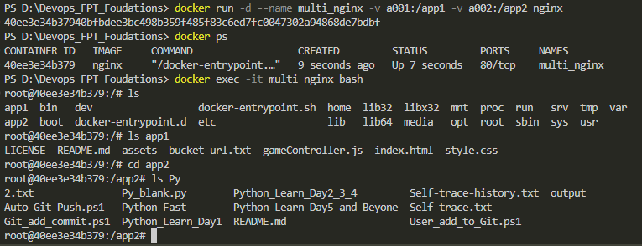

Task 9: Create two containers, migrate data from one to the other using volumes, and ensure minimal downtime.
I got an idea will moutn data from container 1 to volume a003, copy a003 data to host and to 2
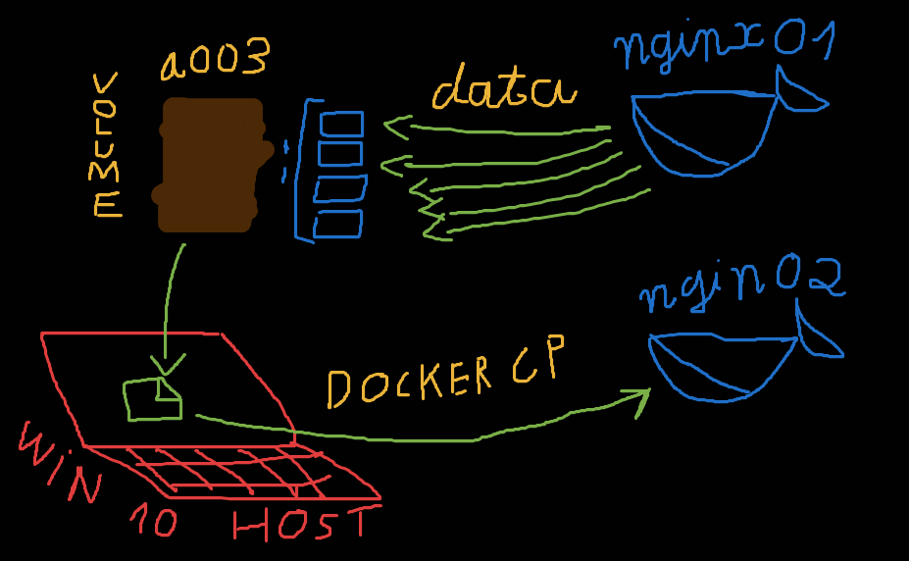
We wirte an automation script to auto run migrate data from container 1 to container 2
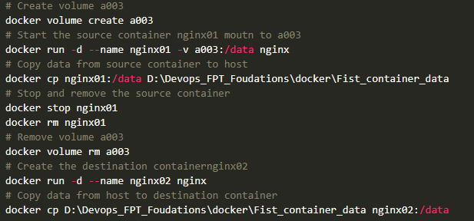
This is ther result of the script and we also docker ps to sure only nginx02 is run and nginx01 is rm
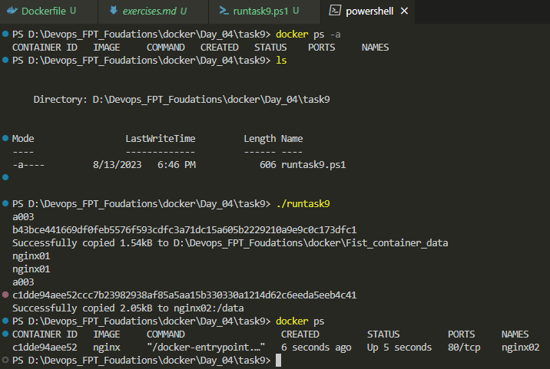
We get into nginx02 to sure data is migrate
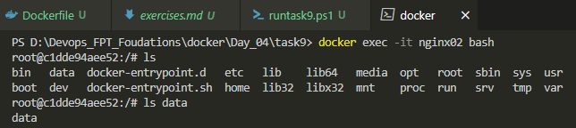

Task 10: Launch multiple instances of a container and share data using the same volume between them.
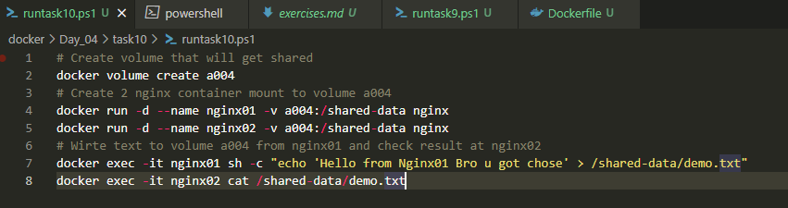
We make volume a004 and shared it with 2 continer nginx01 and nginx02
We run the script to auto report us if we have success share data using the volume a004
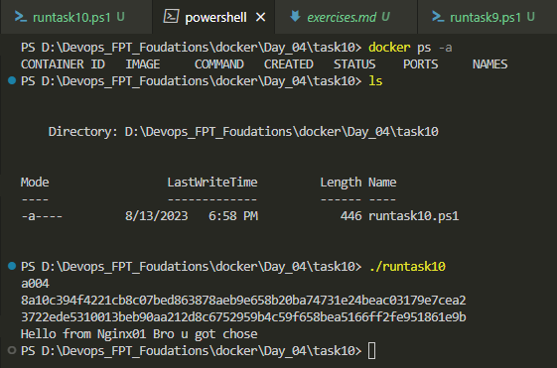
As nginx02 cat out text we make from nginx01 to volume a004 I said we has finish task 10

