Nguyễn Thái Dương Day 3 exerise:

Task: create a docker compose file that run 2 container in a same network then try to check connection within that network using container dns
Here is that file docker compose and file env that docker compose will use to run
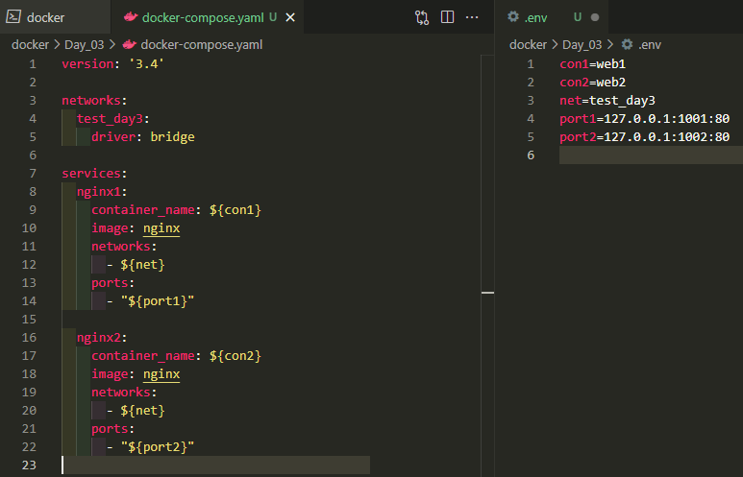
This is terminal result after we enter command “docker compose up -d” at wor dir
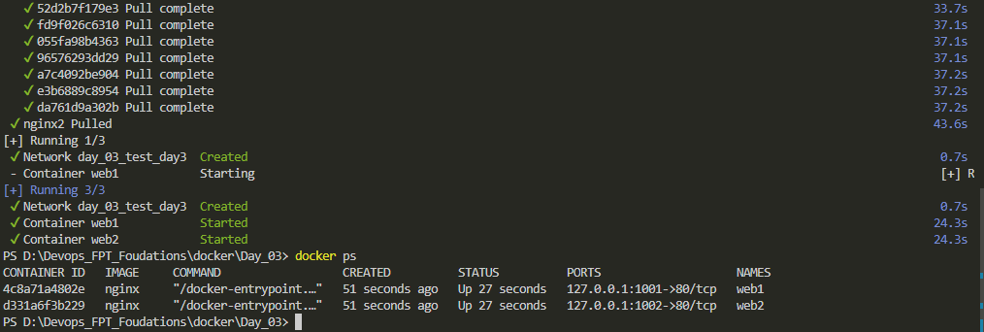
Folow the docker ps we run nginx with name web1 and web2 on localhost:1001 and localhost:1002
We have success pull and run nginx as container name web1 and web2 on port 1001 and 1002
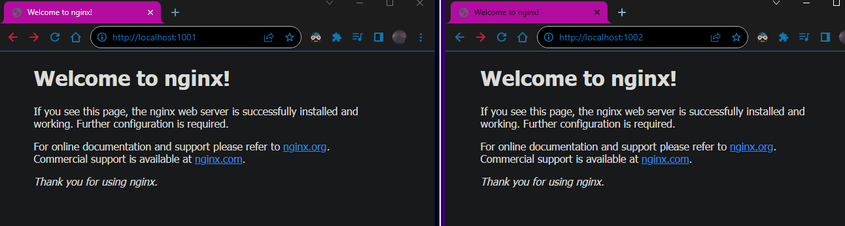
Now we check for web1 and web2 network
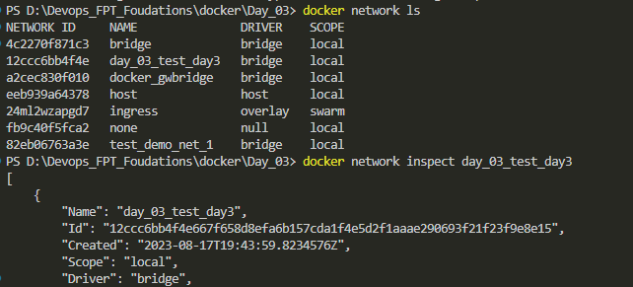
Our network named day_03_test_day3
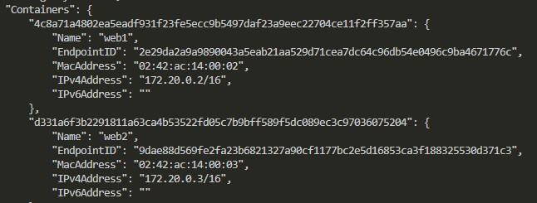
With docker network inspect we find out ip of web1 within docker network is 172.20.0.2 and web2 ip is 172.20.0.3
We enter container web1 by using “docker exec -it web1 bash”
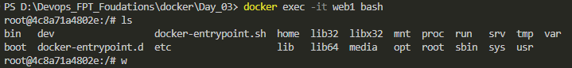

We then try to make sure connection between web1 and web2 is good by using curl and domaname
