Nguyễn Thái Dương – sieudenoo1512@gmail.com – duongtn1512@gmail.com
Exerise_1:

- Install Docker on your local machine.
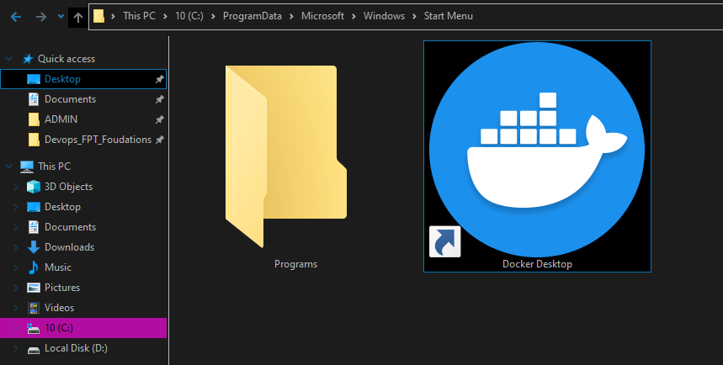
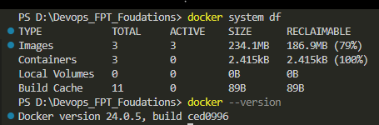

- Create a DockerHub account.
