Nguyễn Thái Dương Day 2 exerise:

Task 1: Create a Dockerfile for a Python application that prints a message.
Build the image and run a container from it.
Task 2: Build an image with multiple tags and push it to Docker Hub.
( I do fist 2 task in 1 run )
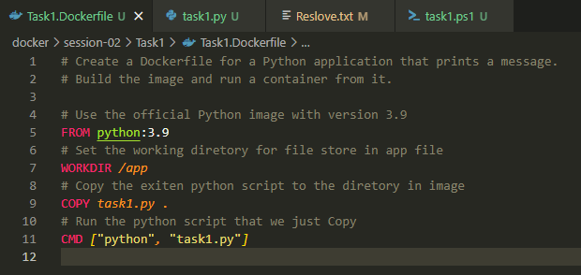
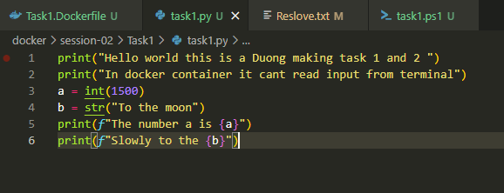
Powershell script to auto muti tag, build, push, run and login Docker
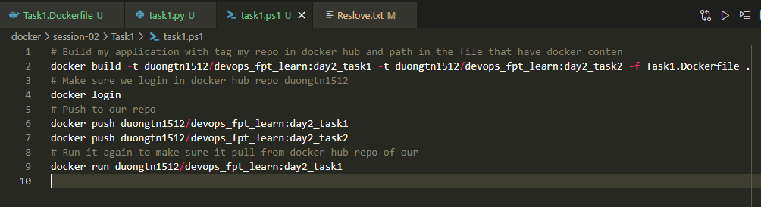

Run the script and get result printed on terminal
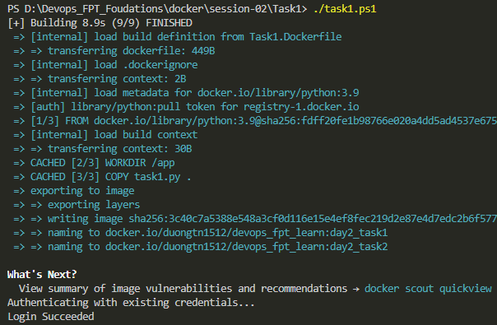
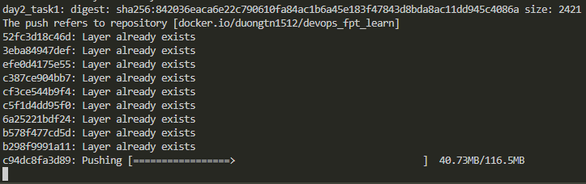
Success login docker hub, build many tag docker images, push it to repo and run a image
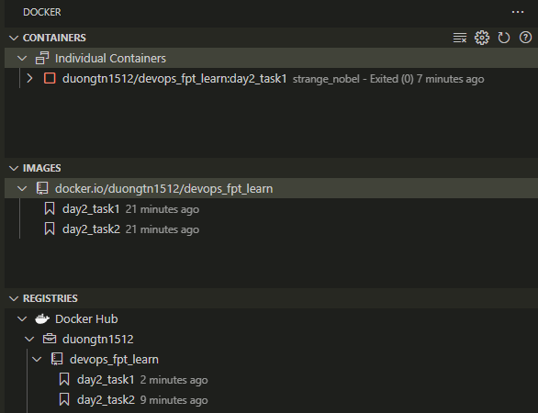
Log from container
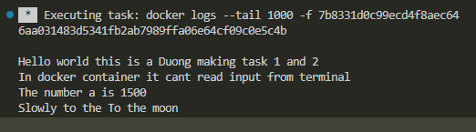
Output of python code I make it into a docker image then run it in a container day2_task1
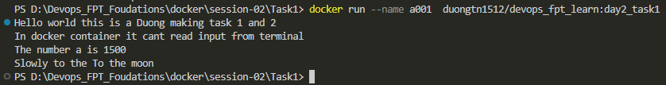

Task 3: Create a multi-stage Dockerfile for a Node.js app. Build the app and copy only the necessary files to the final image.
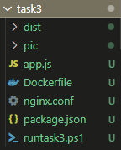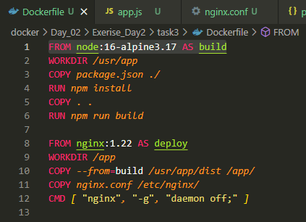
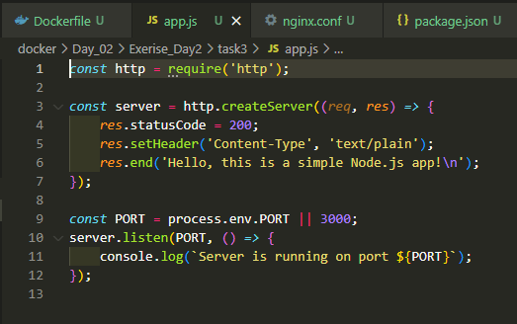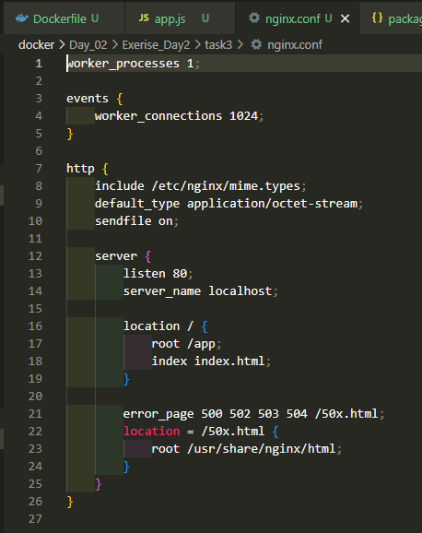
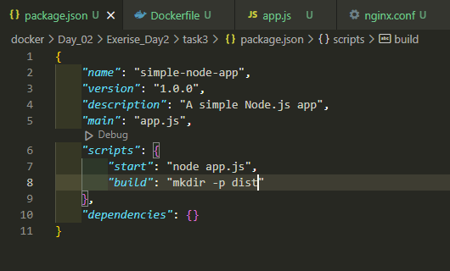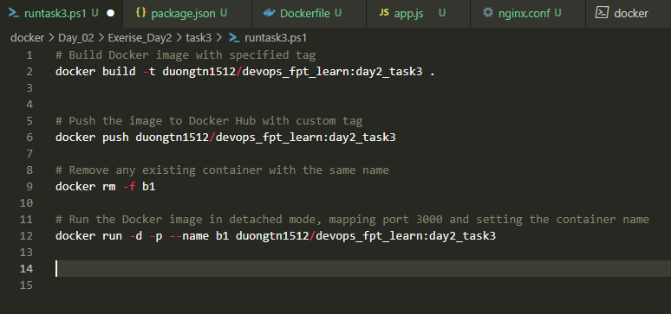
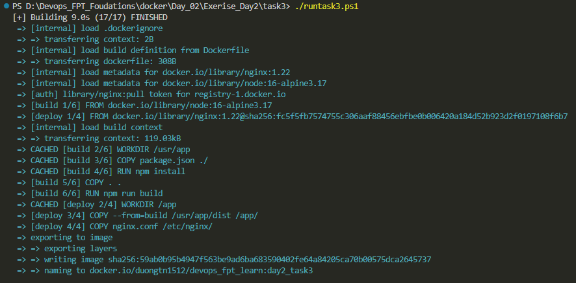
End result we enter the container, list the files in app and curl localhost:80
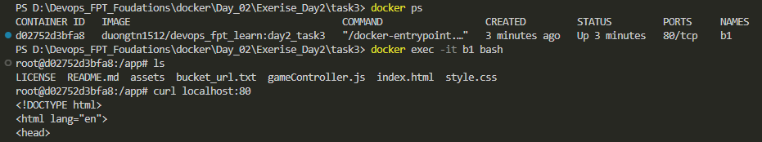

Task 4: Push an image you've created to your Docker Hub repository. Then, pull it to a different machine and run a container.
Create an ec2 aws instance
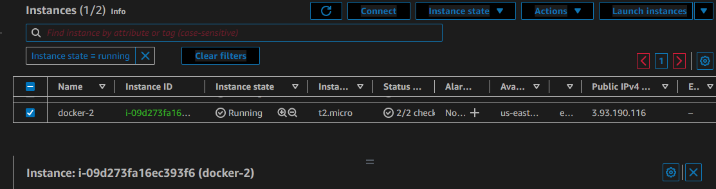
Connect to ec2 via SSH from vs code
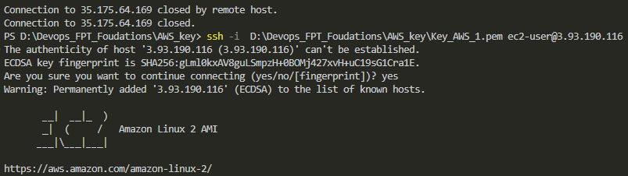
Check images on docker hub repo
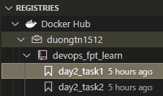
Install docker on cenos and check for status
sudo yum update -y
sudo amazon-linux-extras install docker
sudo service docker start
sudo systemctl enable docker
sudo usermod -a -G docker ec2-user
docker info

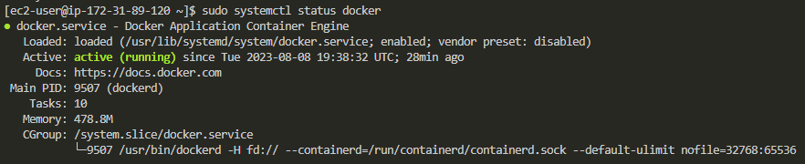
Docker login to docker hub repo
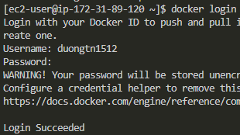
Pull a image and run ( Docker Image is Python base image with code wirted on Task 1 )
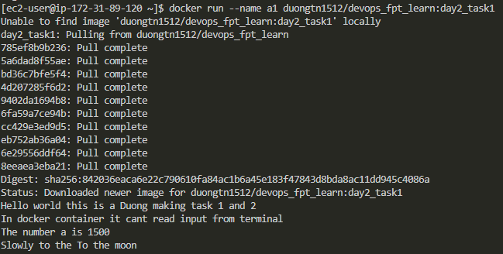
Check docker contaner on this EC2 machine
Task 5: From an official Nginx image, build a custom Nginx image to output a customized homepage.
Task 6: Run an Nginx container in detached mode, map a local port to the container's port, and access the Nginx welcome page. (2 Task 1 run)
Fist we make custom html file display what we want
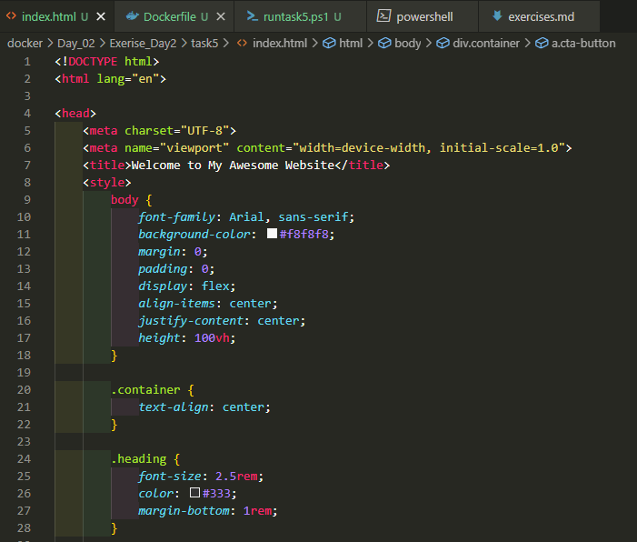
Dockerfile will put index.html file to the folder that will deploy our frontend web we custom build
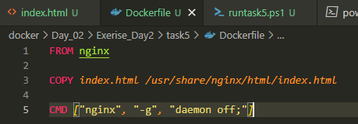
Auto run script that will run a container in detached mode map port 1512 to the container's port 80
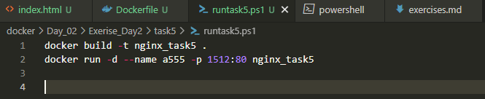
We start the script
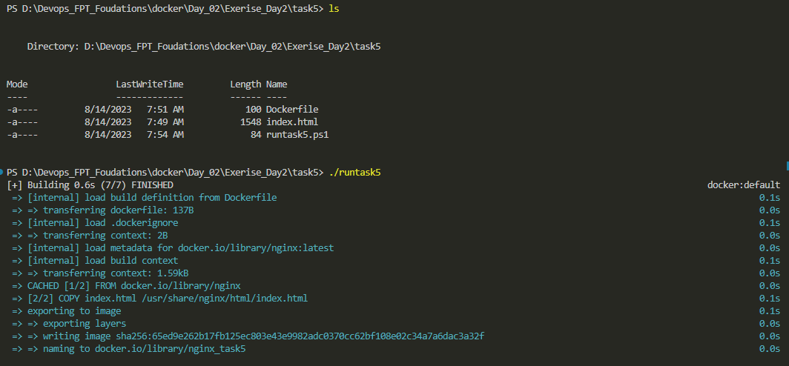
Check for the result
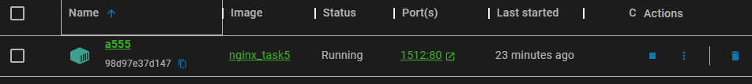
The homepage we just deploy
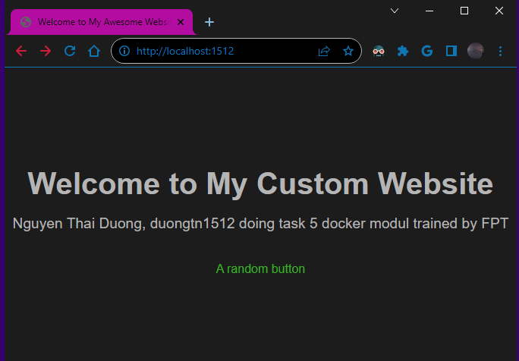

Task 7: Run an Ubuntu container interactively, access its shell, and execute basic commands.
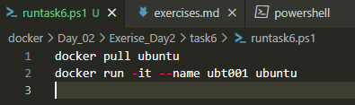
Run the script and do basic command
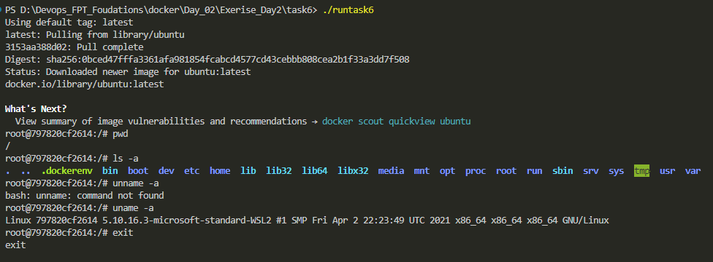
Task 8: Run a container with environment variables set using the -e flag and `ENV` instruction. Access these variables from within the container.
We fist create an env file and assign the variables same with the path we make docker command
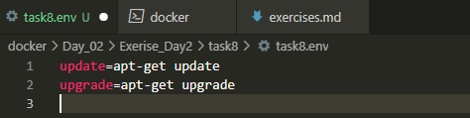
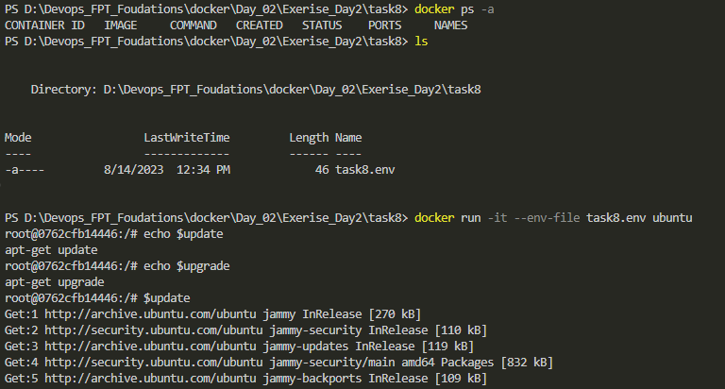
Folow the result we run a ubuntu container with flag -env to task8.env file where we make our varible we then echo our varible and try one to see if they work

Task 9: Build a Docker image using the Dockerfile in the `issue` directory and run a container using that image. What happened with the container? Troubleshoot so the container is able to run.
Fist we make script stage 1 to build and run stage 2 to use different command to inspect container
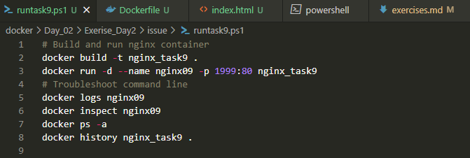
Result of build stage
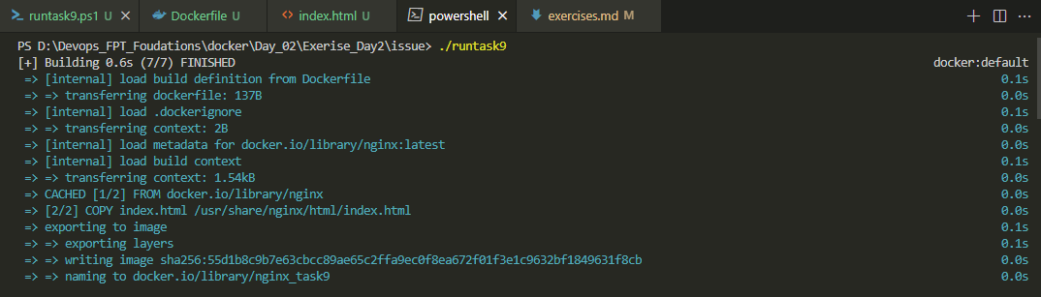
Log and deep inspect
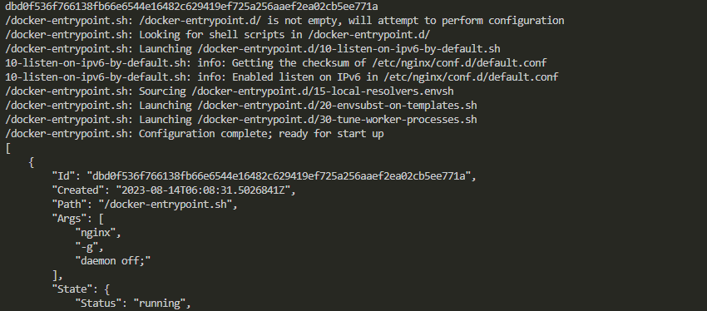
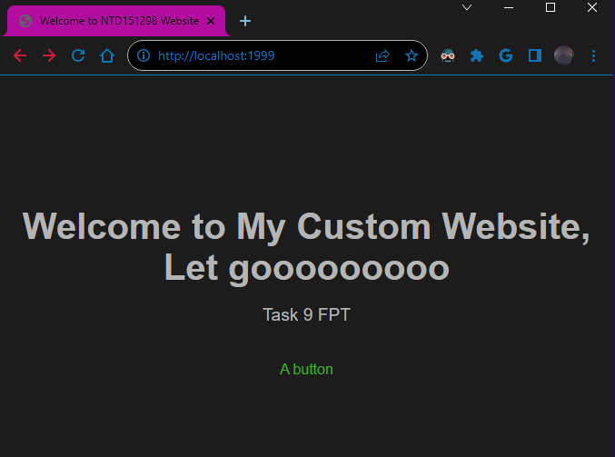
It appear that container run smotly and we can curl to it port public at localhost:1999

Task 10: Run a container, stop it, and then remove it.
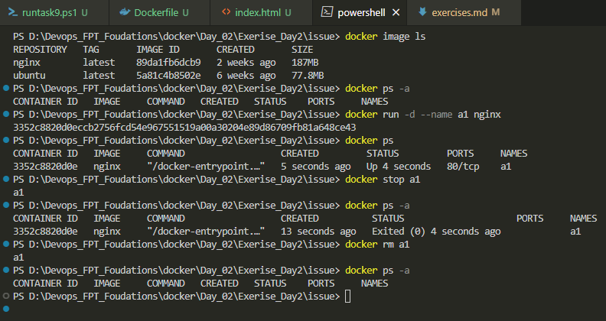

Task 11: Build an image with a custom HTML file. Run a container from the image and copy a file from the host to the container.
The custom HTML file:
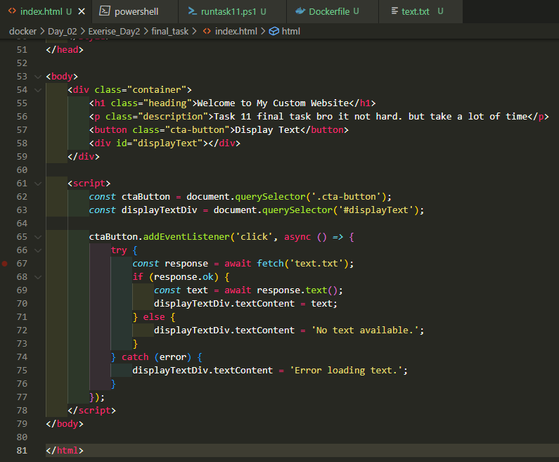
Dockerfile
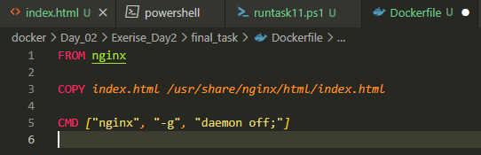
Auto build and run script
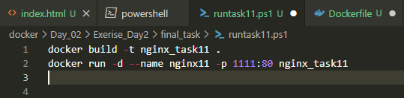

Run script
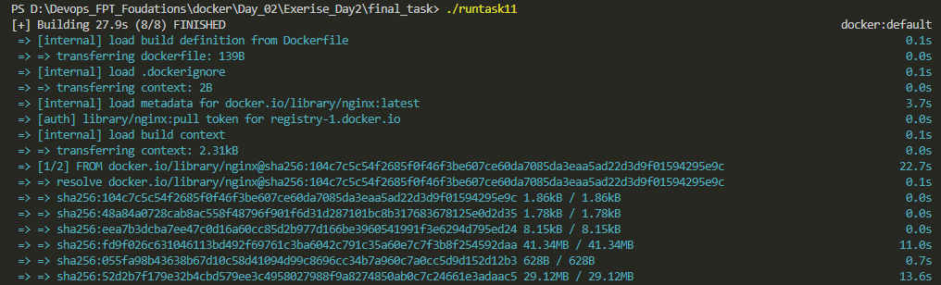
Check the localhost:1111
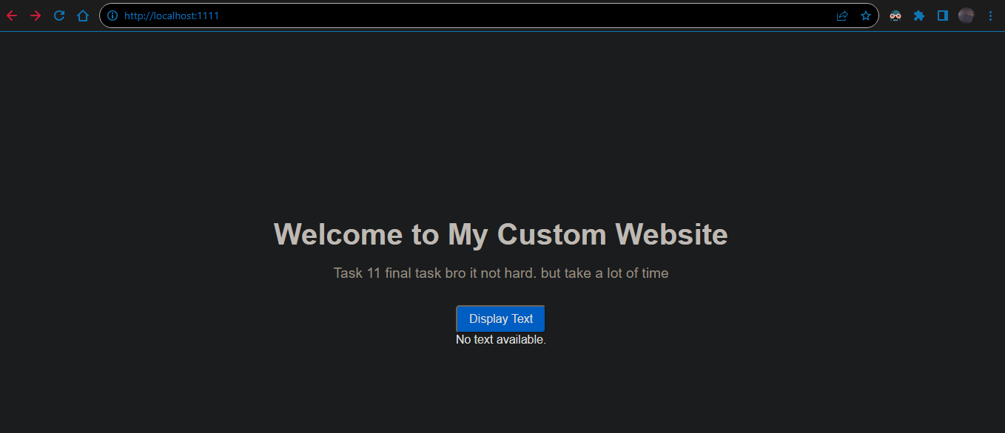
Check container file
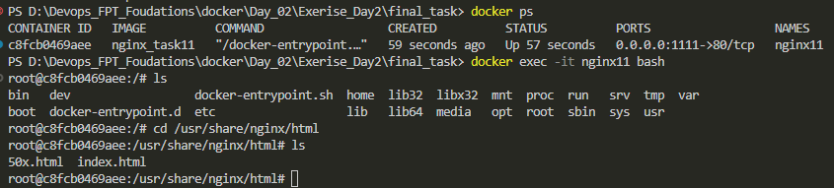
Create file text.txt on the same dir terminal at
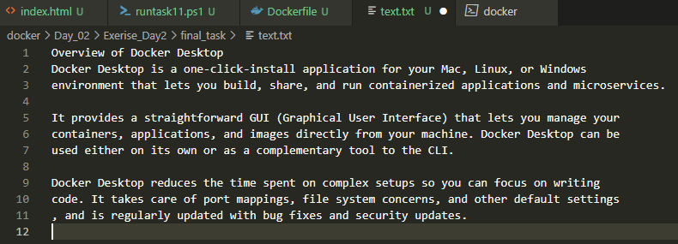
Docker copy the text file to docker container at the same dir that container are display web code
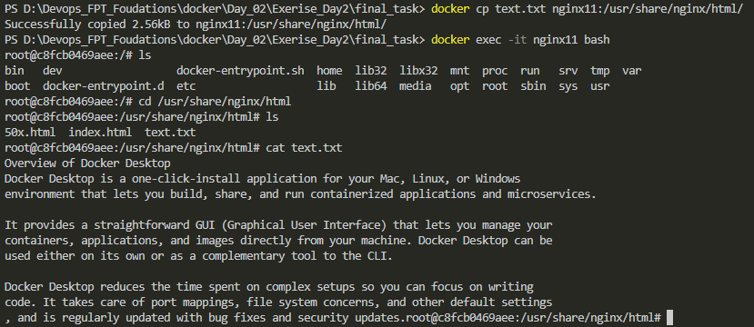
We also check the file data after copy finish and check web brower that code are deploy at
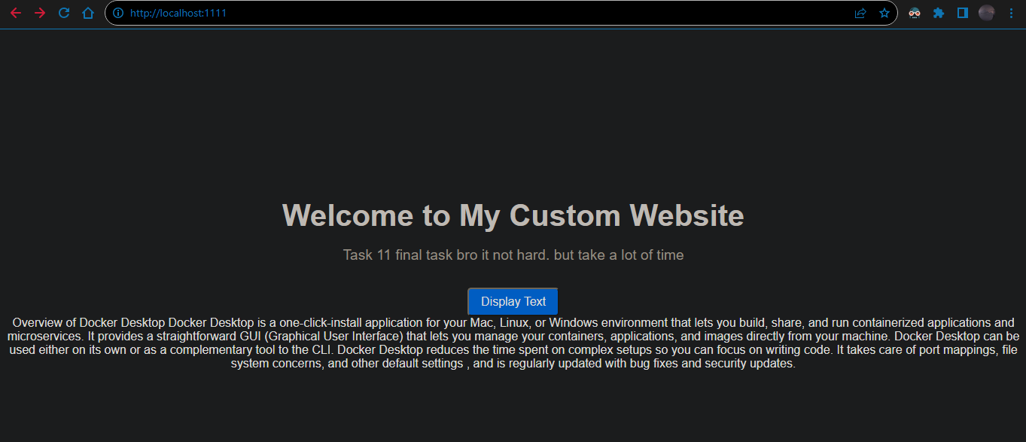
Folow the logic in html file code the button Display Text will display data from file text.txt
