Nguyễn Thái Dương Day 1 docker install exerise:
1. Install Docker on your local machine.
2. Create a DockerHub account.

Task1: Install Docker on your local machine.
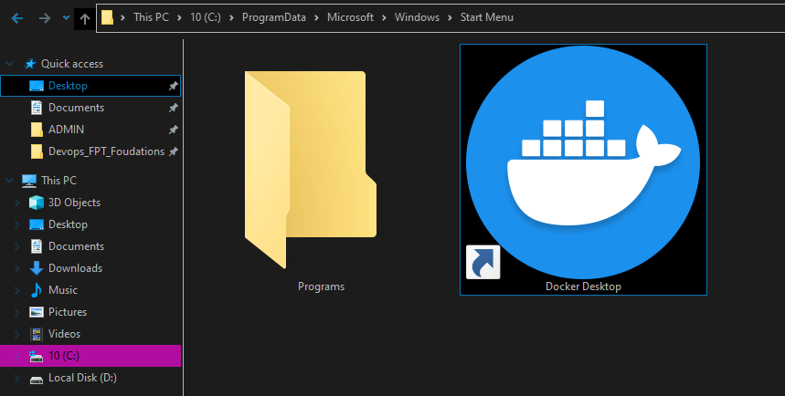
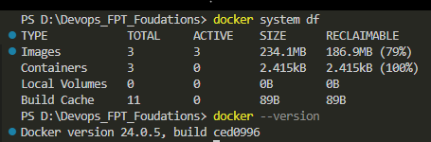

Task2: Create a DockerHub account.
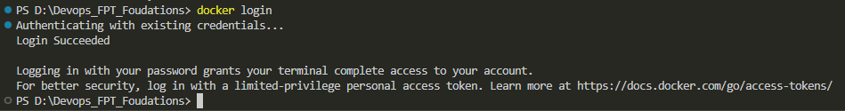
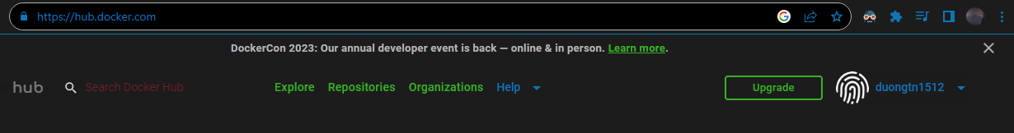
Nguyễn Thái Dương Day 2 docker image exerise:
1. Create a Dockerfile for a Python application that prints a message. Build the image and run a container from it.
2. Build an image with multiple tags, such as "latest" and a specific version. Push the image to Docker Hub.
3. Create a multi-stage Dockerfile for a Node.js app. Build the app and copy only the necessary files to the final image.
4. Push an image you've created to your Docker Hub repository. Then, pull it to a different machine and run a container.
5. From an official Nginx image, build a custom Nginx image to output a customized homepage.
6. Run an Nginx container in detached mode, map a local port to the container's port, and access the Nginx welcome page.
7. Run an Ubuntu container interactively, access its shell, and execute basic commands.
8. Run a container with environment variables set using the -e flag and `ENV` instruction. Access these variables from within the container.
9. Build a Docker image using the Dockerfile in the `issue` directory and run a container using that image. What happened with the container? Troubleshoot so the container is able to run.
10. Run a container, stop it, and then remove it.
11. Build an image with a custom HTML file. Run a container from the image and copy a file from the host to the container.

Task 1: Create a Dockerfile for a Python application that prints a message.
Build the image and run a container from it.
Task 2: Build an image with multiple tags and push it to Docker Hub.
( I do fist 2 task in 1 run )
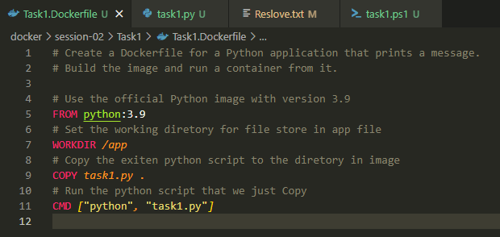
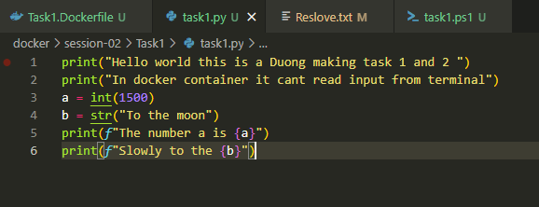
Powershell script to auto muti tag, build, push, run and login Docker
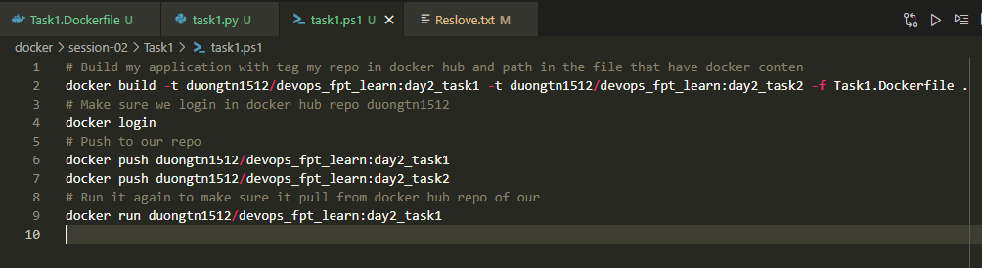

Run the script and get result printed on terminal
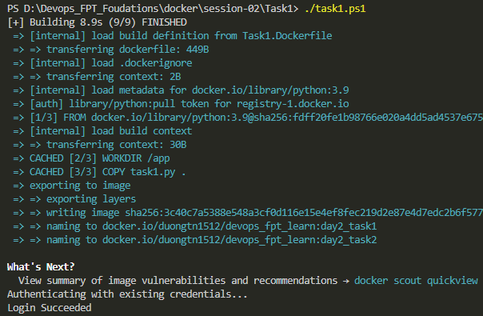
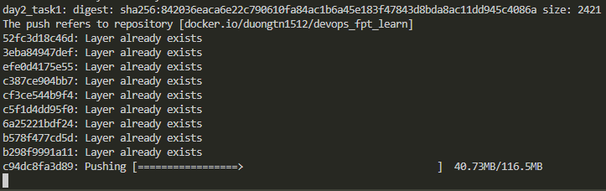
Success login docker hub, build many tag docker images, push it to repo and run a image
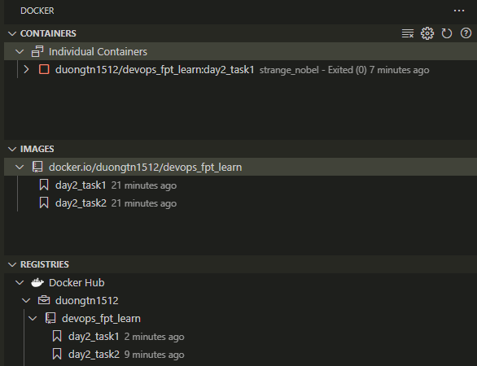
Log from container
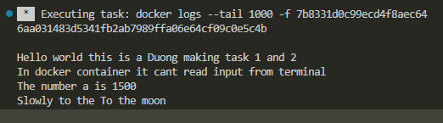
Output of python code I make it into a docker image then run it in a container day2_task1
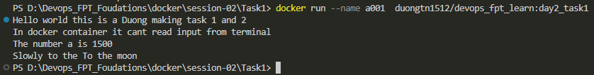

Task 3: Create a multi-stage Dockerfile for a Node.js app. Build the app and copy only the necessary files to the final image.
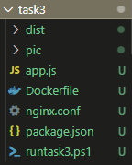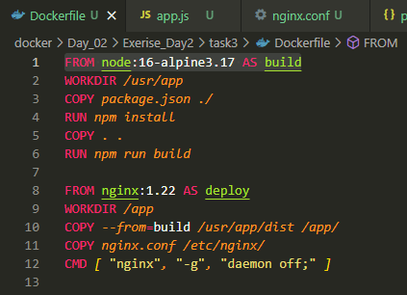
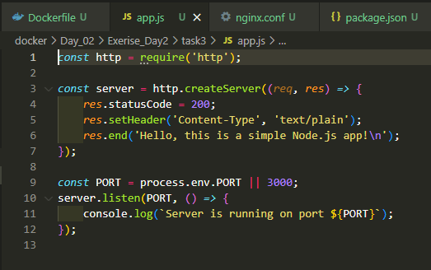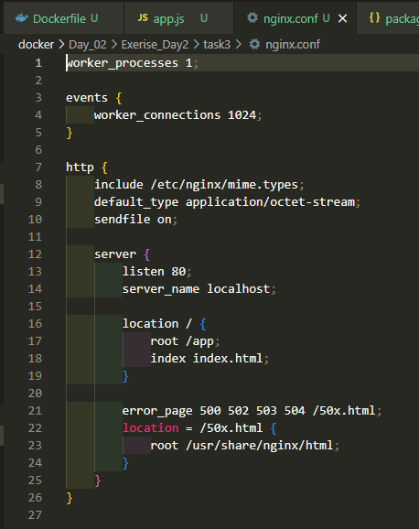
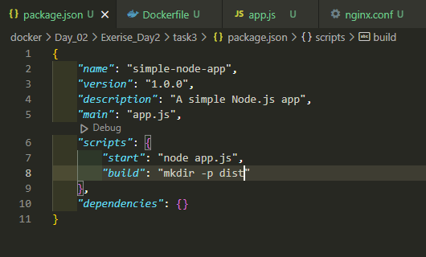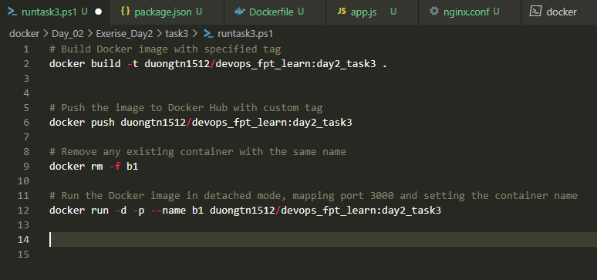
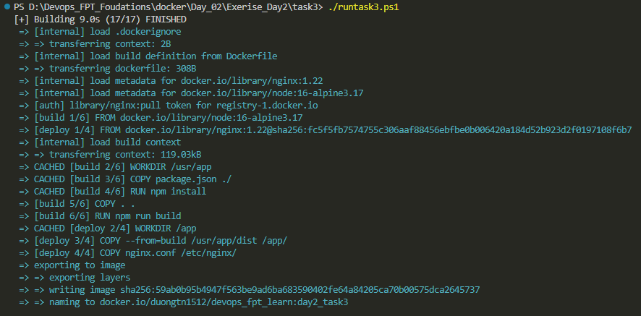
End result we enter the container, list the files in app and curl localhost:80
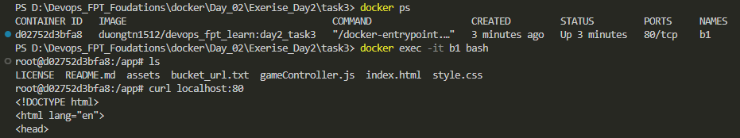

Task 4: Push an image you've created to your Docker Hub repository. Then, pull it to a different machine and run a container.
Create an ec2 aws instance
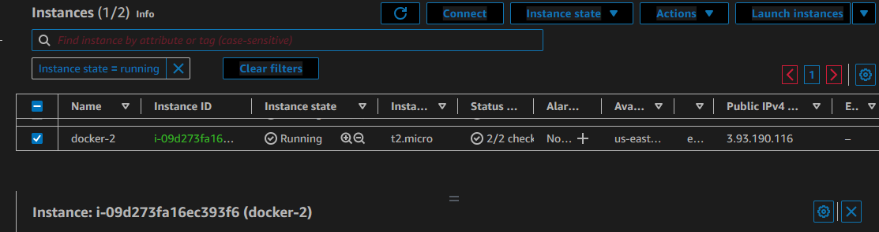
Connect to ec2 via SSH from vs code
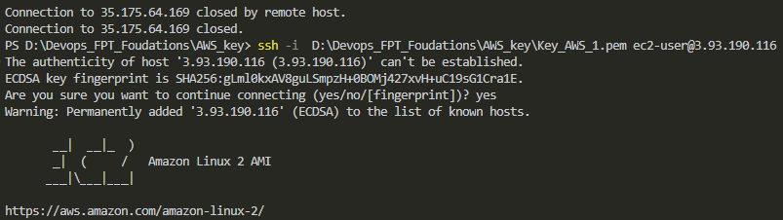
Check images on docker hub repo
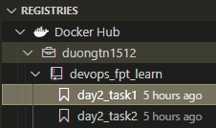
Install docker on cenos and check for status
sudo yum update -y
sudo amazon-linux-extras install docker
sudo service docker start
sudo systemctl enable docker
sudo usermod -a -G docker ec2-user
docker info

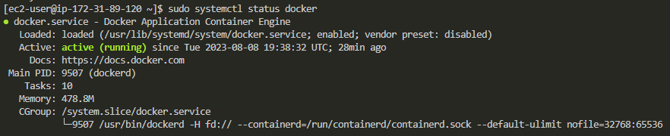
Docker login to docker hub repo
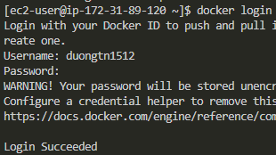
Pull a image and run ( Docker Image is Python base image with code wirted on Task 1 )
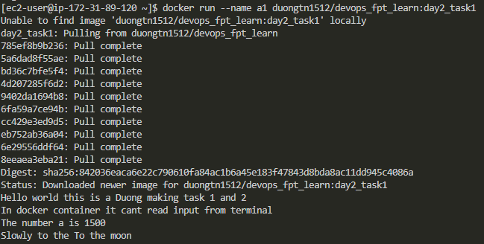
Check docker contaner on this EC2 machine
Task 5: From an official Nginx image, build a custom Nginx image to output a customized homepage.
Task 6: Run an Nginx container in detached mode, map a local port to the container's port, and access the Nginx welcome page. (2 Task 1 run)
Fist we make custom html file display what we want
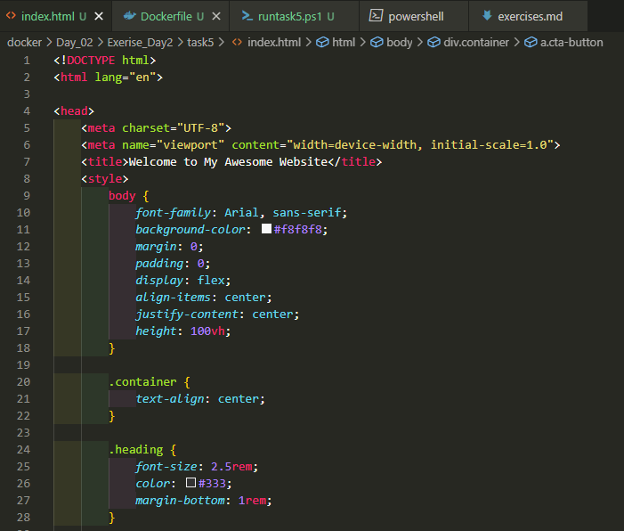
Dockerfile will put index.html file to the folder that will deploy our frontend web we custom build
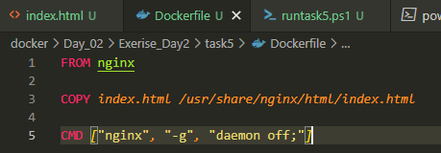
Auto run script that will run a container in detached mode map port 1512 to the container's port 80
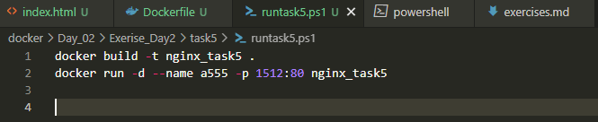
We start the script
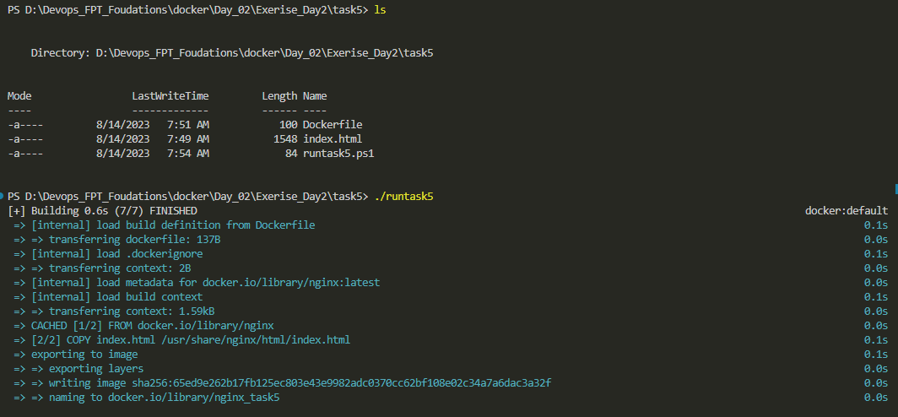
Check for the result
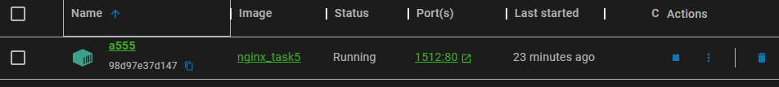
The homepage we just deploy
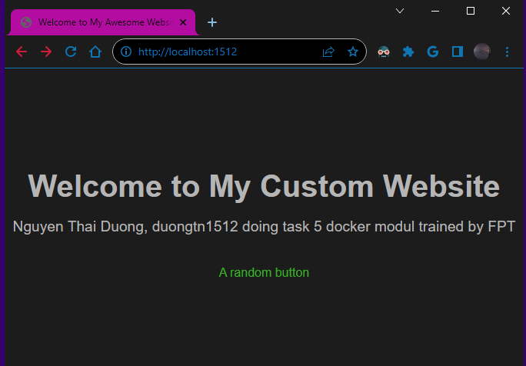

Task 7: Run an Ubuntu container interactively, access its shell, and execute basic commands.
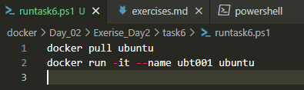
Run the script and do basic command
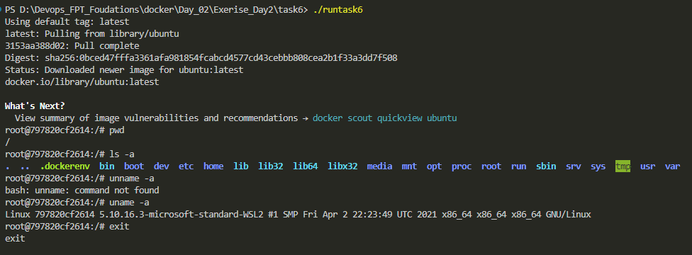
Task 8: Run a container with environment variables set using the -e flag and `ENV` instruction. Access these variables from within the container.
We fist create an env file and assign the variables same with the path we make docker command
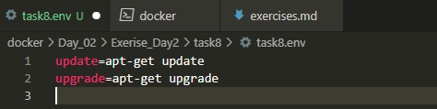
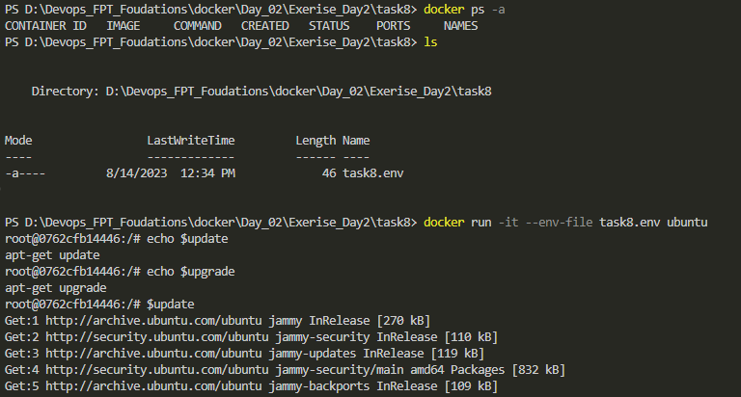
Folow the result we run a ubuntu container with flag -env to task8.env file where we make our varible we then echo our varible and try one to see if they work

Task 9: Build a Docker image using the Dockerfile in the `issue` directory and run a container using that image. What happened with the container? Troubleshoot so the container is able to run.
Fist we make script stage 1 to build and run stage 2 to use different command to inspect container
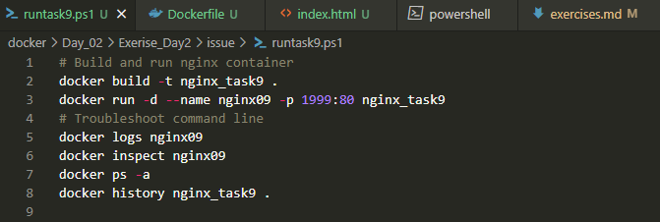
Result of build stage
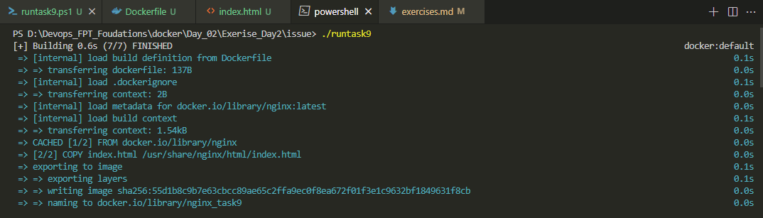
Log and deep inspect
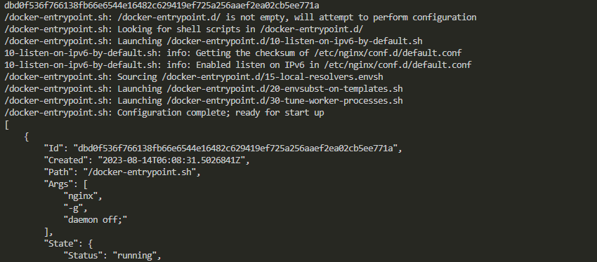
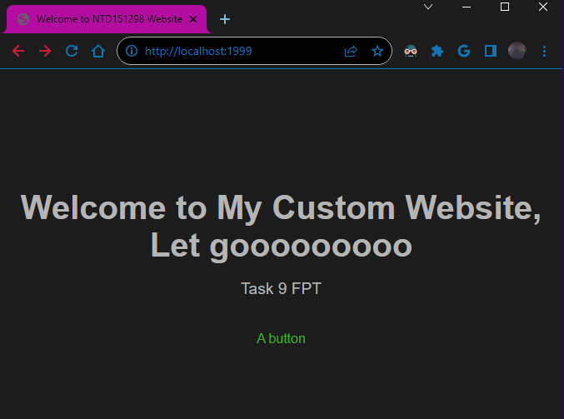
It appear that container run smotly and we can curl to it port public at localhost:1999

Task 10: Run a container, stop it, and then remove it.
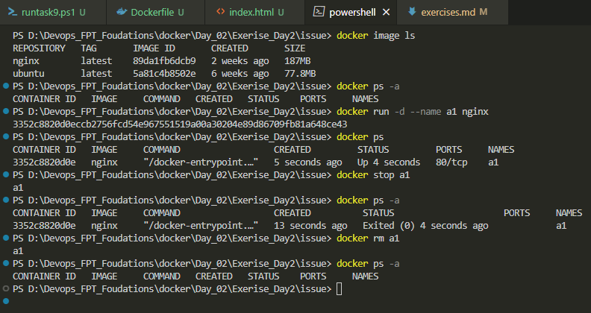

Task 11: Build an image with a custom HTML file. Run a container from the image and copy a file from the host to the container.
The custom HTML file:
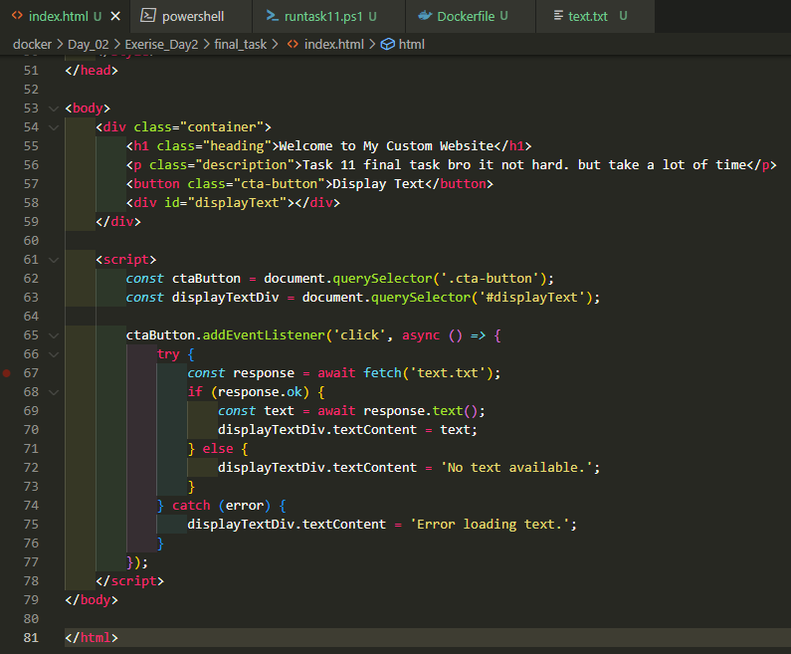
Dockerfile
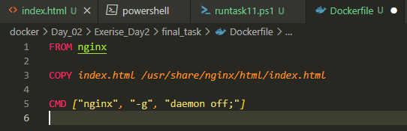
Auto build and run script
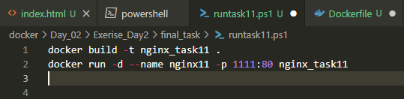

Run script
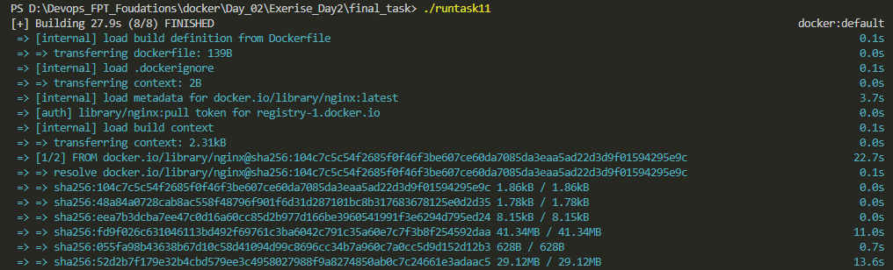
Check the localhost:1111
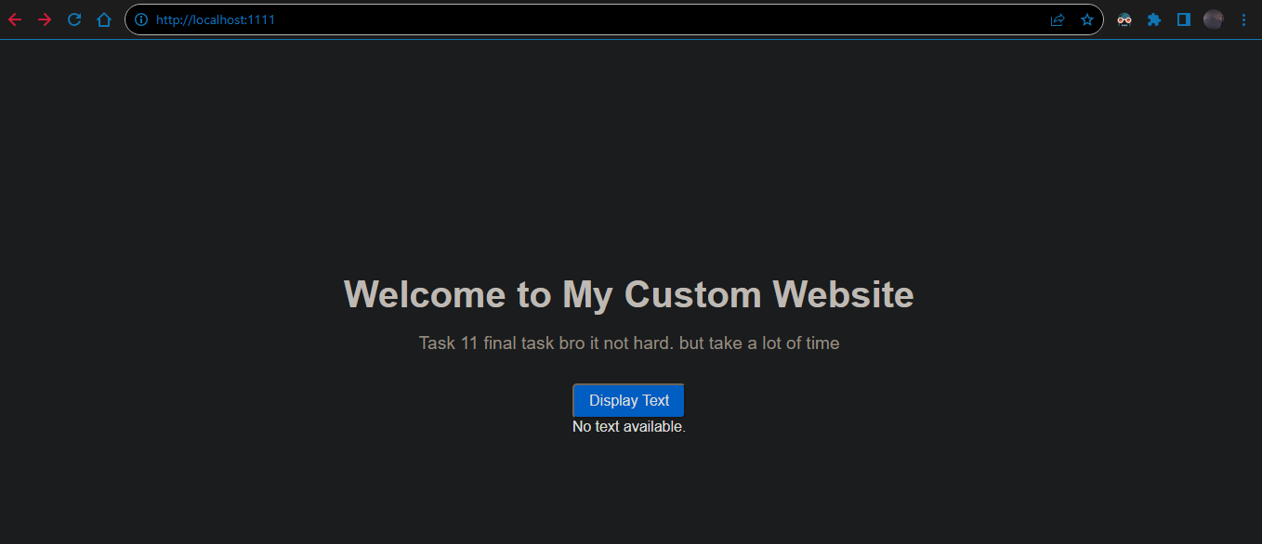
Check container file
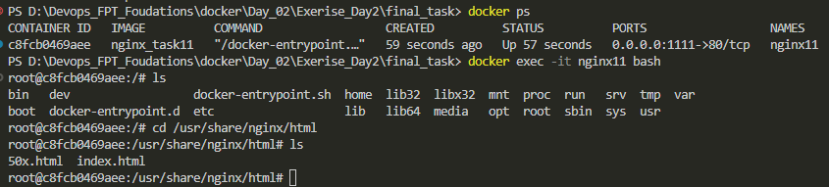
Create file text.txt on the same dir terminal at
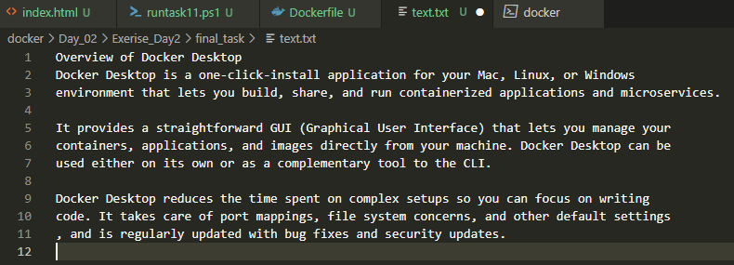
Docker copy the text file to docker container at the same dir that container are display web code
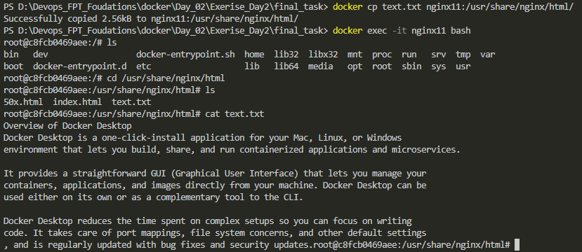
We also check the file data after copy finish and check web brower that code are deploy at
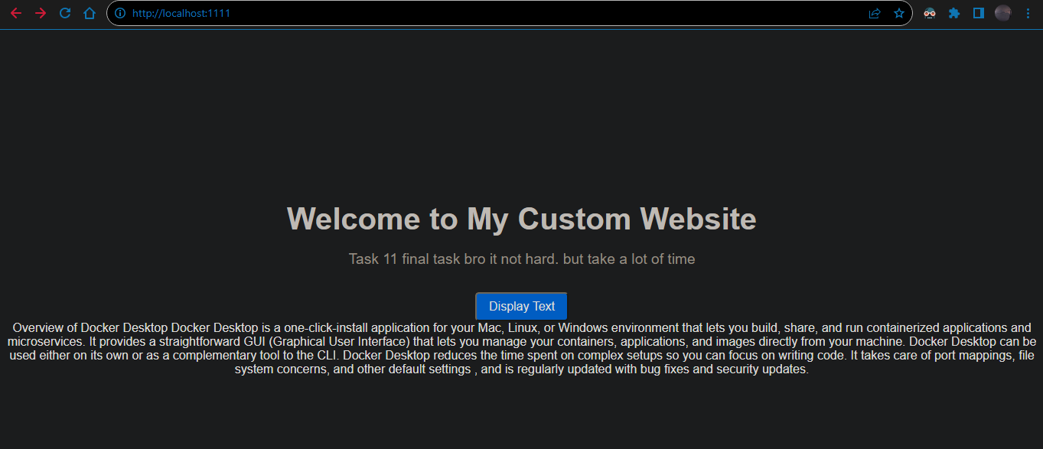
Folow the logic in html file code the button Display Text will display data from file text.txt
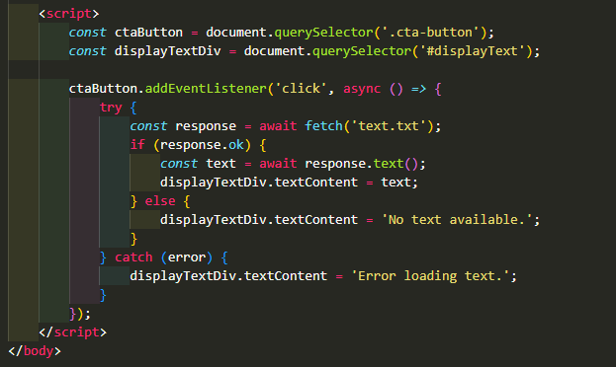
Nguyễn Thái Dương Day 3 docker network exerise:
Task: create a docker compose file that run 2 container in a same network then try to check connection within that network using container dns
Here is that file docker compose and file env that docker compose will use to run
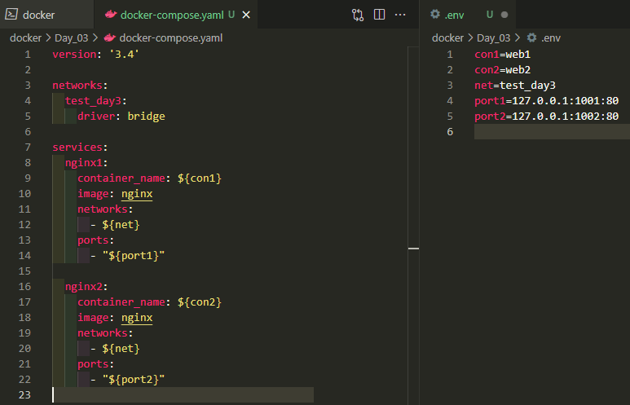
This is terminal result after we enter command “docker compose up -d” at wor dir
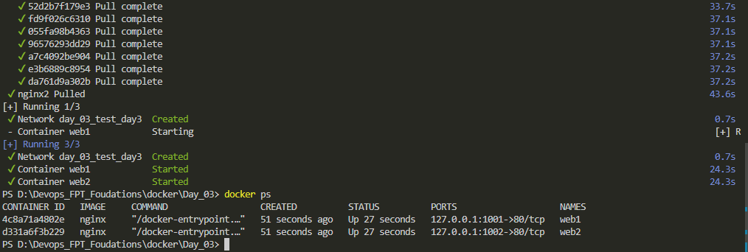
Folow the docker ps we run nginx with name web1 and web2 on localhost:1001 and localhost:1002
We have success pull and run nginx as container name web1 and web2 on port 1001 and 1002
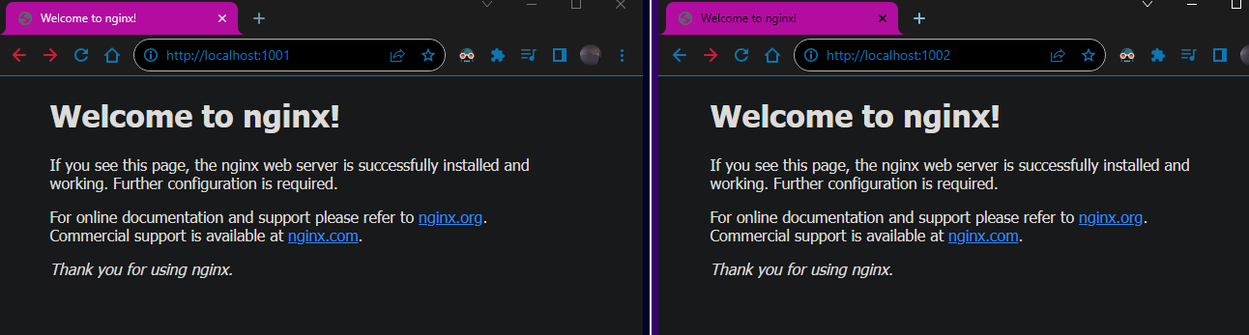
Now we check for web1 and web2 network
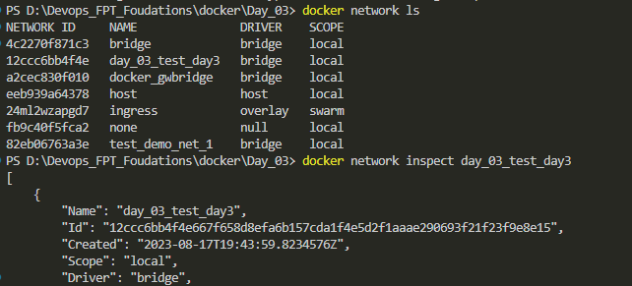
Our network named day_03_test_day3
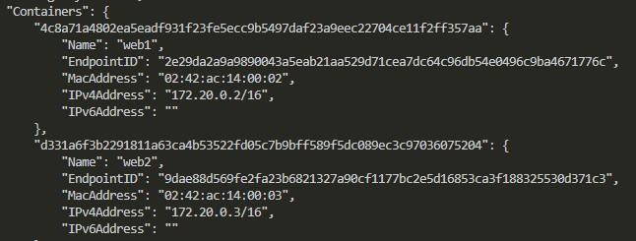
With docker network inspect we find out ip of web1 within docker network is 172.20.0.2 and web2 ip is 172.20.0.3
We enter container web1 by using “docker exec -it web1 bash”
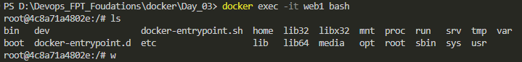

We then try to make sure connection between web1 and web2 is good by using curl and domaname
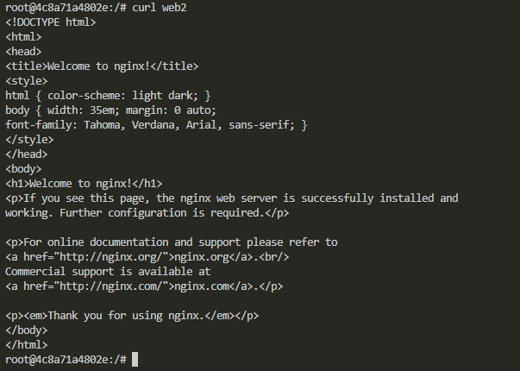
Nguyễn Thái Dương Day 4 docker volume exerise:
1. Create a named volume called "data_volume" and mount it to a container. Verify that data is persisted even after the container is removed.
2. Mount a directory from your host machine to a container using a bind mount. Modify files from both the host and the container to observe changes.
3. Use the docker volume inspect command to view metadata and configuration details of a volume.
4. Identify and remove volumes that are no longer in use to free up storage space.
5. Backup the contents of a volume to your local machine and then restore it to a new volume.
6. Create a container with a tmpfs mount to store temporary data in memory. Observe how the data is lost when the container stops.
7. Write a docker-compose.yml file that defines a service using volumes, then launch multiple containers to share data.
8. Launch a container that uses multiple volumes for different parts of its filesystem.
9. Create two containers, migrate data from one to the other using volumes, and ensure minimal downtime.
10. Launch multiple instances of a container and share data using the same volume between them.
Task 1: Create a named volume called "data_volume" and mount it to a container. Verify that data is persisted even after the container is removed.
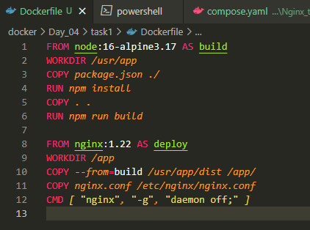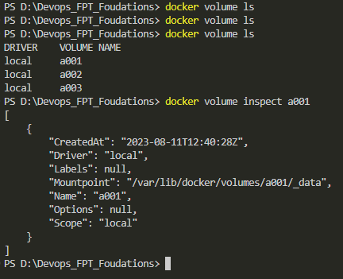
Using dockerfile we create image duongtn1512/devops_fpt_learn:day2_task3 and use volume a001
From docker compose we mount a001 to new image we created and name container bb1
The file in dist folder will get put into folder app in container bb1 folow docker file in deploy stage
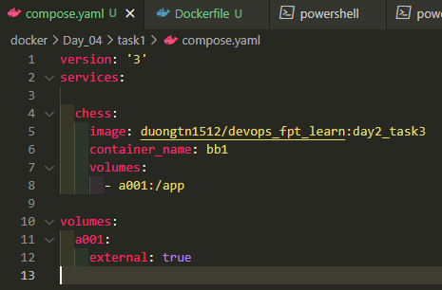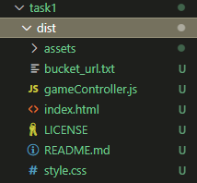
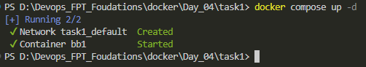
The file in app folder will get mount to storage a001
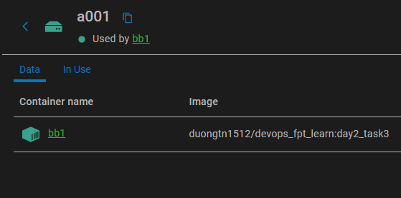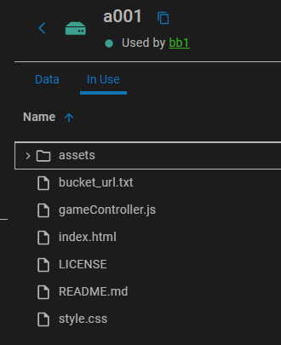
We delete container bb1
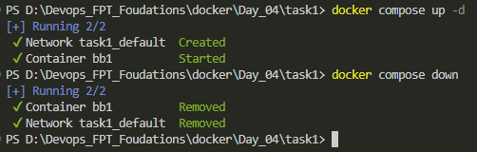
And then we check data in storage a001 when not in use by any docker containers
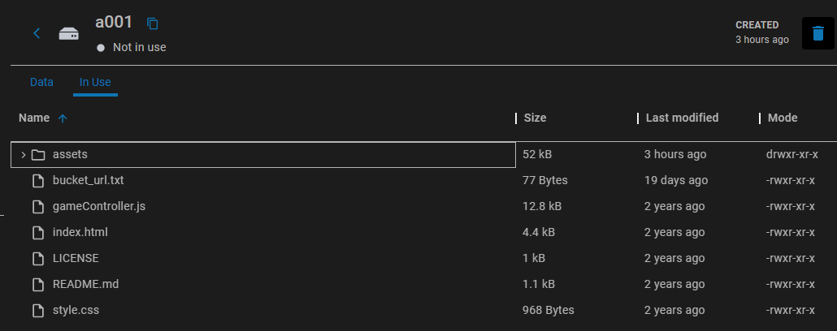
Its still here.

Task 2: Mount a directory from your host machine to a container using a bind mount. Modify files from both the host and the container to observe changes.
Prepare Directory and Files:
With host folder is task2_host_floder and host file is host_file.txt
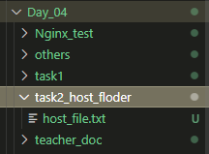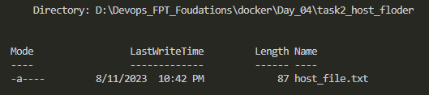
Data in file host_file.txt
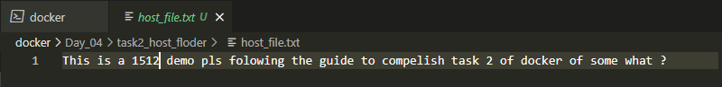
Create an contaner name cc1 with bind mount task2_host_floder to it contaner path /app:
docker run -it --name cc1 -v D:\Devops_FPT_Foudations\docker\Day_04\task2_host_floder:/app nginx bash
We then enter container and check for the file host_file.txt
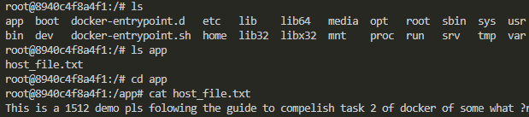
We had success bring file from windows host to docker nginx container
Modify from Host
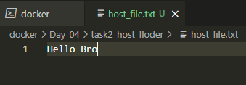
And then we enter container to see if it change the txt file
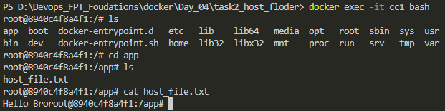
Yes it dose change the data in host_file.txt
Modify from Container
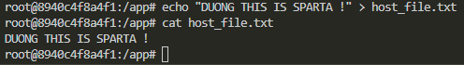
And in the host is changed
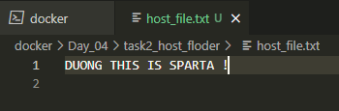
So both ways are ok and can make change to the file its bind mouth
Task 3: Use the docker volume inspect command to view metadata and configuration details of a volume.
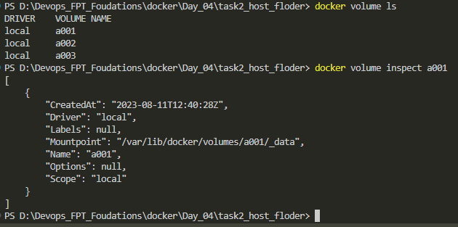
Task 4: Identify and remove volumes that are no longer in use to free up storage space.
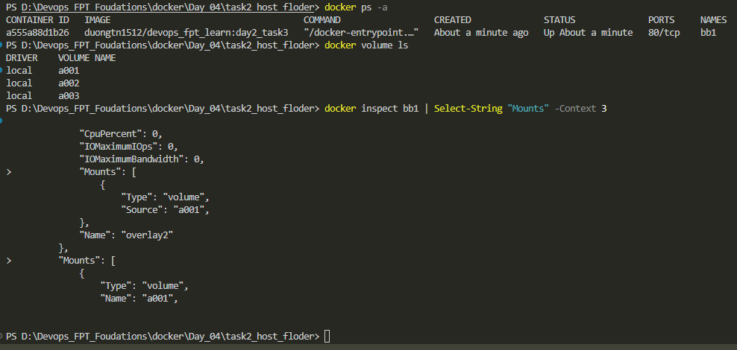
So from the image I get, I belive that only volume a001 in used with container bb1
We rm volume a002 and a003 because it not in use
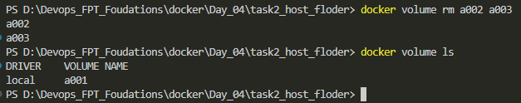

Task 5: Backup the contents of a volume to your local machine and then restore it to a new volume.
Fist we use volume a001 created before in task 1
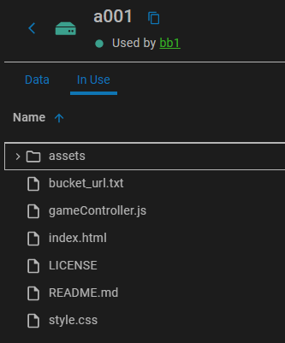We use this comand too backup at host windows
docker run --rm -v a001:/data -v C:\local\backup\path:/backup nginx tar cvf /backup/backup.tar /data
Check path we backup data C:\local\backup\path using ls command
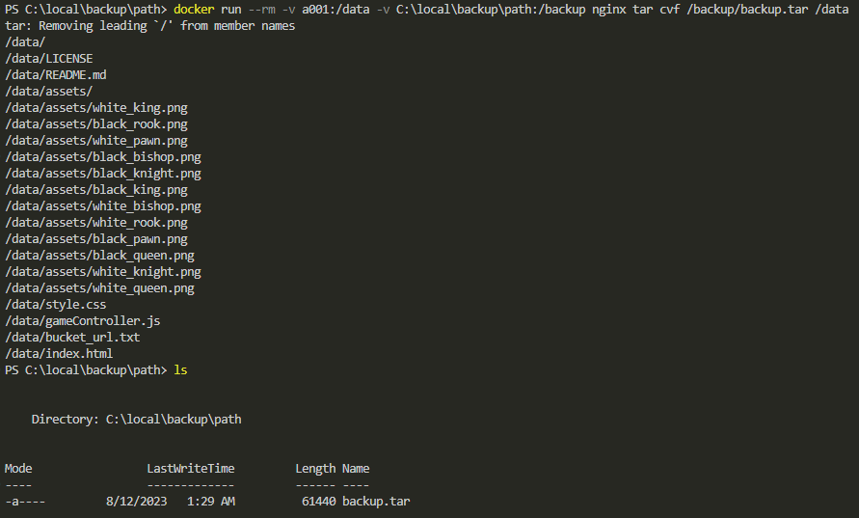
As we can see we have store volume a001 data to file backup.tar at C:\local\backup\path
For the restore the data to another volume, we create a new volume and bring data to that volume
docker volume create a002
docker run --rm -v a002:/data -v C:\local\backup\path:/backup nginx tar xvf /backup/backup.tar -C /data
We inspect the data from docker desktop
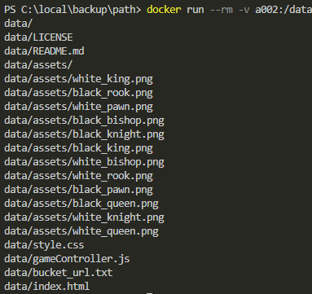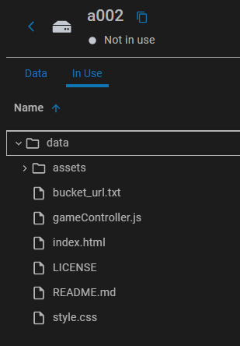

Task 6: Create a container with a tmpfs mount to store temporary data in memory. Observe how the data is lost when the container stops.
We create a nginx container temporary mount it at path /data inside container using this command
docker run -itd --mount type=tmpfs,target=/data nginx
We make a test.txt file echo in it “Hello, temporary data!” and save file within peaceful_kalam
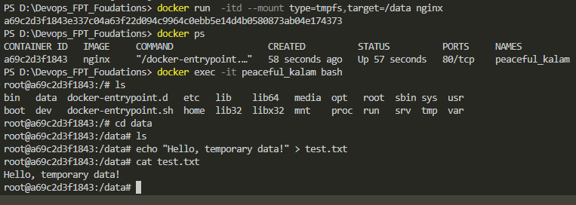
Using same command we create another container with docker name it thirsty_nightingale
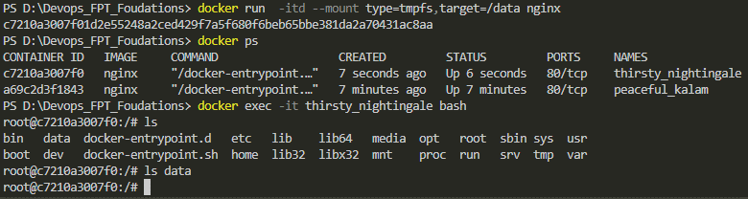
As you see we enter container with same type of tmpfs mount and in data folder there is no test.txt
We stop container peaceful_kalam and restart it again
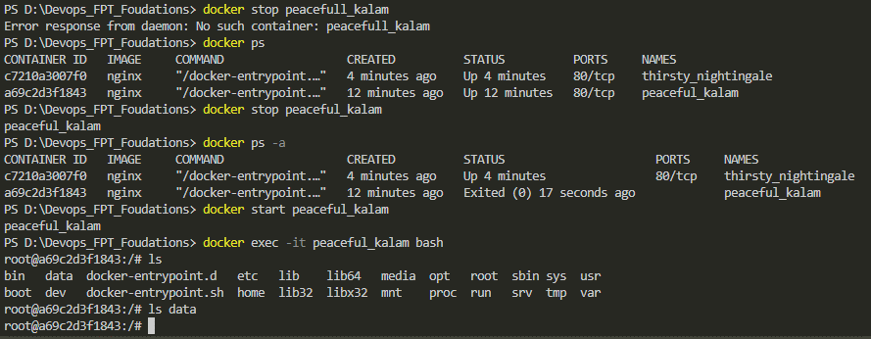
And then enter container, the file test.txt we make has alredy gone. This is how tmpfs mount work

Task 7: Write a docker-compose.yml file that defines a service using volumes, then launch multiple containers to share data.
Fist off we will use volume a001 to use with multiple container that will share eachother same data

Here is a docker compose file that will make 3 nginx container with it data will be take from volume a001 and then store in /usr/share/nginx/html folder inside container to make an frontend web
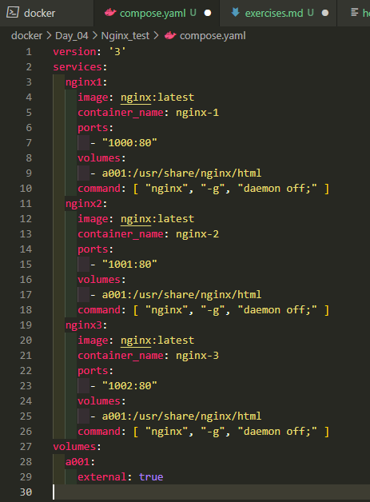
We docker compose up -d to make them run and curl each of nginx port to see result
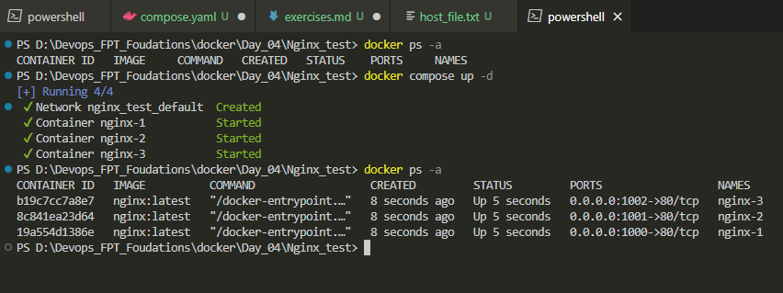
So all 3 port take same resource from volume a001 to make web chess game and expose to port
Localhost: 1000, 1001, 1002
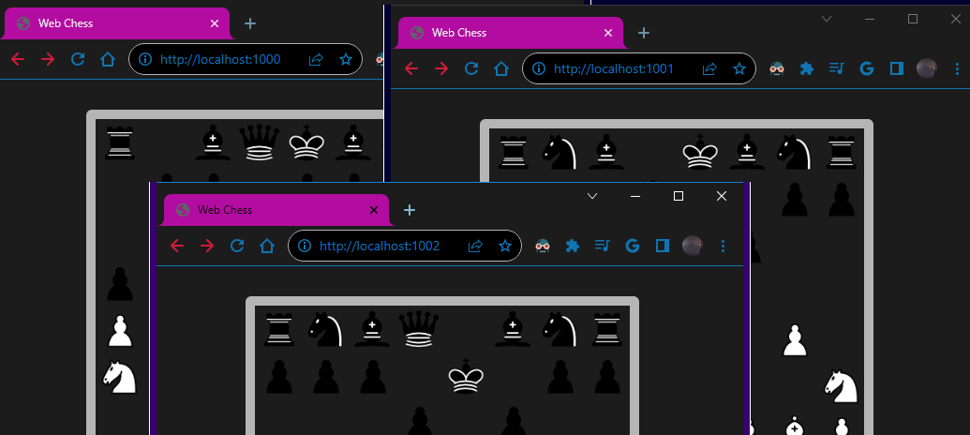

Task 8: Launch a container that uses multiple volumes for different parts of its filesystem.
We will use 2 volume a001 and a002 with them own distinctive data
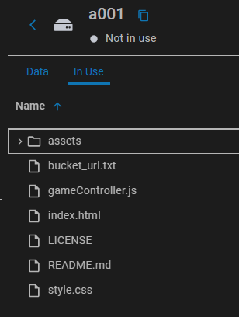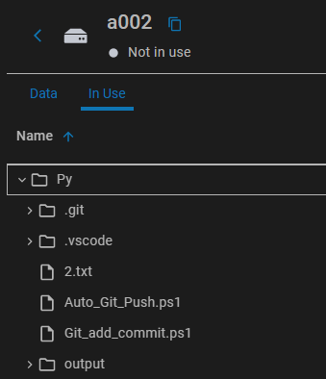We then run
docker run -d --name multi_nginx -v a001:/app1 -v a002:/app2 nginx
This command line will fist pull and run image nginx:latest to a container name multi_nginx and attach data from volume a001 to app1 folder in container, so on with data from a002 to app2 floder
We then enter container and check if the data from volume a001 and a002 has successfully deploy inside container multi_nginx folder app1, app2.
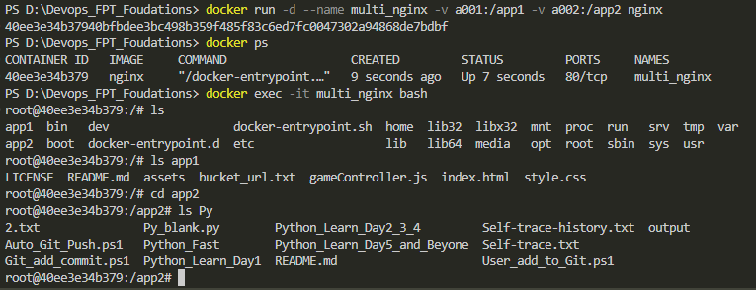

Task 9: Create two containers, migrate data from one to the other using volumes, and ensure minimal downtime.
We fist will using volume a001 mount it to new container we will create nginx01
We then using volume-from to let new container take data
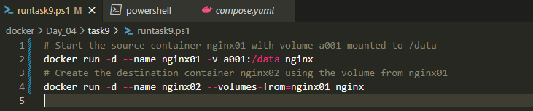
We name our new container nginx02 using volume from nginx01 the path to data will be the same when we create nginx01 and mount it to a001
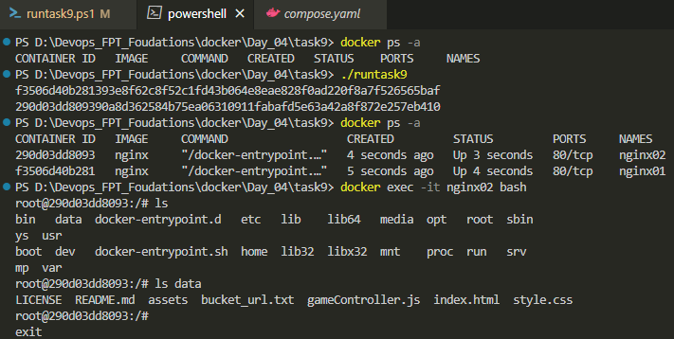
Folow the result we have success transfer data floder from nginx01 mount a001 to nginx02
Task 10: Launch multiple instances of a container and share data using the same volume between them.
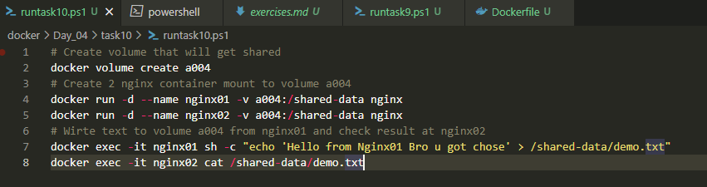
We make volume a004 and shared it with 2 continer nginx01 and nginx02
We run the script to auto report us if we have success share data using the volume a004
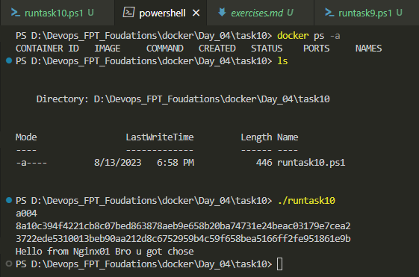
As nginx02 cat out text we make from nginx01 to volume a004 I said we has finish task 10
Nguyễn Thái Dương Day 5 docker deploy exerise:
1. Deploy a working application:
- Clone ReactJS frontend repo: https://github.com/thai-nm/sample-webapp-reactjs.git
- Clone NodeJS backend repo: https://github.com/uet-app-distributor/sample-nodejs-webapp.git
- Change directory to the frontend repo and build your own image with the pre-provided Dockerfile. You should check for the Dockerfile and its build workflow to understand and review about multi-stage and image build process.
- Change directory to the backend repo and build your own image without seeing the pro-provided Dockerfile. After trying to build your own image or being get stuck, you can use the Dockerfile in the repository as a reference.
- Upload those new images to your own DockerHub account.
- Develop your own `compose.yml` file for Docker Compose to do the following:
- Create a new network named `deployment-practice-network`
- Create 2 services:
- Service `backend` will create a container name `sample-webapp-nodejs` and refer to the backend image you just pushed above. This service requires environment variables: `USER=practioner-be` and `ENV=dev`. This service will only be exposed at port `13000` of the `loopback` interface and mapped to port `3000` of the container.
- Service `frontend` will create a container name `sample-webapp-reactjs` and refer to the frontend image you just pushed above. This service requires environment variables: `USER=practioner-fe` and `ENV=dev`. This service will be exposed at port `18080` of the `0.0.0.0` interface and mapped to port `80` of the container.
- Deploy with Docker Compose.
- To check if the containers are working or not, open your browser and go to http://localhost:18080. Then click `Give me a quote`. If there is a quote sent to you, everything is working well!
Task : 1. Deploy a working application:
- Clone ReactJS frontend repo: https://github.com/thai-nm/sample-webapp-reactjs.git
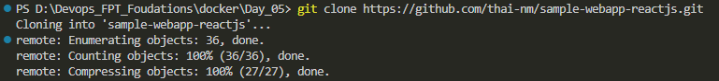
- Clone NodeJS backend repo: https://github.com/uet-app-distributor/sample-nodejs-webapp.git
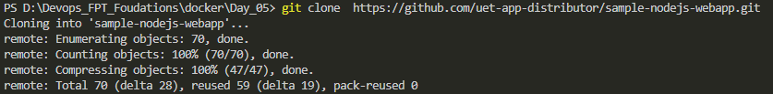
Check the 2 file:
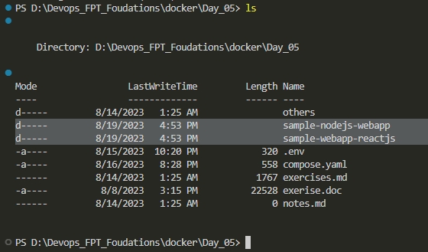
- Change directory to the frontend repo and build your own image with the pre-provided Dockerfile. You should check for the Dockerfile and its build workflow to understand and review about multi-stage and image build process. ( I change folder name to FE and build image with this docker file)
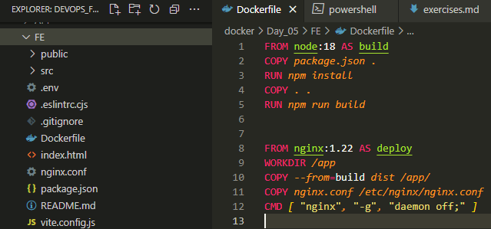
Fist I change the .env file to match API public port that I will public on “127.0.0.1:13000”
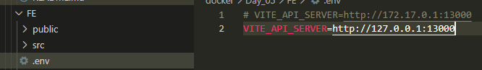
I then build fronend image with tag duongtn1512/docker_day5:fe_homework
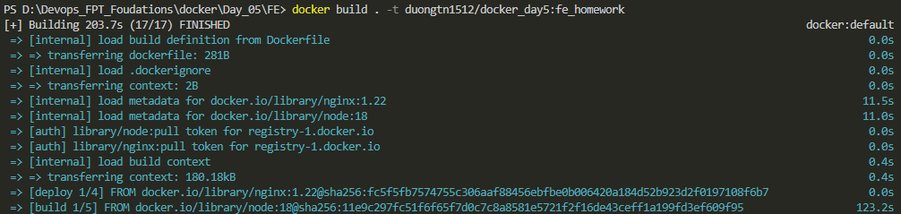
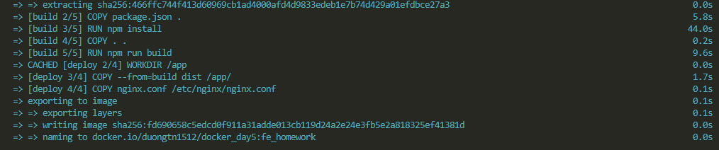
Finish the build successfully
- Change directory to the backend repo and build your own image without seeing the pro-provided Dockerfile. After trying to build your own image or being get stuck, you can use the Dockerfile in the repository as a reference.
I change folder hold node application to API and use docker file within the foldor to build
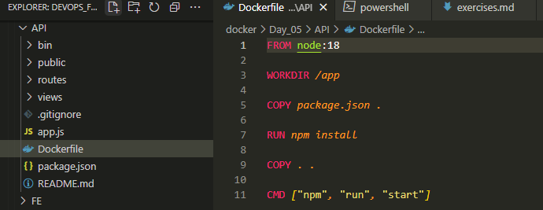
Then build it with tag duongtn1512/docker_day5:api_homework
Here terminal print result
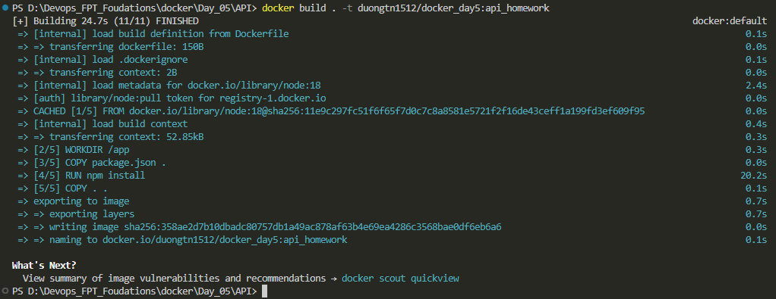
- Upload those new images to your own DockerHub account.
Check for images we have
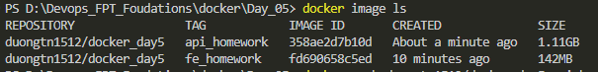
Push to docker hub
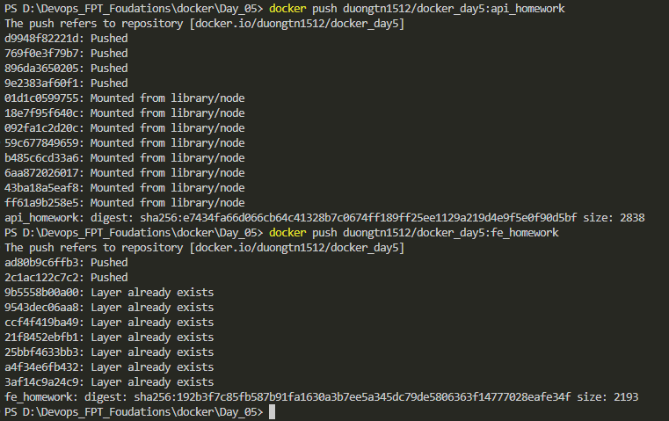
- Develop your own `compose.yml` file for Docker Compose to do the following:
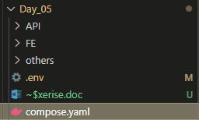 We wirte our compose file at same folder with env file
- Create a new network named `deployment-practice-network`
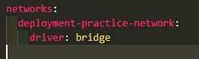
- Create 2 services:
- Service `backend` will create a container name `sample-webapp-nodejs` and refer to the backend image you just pushed above. This service requires environment variables: `USER=practioner-be` and `ENV=dev`. This service will only be exposed at port `13000` of the `loopback` interface and mapped to port `3000` of the container.
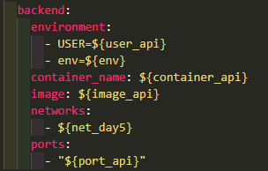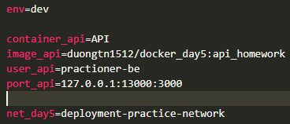
- Service `frontend` will create a container name `sample-webapp-reactjs` and refer to the frontend image you just pushed above. This service requires environment variables: `USER=practioner-fe` and `ENV=dev`. This service will be exposed at port `18080` of the `0.0.0.0` interface and mapped to port `80` of the container.
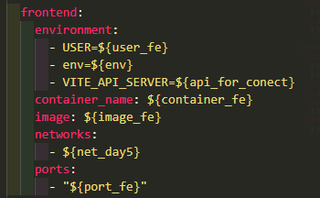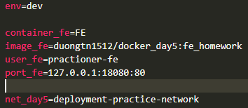
- Deploy with Docker Compose.
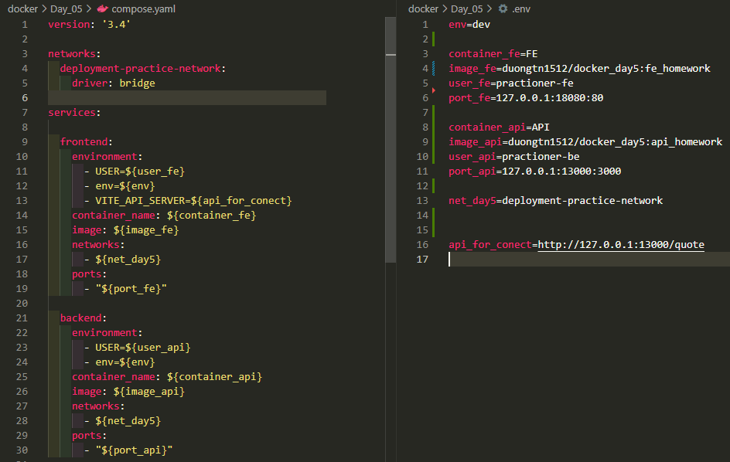
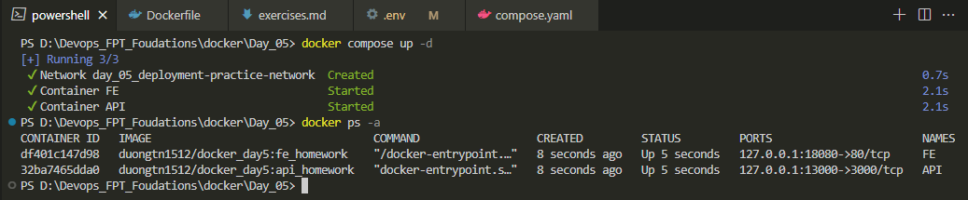
We docker compose up and success run 2 container and a network
- To check if the containers are working or not, open your browser and go to http://localhost:18080. Then click `Give me a quote`. If there is a quote sent to you, everything is working well!
Frontend with return network status code 200 and can get the quote
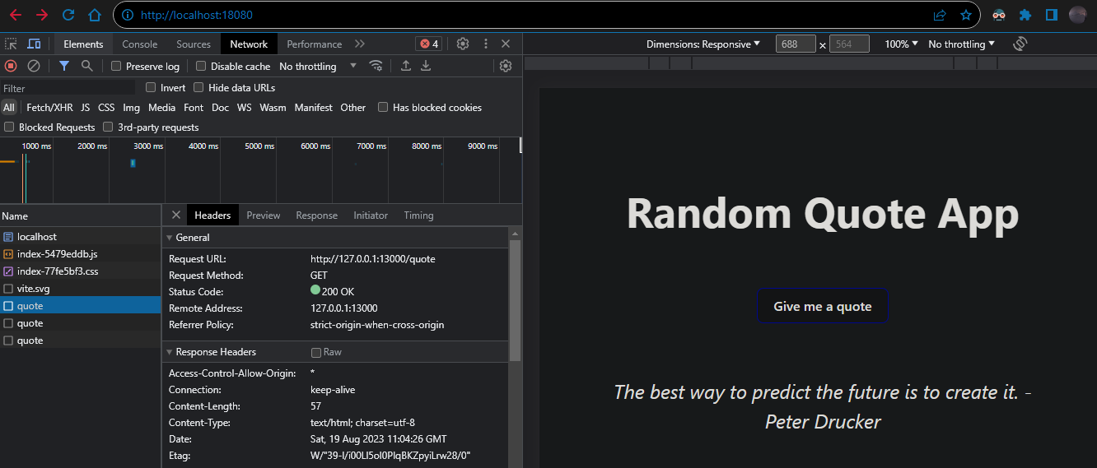
Back end api result
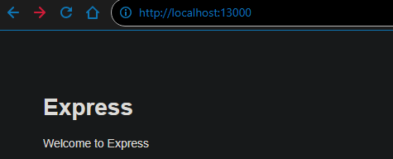
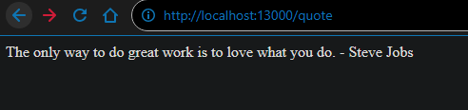
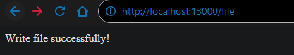
Nguyễn Thái Dương Day 6 docker compose exerise:
Task: Viết và run 1 docker-compose file chạy 2 service là wordpress và database bất kỳ. Check web bằng cách tương tác thử với app
Chúng ta sẽ viết 1 file docker compose bao gồm 3 service : mysql, phpmyadmin, wordpress
Chúng ta sẽ public cổng 1001 cho php và 1002 cho wordpress, try cập vào trình duyệt web và tương tác với ứng dụng chạy trên container với config theo docker-compose sau:
Database config Phpmyadmin config
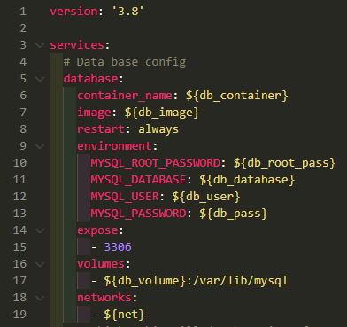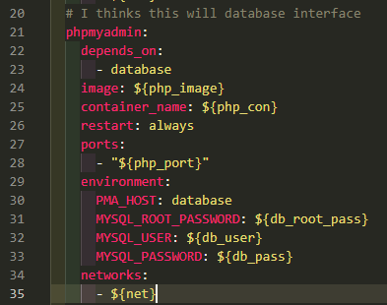
Wordpress config. Storage and network File env chứa biến môi trường của 3 service
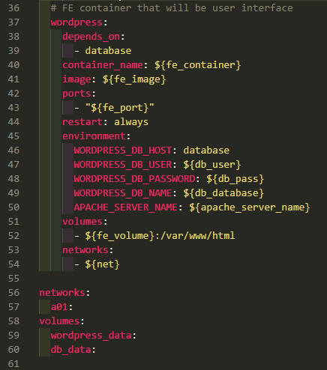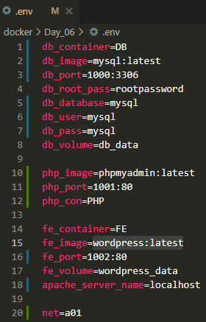
Kiểm tra xem có container nào đang chạy không và chắc chắn rằng thư mục compose.yaml và thư mục .env nằm trên cùng đường dẫn
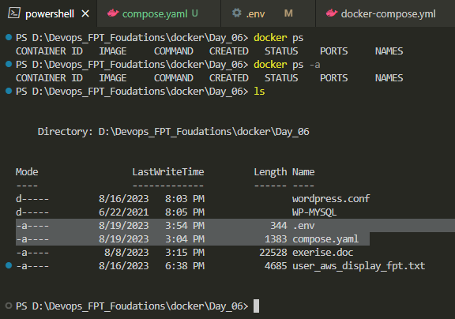
Kiểm tra docker image, network và volume:
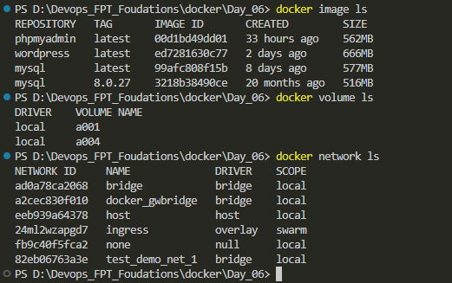
Chúng ta thấy chúng ta đã kéo 3 image base của 3 service cần chạy, không có network và volume tương ứng với tên của volume chúng sẽ tạo ra khi chạy file docker compose
Chạy file docker compose bằng lệnh docker compose up -d (để docker không in log lên terminal )
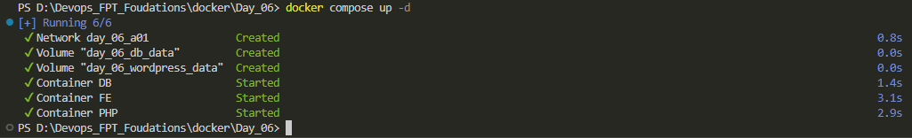
Theo kết quả in chúng ta đã dựng lên thành công 3 container tương ứng với 3 service cần chạy và tạo được 2 volume dùng cho workpress, mysql và 1 network dùng chung của 3 service đó
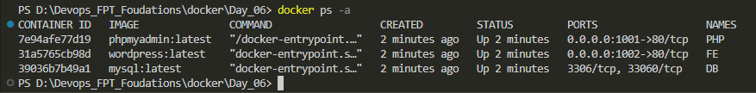
Chúng ta thấy 3 conatainer đang chạy và truy cập vào 2 web site chúng ta đã public cổng 1001 1002
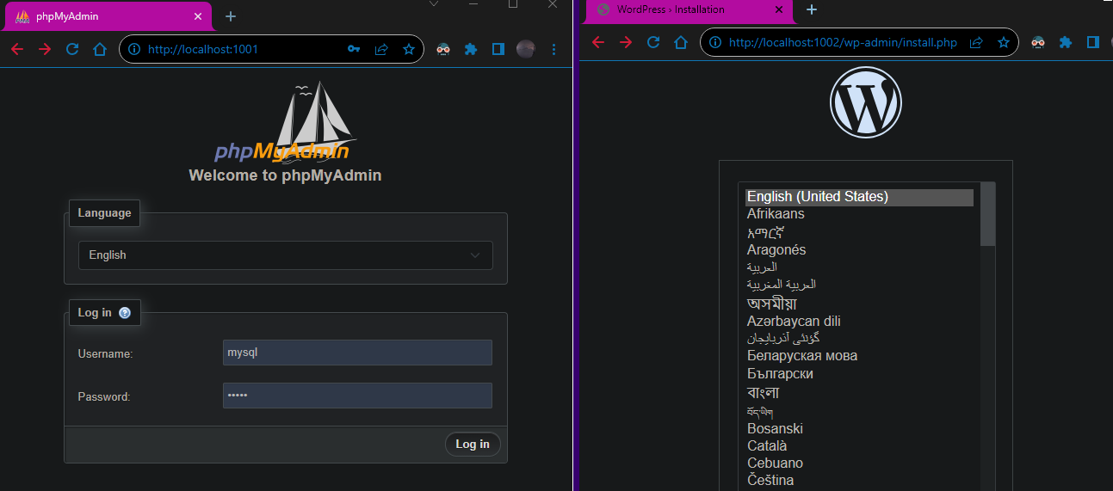
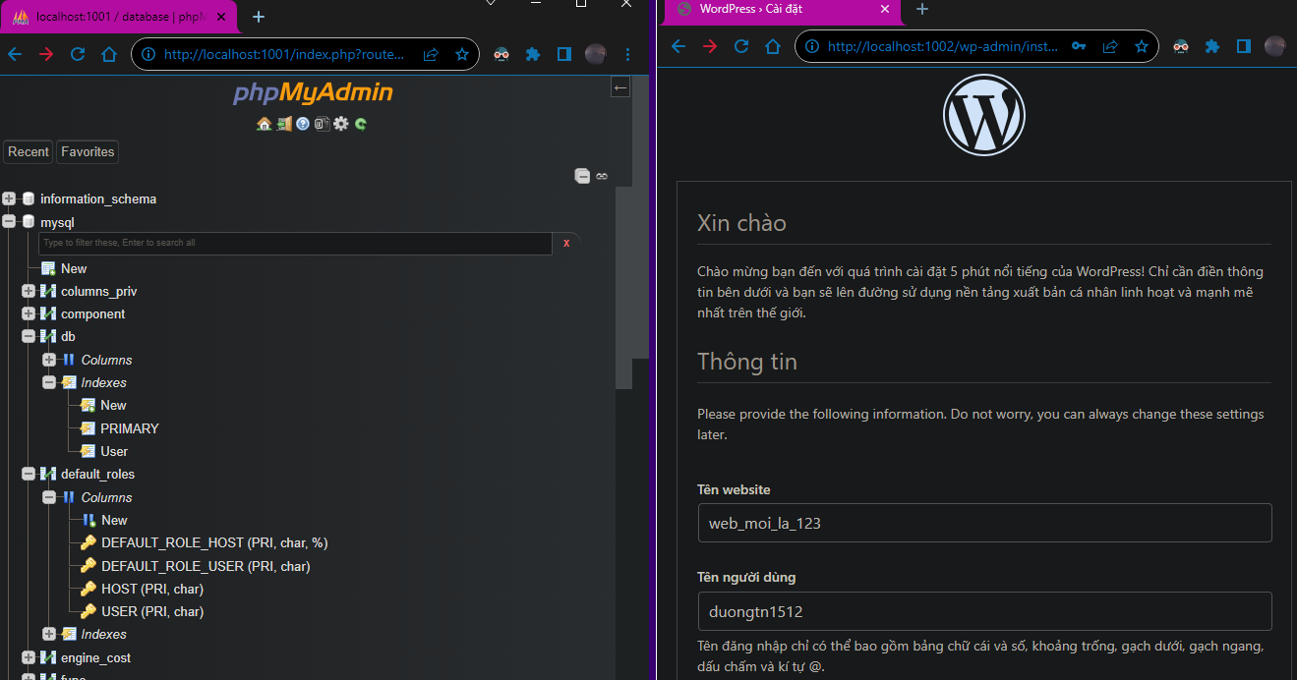
Theo như kết quả hiển thị vậy chúng ta đã hoàn thành xong Task việc còn lại là của backend và frontend dev

