Nguyễn Thái Dương Day 2 exerise:

Task 1: Create a Dockerfile for a Python application that prints a message.
Build the image and run a container from it.
Task 2: Build an image with multiple tags and push it to Docker Hub.
( I do fist 2 task in 1 run )
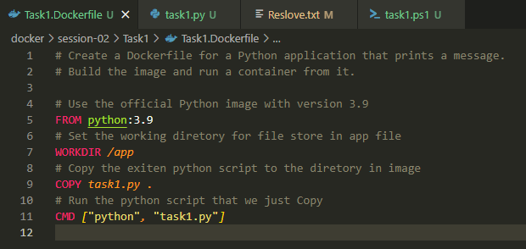
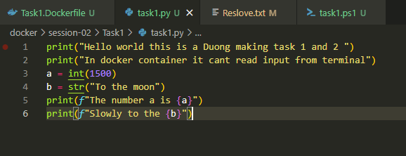
Powershell script to auto build push run login Docker
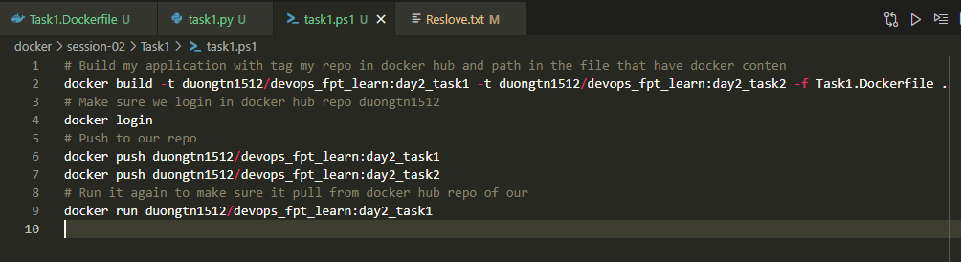

Run the script and get result printed on terminal
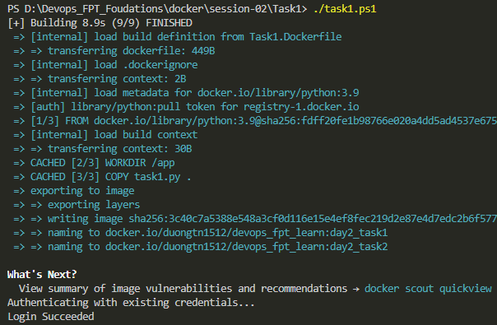
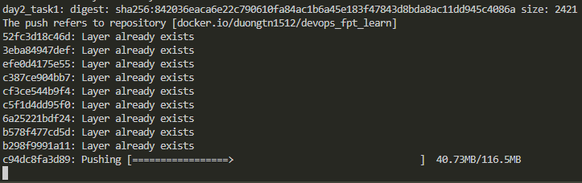
Success login docker hub, build many tag docker images, push it to repo and run a image
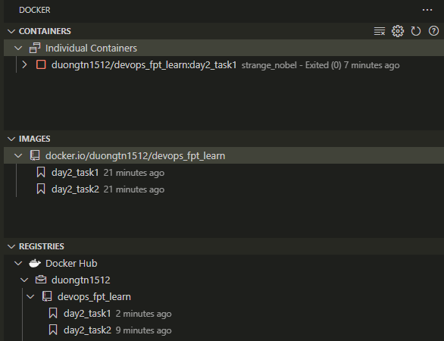
Log from container
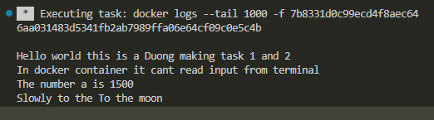
Output of python code I make it into a docker image then run it in a container day2_task1
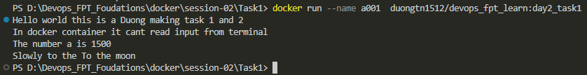

Task 4: Push an image you've created to your Docker Hub repository. Then, pull it to a different machine and run a container.
Create an ec2 aws instance
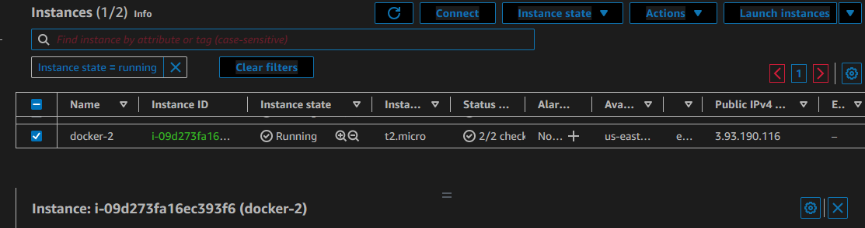
Connect to ec2 via SSH from vs code
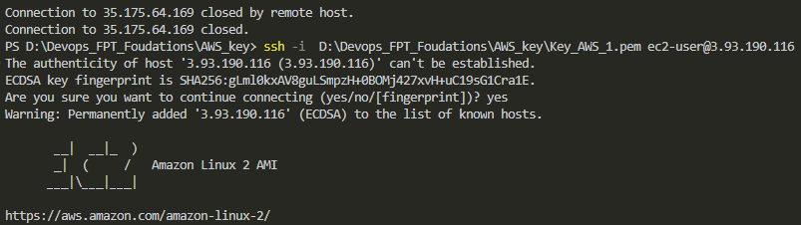

Check images on docker hub repo
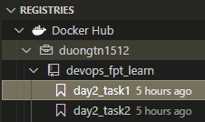
Install docker on cenos and check for status
sudo yum update -y
sudo amazon-linux-extras install docker
sudo service docker start
sudo systemctl enable docker
sudo usermod -a -G docker ec2-user
docker info
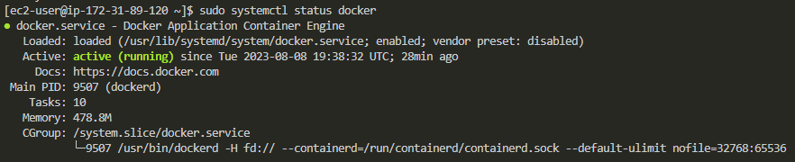
Docker login to docker hub repo
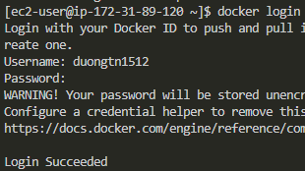
Pull a image and run ( Docker Image is Python base image with code wirted on Task 1 )
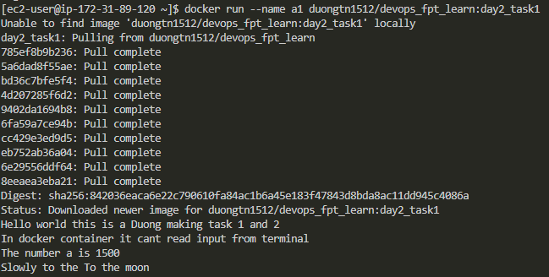
Check docker contaner on this EC2 machine

