Nguyễn Thái Dương Day 5 exerise:

Task : 1. Deploy a working application:
- Clone ReactJS frontend repo: https://github.com/thai-nm/sample-webapp-reactjs.git
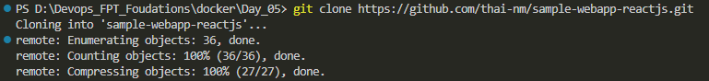
- Clone NodeJS backend repo: https://github.com/uet-app-distributor/sample-nodejs-webapp.git
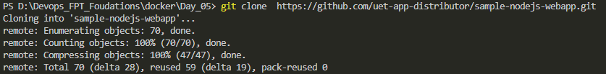
Check the 2 file:
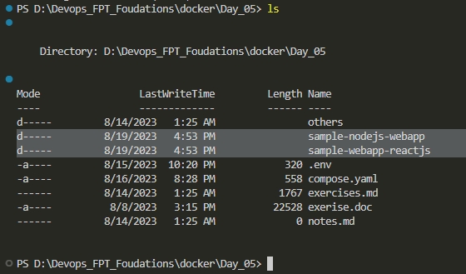
- Change directory to the frontend repo and build your own image with the pre-provided Dockerfile. You should check for the Dockerfile and its build workflow to understand and review about multi-stage and image build process. ( I change folder name to FE and build image with this docker file)
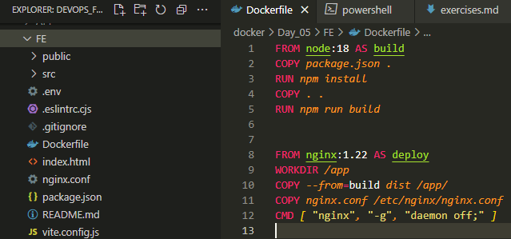
Fist I change the .env file to match API public port that I will public on “127.0.0.1:13000”
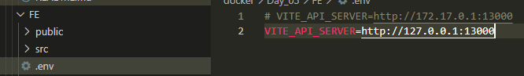
I then build fronend image with tag duongtn1512/docker_day5:fe_homework
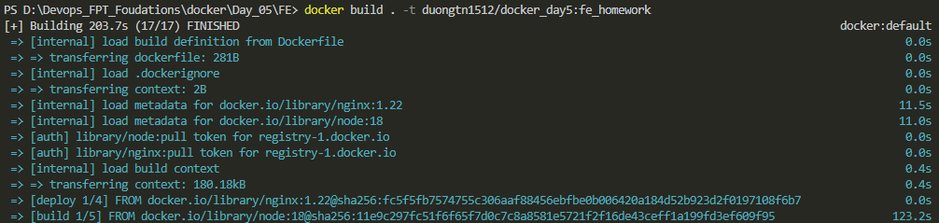
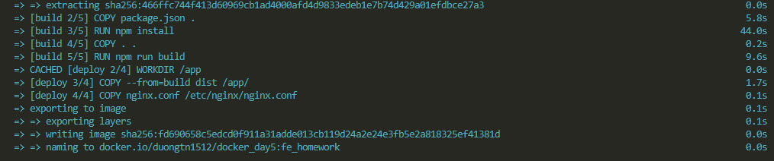
Finish the build successfully
- Change directory to the backend repo and build your own image without seeing the pro-provided Dockerfile. After trying to build your own image or being get stuck, you can use the Dockerfile in the repository as a reference.
I change folder hold node application to API and use docker file within the foldor to build
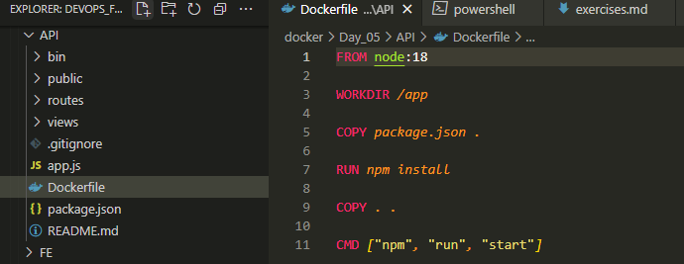
Then build it with tag duongtn1512/docker_day5:api_homework
Here terminal print result
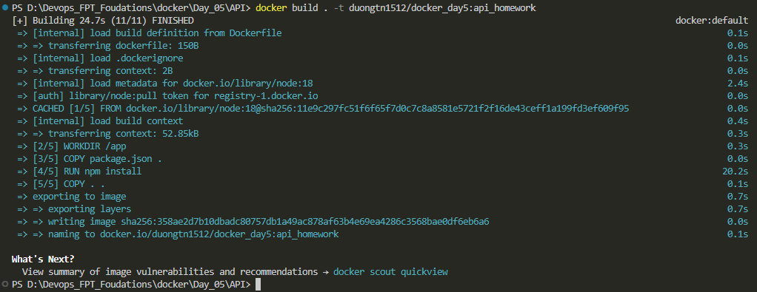
- Upload those new images to your own DockerHub account.
Check for images we have
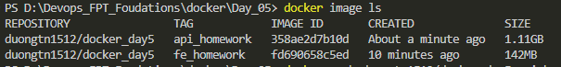
Push to docker hub
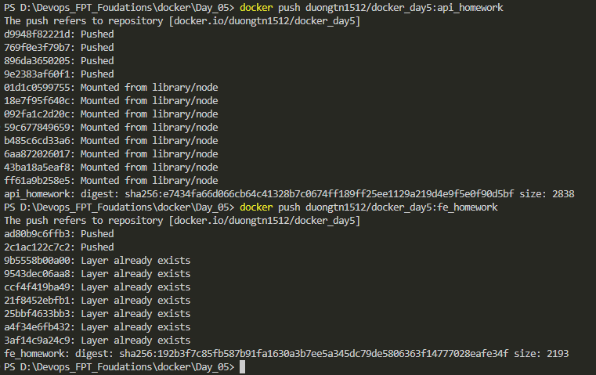
- Develop your own `compose.yml` file for Docker Compose to do the following:
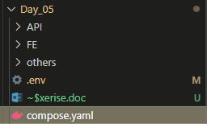 We wirte our compose file at same folder with env file
- Create a new network named `deployment-practice-network`
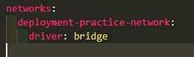
- Create 2 services:
- Service `backend` will create a container name `sample-webapp-nodejs` and refer to the backend image you just pushed above. This service requires environment variables: `USER=practioner-be` and `ENV=dev`. This service will only be exposed at port `13000` of the `loopback` interface and mapped to port `3000` of the container.
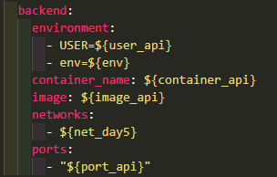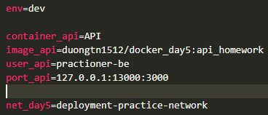
- Service `frontend` will create a container name `sample-webapp-reactjs` and refer to the frontend image you just pushed above. This service requires environment variables: `USER=practioner-fe` and `ENV=dev`. This service will be exposed at port `18080` of the `0.0.0.0` interface and mapped to port `80` of the container.
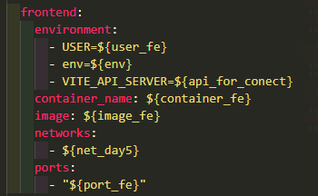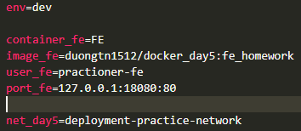
- Deploy with Docker Compose.
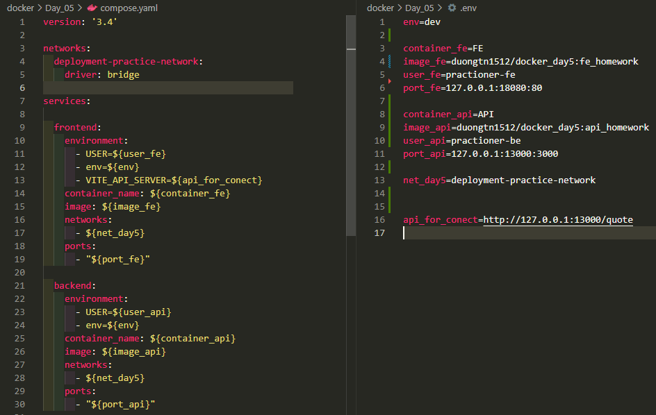
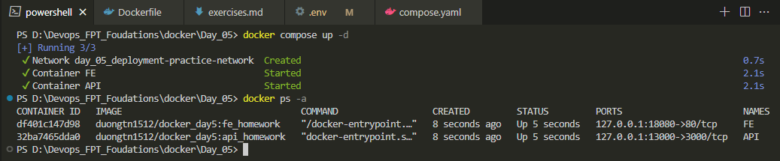
We docker compose up and success run 2 container and a network
- To check if the containers are working or not, open your browser and go to http://localhost:18080. Then click `Give me a quote`. If there is a quote sent to you, everything is working well!
Frontend with return network status code 200 and can get the quote
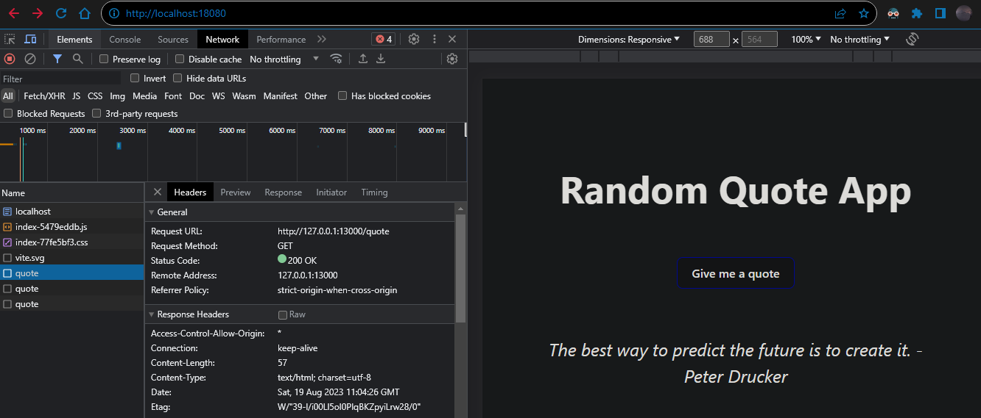
Back end api result
