Writing exercises

1. (a) preorder: D B A C F E G

inorder: A B C D E F G

postorder: A C B F G F D

level: 3

(b) preorder: C B A D E

inorder: A B C D E

postorder: A B E D C

level: 3

(c) preorder: E C B A D H F G I

inorder: A B C D E F G H I

postorder: A B D C G F I H E

level: 4

2. (1) preorder: 4 3 1 2 11 5 9 6 15 12

inorder: 1 2 3 4 5 6 9 11 12 15

postorder: 2 1 3 6 9 5 12 15 11 4

level: 5

After delete 2,3,11:

preorder: 4 1 12 5 9 6 15

inorder: 1 4 5 6 9 12 15

postorder: 1 6 9 5 15 12 4

level: 5

(2) preorder: 12 7 1 3 2 5 6 10 8 9

inorder: 1 2 3 5 6 7 8 9 10 12

postorder: 6 2 5 3 1 9 8 10 7 12

level: 6

After delete 5,6,7:

preorder: 12 8 1 3 2 10 9

inorder: 1 2 3 8 9 10 12

postorder: 2 3 1 9 10 8 12

level: 5

3. (1) preorder: 4 2 1 3 11 6 5 9 15 12

inorder: 1 2 3 4 5 6 9 11 12 15

postorder: 1 3 2 5 9 6 12 15 11 4

level: 4

(2) preorder: 7 3 1 2 5 6 10 8 9 12

inorder: 1 2 3 5 6 7 8 9 10 12

postorder: 1 2 6 5 3 8 12 10 9 7

level: 4

4. The tree(c) in question 1 is height balanced (AVL). Delete the node D and perfom necessary operations so that the tree is still AVL after deletion.  
Rotation right at node B and C



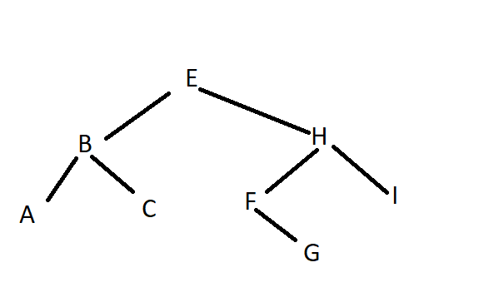

5. a) There are at most 2n+1 nodes

b) There are at most [n/2h+1] nodes of height h

6. It’s not possible 57 is less than 63 but it’t was on the right side of 63,68

