**1**.

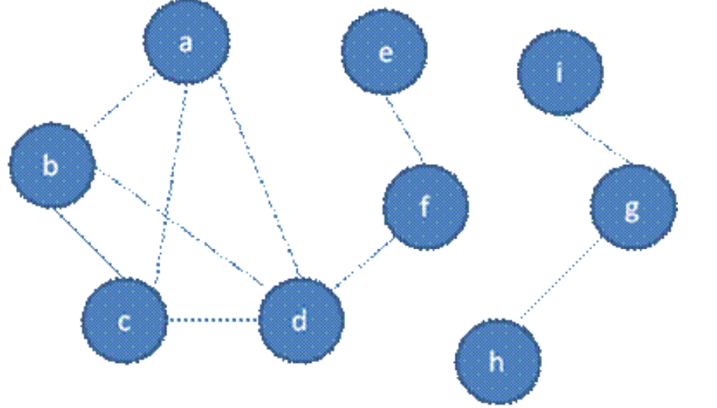

|  |  |  |  |  |  |  |  |  |  |
| --- | --- | --- | --- | --- | --- | --- | --- | --- | --- |
|  | A | B | C | D | E | F | G | H | I |
| A | 0 | 1 | 1 | 1 | 0 | 0 | 0 | 0 | 0 |
| B | 1 | 0 | 1 | 1 | 0 | 0 | 0 | 0 | 0 |
| C | 1 | 1 | 0 | 1 | 0 | 0 | 0 | 0 | 0 |
| D | 1 | 1 | 1 | 0 | 0 | 1 | 0 | 0 | 0 |
| E | 0 | 0 | 0 | 0 | 0 | 1 | 0 | 0 | 0 |
| F | 0 | 0 | 0 | 1 | 1 | 0 | 0 | 0 | 0 |
| G | 0 | 0 | 0 | 0 | 0 | 0 | 0 | 1 | 1 |
| H | 0 | 0 | 0 | 0 | 0 | 0 | 1 | 0 | 0 |
| I | 0 | 0 | 0 | 0 | 0 | 0 | 1 | 0 | 0 |

* Breadth-first traversal: b-a-c-d-f-e g-h-i

**2**.

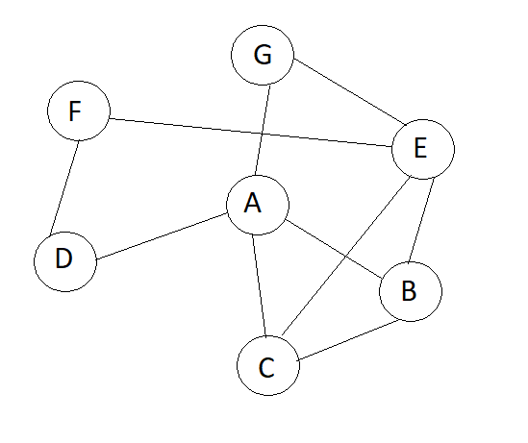

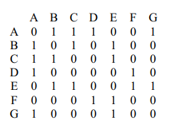

- Breadth-first traversal: a-b-c-d-g-e-f

**3**. A-B-C-D-F-G-E

**4**. 1-2-3-5

**5**. label of vertex 4: 6

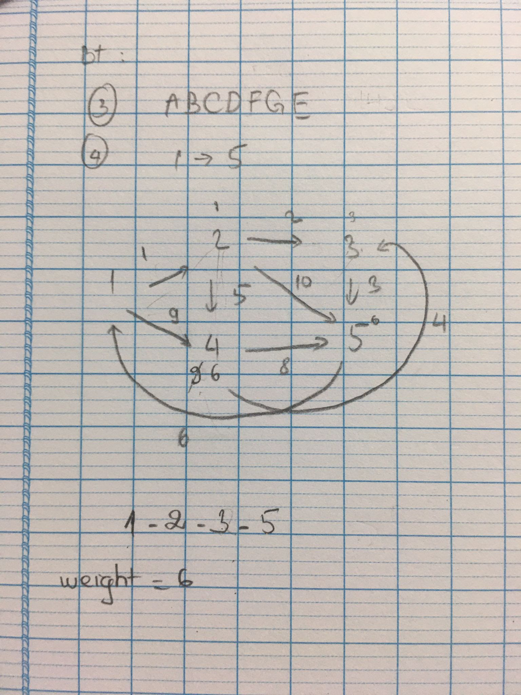

**6**. A-C-E-F

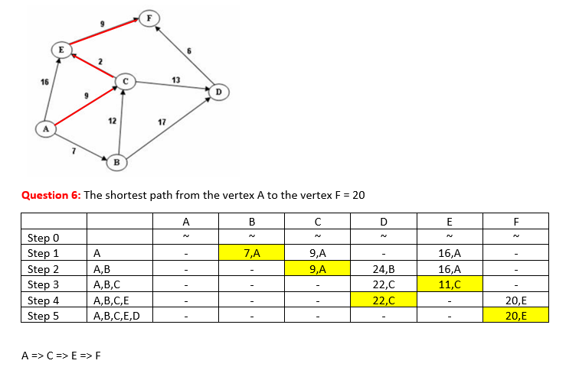

7. Graph is Euler cycle: A-B-D-C-B-A

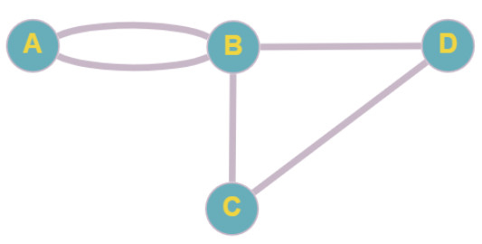

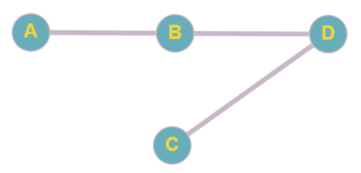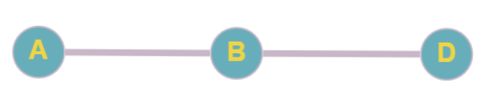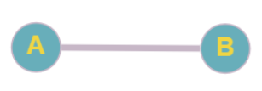

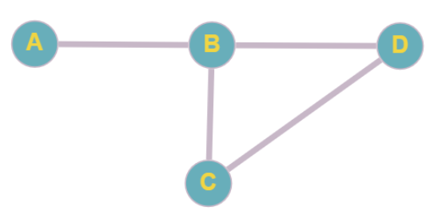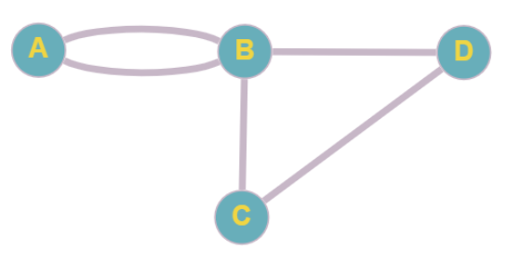

8. Graph is Euler path: A-B-C-B-D-A-D

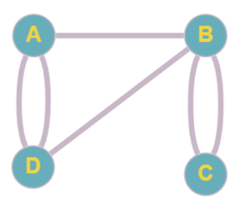

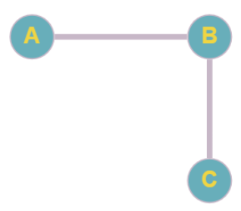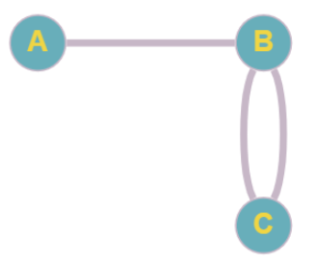



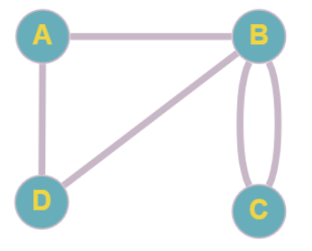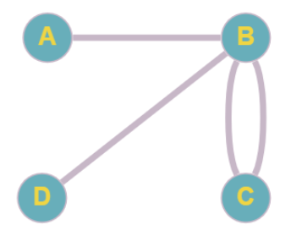

9. Graph is Hamiton cycle: a-b-c-d-e-a

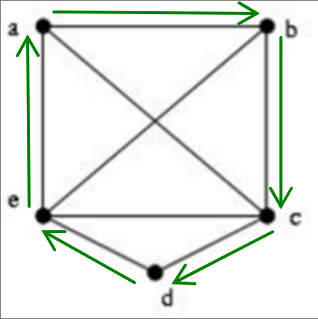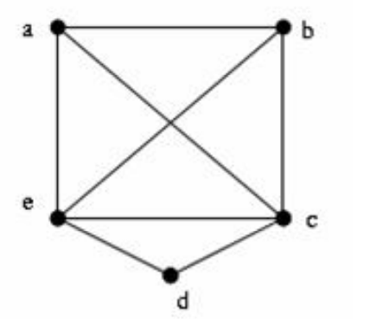

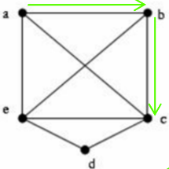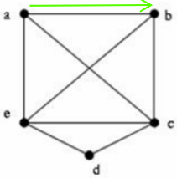

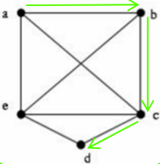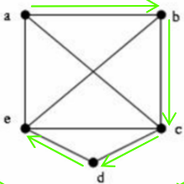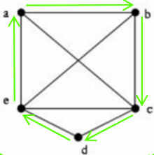

10.

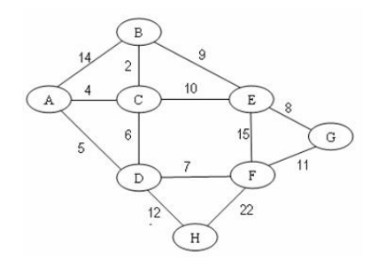

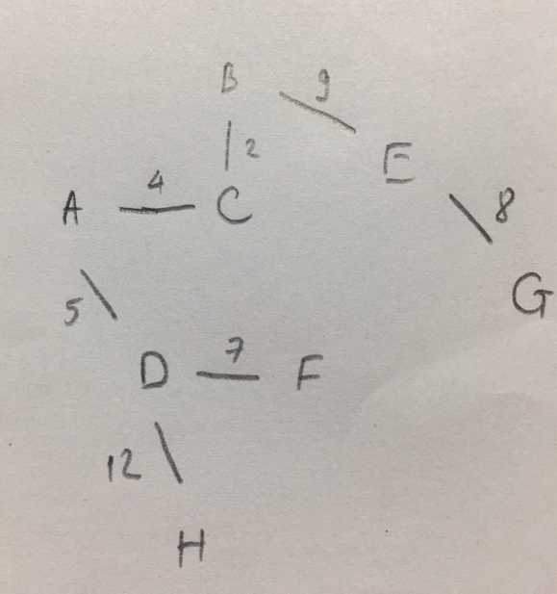

* thuật toán Kruskal: 2,4,5,7,8,9,12
* thuật toán Prim-Jarnik: A-C-B-D-F-E-G-H
* Total edge-weight: 47

11.

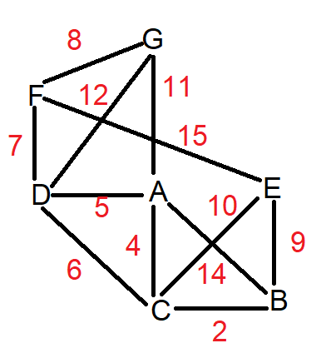

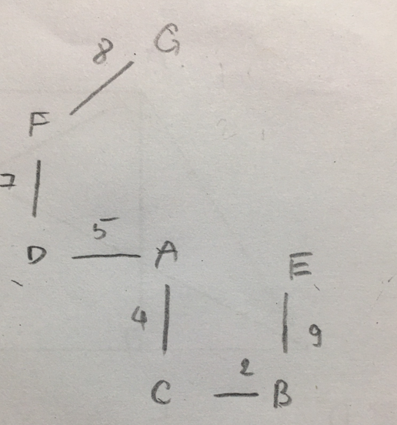

* thuật toán Kruskal: 2,4,5,7,8,9
* thuật toán Prim-Jarnik: A-C-B-D-F-G-E
* Total edge-weight: 35

12. The color of the vertex H is 1

1=RED

2=BLUE

3=GREEN

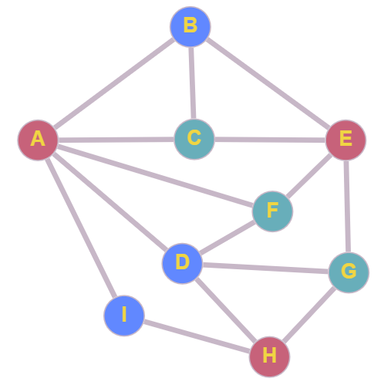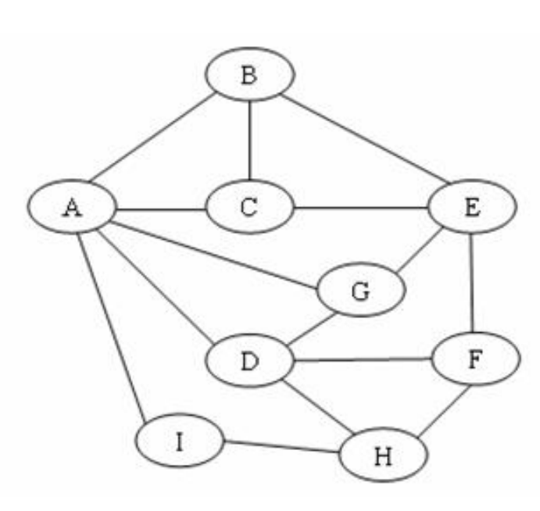

13. The color of the vertex H is 1

1=RED

2=BLUE

3=GREEN

