Gate 2 Design: Behavioural Diagrams
CS4433 Moderated Learning Management System
This document completes the behavioural models: the activity diagram with swimlanes and the two sequence diagrams. They use the same class, service and status names as the class diagram, the use case specifications and the Submission state machine.

1. Activity Diagram: Submission to Released Mark
The swimlanes show who does each step: Student, System, Lecturer and HoD. The student can resubmit as long as the deadline has not passed. A late submission is accepted and flagged as Late. The lecturer marks the work, the HoD checks it, and the student sees the mark only after the HoD releases it.
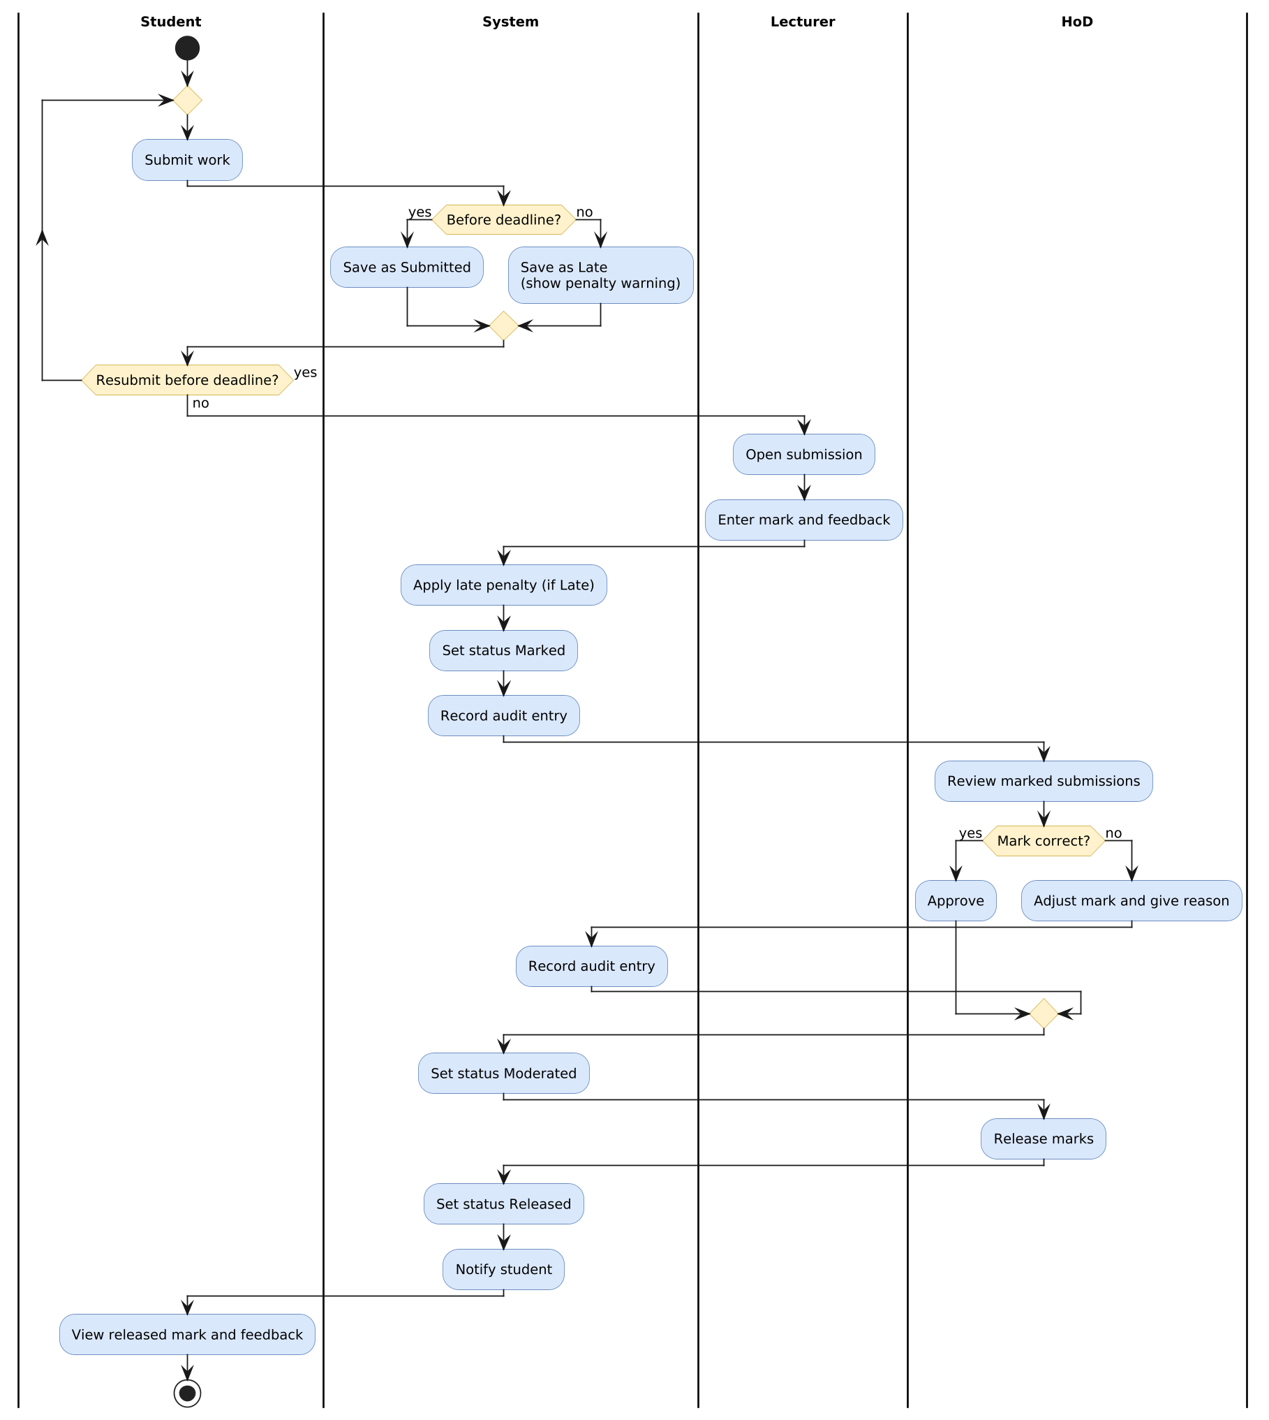
Figure 1: Activity diagram with swimlanes

2. Sequence Diagram: Submit Assignment
This diagram follows the use case “Submit assignment” (UC-1) and shows the normal path, the resubmission path, the late path and the exception flows.
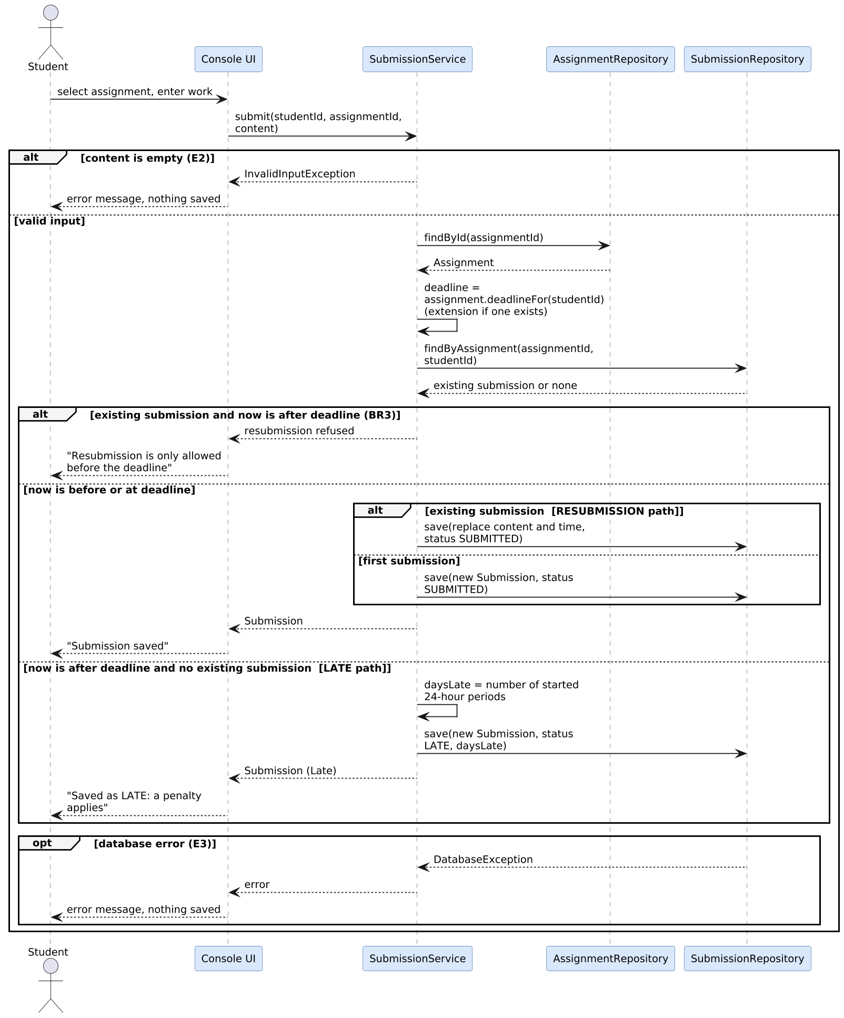
Figure 2: Sequence diagram, Submit assignment
Path | What happens
Normal | Submitted before the deadline, saved with status SUBMITTED.
Resubmission (A1) | A submission already exists and the deadline has not passed, so the old one is replaced.
Late (A2) | The deadline has passed and there is no earlier submission, so it is saved as LATE with the number of late days.
Refused (BR3) | A submission already exists and the deadline has passed, so resubmission is refused.
Errors (E2, E3) | Empty input or a database error shows a message and nothing is saved.
The deadline used is the student’s own deadline, which is the extension date if the lecturer granted one.

3. Sequence Diagram: Moderate and Release Marks
This diagram follows the use case “Moderate and release marks” (UC-3). The HoD approves or adjusts each mark, then releases the moderated marks. Every adjustment is written to the audit log, and the student is notified when a mark is released.
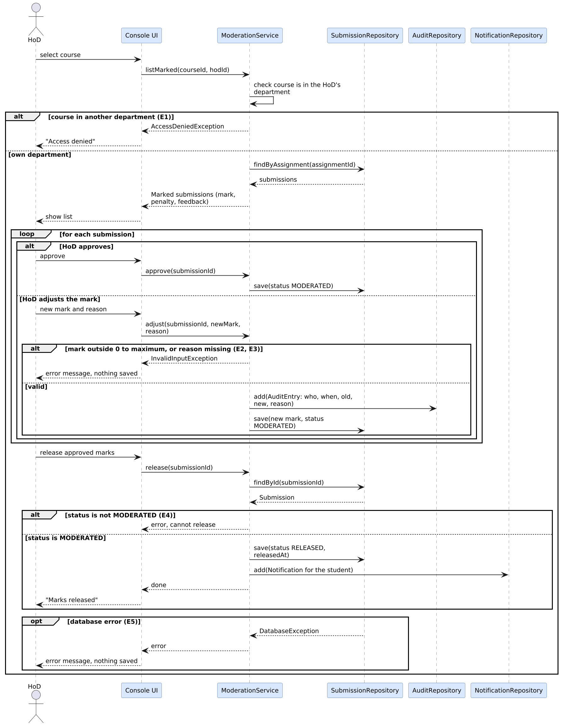
Figure 3: Sequence diagram, Moderate and release marks

4. How the Diagrams Match the Rest of the Design
Diagram | Use case | Requirements | Main classes
Activity (whole process) | UC-1, UC-2, UC-3 | FR-07 to FR-13, FR-16 | Submission, MarkingService, ModerationService
Sequence: Submit assignment | UC-1 | FR-07, FR-08, FR-09, FR-10 | SubmissionService, AssignmentRepository, SubmissionRepository
Sequence: Moderate and release | UC-3 | FR-12, FR-13, FR-14, FR-16 | ModerationService, SubmissionRepository, AuditRepository, NotificationRepository

