Gate 2 Design: Class Diagram, ERD and SQL Schema
CS4433 Moderated Learning Management System
This document completes the class diagram and the database design.

1. Class Diagram
The class diagram is shown in two views to keep it readable. Figure 1 shows the domain classes (the data and the users). Figure 2 shows the services, the repositories and the design patterns. Visibility: - private, + public. Italic names are abstract.
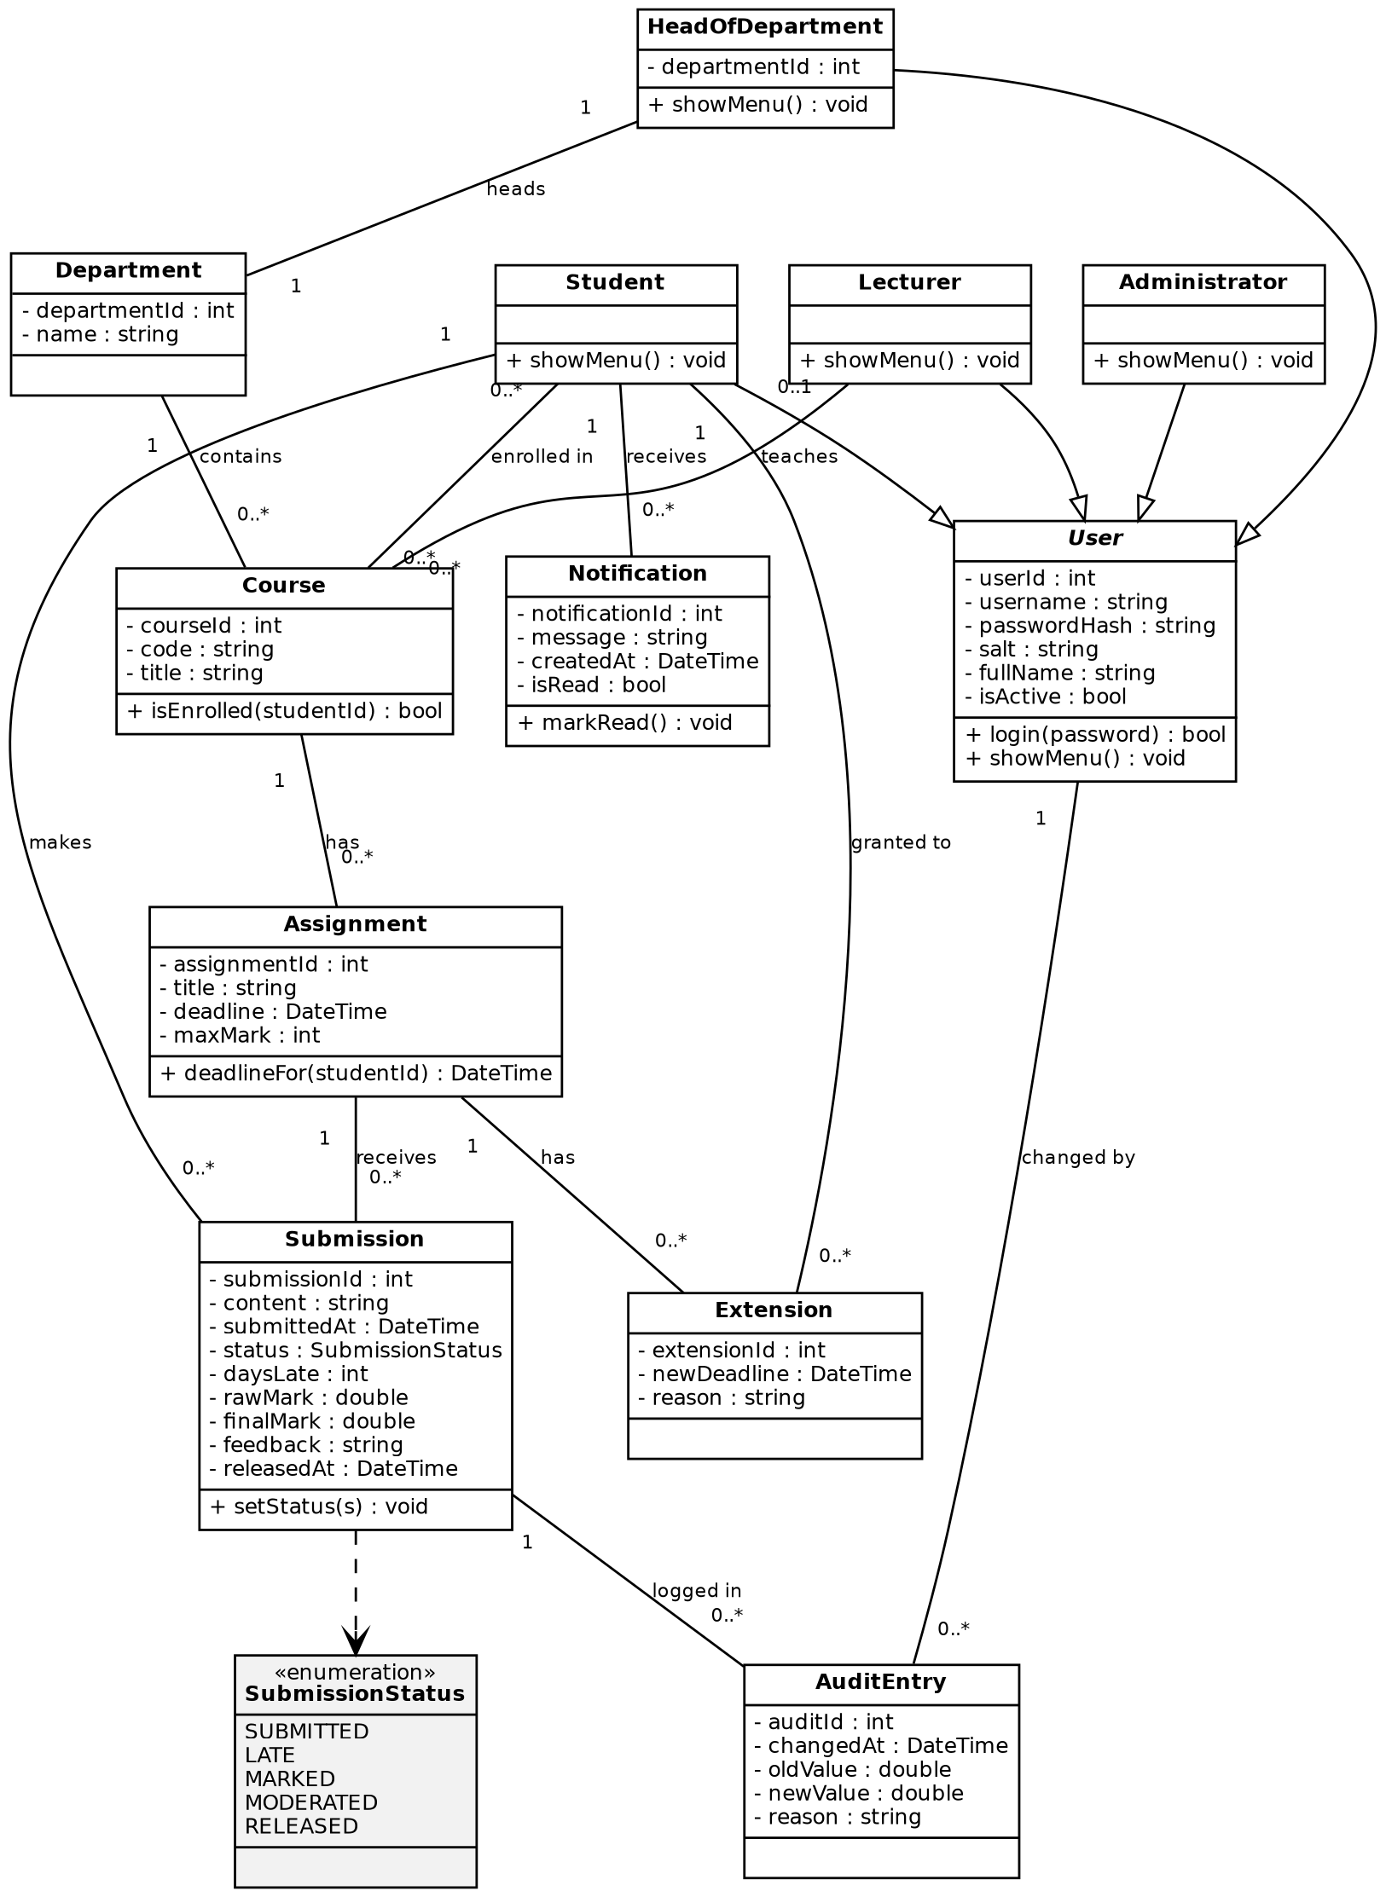
Figure 1: Class diagram, domain classes
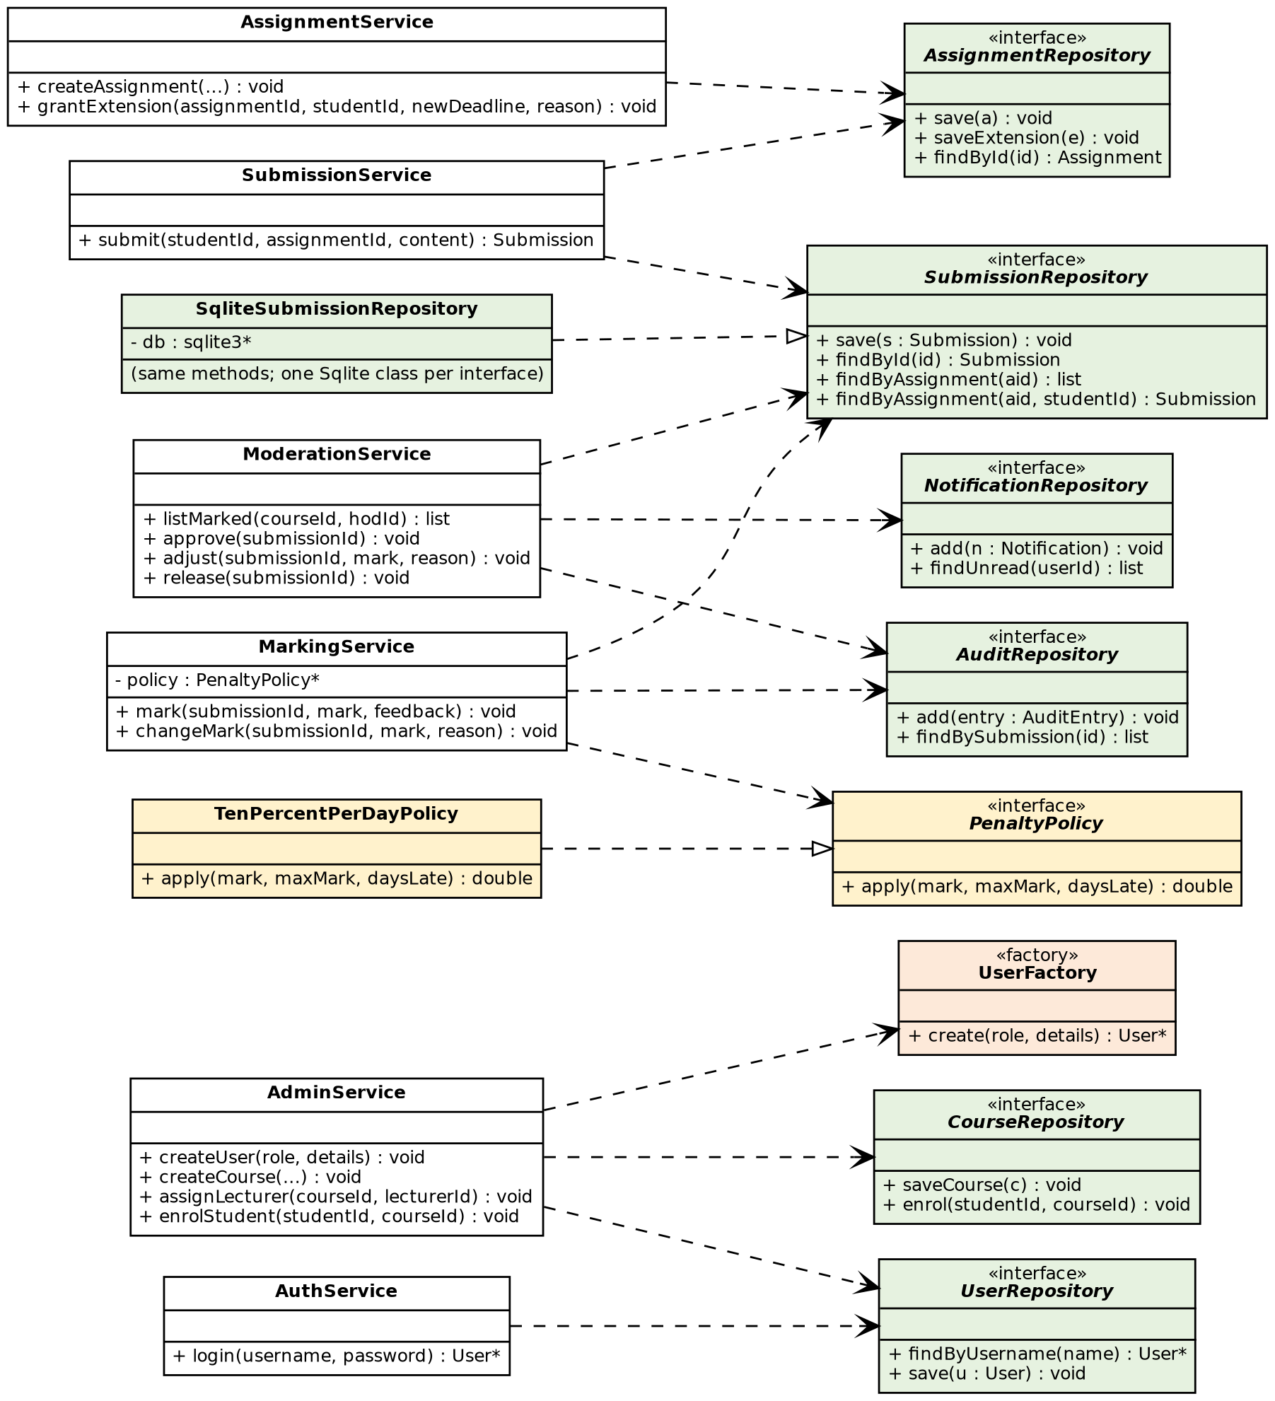
Figure 2: Class diagram, services, repositories and design patterns

Design patterns
Pattern | Classes | Why it was chosen
Strategy | PenaltyPolicy, TenPercentPerDayPolicy | The late-penalty rule is the rule most likely to change. A new rule is a new class; MarkingService does not change.
Repository | the six repository interfaces, SqliteSubmissionRepository (and one Sqlite class per interface) | All SQL lives in the data-access layer. Services depend on interfaces, so tests can use fake repositories.
Factory | UserFactory | AdminService creates a Student, Lecturer, HeadOfDepartment or Administrator through one method, so the role choice is in one place.
SOLID. Each service has one job (S). A new penalty rule is added without editing existing code (O). Any of the four user types can be used where a User is expected (L). Interfaces are small, with one to three methods (I). Services depend on interfaces such as PenaltyPolicy and SubmissionRepository, not on concrete classes or SQLite (D).

2. Entity Relationship Diagram (ERD)
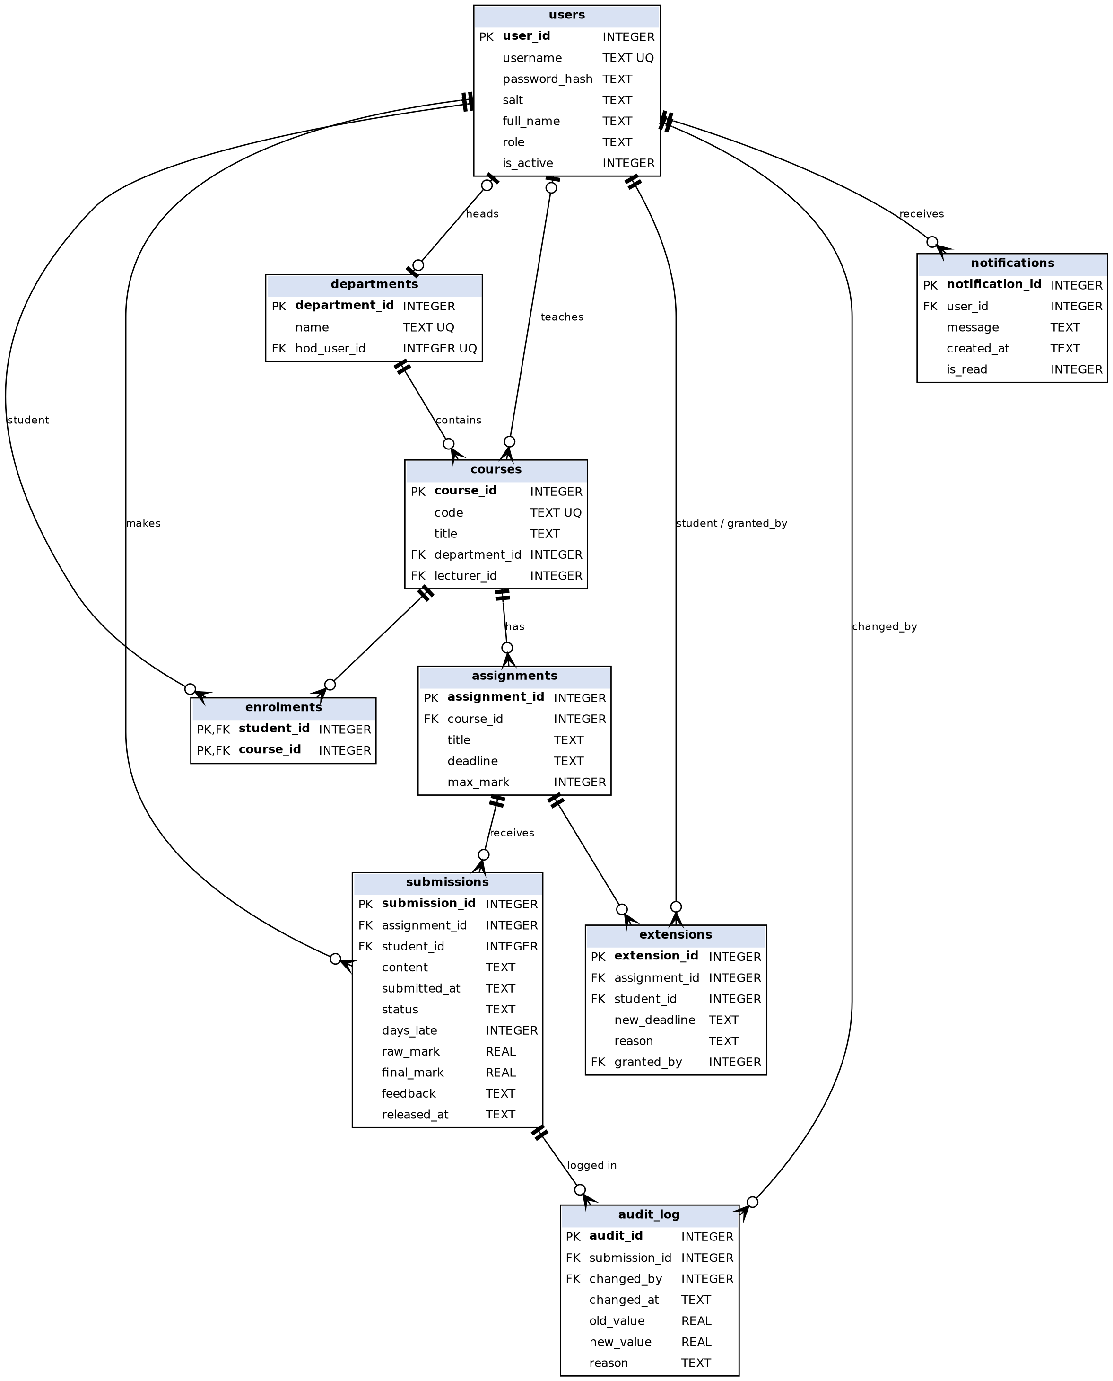
Figure 3: ERD (crow’s foot notation). PK = primary key, FK = foreign key, UQ = unique
Normalisation (3NF). Every table has a primary key and only single-valued columns (1NF). The only composite key is enrolments, which has no other columns, so there are no partial dependencies (2NF). Facts are stored once: for example a department’s name is in departments only, and a course refers to it by department_id, so there are no transitive dependencies (3NF). The one deliberate exception is explained in Section 5.

3. Data Dictionary (summary)
Full column types and constraints are in the SQL schema (Section 4). Dates are stored as ISO 8601 text (for example 2026-11-20T23:59:00) because SQLite has no date type.
Table | Purpose | Notes
users | All people who log in | role is ADMIN, LECTURER, HOD or STUDENT. Passwords are stored only as password_hash plus salt.
departments | School departments | hod_user_id points to the one HoD of the department.
courses | Courses | Belongs to one department; lecturer_id is empty until a lecturer is assigned.
enrolments | Which students take which courses | Many-to-many join table.
assignments | Work set by a lecturer | max_mark must be above 0.
extensions | Individual deadline extensions | One per student per assignment. granted_by records the lecturer.
submissions | A student’s work and its life cycle | status is SUBMITTED, LATE, MARKED, MODERATED or RELEASED. One per student per assignment (a resubmission replaces it).
audit_log | Every mark change | Who (changed_by), when, old_value, new_value and reason. old_value is empty for the first mark.
notifications | On-screen messages | Created when marks are released (FR-16).

4. SQL Schema
PRAGMA foreign_keys = ON;
CREATE TABLE users (
user_id INTEGER PRIMARY KEY AUTOINCREMENT,
username TEXT NOT NULL UNIQUE,
password_hash TEXT NOT NULL,
salt TEXT NOT NULL,
full_name TEXT NOT NULL,
role TEXT NOT NULL
CHECK (role IN ('ADMIN','LECTURER','HOD','STUDENT')),
is_active INTEGER NOT NULL DEFAULT 1 CHECK (is_active IN (0,1))
);
CREATE TABLE departments (
department_id INTEGER PRIMARY KEY AUTOINCREMENT,
name TEXT NOT NULL UNIQUE,
hod_user_id INTEGER UNIQUE REFERENCES users(user_id)
);
CREATE TABLE courses (
course_id INTEGER PRIMARY KEY AUTOINCREMENT,
code TEXT NOT NULL UNIQUE,
title TEXT NOT NULL,
department_id INTEGER NOT NULL REFERENCES departments(department_id),
lecturer_id INTEGER REFERENCES users(user_id)
);
CREATE TABLE enrolments (
student_id INTEGER NOT NULL REFERENCES users(user_id),
course_id INTEGER NOT NULL REFERENCES courses(course_id),
PRIMARY KEY (student_id, course_id)
);
CREATE TABLE assignments (
assignment_id INTEGER PRIMARY KEY AUTOINCREMENT,
course_id INTEGER NOT NULL REFERENCES courses(course_id),
title TEXT NOT NULL,
deadline TEXT NOT NULL, -- ISO 8601, e.g. 2026-11-20T23:59:00
max_mark INTEGER NOT NULL CHECK (max_mark > 0)
);
CREATE TABLE extensions (
extension_id INTEGER PRIMARY KEY AUTOINCREMENT,
assignment_id INTEGER NOT NULL REFERENCES assignments(assignment_id),
student_id INTEGER NOT NULL REFERENCES users(user_id),
new_deadline TEXT NOT NULL,
reason TEXT,
granted_by INTEGER NOT NULL REFERENCES users(user_id),
UNIQUE (assignment_id, student_id)
);
CREATE TABLE submissions (
submission_id INTEGER PRIMARY KEY AUTOINCREMENT,
assignment_id INTEGER NOT NULL REFERENCES assignments(assignment_id),
student_id INTEGER NOT NULL REFERENCES users(user_id),
content TEXT NOT NULL,
submitted_at TEXT NOT NULL,
status TEXT NOT NULL DEFAULT 'SUBMITTED'
CHECK (status IN ('SUBMITTED','LATE','MARKED','MODERATED','RELEASED')),
days_late INTEGER NOT NULL DEFAULT 0 CHECK (days_late >= 0),
raw_mark REAL CHECK (raw_mark >= 0),
final_mark REAL CHECK (final_mark >= 0),
feedback TEXT,
released_at TEXT,
UNIQUE (assignment_id, student_id)
);
CREATE TABLE audit_log (
audit_id INTEGER PRIMARY KEY AUTOINCREMENT,
submission_id INTEGER NOT NULL REFERENCES submissions(submission_id),
changed_by INTEGER NOT NULL REFERENCES users(user_id),
changed_at TEXT NOT NULL,
old_value REAL, -- NULL for the first mark
new_value REAL NOT NULL,
reason TEXT NOT NULL
);
CREATE TABLE notifications (
notification_id INTEGER PRIMARY KEY AUTOINCREMENT,
user_id INTEGER NOT NULL REFERENCES users(user_id),
message TEXT NOT NULL,
created_at TEXT NOT NULL,
is_read INTEGER NOT NULL DEFAULT 0 CHECK (is_read IN (0,1))
);
-- Indexes for the 800-student performance target (NFR-02)
CREATE INDEX idx_submissions_assignment ON submissions(assignment_id);
CREATE INDEX idx_submissions_student ON submissions(student_id);
CREATE INDEX idx_enrolments_course ON enrolments(course_id);
CREATE INDEX idx_assignments_course ON assignments(course_id);
CREATE INDEX idx_audit_submission ON audit_log(submission_id);
CREATE INDEX idx_notifications_user ON notifications(user_id, is_read);
The upper limit of a mark (raw_mark not above the assignment’s max_mark) compares two tables, so SQLite cannot check it in the schema. The service layer checks it before saving (see Mark Submission, exception E1).

5. Mapping from Classes to Tables
Class | Table | Notes and differences
User, Administrator, Lecturer, HeadOfDepartment, Student | users | One table for the whole hierarchy. The role column says which subclass to create (this is what UserFactory reads). Subclasses add no extra columns.
HeadOfDepartment.departmentId | departments.hod_user_id | Stored on the department side so that a department has exactly one HoD.
Department | departments | Direct match.
Course | courses | lecturer_id and department_id are the foreign keys for “teaches” and “contains”.
Student to Course (many-to-many) | enrolments | A join table is needed in a database; it has no class of its own.
Assignment | assignments | Direct match.
Extension | extensions | Direct match.
Submission | submissions | SubmissionStatus is stored as text with a CHECK constraint. days_late and final_mark can be calculated, but they are stored on purpose as a snapshot. If the penalty rule changes later (Strategy), marks that are already released must not change.
AuditEntry | audit_log | Direct match.
Notification | notifications | Direct match.
Services, repositories, PenaltyPolicy, UserFactory | none | They contain behaviour only and hold no stored data.

