Fully Dressed Use Case Specifications
Three use cases for Gate 1. They follow the SRS requirement IDs (FR) and the Submission life cycle: Submitted or Late → Marked → Moderated → Released.

UC-1: Submit Assignment
Field | Content
Actor | Student
Related requirements | FR-07, FR-08, FR-09
Preconditions | Student is logged in and enrolled in the course; the assignment exists.
Main flow | 1. Student selects the course and assignment. 2. System shows the deadline (extended if applicable). 3. Student enters the file path or text. 4. System checks that it is before the deadline. 5. System saves the submission with status Submitted and a timestamp. 6. System confirms.
Alternative flows | A1 Resubmission: a submission already exists and the deadline has not passed → system replaces it and updates the timestamp. A2 Late: the deadline has passed and the mark is not yet given → system saves it with status Late and shows the penalty warning.
Exception flows | E1 Not enrolled → access denied. E2 Empty or invalid input → error message, nothing saved. E3 Database error → message shown, nothing saved, no crash. E4 Resubmission after the deadline → refused.
Postconditions | The submission is stored with its status and time; the earlier version (if any) is replaced.
Business rules | BR1 Late penalty is 10% of the max mark per late day, up to 3 days, then 0. BR2 Extensions move the deadline for that student. BR3 Resubmission only before the deadline.

UC-2: Mark Submission
Field | Content
Actor | Lecturer
Related requirements | FR-05, FR-11, FR-14
Preconditions | Lecturer is logged in and assigned to the course; a submission has status Submitted or Late.
Main flow | 1. Lecturer selects the course and assignment. 2. System lists the submissions. 3. Lecturer opens a submission. 4. Lecturer enters a mark and written feedback. 5. System checks the mark is between 0 and the maximum. 6. System applies the late penalty if the status is Late. 7. System saves the mark and feedback and sets the status to Marked. 8. System records an audit entry.
Alternative flows | A1 Changing a mark: the submission is already Marked but not yet Moderated → Lecturer enters a new mark and a reason; system saves it and logs the old value, new value and reason.
Exception flows | E1 Mark below 0 or above the maximum → error message, nothing saved. E2 Reason missing when changing a mark → change refused. E3 Submission already Moderated → lecturer cannot edit it. E4 Database error → message shown, nothing saved, no crash.
Postconditions | The submission has status Marked; the mark and feedback are stored; the audit log has a new entry; the student cannot see the mark yet.
Business rules | BR1 Late penalty is 10% of the max mark per late day, up to 3 days, then 0. BR2 Only the lecturer of that course may mark. BR3 Every mark change is logged with who, when, old value, new value and reason. BR4 Marks stay hidden from students until released.

UC-3: Moderate and Release Marks
Field | Content
Actor | Head of Department (HoD)
Related requirements | FR-12, FR-13, FR-14, FR-16
Preconditions | HoD is logged in; the course belongs to the HoD’s department; submissions have status Marked.
Main flow | 1. HoD selects a course in their department. 2. System lists all Marked submissions with mark, penalty and feedback. 3. HoD reviews each mark and approves it. 4. System sets the status to Moderated. 5. HoD selects the approved marks and chooses Release. 6. System sets the status to Released and shows the mark and feedback to the students. 7. System notifies each student.
Alternative flows | A1 Adjusting a mark: HoD disagrees with a mark → enters a new mark and a reason; system saves it, logs the change, then continues from step 4.
Exception flows | E1 Course is in another department → access denied. E2 Adjusted mark is outside 0 to maximum → error message, nothing saved. E3 Reason missing for an adjustment → change refused. E4 Submission not yet Marked → cannot be moderated or released. E5 Database error → message shown, nothing saved, no crash.
Postconditions | Approved submissions have status Released; students can see their marks and feedback; every adjustment is in the audit log.
Business rules | BR1 Students see no mark until the HoD releases it. BR2 The HoD may only moderate courses in their own department. BR3 Only Moderated marks can be released. BR4 Every adjustment is logged with who, when, old value, new value and reason.

Risk Register Update (Gate 1)
Scores are Likelihood (L) and Impact (I) from 1 to 5; Exposure = L × I. Date updated: [enter Gate 1 date].
# | Risk | Old Exp | L | I | Exp | Change since Week 1
R1 | Requirements conflict or are misunderstood | 16 | 2 | 4 | 8 | Conflicts resolved (Part B); three use cases written.
R2 | Falling behind schedule | 20 | 4 | 5 | 20 | Unchanged: design is heavy and implementation has only 2 weeks.
R3 | Unfamiliar tools (CMake, SQLite, GoogleTest, CI) | 9 | 2 | 3 | 6 | CMake + GoogleTest build working.
R4 | Bugs in late-penalty or moderation logic | 12 | 2 | 4 | 8 | Rules clarified; isolated in PenaltyPolicy (Strategy).
R5 | Data loss or corrupted database | 10 | 2 | 5 | 10 | Unchanged.
R6 | Insecure passwords or SQL injection | 10 | 2 | 5 | 10 | Unchanged: salted hashes and parameterised queries planned.
R7 | Illness or laptop failure | 10 | 2 | 5 | 10 | Unchanged: push to Git daily.
R8 | Design and code drift apart | 12 | 3 | 4 | 12 | Unchanged: keep class names identical in code.
R9 | Supervisor or stakeholder unavailable | 6 | 2 | 3 | 6 | Unchanged: Gate 1 review booked.
R10 | New: Design not approved at Gate 2, blocking implementation | - | 3 | 4 | 12 | Keep the design simple; review early with supervisor.

Software Design (start)

1. Architecture
The system uses a layered architecture: Console UI → Services (business rules) → Repositories (data access) → SQLite. Each layer only talks to the layer directly below it.
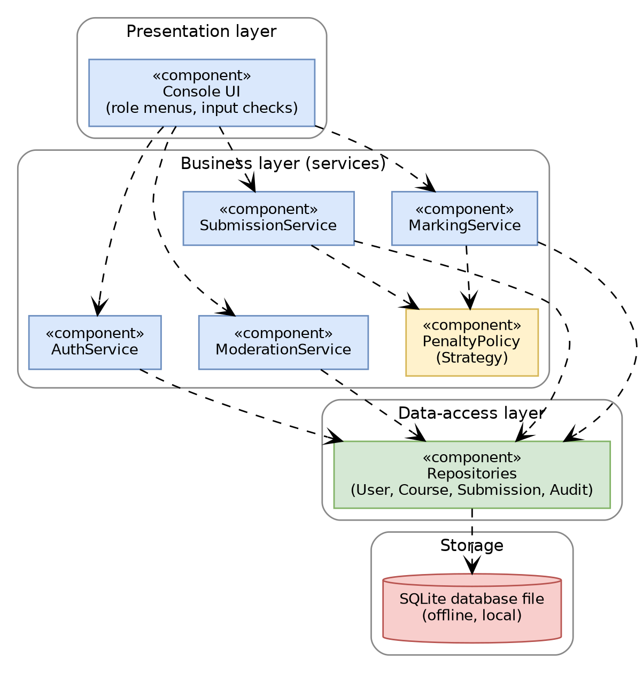
Component diagram
Option | Decision | Reason
Layered (UI → Services → Repositories → SQLite) | Chosen | Simple to understand and build alone. Keeps SQL out of business rules. Services can be unit-tested without the UI or database (supports the 70% coverage target). Works offline on one computer.
MVC | Rejected | MVC suits GUIs where views update from models. A console menu has one text screen, so MVC adds extra wiring without benefit.
All code in the menu functions (no layers) | Rejected | Quickest at first, but mixes SQL with rules, is hard to test and hard to change later (for example CR1).

2. Class Diagram (starter)
Visibility: - private, + public. Italic names are abstract. Department, Extension, AuditEntry and the remaining services will be added in Week 3 together with the database design.
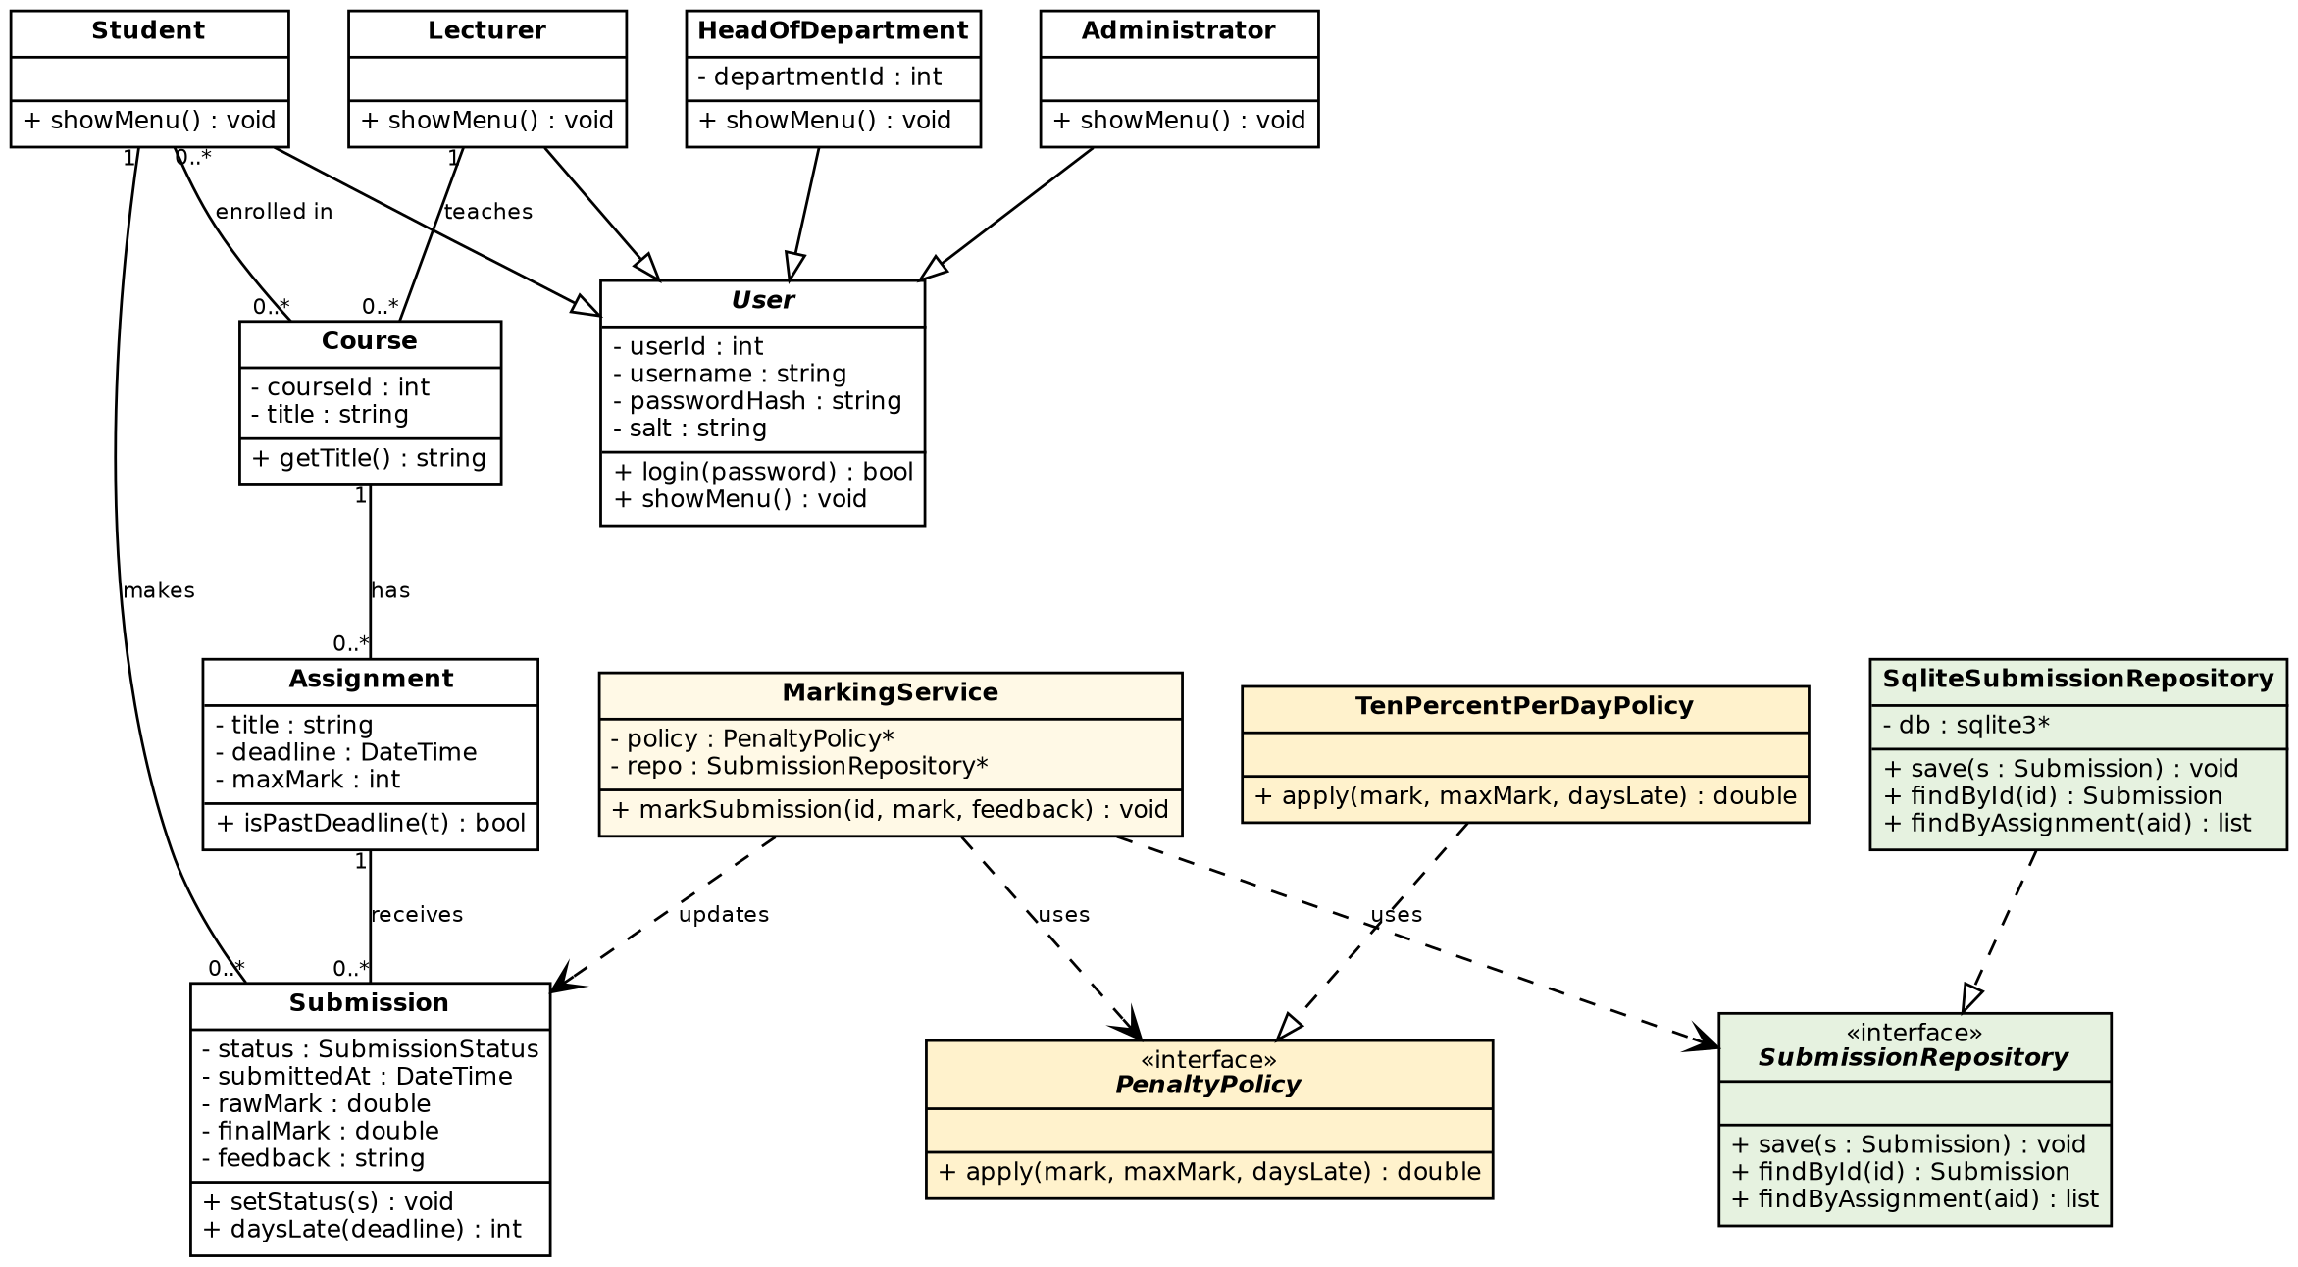

Pattern | Classes | Why it was chosen
Strategy | PenaltyPolicy, TenPercentPerDayPolicy | The late-penalty rule is the most likely rule to change. A new rule is a new class; MarkingService does not change.
Repository | SubmissionRepository, SqliteSubmissionRepository | All SQL lives in one place. Services depend on the interface, so tests can use a fake repository and SQLite can be swapped.
SOLID: each service has one job (S). A new penalty rule is added without editing existing code (O). Any of the four user types can be used where a User is expected (L). Interfaces are small, with one to three methods (I). Services depend on the PenaltyPolicy and SubmissionRepository interfaces, not on concrete classes or SQLite (D).

3. State Machine Diagram: Submission life cycle
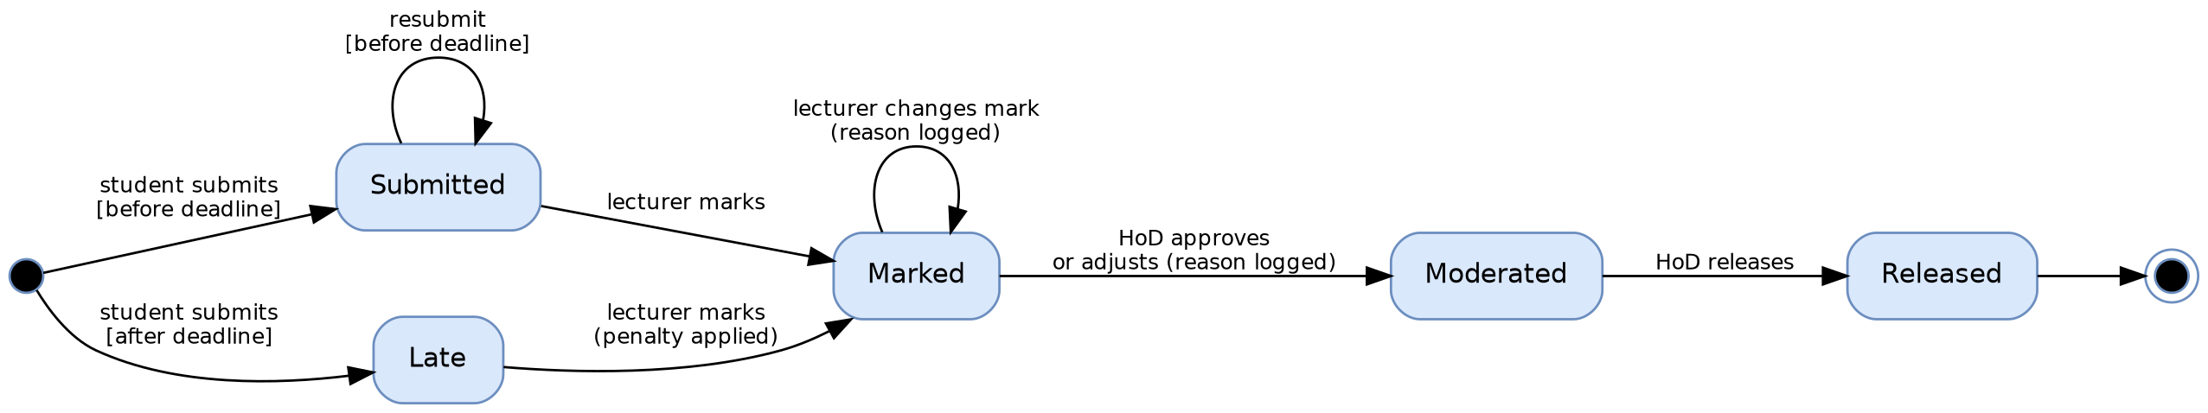

A student can see a mark only when the submission is in the Released state. Marks can be changed only in Marked, and every change is logged with who, when, old value, new value and reason.

