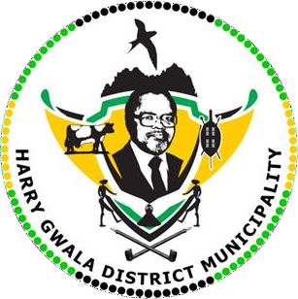
HARRY GWALA DISTRICT MUNICIPALITY
“Together We Deliver and Grow”

OFFICE OF THE MUNICIPAL MANAGER
40 Main Street, Private Bag X501, IXOPO 3276 Tel: (039) 834 8707 Fax: (039) 834 1701
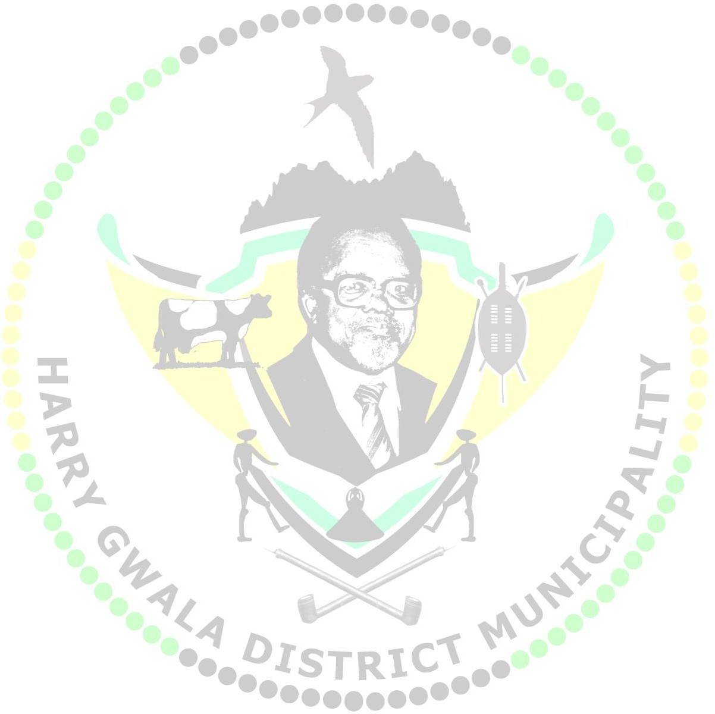
Email: KuneneS@harrygwaladm.gov.za

PROHIBITION NOTICE
ISSUED IN TERMS OF SECTION 8 OF THE HARRY GWALA DISTRICT MUNICIPALITY MUNICIPAL HEALTH SERVICES BYLAWS 2024

NAME OF OWNER NAME OF PERSON IN CHARGE: {{ owner_name }} {{ Surname }}
ADDRESS OF PREMISES: {{address__ }}
DATE OF INSPECTION: {{EditDate }}

- It is hereby instructed that the following activities on the above-mentioned premises pose an immediate health risk and must be seized with immediate effect.
{{ Prohibitions_activities }}

- The reason(s) for the prohibition:
{{Reasons_for_prohibition }}

- The health certificate may not be displayed on the premises until such time that the prohibition has been removed.

- The prohibition will in writing be removed by the Environmental Health Practitioner as soon as the reason(s) for the prohibition has been removed, and provided that the Environmental Health Practitioner is satisfied that the reason(s) for the prohibition is (are) addressed and not likely to recur.

- Any person performing an act contrary to this prohibition order will be guilty of an offence and liable for prosecution.

Signature of the EHP: {{signature }} Date: {{EditDate }}

