Peak Signal to Noise Ratio Search (PSNR_SEARCH) and
PSNR Variable Frame Delay (PSNR_VFD)
Software Release Version 1.2 Release Notes
July, 2011

This file contains information about the above product in the following sections:

1. Release Contents
2. Package Contents
3. System Requirements
4. Technical Support Information
5. Install/Uninstall Instructions
6. Operating Instructions
7. Product Release Notes
8. Usage, Copyright, and Patent Information
9. Use of VQM Numbers in Outside Reporting
10. Input and Output Arguments
11. Validation

1) Release Contents
-------------------------------------------
The PSNR_SEARCH and PSNR_VFD software was developed by the Institute for Telecommunication Sciences (ITS). PSNR_SEARCH performs automated processing on all pairs of video files (original and processed) within a user specified input directory. The original video sequence (e.g., straight from the camera) is the reference sequence and the processed video sequence is the impaired video sequence (e.g., after coding and transmission and decoding). This program runs under the Windows operating system. PSNR_SEARCH automatically determines the optimal video calibration (e.g., spatial shift, temporal shift, gain, offset) for a given set of uncertainty search ranges such that PSNR is maximized. The processed video sequence is only allowed to have one temporal shift with respect to the original video sequence (i.e., frame-by-frame variable video delays are not estimated or removed by the program).

PSNR_VFD uses the results file output by PSNR_SEARCH ("psnr_file") as a calibration starting point, but goes one step further by applying variable frame delay (VFD) matching of the original video stream to the processed video stream (i.e., the original video stream is modified so that it matches the processed video stream frame-by-frame, or field-by-field for interlaced video). Output results from the PSNR_VFD program are stored in a file with the same root name as "psnr_file" (i.e., name without the file extension), appended with "_vfd.csv" (for Comma Separated Value). PSNR_VFD also extracts two perception based VFD parameters (see ntia_tm-11-475.pdf for more information).

2) Package Contents
-------------------------------------------

The PSNR_SEARCH / PSNR_VFD software Version 1.2 package contains the following:

Installation related files:
MCRInstaller.exe

Software related files:
psnr_search.exe
psnr_vfd.exe

Video Sequences:
psnr_calmob_original.yuv
psnr_calmob_hrc2.yuv
psnr_flogar_original.yuv
psnr_flogar_hrc1.yuv

Technical documentation:
psnr_pc_readme.pdf
ITUT_COM9_C6.pdf
ntia_tm_10_463.pdf
ntia_tm-11-475.pdf

If any of these files are missing, you have not received an official distribution of the PSNR_SEARCH / PSNR_VFD software.

3) System Requirements
-------------------------------------------
PSNR_SEARCH / PSNR_VFD software version 1.2 requires the following software and hardware:

Minimum Configuration:
Processor 2.0 GHz Pentium
RAM 2.0 GB (for SD video), >4.0 GB (for HD video)
Software XP 32-bit (for 32-bit executable), Windows 7 64-bit (for 64-bit executable). The software may run under Vista but this has not been tested.
Disk >4 GB free disk space

4) Technical Support Information
-------------------------------------------
Please send any problems or requests for future improvements to vqm@its.bldrdoc.gov

For information on other video quality NTIA/ITS publications, visit <http://www.its.bldrdoc.gov/pub/n3/video/index.php >. For information on other NTIA/ITS publications, visit the NTIA/ITS web site at <www.its.bldrdoc.gov>. Other video quality measurement software tools may be obtained at <http://www.its.bldrdoc.gov/vqm/>.

5) Install/Uninstall Instructions
-------------------------------------------

*******************************************
*****Install Instructions
*******************************************
The PSNR_SEARCH / PSNR_VFD software was developed using MATLAB and its associated toolboxes. It is therefore necessary to install the MATLAB Component Runtime (MCR) library before running PSNR_SEARCH. If a prior version of the software was installed, you must first uninstall the old version of the MATLAB Component Runtime Library before proceeding (see Uninstall Instructions below). Follow this installation procedure for PSNR_SEARCH / PSNR_VFD:

1. Copy the distribution files to a directory on your computer. This directory will be denoted as c:\PSNR for the rest of the installation instructions given below.

2. Double click MCRInstaller.exe in c:\PSNR and follow the instructions to install the MCR library on your computer.

3. After completing installation, check to make sure that the MATLAB Component Runtime library installed properly. From the "Start" menu, select "Control Panel", and in the window that appears, double-click "Add or Remove Programs" and see if the MATLAB Component Runtime library appears in the list of installed programs. If not, repeat step 2.

*******************************************
*****Uninstall Instructions
*******************************************
1. Select "Start", "Control Panel", "Add/Remove Programs". From the list of programs, select "MATLAB Component Runtime", and press "Remove".

2. Delete your installation directory and all files in it.

6) Operating Instructions
-------------------------------------------
Open a command prompt window by selecting "Start", "Program", "Accessories", "Command Prompt". Change to the c:\PSNR installation directory in step 1 of the Installation Instructions by typing "cd c:\PSNR" at the command prompt.

To start the PSNR_SEARCH software, type "psnr_search" at the command prompt. To start the PSNR_VFD software, type "psnr_vfd" at the command prompt.

Execute PSNR_SEARCH / PSNR_VFD with no arguments for syntax and brief operating instructions. See also #10 below for details.

Since PSNR_SEARCH / PSNR_VFD load the entire original and processed video clips into memory in double precision format, you may encounter out of memory problems for long video sequences and/or high resolution video sequences (e.g., HDTV). The solution to this problem is to utilize the 64-bit executable version and to install more RAM.

7) Product Release Notes
-------------------------------------------
Version 1.0 is the first released version of the software (versions 1.0 and 1.1 only included the PSNR_SEARCH module).

-----
The following changes have been made in version 1.2 (when compared with version 1.1):

1. Added a variable frame delay (VFD) PSNR software module (PSNR_VFD) to the distribution package. PSNR_VFD uses the results output file from PSNR_SEARCH as a starting point.

2. Improvements and bug fixes have been made to the read_avi function, including support for the ‘YV12’ format.

-----
The following changes have been made in version 1.1 (when compared with version 1.0):

1. Improved read_avi function to read more uncompressed formats and files larger than 2 GB. Support has been added for 10-bit uncompressed UYVY files in the ‘V210’ format (but the read times are very slow).

2. Added a ‘fraction_sampled’ option that uses randomly sub-sampled pixels to compute the gain and level offset. This greatly reduces the maximum memory required. If users are encountering ‘out of memory’ issues they should try this option.

3. Added a ‘video_standard’ option for processing interlaced video sequences. This option allows for the possibility that the processed video is ‘reframed’, or off by one-field, with respect to the original video.

4. Added a ‘full_results’ option that will save the PSNR results for each spatial and temporal shift that is examined. One full results file is output for each processed clip that is examined.

5. In ‘verbose’ mode, added a 3D plot of PSNR (PSNR as a function of spatial uncertainty x and y) for each time shift that produces an improved PSNR estimate. These plots are only output for ‘progressive’ video when the spatial uncertainty in the both the x and y directions are greater than zero.

8) Usage, Copyright, and Patent Information
-------------------------------------------
THE NATIONAL TELECOMMUNICATIONS AND INFORMATION ADMINISTRATION, INSTITUTE FOR TELECOMMUNICATION SCIENCES (“NTIA/ITS”) DOES NOT MAKE ANY WARRANTY OF ANY KIND, EXPRESS, IMPLIED OR STATUTORY, INCLUDING, WITHOUT LIMITATION, THE IMPLIED WARRANTY OF MERCHANTABILITY, FITNESS FOR A PARTICULAR PURPOSE, NON-INFRINGEMENT AND DATA ACCURACY. THIS SOFTWARE IS PROVIDED "AS IS." NTIA/ITS does not warrant or make any representations regarding the use of the software or the results thereof, including but not limited to the correctness, accuracy, reliability or usefulness of the software or the results. You can use, copy, modify, and redistribute the NTIA/ITS developed software upon your acceptance of these terms and conditions and upon your express agreement to provide appropriate acknowledgments of NTIA's ownership of and development of the software by keeping this exact text present in any copied or derivative works.

The user of this Software (“Collaborator”) agrees to hold the U.S. Government harmless and indemnifies the U.S. Government for all liabilities, demands, damages, expenses, and losses arising out of the use by the Collaborator, or any party acting on its behalf, of NTIA/ITS’ Software, or out of any use, sale, or other disposition by the Collaborator, or others acting on its behalf, of products made by the use of NTIA/ITS’ Software.

9) Use of PSNR Numbers in Outside Reporting
---------------------------------------------------------------------
U.S. Department of Commerce policy prohibits NTIA/ITS from endorsing products. However, the NTIA PSNR Method has been included in ITU-T Recommendation J.340, “Reference Algorithm for Computing Peak Signal to Noise Ratio (PSNR) of a Processed Video Sequence with Constant Spatial Shifts and a Constant Delay” (see ITUT_COM9_C6.pdf).

Therefore, you can reference the PSNR numbers in outside reporting of performance as long as you:

1. Reference the ITU-T standard given above, and
2. Do not mention NTIA/ITS.

Variable frame delay (VFD) PSNR, as calculated by PSNR_VFD, has not yet been standardized by the ITU.

10) Input and Output Arguments
---------------------------------------------------------------------
Document ITUT_COM9_C6.pdf, provided with this release, provides a preliminary description of the PSNR_SEARCH algorithms and MATLAB reference code. Additions were made to the PSNR_SEARCH routine so it could accept uncompressed UYVY AVI files as input (which is now the default video file format that is assumed by PSNR_SEARCH), and to allow the user to specify an output file that will contain the results. The following three command line arguments are required by PSNR_SEARCH:

'clip_dir' Specifies the directory that contains the original and processed video clip pairs.

'test' The name of the video test to process. Video files in the clip_dir must conform to standard naming conventions, test_scene_hrc.yuv (for Big YUV files) and test_scene_hrc.avi (for uncompressed UYVY AVI files), with no extra '_' or '.' in the file names. 'test' is the name of the test, 'scene' is the name of the scene, and 'hrc' is the name of the HRC. The original reference clip must have an HRC name of 'original'.

'results_file' The full path name of the file to save PSNR results, in Comma-Separated Values (CSV) format.

Document ntia_tm-11-475.pdf, provided with this release, provides a description of the PSNR_VFD algorithms and MATLAB reference code. The following four command line arguments are required by PSNR_VFD:

'clip_dir' Specifies the directory that contains the original and processed video clip pairs.

'test' The name of the video test to process. Video files in the clip_dir must conform to standard naming conventions, test_scene_hrc.yuv (for Big YUV files) and test_scene_hrc.avi (for uncompressed UYVY AVI files), with no extra '_' or '.' in the file names. 'test' is the name of the test, 'scene' is the name of the scene, and 'hrc' is the name of the HRC. The original reference clip must have an HRC name of 'original'.

‘scan_type’ Specifies the scan type of the video files as either ‘progressive’, ‘interlaced_lff’ (interlaced lower field first), or ‘interlaced_uff’ (interlaced upper field first).

'psnr_file' The full path name of the 'results_file' as output by PSNR_SEARCH run using the same 'clip_dir' and 'test'.

Run PSNR_SEARCH / PSNR_VFD with no command line options to obtain further help information and documentation and to obtain a complete list of the optional command line arguments accepted by the software.

11) Validation
---------------------------------------------------------------------

To validate PSNR_SEARCH, run on the provided video sequences with the following command line (this assumes that the software was installed as given in item 5):

psnr_search 'c:\psnr' 'psnr' 'psnr_results.csv' 'yuv' 144 176 'sroi' 5 5 140 172 'spatial_uncertainty' 1 1 'temporal_uncertainty' 8 'verbose'

You should get the printout as specified in Appendix I of ITUT_COM9_C6.pdf. The file 'psnr_results.csv' will be created that contains these results when loaded into a spreadsheet program:

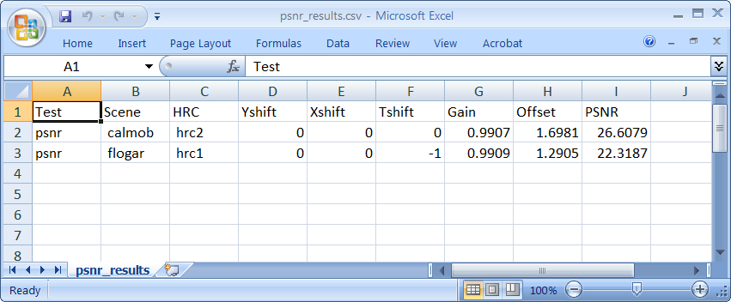

After validating PSNR_SEARCH, PSNR_VFD can be validated with the following command line

psnr_vfd 'c:\psnr' 'psnr' 'progressive' 'psnr_results.csv' 'yuv' 144 176 'sroi' 5 5 140 172 't_uncert' 8 'causal' 'verbose'

The file 'psnr_results_vfd.csv' will be created that contains these results when loaded into a spreadsheet program:

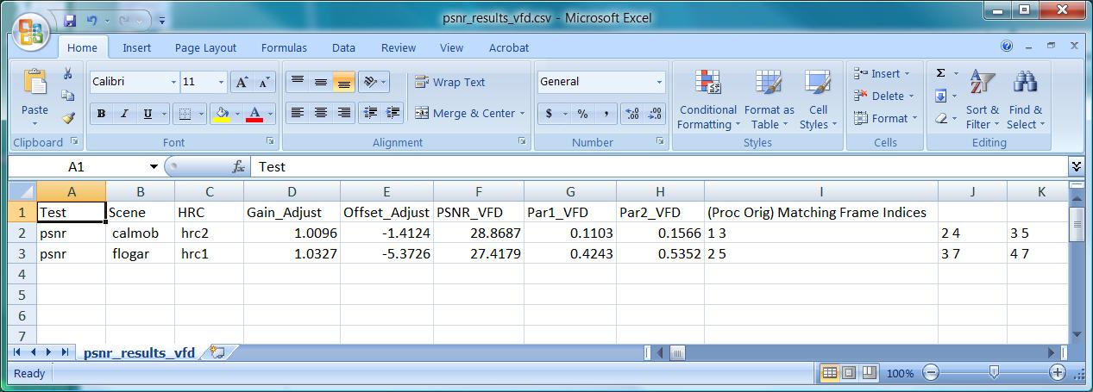

Only the first three (Proc Orig) matching frame indices are displayed for the 'psnr_results_vfd.csv' file (these results continue to the right).

