Faculty of Information Technology

Field of Study: Information Technology
Specialty: Programming

Cody Voon Jun Jie, Zhibek Tyulemissove, Hai Duy Huynh
64828,63911,64750
ECommerce
Supervisor: Dr inż. Łukasz Piątek
TEAM PROJECT

Rzeszów, 2020
Contents
Introduction 4
Theoretical Part 5
Practical Part 5
Summary 5
Literature 5

Introduction

Ecommerce, often known as electronic commerce, has completely changed how consumers and businesses transact when buying and selling goods and services. It includes all online transactions and activities that take place online and allow people and organizations to do business at any time and from any location. Customers can explore and buy a variety of things, from apparel and gadgets to groceries and even digital content, through ecommerce platforms and websites. By bridging geographic divides and connecting companies with worldwide markets, the digital market has given customers unprecedented convenience and accessibility. Ecommerce has become a crucial component of our modern economy, transforming industries and reinventing the conventional shopping experience as a result of the rapid improvements in technology and the increasing reliance on digital platforms.

2.0 Requirements

2.1 Functional
Functional requirements are descriptions or specifications of the attributes, capabilities, and actions that a system or piece of software must have in order to meet the needs of its users. These specifications specify the functions or duties that the system must carry out. They typically include any restrictions or requirements that must be met, as well as the intended input, processing, and output of the system. A system's design and development are built on its functional requirements, which direct the development team in producing a final product that meets the intended goals and user expectations. These specifications, which frequently form the core of a formal requirement specification document, are used to test and assess the functionality of the system.
Examples of functional requirement for this project are as follows:
- The system will save the items that the customer wishes to purchase into the cart section.
- The total cost is automatically calculated based on the type of item and quantity of items.
- A form is displayed for the customer if shipping is necessary.
- Items saved in the cart will be remembered and will only be removed if the customer chooses to.

2.2 Non-functional
Non-functional requirements, also referred to as quality requirements, outline the traits, qualities, and limitations that specify how a system ought to operate or function rather than what it ought to accomplish. Non-functional requirements cover broader topics including performance, stability, security, usability, scalability, maintainability, and other factors that influence the entire user experience and system behavior, in contrast to functional requirements, which are focused on specific functionality. Non-functional requirements offer standards for assessing the efficiency and caliber of the system. They are necessary to make sure that the system satisfies stakeholder expectations and conforms with rules and regulations. Response time, system availability, data integrity, UI aesthetics, system performance under load situations, and coding standards adherence are a few examples of non-functional requirements.
Examples of non-functional requirement for this project are as follows:
- The website should load at most 3 seconds.

3.0 UML Diagrams

Software systems are designed and represented using the standardized visual modeling language known as UML (Unified Modeling Language). For building visual representations of software-intensive systems, it offers a set of graphical notations.
The various components of a software system are visualized, specified, built, and documented using UML diagrams. They improve communication between stakeholders, including software developers, designers, project managers, and clients, and they assist in understanding the structure and behavior of the system.
The following diagrams shows the representation of the project:
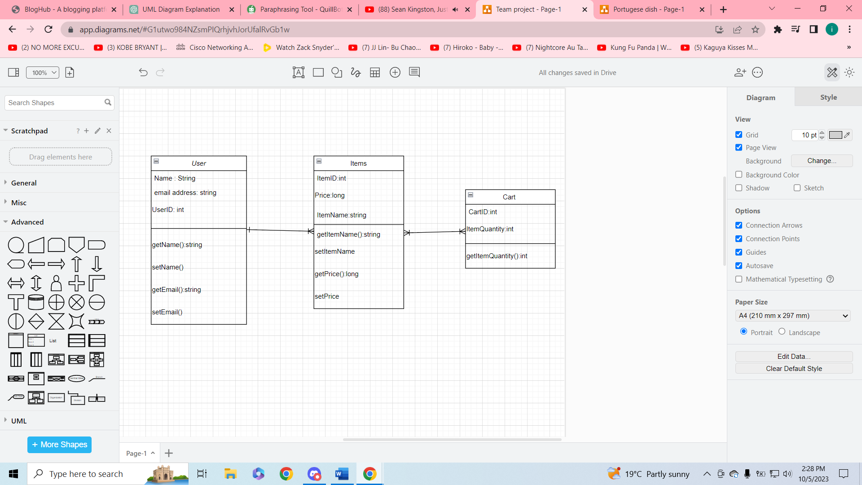

Methodology

Cooperation method
For this project, our group decided to follow the scrum method and have 1-week sprints. This is because it offers a flexible and iterative management and delivery method for challenging products or projects. The Scrum technique divides work into "sprints," which are iterations. A sprint is a time-boxed period of completion of a set of prioritized tasks, typically lasting 1-4 weeks.
The tasks are divided using boards on azure. The tasks are reviewed and commented on.

Version control
The version control used is GitHub on azure. It Is an online platform called GitHub hosts version control repositories and provided a range of collaboration tools for software development projects. It can manage different kinds of files and documents, but its main usage is organizing and distributing source code. On top of that, GitHub is something that everyone is familiar with and comfortable with which makes it the best option for the team.

4.3 Technological Stack
The technological stack chosen for the project are as follows:
- Python
- Django
- Django REST framework

