# Lab 09: Database

**Nguyễn Thế Minh Quân 20215237**

**SQL TABLE:**

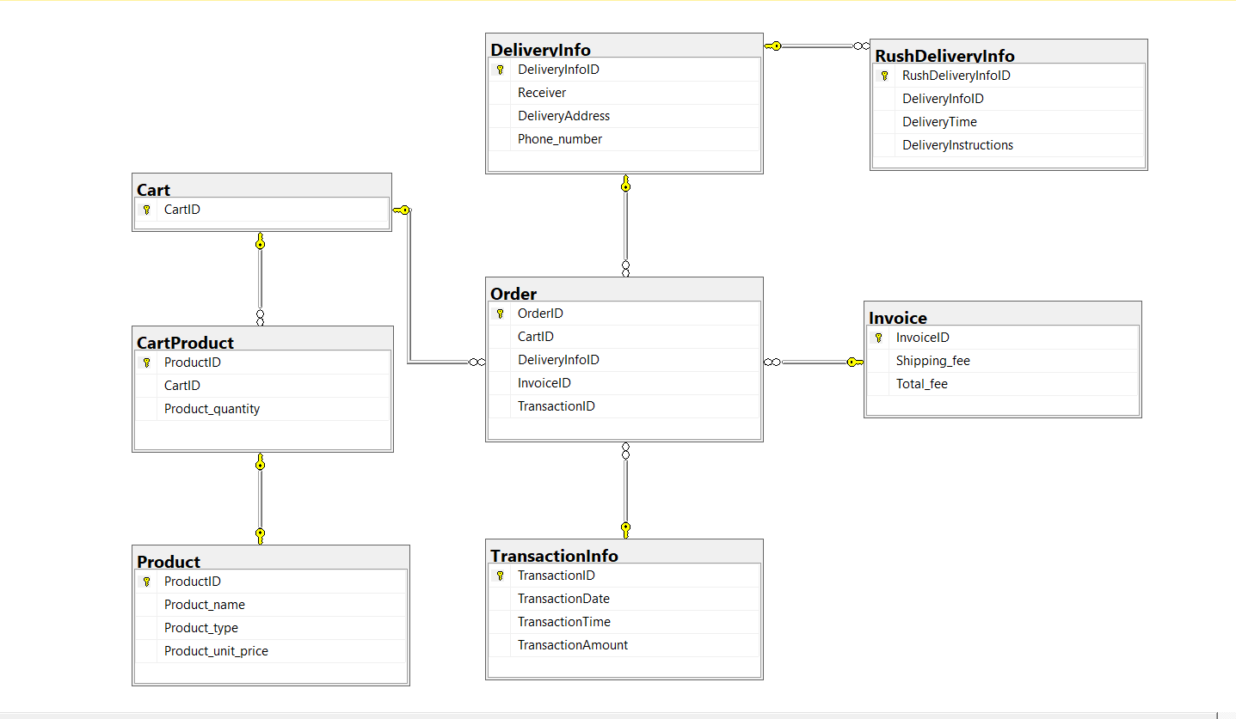

**QUERRY:**  
CREATE TABLE Products (

ProductID CHAR(x) PRIMARY KEY,

ProductName VARCHAR(y),

ProductType VARCHAR(z),

UnitPrice DECIMAL(10, 2)

);

CREATE TABLE Carts (

CartID CHAR(x) PRIMARY KEY

);

CREATE TABLE CartProducts (

ProductID CHAR(x),

CartID CHAR(x),

ProductQuantity INT,

PRIMARY KEY (ProductID, CartID),

FOREIGN KEY (ProductID) REFERENCES Products(ProductID),

FOREIGN KEY (CartID) REFERENCES Carts(CartID)

);

CREATE TABLE DeliveryInfo (

DeliveryInfoID CHAR(x) PRIMARY KEY,

Receiver VARCHAR(y),

DeliveryAddress VARCHAR(z),

PhoneNumber CHAR(w)

);

CREATE TABLE RushDeliveryInfo (

RushDeliveryInfoID CHAR(x) PRIMARY KEY,

DeliveryInfoID CHAR(x),

DeliveryTime TIME,

DeliveryInstructions VARCHAR(y),

FOREIGN KEY (DeliveryInfoID) REFERENCES DeliveryInfo(DeliveryInfoID)

);

CREATE TABLE Invoices (

InvoiceID CHAR(x) PRIMARY KEY,

ShippingFee DECIMAL(10, 2),

TotalFee DECIMAL(10, 2)

);

CREATE TABLE Transactions (

TransactionID CHAR(x) PRIMARY KEY,

TransactionDate DATE,

TransactionTime TIME,

TransactionAmount DECIMAL(10, 2)

);

CREATE TABLE Orders (

OrderID CHAR(x) PRIMARY KEY,

CartID CHAR(x),

DeliveryInfoID CHAR(x),

InvoiceID CHAR(x),

TransactionID CHAR(x),

FOREIGN KEY (CartID) REFERENCES Carts(CartID),

FOREIGN KEY (DeliveryInfoID) REFERENCES DeliveryInfo(DeliveryInfoID),

FOREIGN KEY (InvoiceID) REFERENCES Invoices(InvoiceID),

FOREIGN KEY (TransactionID) REFERENCES Transactions(TransactionID)

);