## AVR Revision History

|  |  |  |  |
| --- | --- | --- | --- |
| Version | Date | Author | Changes Made |
| 1 | YYYY/MM/DD | Torstein Ingebrigtsen Bø | Initial |
|  |  |  |  |

## Model Hierarchy

Electrical system  
> GensetACx  
>> Genset  
>>> AVR

## Description

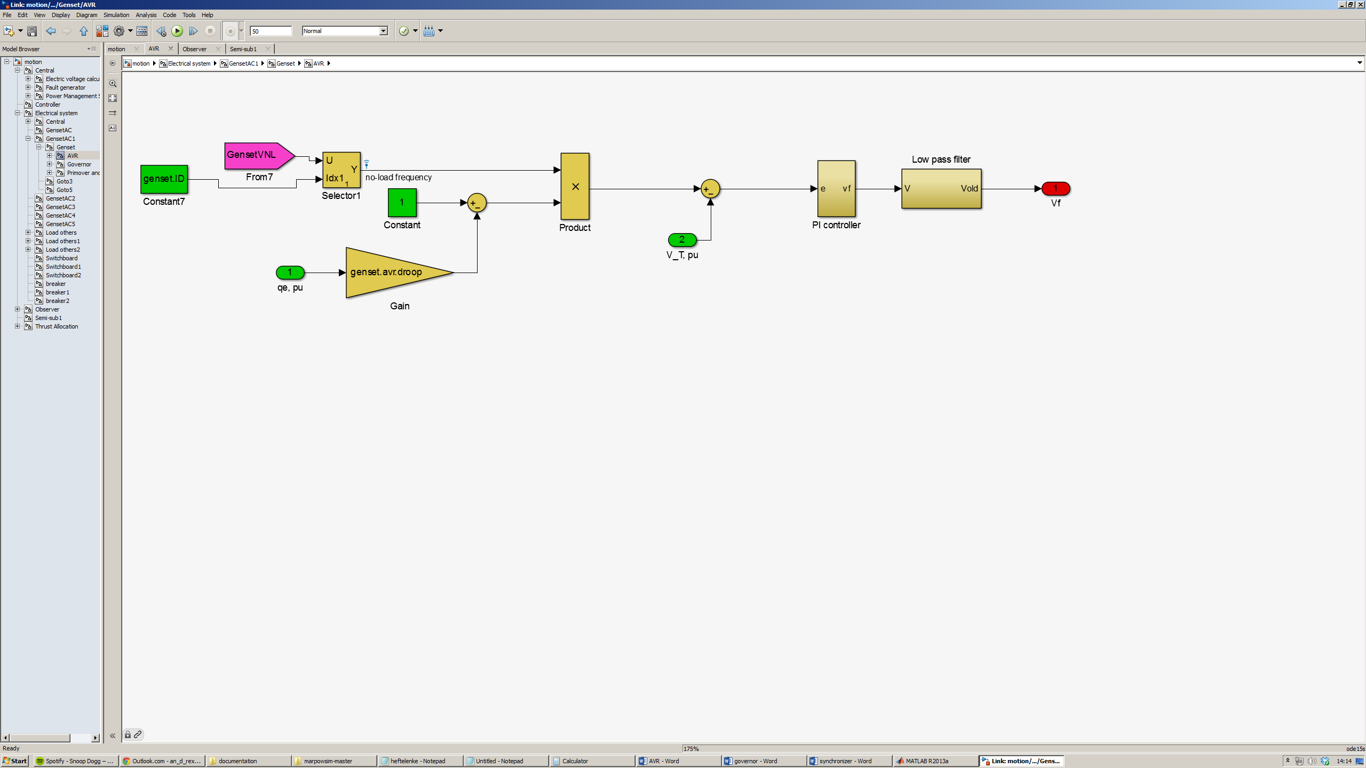

Control the field voltage to achieve the desired terminal voltage.

The controlled variable is  
 e = ( - qe, pu * genset.avr.droop * GensetVNL ) – V_T, pu

The controller has proportional and integral (PI) action.

## How to build

-

### Implementation details

-

## Parameters (include parameter identification)

|  |  |  |  |
| --- | --- | --- | --- |
| Name | Dimension | Unit | Description |
| genset.avr.droop |  |  | genset voltage regulator droop gain |
| GensetVNL |  |  | genset no-load voltage |
| genset.avr.Kp |  |  | proportional gain |
| genset.avr.Ki |  |  | integral gain |
|  |  |  |  |

## Input

### Ports

|  |  |  |  |  |
| --- | --- | --- | --- | --- |
| ID | Name | Dimension | Unit | Description |
| 1 | qe, pu |  |  | Reactive power (per unit) |
| 2 | V_T, pu |  |  | Terminal voltage (per unit) |

### From

|  |  |  |  |  |
| --- | --- | --- | --- | --- |
| Name | Dimension | Unit | Description | From |
|  |  |  |  |  |
|  |  |  |  |  |
|  |  |  |  |  |
|  |  |  |  |  |

## Output

### Ports

|  |  |  |  |  |
| --- | --- | --- | --- | --- |
| ID | Name | Dimension | Unit | Description |
|  | Vf |  |  | Field voltage (per unit) |
|  |  |  |  |  |
|  |  |  |  |  |

### Goto

|  |  |  |  |
| --- | --- | --- | --- |
| Name | Dimension | Unit | Description |
|  |  |  |  |
|  |  |  |  |
|  |  |  |  |

## Limitation

-

## Validation

-

## Comments

## Reference

Skjetne, Roger. 2013. *Modeling a diesel-generator power plant*. TMR4290, Norwegian University of Science and Technology.