## Governor Revision History

|  |  |  |  |
| --- | --- | --- | --- |
| Version | Date | Author | Changes Made |
| 1 | YYYY/MM/DD | Torstein Ingebrigtsen Bø | Initial |
|  |  |  |  |

## Model Hierarchy

Electrical system  
> GensetACx  
>> Genset  
>>> Governor

## Description

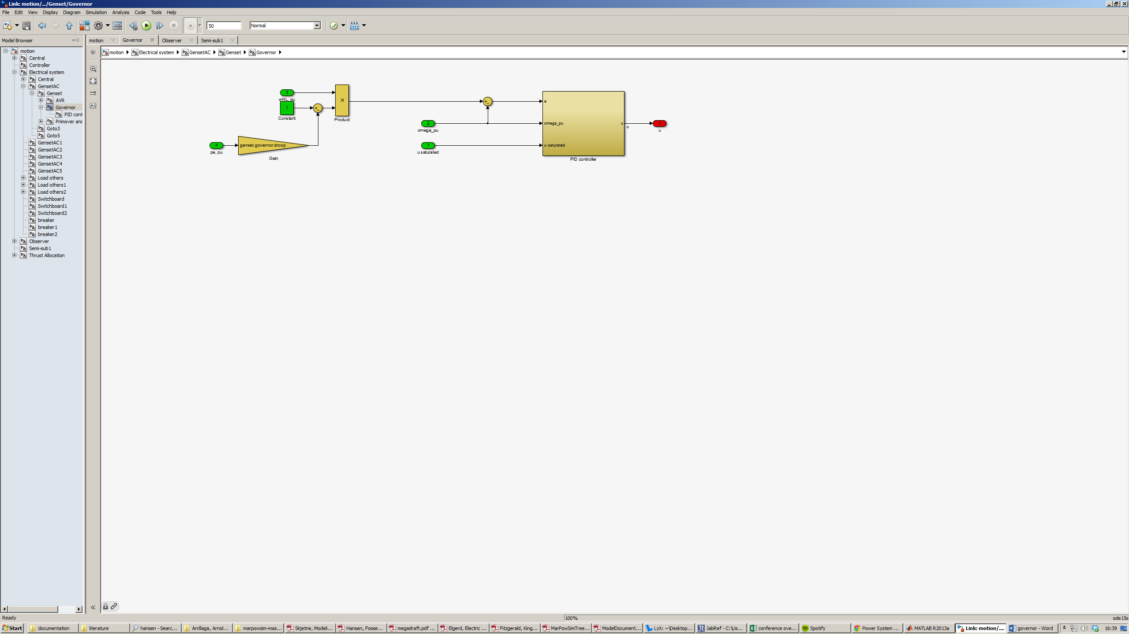

Controls the fuel rack position to achieve the desired genset speed.

The controlled variable is the error  
 e = ( - pe, pu * genset.governor.droop * wNL_pu ) - omega_pu  
between the actual genset speed omega_pu and the droop-based setpoint.

The controller has proportional, integral and derivative (PID) action. There is saturation limits on the output and a mechanism for saturation compensation/anti wind-up.

## How to build

-

### Implementation details

-

## Parameters (include parameter identification)

|  |  |  |  |
| --- | --- | --- | --- |
| Name | Dimension | Unit | Description |
| genset.governor.droop |  |  | genset governor droop gain |
| genset.governor.Kp |  |  | proportional gain |
| genset.governor.Ki |  |  | integral gain |
| genset.governor.Kd |  |  | derivative gain |
| genset.governor.N |  |  | dirty derivative gain |
| genset.governor.Kb |  |  | back-calculation gain |
| genset.u_max |  |  | controller output saturation upper limit |
| genset.u_min |  |  | controller output saturation lower limit |

## Input

### Ports

|  |  |  |  |  |
| --- | --- | --- | --- | --- |
| ID | Name | Dimension | Unit | Description |
| 1 | u saturated |  |  | actual fuel rack position, i.e. PID controller output saturated both by controller internal saturation and by turbo dead-band rate limiter |
| 2 | omega_pu |  | per unit | genset speed |
| 3 | wNL_pu |  |  | prime mover no-load speed |
| 4 | pe, pu |  | per unit | active power |

### From

|  |  |  |  |  |
| --- | --- | --- | --- | --- |
| Name | Dimension | Unit | Description | From |
|  |  |  |  |  |
|  |  |  |  |  |
|  |  |  |  |  |
|  |  |  |  |  |

## Output

### Ports

|  |  |  |  |  |
| --- | --- | --- | --- | --- |
| ID | Name | Dimension | Unit | Description |
| 1 | u |  | [0,1] | fuel rack position, manipulated variable |
|  |  |  |  |  |
|  |  |  |  |  |

### Goto

|  |  |  |  |
| --- | --- | --- | --- |
| Name | Dimension | Unit | Description |
|  |  |  |  |
|  |  |  |  |
|  |  |  |  |

## Limitation

Limitations of model, include some comments of possibility to increase/decrease fidelity

## Validation

How to validate model

## Comments

## Reference

Skjetne, Roger. 2013. *Modeling a diesel-generator power plant*. TMR4290, Norwegian University of Science and Technology.