R09943091 電子一 陳威旭

HW1 part1

1.

blif file name: 4bitadder.blif

structure is (a4,a3,a2,a1)+(b4,b3,b2,b1) = (cout,s4,s3,s2,s1)

2. (The original pictures are in show_picture/final_upload)

show the initial network structure:

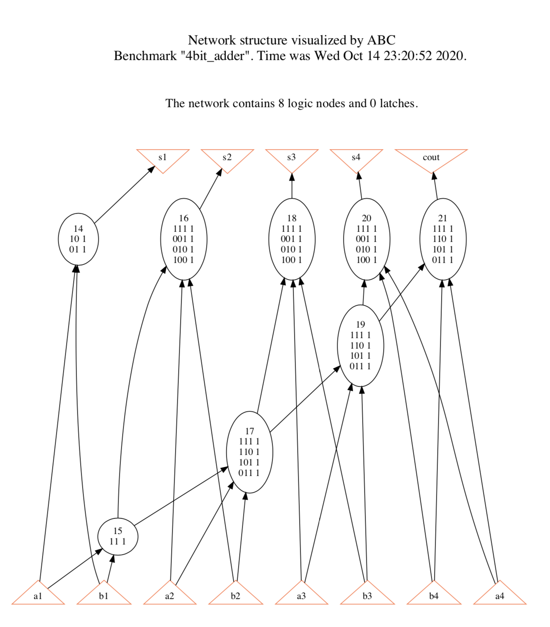

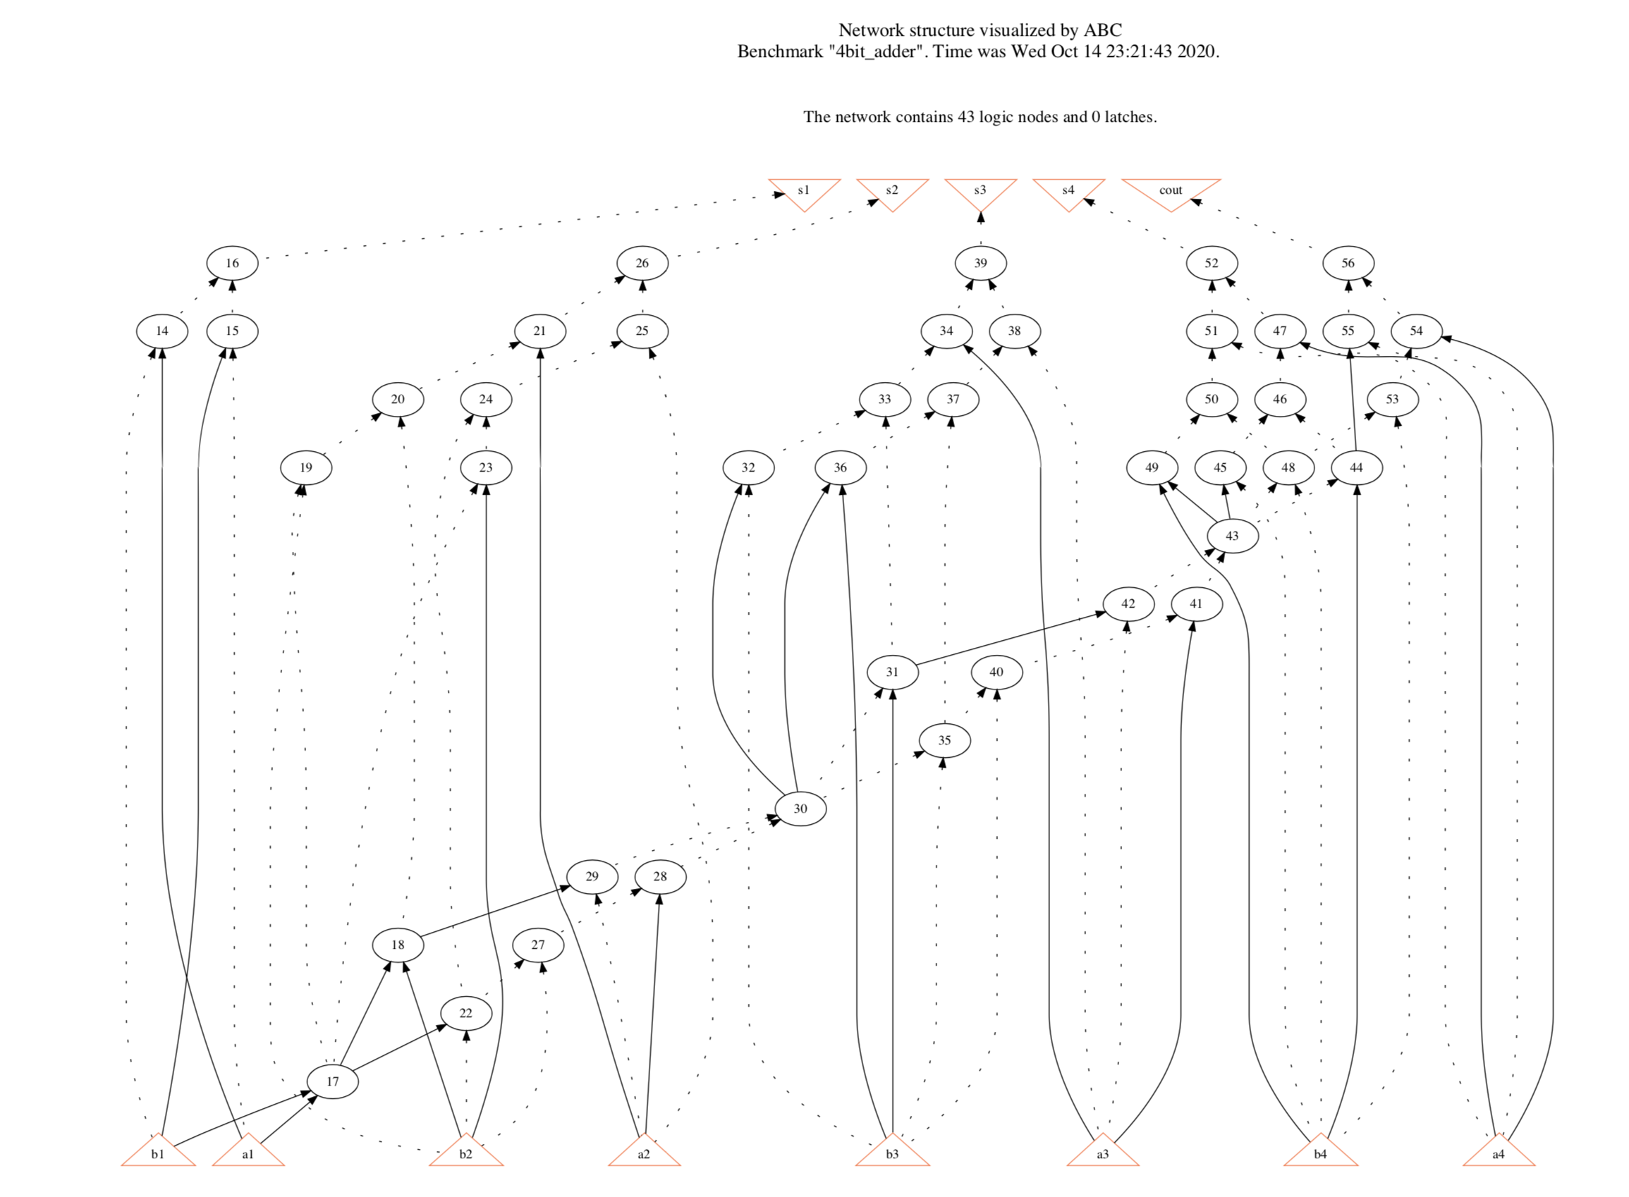after strash:

show_bdd of s1:

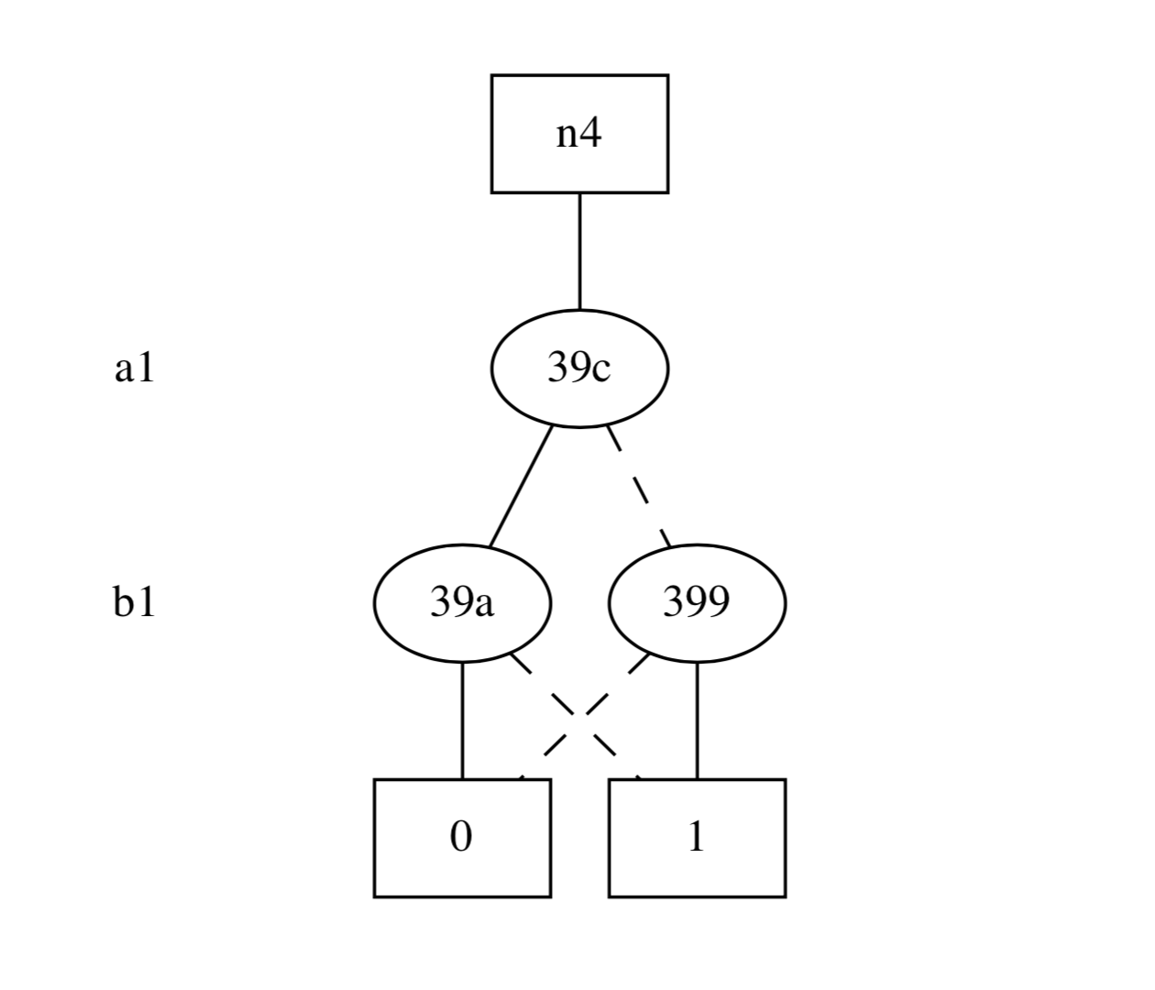

show_bdd of s2:

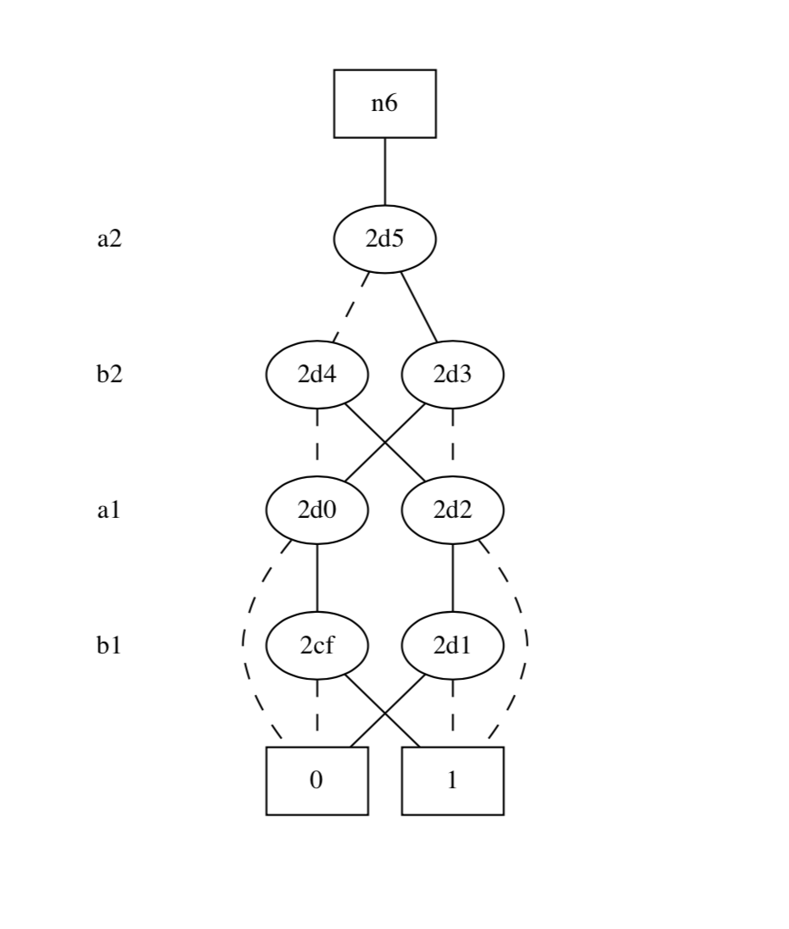

show_bdd of s3: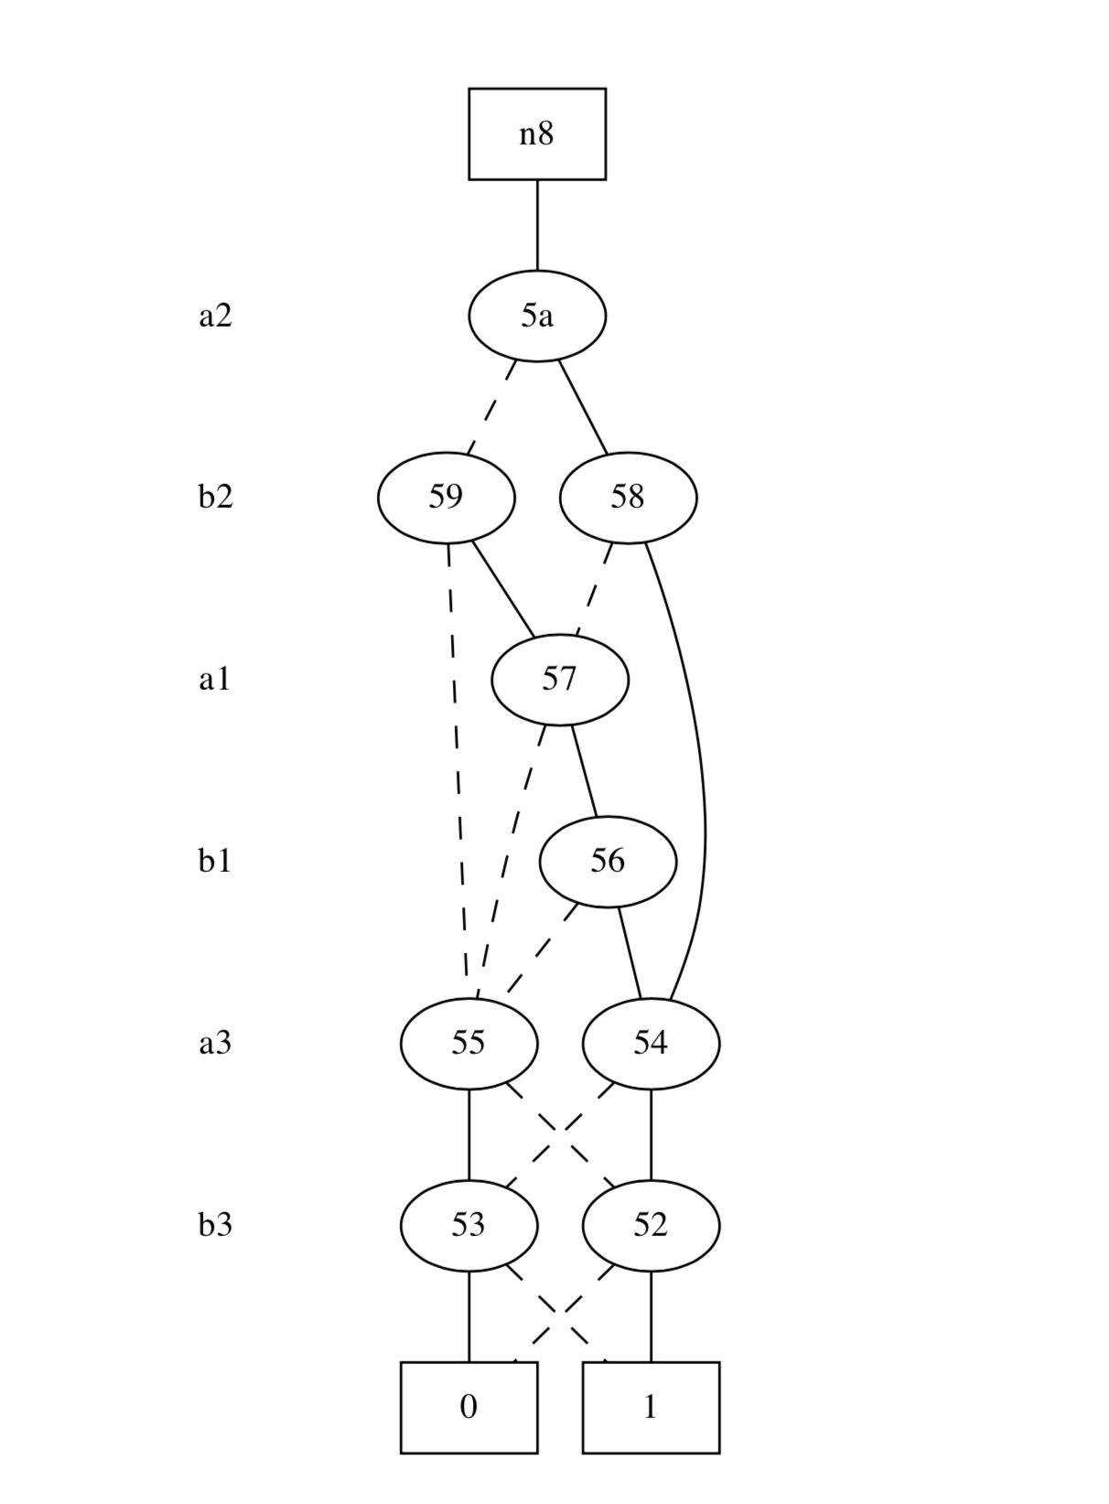

show_bdd of s4: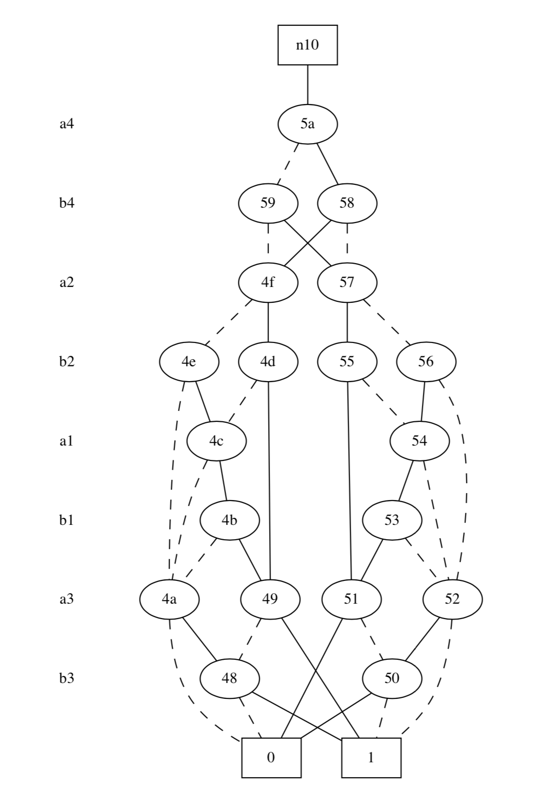

show_bdd of cout:

