LSV PA1

R10943095 梁哲嘉

Part1

1. The structure of comp.blif is based on [1].
2. Execution result :

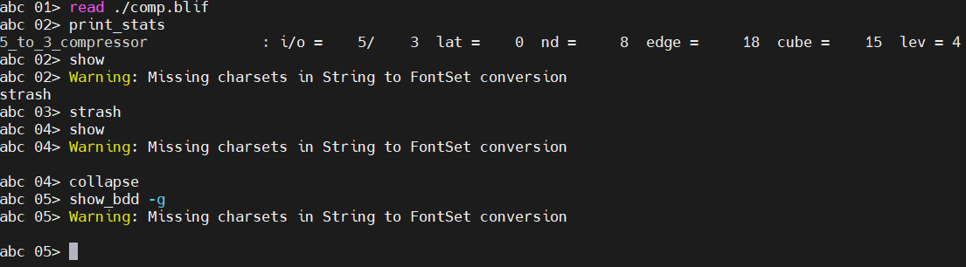

Result of “show” in step 3,

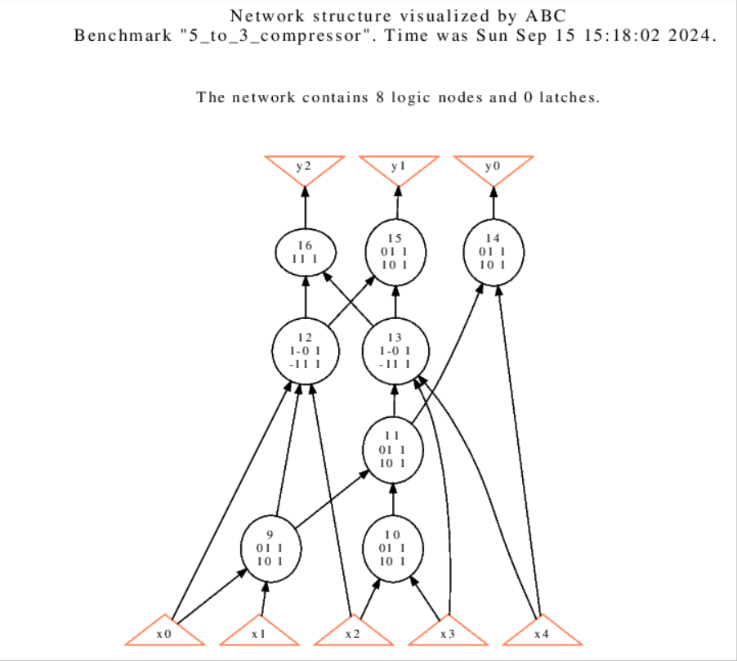



Result of “show” in step 5,

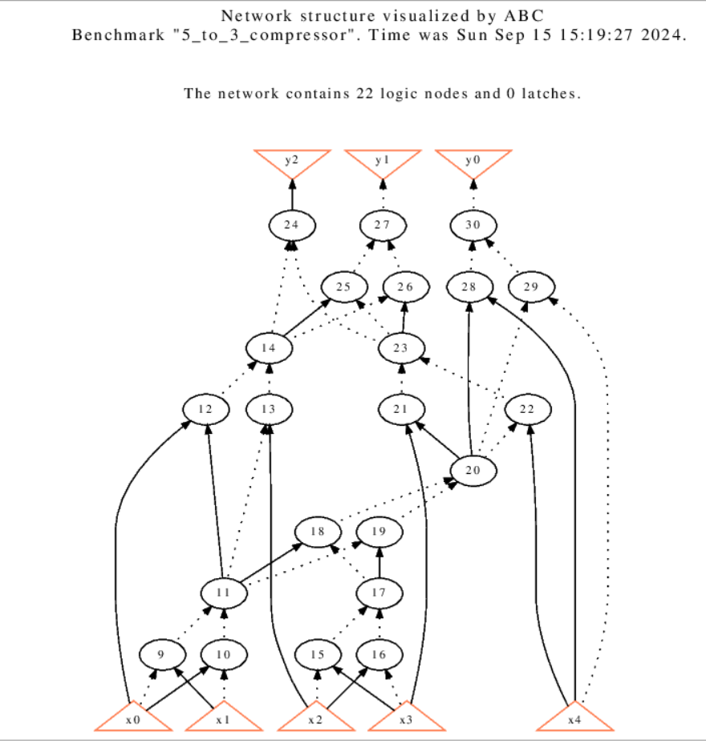



Result of “show_bdd -g” in step 7,

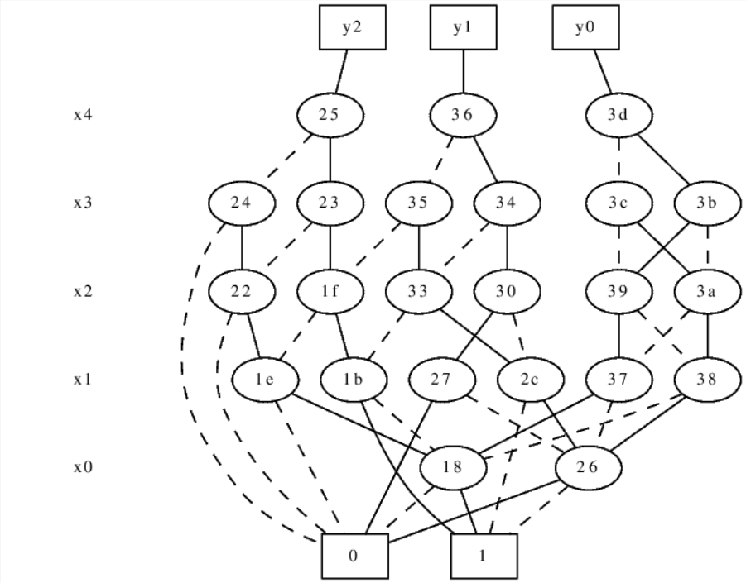

Part2

1.

Command “aig” converts local functions of the nodes to AIGs. Its network from command “show” is still the single-output-cover form from the blif file.

Command “strash” would transforms the current network into an AIG by one-level structural hashing; the resulting logic network is composed of two-input AND gates.

After command “aig,” the level of the network remains the same, whereas the network after command “strash” become 8.

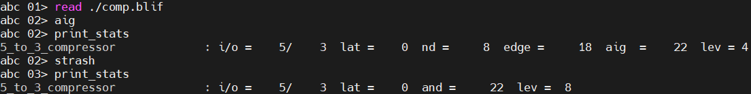

2.

Command “bdd” Converts local functions of the nodes to BDDs. After command “aig,” the statistics shows that cubes are converts to bdds.

Command “collapse” recursively composes the fanin nodes into the fanout nodes resulting in a network, in which each CO is produced by a node, whose fanins are CIs.

After command “collapse,” the number of nd, edge, bdd, and lev changed. The lev is reduced from 2 to 1.

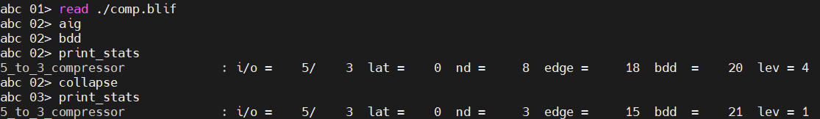

1. Command “logic” can transform the AIG into a logic network with the SOP representation of the two-input AND-gates.

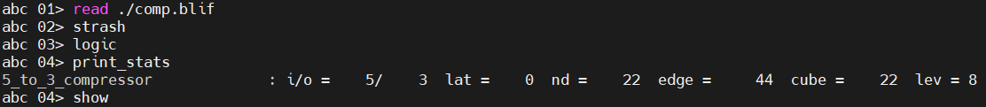

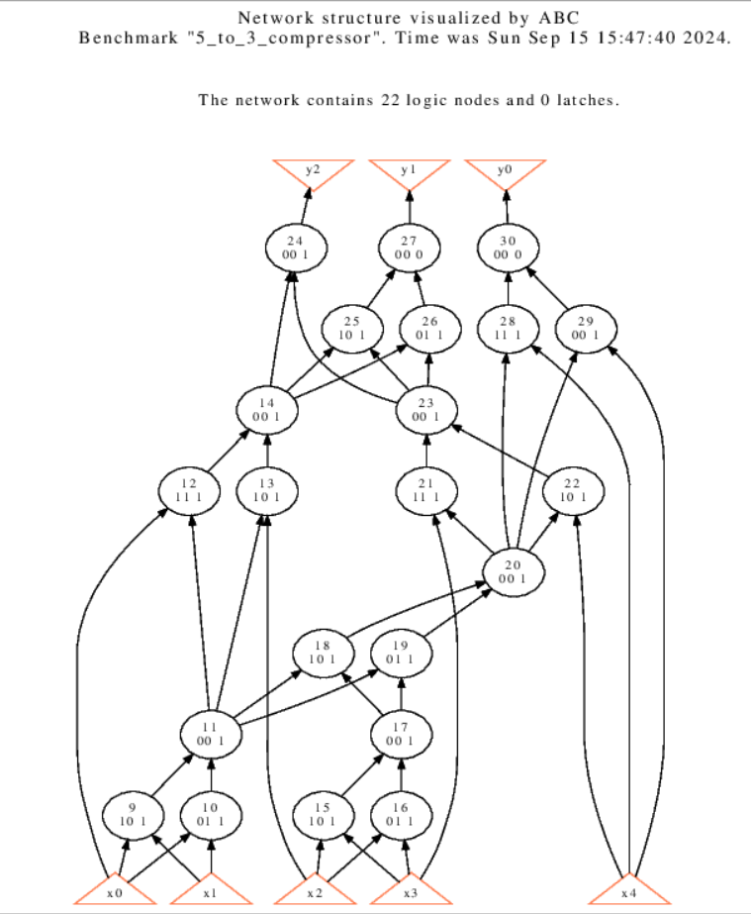

Reference :

[1]. R. Marimuthu, M. Pradeepkumar, D. Bansal, S. Balamurugan and P. S. Mallick, "Design of high speed and low power 15-4 compressor," 2013 International Conference on Communication and Signal Processing, Melmaruvathur, India, 2013, pp. 533-536