* 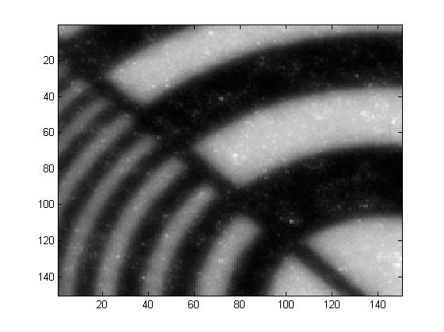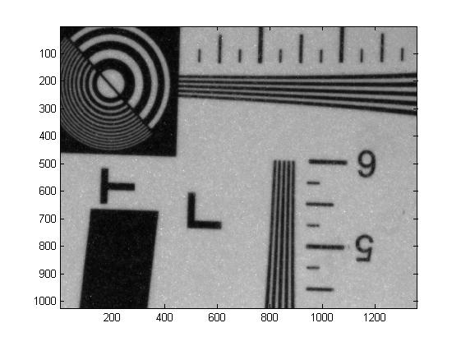While trying to figure out why the focussing routine was not working properly for the EoG (Energy of the Gradient) but worked better with the SML (Sum Modified Laplacian) and also noting that the ROI size made a difference, I rechecked the way the FM (focus measure) and the images were processed in PRISMS. I discovered that the string of bytes received from the camera splits the image into 4 regions and it is 16bit. The way they are contained in the string is thusly: for the first 1024x1360 bits we have the upper two corners of the image with the bits intercalated. The remaining two bottom corners are offset by 1024x1360 bits and their bits are intercalated as well. What we thought PRISMS was calculating for the ROI was wrong, however. Instead of taking the ROI of the entire image, PRISMS was taking a ROI of each individual corner of the image. I corrected these errors and now the program is indeed taking the ROI correctly. **Test**: below is a small (150x150) ROI of the image from the camera centred at the upper left corner.
* After I fixed the way the ROI was taken from the entire image, I proceeded to retake measurements with various FM to assess which one was the best. Previous papers suggested that the SML is the best FM even though mathematically is not robust. However, the SML requires two extra parameters (a step and a threshold) that not many people talk in depth about, so we decided initially to test the FMs that have no such extra parameters. Therefore, I discarded the SML and Ten (Tenengrad) measures from the following tests for now.
* Another issue came to our attention: the accuracy with which a Gaussian curve is fitted to the FM. Initially we had a 5-point Gaussian fit which appeared to fail half of the times. This was so because the shape of the curves were not Gaussian-like (except for the Variance FM). I change the program so that now it fits a gaussian to only 3 points around the maximum. The fitting failure is now drastically reduced. The initial FWHM parameter for the fitting routine was also changed from 600 to 200. The FMs that sometimes fail to produce a good Gaussian fit are EoG and EoL, but this happens rarely now: EoG failure = 2.2% and EoL failure = 5.4% out of 93 runs.
* 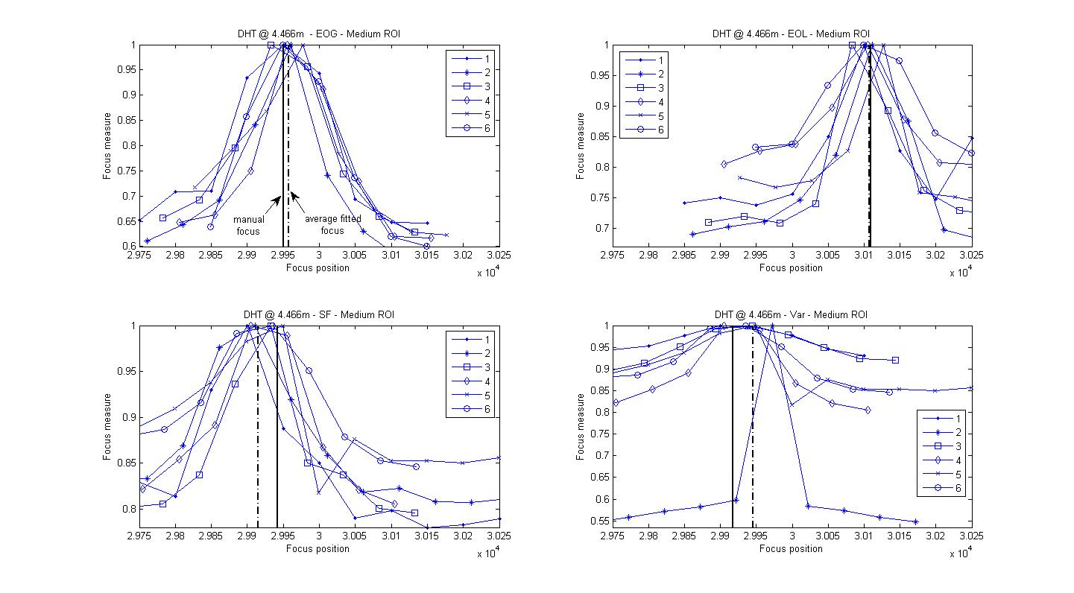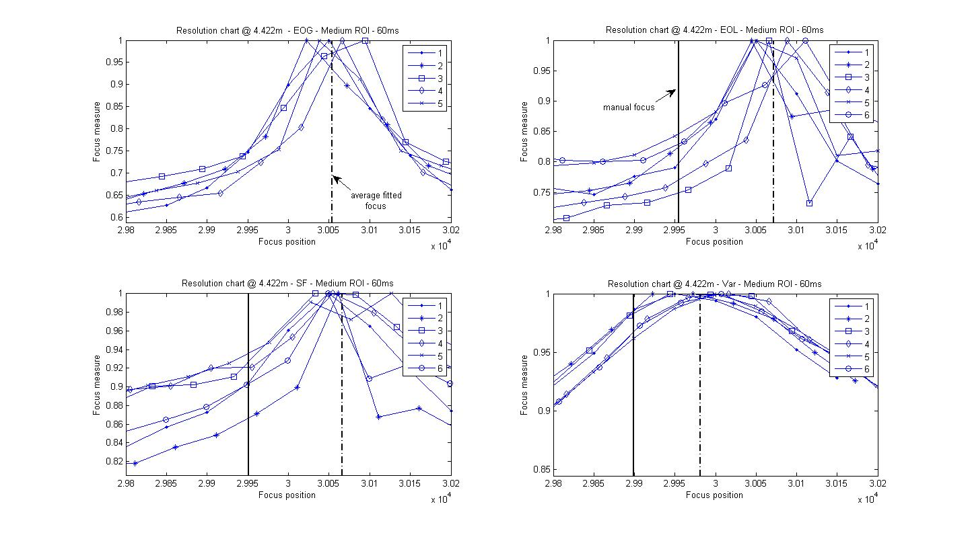The following are the plots of 4 FMs: Var (variance), EoG, EoL and SF for the resolution chart and Dunhuang tile (DHT). The ROI is of medium size (680x512) and the focusing integration time 60ms. Most plots have a manual focus line which shows where the focus position is as calculated by eye. At this stage the manual focus images were saved using the auto exposure time instead of 60ms. In two cases the manual focus was higher than the average fitted focus. However, this might be due to differences in exposure times.
* At this point we thought there might be a drift in the manual focus, so that as time goes on it would agree more with the average fitted focus. For the drift experiments I only used EoG, EoL and Var. For each FM I took 4 sets of 6 focus runs. After each set I saved images to determine the manual focus. The focussing steps were kept at 50 as with previous data. The ROI is medium size (680x512). At this point I used the optimum exposure time for the focussing and for manual focus, of 227ms throughout the measurements. Only the DHT data was taken.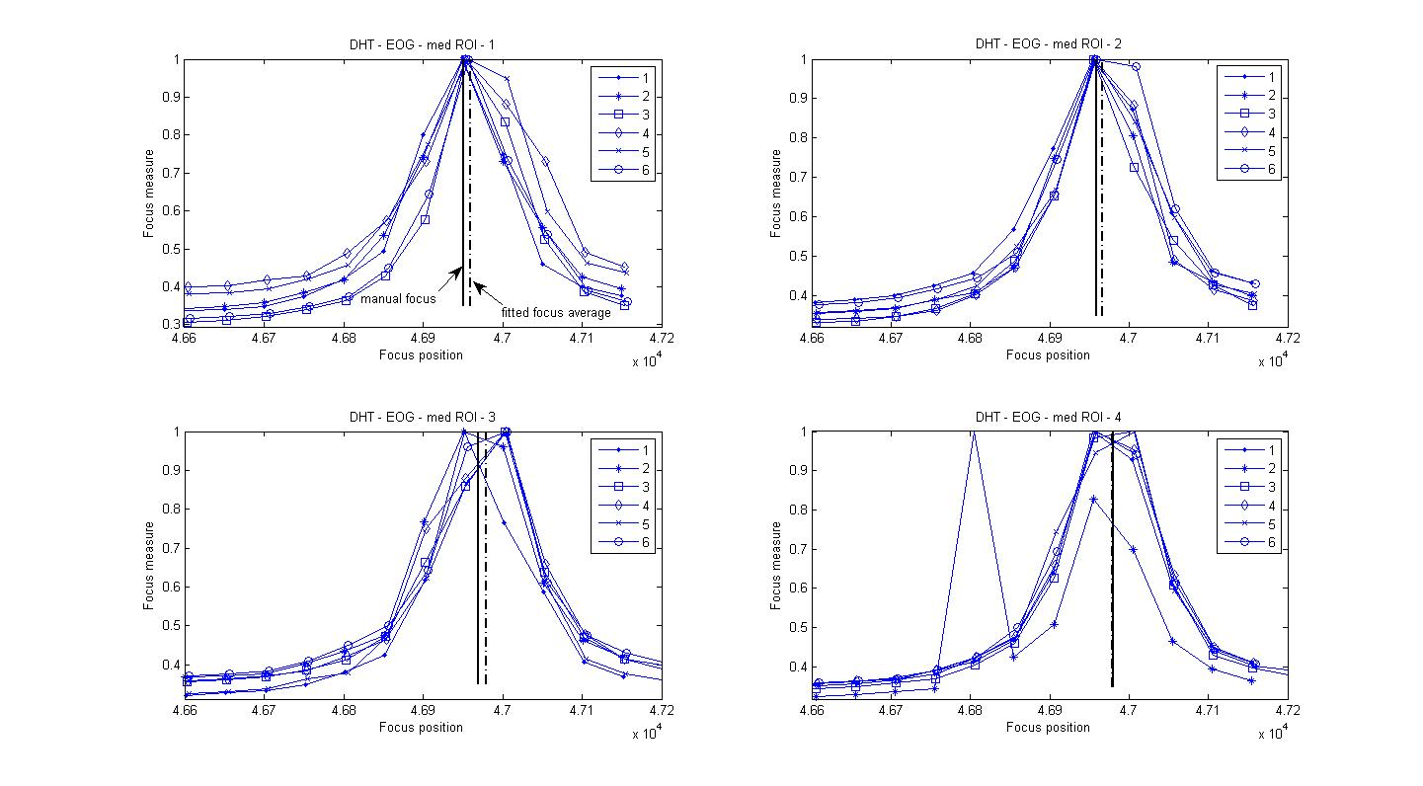

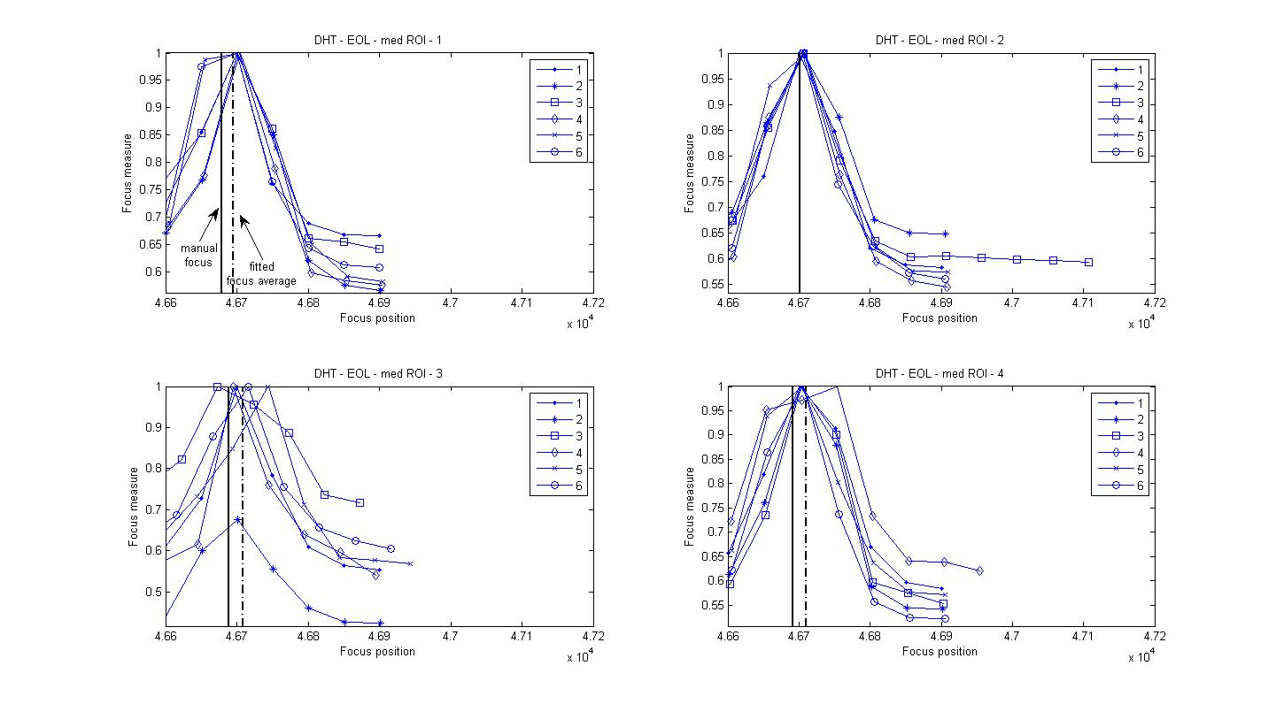

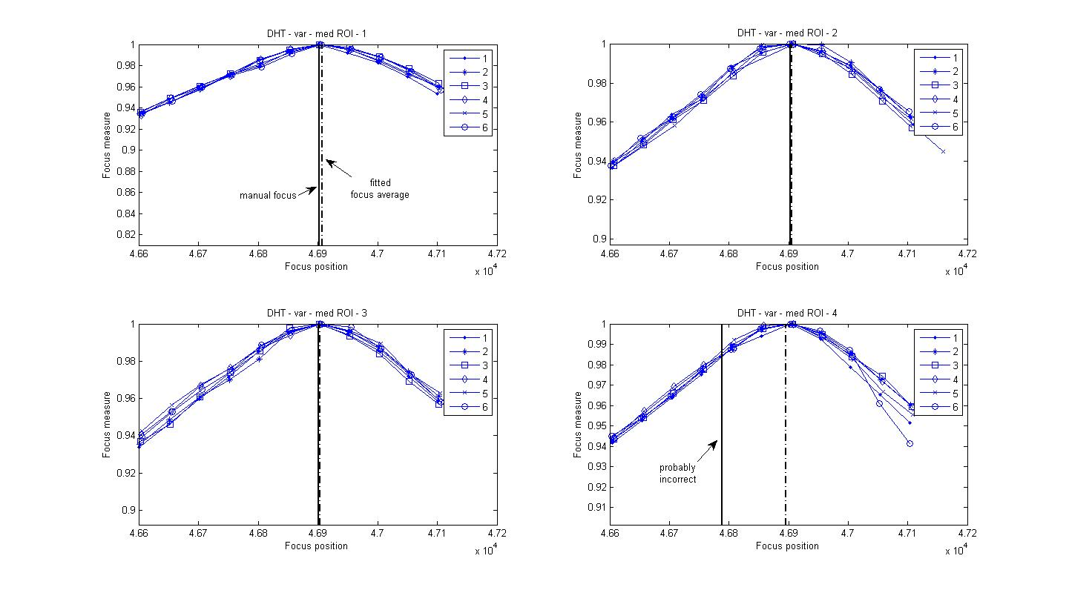

* Next I took a similar data with a resolution chart of my own devising because we initially thought that the kinks in the original resolution chart might have affected previous data. I took 3 sets of 5 runs at 30ms, 60ms and 80ms integration time (manual focus images were saved at these integration times as well). Only EoG and EoL were used. The reason behind this was to test where the threshold is between the optimum exposure time and a lower integration time for focussing since from previous experiments we discovered that the noise can have a large impact on the determination of the focus position. The ROI was kept at medium size (680x512) and the steps at 50. 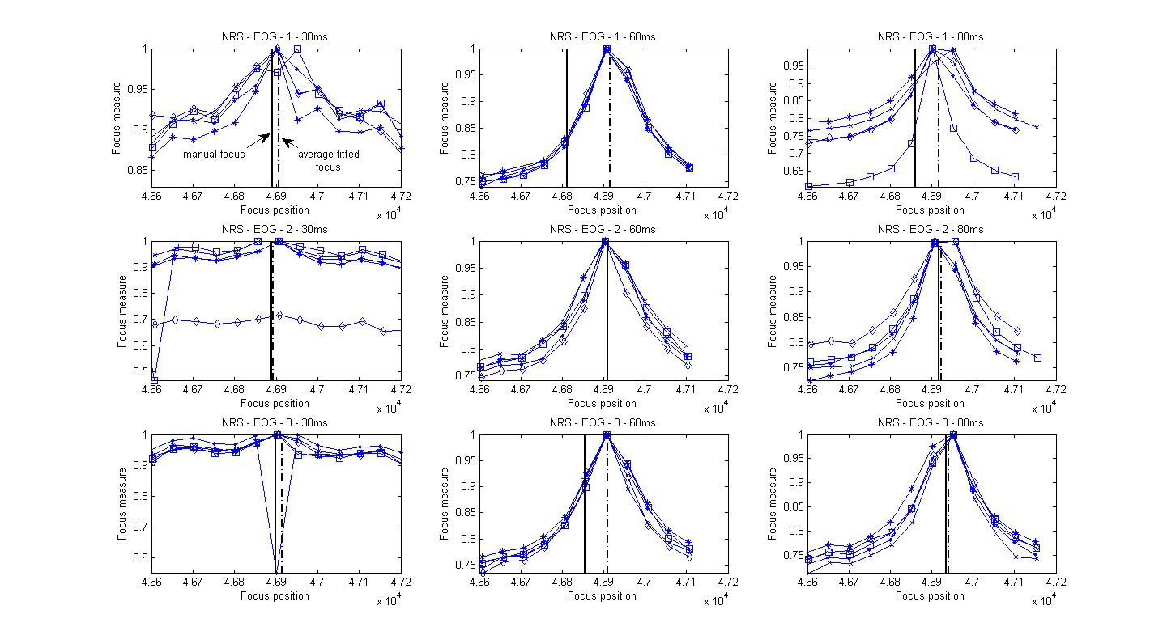

EoG had troubles finding the peak for 30ms and it failed to find the correct peak once (GF - Gaussian fail). At higher integration times it worked better.

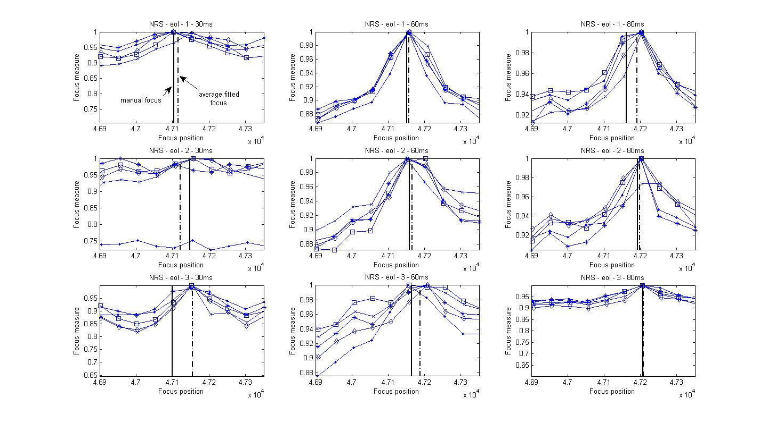  
EoL had more troubles at finding the peaks. It failed to find the right peak twice for 30ms and once for 80ms.

I struggled with the manual focus for both FMs since my resolution chart does not have fine enough lines to make the differentiation easier. This is why, perhaps, some of the manual focus lines are out of place even for 80ms. However, I could say that on the whole the EoG is a better FM than anything else.

* Resolution chart at 30ms, 60ms and 80ms. ROI = medium (680x512). D= 7.107m

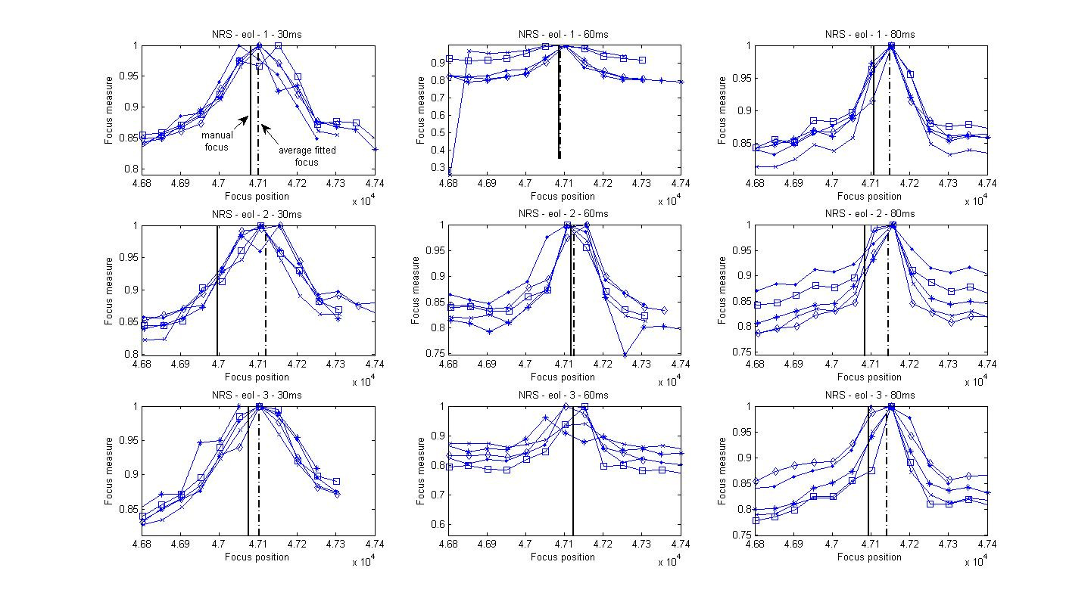

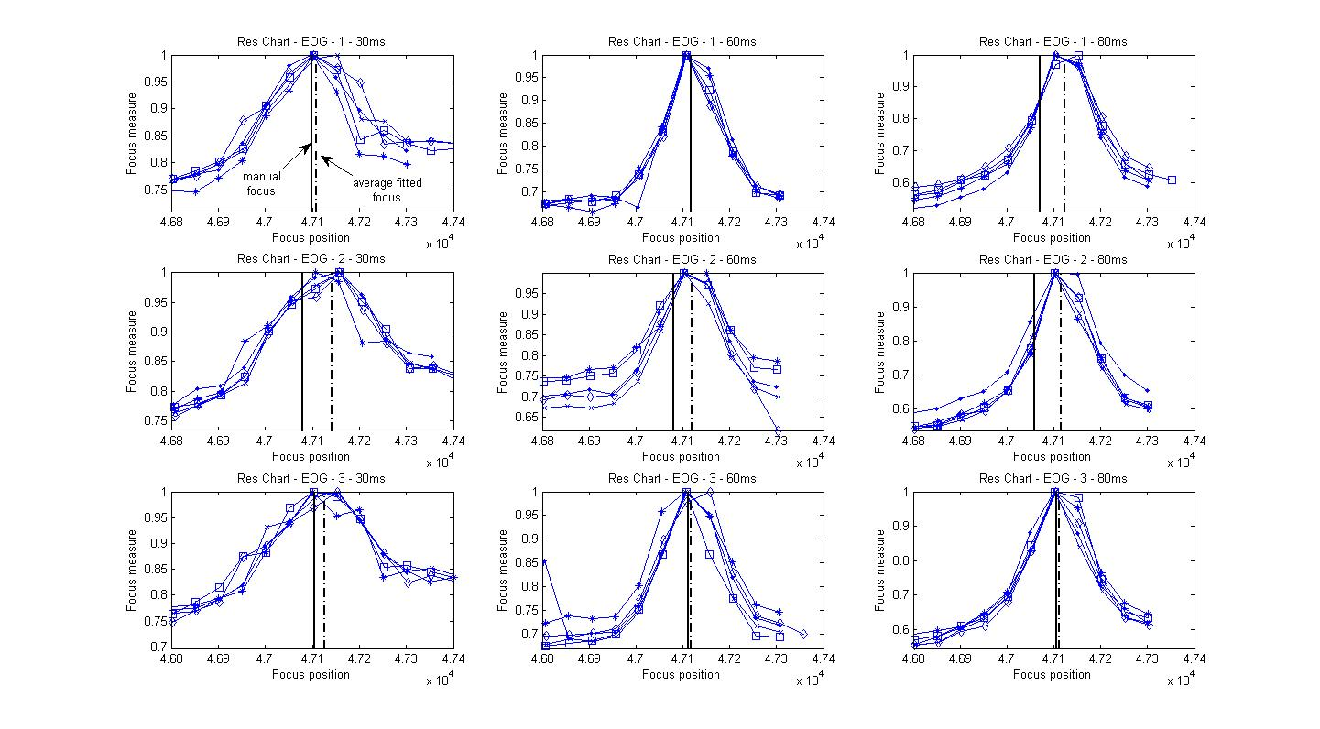

The EoL curves have a worse shape even at 60ms than the EoG while the matching between the manual focus and average fitted focus is similar.