**Bonus Homework Solution**

1. Some Preliminary Calculations.

The goal of this homework is to stimulate motion of a charged particles (mass m and carries charge q) in a Penning Trap. This preliminary calculation shows the steps used to find the motion of the particle, $x\left(t\right), y\left(t\right) and z(t)$ by Lorentz Law and Newton’s Law of motion with some mathematical technique.

A penning trap confines the particle by a constant magnetic field and a superimposed electric potential described in cylindrical coordinate as:

|  |  |  |
| --- | --- | --- |
| Magnetic Field: | $$\vec{B}=B_{0}\hat{z}$$ | (1) |
| Electric Potential: | $$φ\left(\vec{r}\right)=\frac{\frac{φ_{0}}{2}\left(z^{2}-\frac{s^{2}}{2}\right)}{d^{2}}$$ | (2) |

Where $d$ is the characteristic trap dimension defined by the minimum axial and radial distance to electrodes, $z_{0}$ and $s_{0}$ as $d^{2}≡\frac{1}{2}\left({z_{0}}^{2}+\frac{{s_{0}}^{2}}{2}\right)$

Note that $\vec{s}=\left(\begin{matrix}x \\ y\end{matrix}\right)$; $\vec{r}=\left(\begin{matrix}x \\ y \\ z\end{matrix}\right)$

And $s=\sqrt{x^{2}+y^{2}}$; $r=\sqrt{x^{2}+y^{2}+z^{2}}=\sqrt{s^{2}+z^{2}}$

By Lorentz Law, the resulting force on a charged particle by magnetic and electric field is

|  |  |  |
| --- | --- | --- |
|  | $$\vec{F}=q(\vec{E}+\vec{v}×\vec{B})$$ | (3) |

and

|  |  |  |
| --- | --- | --- |
|  | $$\vec{E}=-∇ φ\left(\vec{r}\right)$$ | (4) |

By performing a change of coordinate on electric potential, (2) becomes

|  |  |  |
| --- | --- | --- |
|  | $$φ\left(\vec{r}\right)=\frac{\frac{φ_{0}}{2}\left(z^{2}-\frac{x^{2}+y^{2}}{2}\right)}{d^{2}}$$ | (5) |

The corresponding electric field is

|  |  |  |
| --- | --- | --- |
|  | $$\vec{E}=\frac{φ_{0}}{2d^{2}}\left(\begin{matrix}x \\ y \\ -2z\end{matrix}\right)$$ | (6) |

$\vec{v}$ is velocity of the particle where

|  |  |  |
| --- | --- | --- |
|  | $$\vec{v}=\left(\begin{matrix}\dot{x} \\ \dot{y} \\ \dot{z}\end{matrix}\right)$$ | (7) |

Cross product between $\vec{v},\vec{B}$ is

|  |  |  |
| --- | --- | --- |
|  |  | (8) |

By Newton’s Law of Motion, $\vec{F}=m\ddot{\vec{r}}$, equation (3) can be rewritten as

|  |  |  |
| --- | --- | --- |
|  | $$\left(\begin{matrix}\ddot{x} \\ \ddot{y} \\ \ddot{z}\end{matrix}\right)=\frac{q}{m}\frac{φ_{0}}{2d^{2}}\left(\begin{matrix}x \\ y \\ -2z\end{matrix}\right)+\frac{qB_{0}}{m}\left(\begin{matrix}\dot{y} \\ -\dot{x} \\ 0\end{matrix}\right)$$ | (9) |

We can immediately observe that

|  |  |  |
| --- | --- | --- |
|  | $$\ddot{z}=-\frac{q}{m}\frac{φ_{0}}{d^{2}}z$$ | (10) |

Which can be further solved as a harmonic oscillation of frequency $ω_{z}$ that

|  |  |  |
| --- | --- | --- |
|  | $$z\left(t\right)=z_{0}cos⁡(ω_{z}t)$$ | (11) |

where

|  |  |  |
| --- | --- | --- |
|  | $$ω_{z}=\sqrt{\frac{q}{m}\frac{φ_{0}}{d^{2}}}$$ | (12) |

and the imaginary solution had been omitted.

Since $z(t)$ had been resolved, I will like to introduce a new term, $ω_{c}$, which is the cyclotron frequency (this frequency can be obtained by assuming the superimposed potential to be 0 and solve the equation of motion for that situation, but working is not shown here) and rewrite equation (9) as

|  |  |  |
| --- | --- | --- |
|  | $$\left(\begin{matrix}\ddot{x} \\ \ddot{y}\end{matrix}\right)=\frac{{ω_{z}}^{2}}{2}\left(\begin{matrix}x \\ y\end{matrix}\right)+ω_{c}\left(\begin{matrix}\dot{y} \\ -\dot{x}\end{matrix}\right)$$ | (13) |

where

|  |  |  |
| --- | --- | --- |
|  | $$ω_{c}≡\frac{qB_{0}}{m}$$ | (14) |

From (13), we can also see that $x$ and $y$ are coupled, and by some inspiration, a complex term $C\left(t\right)$ is introduced:

|  |  |  |
| --- | --- | --- |
|  | $$C\left(t\right)=x\left(t\right)+iy(t)$$ | (15) |

Take first and second derivative of $C(t)$ and some rearrangement from (13),

|  |  |  |
| --- | --- | --- |
|  | $$\dot{C}=\left(-\frac{1}{ω_{c}}\ddot{y}+\frac{{ω_{z}}^{2}}{2}y\right)+i\left(\frac{1}{ω_{c}}\ddot{x}-\frac{{ω_{z}}^{2}}{2}x\right)$$ | (16) |
|  | $$\ddot{C}=\ddot{x}+i\ddot{y}$$ | (17) |

and (mathemagically), we have

|  |  |  |
| --- | --- | --- |
|  | $$\ddot{C}=-iω_{c}\dot{C}+\frac{{ω_{z}}^{2}}{2}C$$ | (18) |

Recall why we need a function of $C\left(t\right)$? Because we want to solve for $x(t)$ and $y(t)$.

We have two unknowns, but only one equation, so we will need another one to solve explicitly for $x(t)$ and $y(t)$.

Differential equation like (18) represents a form of damped oscillation where we can solve by taking ansatz: $C(t)=C_{0}e^{-iωt}$ where $ω$ is frequency of $C$, we will have

|  |  |  |
| --- | --- | --- |
|  | $$\dot{C}=-iωC$$ | (19) |
|  | $$\ddot{C}=ω^{2}C$$ | (20) |

Substitute (19)&(20) into (18), we will have two solutions for the frequency $ω$:

|  |  |  |
| --- | --- | --- |
|  | $$ω=ω_{±}=\frac{ω_{c}±\sqrt{{ω_{c}}^{2}-2{ω_{z}}^{2}}}{2}$$ | (21) |

and it is required that ${ω_{c}}^{2}≥2{ω_{z}}^{2}$ for trapping to occur as we can see from (21) that the $ω$ will be complex if the condition is not fulfil (although I am not sure why it can’t be complex, if the examiner can give me feedback on this will be great :D)

Let’s start to think what are the meaning of $ω_{+} and ω_{-}$. First we know that from (15),

|  |  |  |
| --- | --- | --- |
|  |  | (22) |

So $C(t)$ is actually a function representing the radial motion of the particle and the two frequencies we have represent the frequencies of the modified cyclotron motion (${ω_{c}}^{'}$, larger) and magnetron motion ($ω_{m}$, smaller) respectively. From now on, I will rename them as

|  |  |  |
| --- | --- | --- |
|  | $${ω_{c}}^{'}=ω_{+}=\frac{ω_{c}+\sqrt{{ω_{c}}^{2}-2{ω_{z}}^{2}}}{2}$$ | (23) |
|  | $$ω_{m}=ω_{-}=\frac{ω_{c}-\sqrt{{ω_{c}}^{2}-2{ω_{z}}^{2}}}{2}$$ | (24) |

Finally, general solution of $C(t)$ yields

|  |  |  |
| --- | --- | --- |
|  |  | (25) |

After comparing real and imaginary terms of (15) and (24), finally we obtain

|  |  |  |
| --- | --- | --- |
|  |  | (26) |
|  |  | (27) |

Where $\left|C_{c^{'}}\right| and |C_{m}|$ are generally complex and depend on the initial condition, $x_{0}{,y}_{0}$ of the particle, representing magnitude of modified cyclotron motion and magnetron motion respectively, and has to be confined within $s_{0}$.

For the two $\left|C_{c^{'}}\right| and |C_{m}|$, different trajectories of particle can occur when their respective magnitude are larger or smaller or equal to each other, and we shall see them in result later.

This marks the end of part 1. Preliminary Calculations :)

2. Introduction to my Code on Matlab.

I try to write my code as a user-to-system reaction type of stimulator. Hope you won’t mind my strange sentences inside the code. I believe despite those nagging, my code still works well.

There are a total of 10 input value required from user:

1. Charge of the particle, $q$.
2. Mass of the particle, $m$.
3. Magnitude of magnetic field strength, $B_{0}$.
4. Electrode’s radial and axial position, $s_{0}$ and $z_{0}$.
5. Potential difference provided by electrode, $φ_{0}$.
6. Modified cyclotron orbit radius factor and magnetron orbit radius, a and b.
7. Time of the stimulation, $t$.
8. Step for the stimulation, $step$.

The code was written in Matlab, and best opened with Matlab. The instruction for the code is… just input whatever you were asked to input, and you will get a stimulation of the particle’s motion based on the initial conditions given. Note that the time and step need to be in dimension as suggested in the code for a “correct image” (maybe several tries are needed), because the frequency can be very large, if the step is also too large, the animated line will be based on polygon instead of circle.

Although the good stimulation time and step can be calculated by some extra code, but I will also like the user to experience through the fun of finding star, octagon or even snowflakes shapes as the result of the stimulation, just like what I did.

3. The Code. (Copy and paste this as a script of Matlab and run it will do.)

clear;

close all;

fprintf ("Welcome to this Penning Trap Stimulator!\n All input and calculation in this stimulator is in user-friendly SI unit. I won't tell you that when I was reading through article by Dr. Koh, the e/c in (2.6) Lorentz force let me go thorugh 1 hour of wikipedia-hyperphysics-griffith marathon to check what did I forget until I realised it is in CGS unit")

fprintf ("First of all let's initialize your particle!")

%------------------------------------------------------------------------------------------------

%Below are prompting conditions of particle and the trap.

q = input ('What is the charge carried by the particle?\n The charge is: ');

m = input ('What is the mass of the particle?\n The mass is: ');

B0 = input ('What is the magnitude of magnetic field would you like to generate?\n The magnetic field has magnitude: ');

S0 = input ('Where would you like to place the electrode? Please specify its radial(S0) and axial(Z0) distance.\nS0 = ');

Z0 = input ('Z0 = ');

d2 = (Z0^2+.5*S0^2)*.5; %This d2 is d^2 directly

fprintf ("Got it, the characteristic trap dimension from your chosen electrode position is %3.2f.\n",d2)

V0 = input ('How much voltage is generated by the electrodes? The potential is ');

fprintf("What is the radius of the modified cyclotron(Cr') and magnetron(Cm) motion? Since they have to be confined in S0, please key in the respective factor, ie Cr'=a*S0 & Cm=b*S0, what are (a) and (b)?\n")

S_modified_cyclotron = input ('a = ');

S_magnetron = input ('b = ');

%Two equation below calculate the actual Cm and Cr'.

R_modified_cyclotron = S_modified_cyclotron*S0;

R_magnetron = S_magnetron*S0;

%------------------------------------------------------------------------------------------------

%Four equation below calculates the four main frequencies used.

w_axial = sqrt(abs(q)*V0/(m*d2)); %Absolute value is used to allow negative charge

w_cyclotron = q*B0/m;

w_modified_cyclotron = w_cyclotron*.5 + sqrt(w_cyclotron^2-2*(w_axial^2))*.5;

w_magnetron = w_cyclotron*.5 - sqrt(w_cyclotron^2-2*(w_axial^2))*.5;

if w_cyclotron^2-2*(w_axial^2)<0 %Check for the trapping condition

fprintf("The trapping condition is not fulfilled, please try again!")

return;

end

%------------------------------------------------------------------------------------------------

%Let's set out time!

fprintf ("The modified cyclotron frequency is %.0f.\n While the magnetron frequency is %.0f.\n", w_modified_cyclotron, w_magnetron)

time = input ('What time (in second) would you like to end you stumulation?\n I would recommend you to key in this value at dimension of 2pi/(magnetron frequency) to observe a full circle of magnetron motion.\n Please end at t = ');

step = input ('What is the step of your time to calculate each location of the particle? I would recommend you to key in this value at dimension of 2pi/(modified cyclotron frequency) to see an almost circular modified cyclotron motion.\n Please use step of ');

%------------------------------------------------------------------------------------------------

%Some plotting code below

figure %This initiate the figure

trajectory = animatedline('LineWidth',0.5); %This defines how the line of trajectory's pattern is

%Below is the "for" loop to run from t=0 to t=time with step=step prompted

%x,y and z value for each time are calculated and added to figure by the

%addpoints function.

for t=0.0:step:time

x = R_modified_cyclotron*cos(w_modified_cyclotron*t)+R_magnetron*cos(w_magnetron*t);

y = R_modified_cyclotron*sin(w_modified_cyclotron*t)+R_magnetron*sin(w_magnetron*t);

z = Z0*cos(w_axial*t);

addpoints(trajectory,x,y,z)

drawnow %Without this line, only the final figure will be shown, but not the animation.

end

xlabel('x') %Label the three axes.

ylabel('y')

zlabel('z')

4. Result.

By using values:

$$q=1.6e-19\left(C\right); m=1.673e-27\left(kg\right); B_{0}=0.01\left(T\right); S_{0}=1\left(m\right); Z_{0}=1\left(m\right);$$

$${ φ}_{0}=100(V);time=0.01(s);step=6.4e-6(s)$$

Left side is top view (x-y plane) while right side is side view.

1. ${C_{r}}^{'}>C_{m}$ (${C_{r}}^{'}=0.7; C_{m}=0.3)$

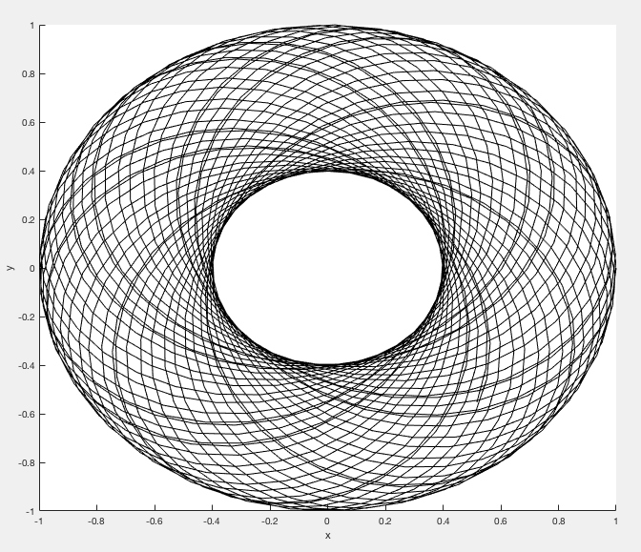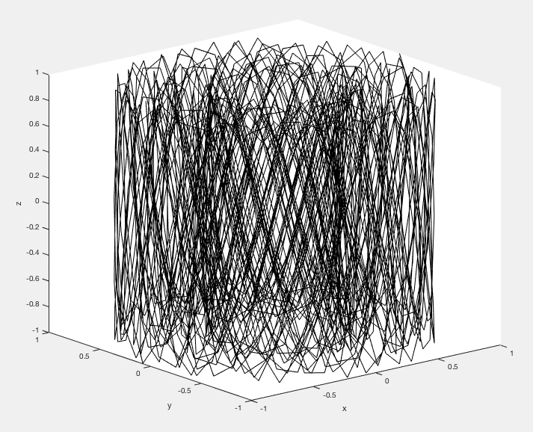

${C_{r}}^{'}=C_{m}=0.5$

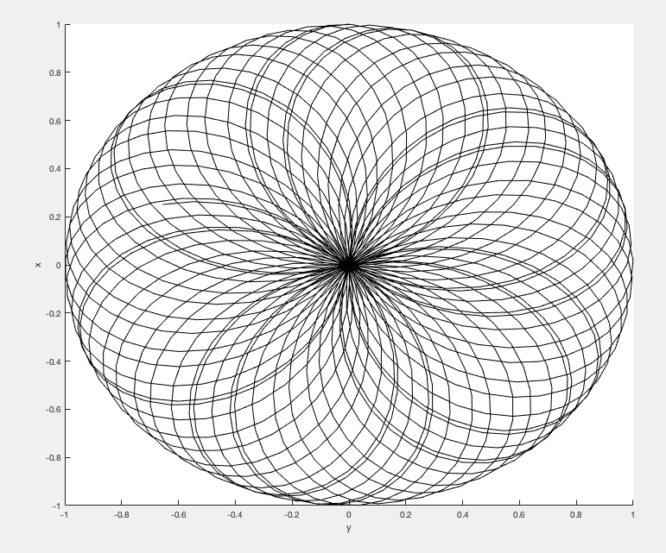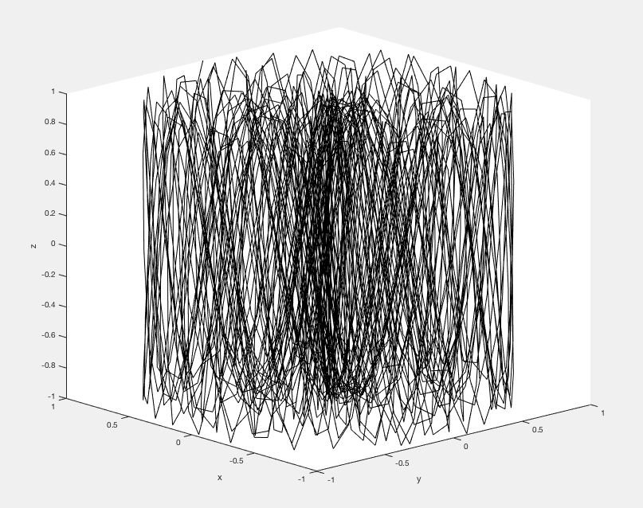

${C_{r}}^{'}<C_{m} ({C_{r}}^{'}{=0.3; C}_{m}=0.7)$

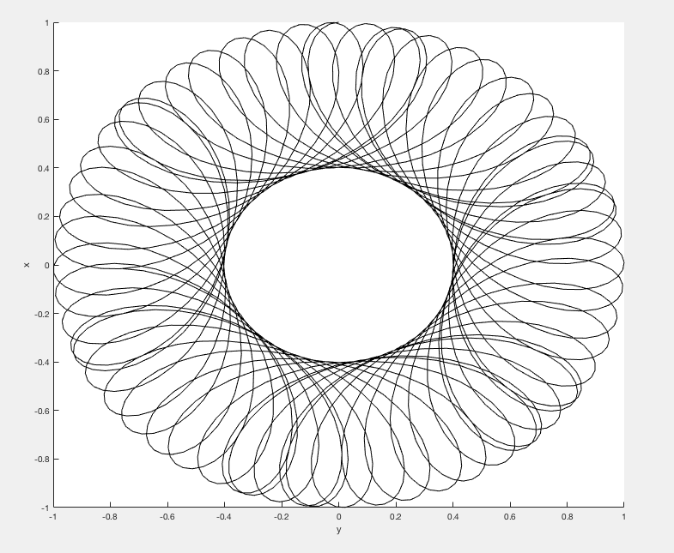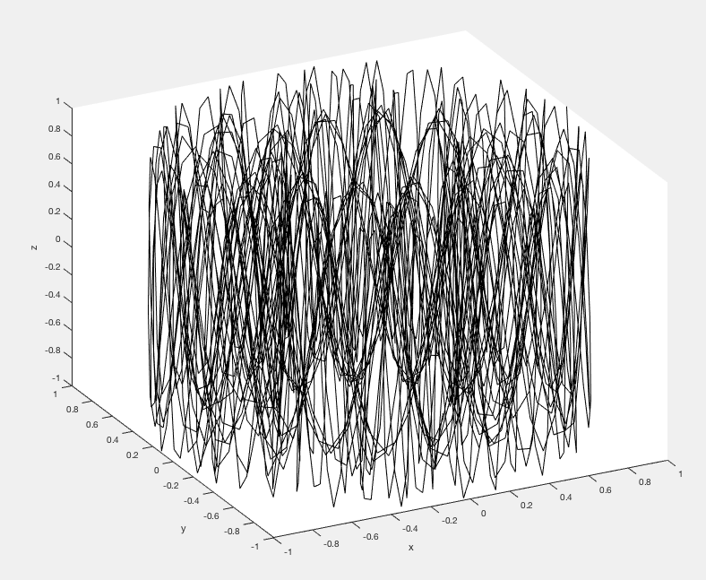

The right side of 3 different situations are the same, since they are all calculated by the same equation. The left side has clear difference on how ${C_{r}}^{'}{ and C}_{m}$’s relation has impact on particle’s motion, and I think it is obvious through direct observation of the three graphs.

5. References

About Calculation and Theories

1. <http://gabrielse.physics.harvard.edu/gabrielse/papers/1990/1990_tjoelker/chapter_2.pdf> (Retrieved 20 Apr, 2018)
2. Jochen K, T. E., M. H., S. S., K. B.,(2014) First-order perturbative calculation of the frequency-shifts caused by static cylindrically-symmetric electric and magnetic imperfections of a Penning trap

About Matlab Animation

1. Animatedline @ Matlab

<https://www.mathworks.com/help/matlab/ref/animatedline.html#mw_fdc2ce2e-db9c-43b1-92c9-e451bd7c3d4d>

1. Addpoints Function @ Matlab

<https://www.mathworks.com/help/matlab/ref/addpoints.html>

1. Drawnow @ Matlab

<https://www.mathworks.com/help/matlab/ref/drawnow.html>

1. Return @ Matlab

<https://www.mathworks.com/help/matlab/ref/return.html>