1. 填表資訊

|  |  |
| --- | --- |
| 填表員工編號 | 123123 |
| 填表員工姓名 | Andu |
| 填表時間 | 2018/01/18 14:24 |

1. 設計條件

|  |  |
| --- | --- |
| 設計潮位高(*HWL*) | 1.66 |
| 設計潮位低(*LWL*) | 0.16 |
| 殘留水位(*RWL*) | 0.66 |
| 平時上載荷重(*Q*) | 1 |
| 地震時上載荷重() | 0.5 |
| 船舶牽引力() | 2.5 |
| 陸上設計震度(*k*) | 0.16 |
| 水中設計震度(*k’*) | 0.32 |
| 水單位重() | 1.03 |
| 繫船柱突出高度 | 0.25 |
| 背填料內摩擦角() | 38 |
| 背填料壁面摩擦角() | 15 |
| 背填料水平傾斜角() | 0 |
| 入土深度(*U*) | 1 |
| 拋石厚度(*D*) | 0.5 |
| 地盤基礎內摩擦角() | 30 |
| 土壤凝聚力(*C*) | 0 |
| Meyerhof土壤承載力係數 | 0 |
| Meyerhof土壤承載力係數 | 8.6 |
| Meyerhof土壤承載力係數 | 7 |
| 平時滑動安全係數 | 1.2 |
| 平時傾倒安全係數 | 1.2 |
| 平時地盤承載力安全係數 | 2.5 |
| 地震時滑動安全係數 | 1 |
| 地震時傾倒安全係數 | 30 |
| 地震時地盤承載力安全係數 | 1.5 |
| 土壤重(陸上) | 1.8 |
| 土壤重(水中) | 1 |

1. 壁體自重及抵抗彎矩

壁體自重 

抵抗彎矩 

|  |  |  |  |  |  |  |
| --- | --- | --- | --- | --- | --- | --- |
| 檢討面  Sec. | 分區 | 面積  A(*m*2) | 單位體重 | 壁體自重 | 力臂 | 抵抗彎矩 |
| I | 1 | 3.04 | 2.30 | 6.99 | 1.14 | 7.99 |
|  | 2 | 2.50 | 2.30 | 5.75 | 2.50 | 14.38 |
|  | 3 | 3.71 | 1.80 | 6.68 | 3.61 | 24.12 |
| EL+1 | 計 |  |  | 19.42 | 2.39 | 46.49 |
|  |  |  |  | 19.42 | 2.39 | 46.49 |
| II | 4 | 1.70 | 1.25 | 2.13 | 2.50 | 5.31 |
|  | 5 | 5.80 | 0.70 | 4.06 | 2.50 | 10.15 |
| EL-0.5 | 計 |  |  | 25.60 | 2.42 | 61.95 |
|  |  |  |  | 25.60 | 2.42 | 61.95 |
| III | 6 | 7.50 | 0.70 | 5.25 | 2.50 | 13.13 |
| EL-2 | 計 |  |  | 30.85 | 2.43 | 75.07 |
|  |  |  |  | 30.85 | 2.43 | 75.07 |
| IV | 7 | 10.50 | 1.27 | 13.34 | 3.50 | 46.67 |
|  | 8 | 4.38 | 1.80 | 7.88 | 6.00 | 47.30 |
|  | 9 | 5.32 | 1.00 | 5.32 | 6.00 | 31.92 |
| EL-3.5 | 計 |  |  | 57.39 | 3.50 | 200.97 |
|  |  |  |  | 57.39 | 3.50 | 200.97 |
| V | 10 | 12.75 | 1.27 | 16.19 | 4.25 | 68.82 |
|  | 11 | 3.29 | 1.80 | 5.91 | 7.75 | 45.83 |
|  | 12 | 6.24 | 1.00 | 6.24 | 7.75 | 48.36 |
| EL-5 | 計 |  |  | 85.74 | 4.25 | 363.97 |
|  |  |  |  | 85.74 | 5.25 | 449.71 |
| VI | 13 | 13.75 | 1.27 | 17.46 | 4.91 | 85.75 |
| EL-6.5 | 計 |  |  | 103.20 | 5.19 | 535.46 |

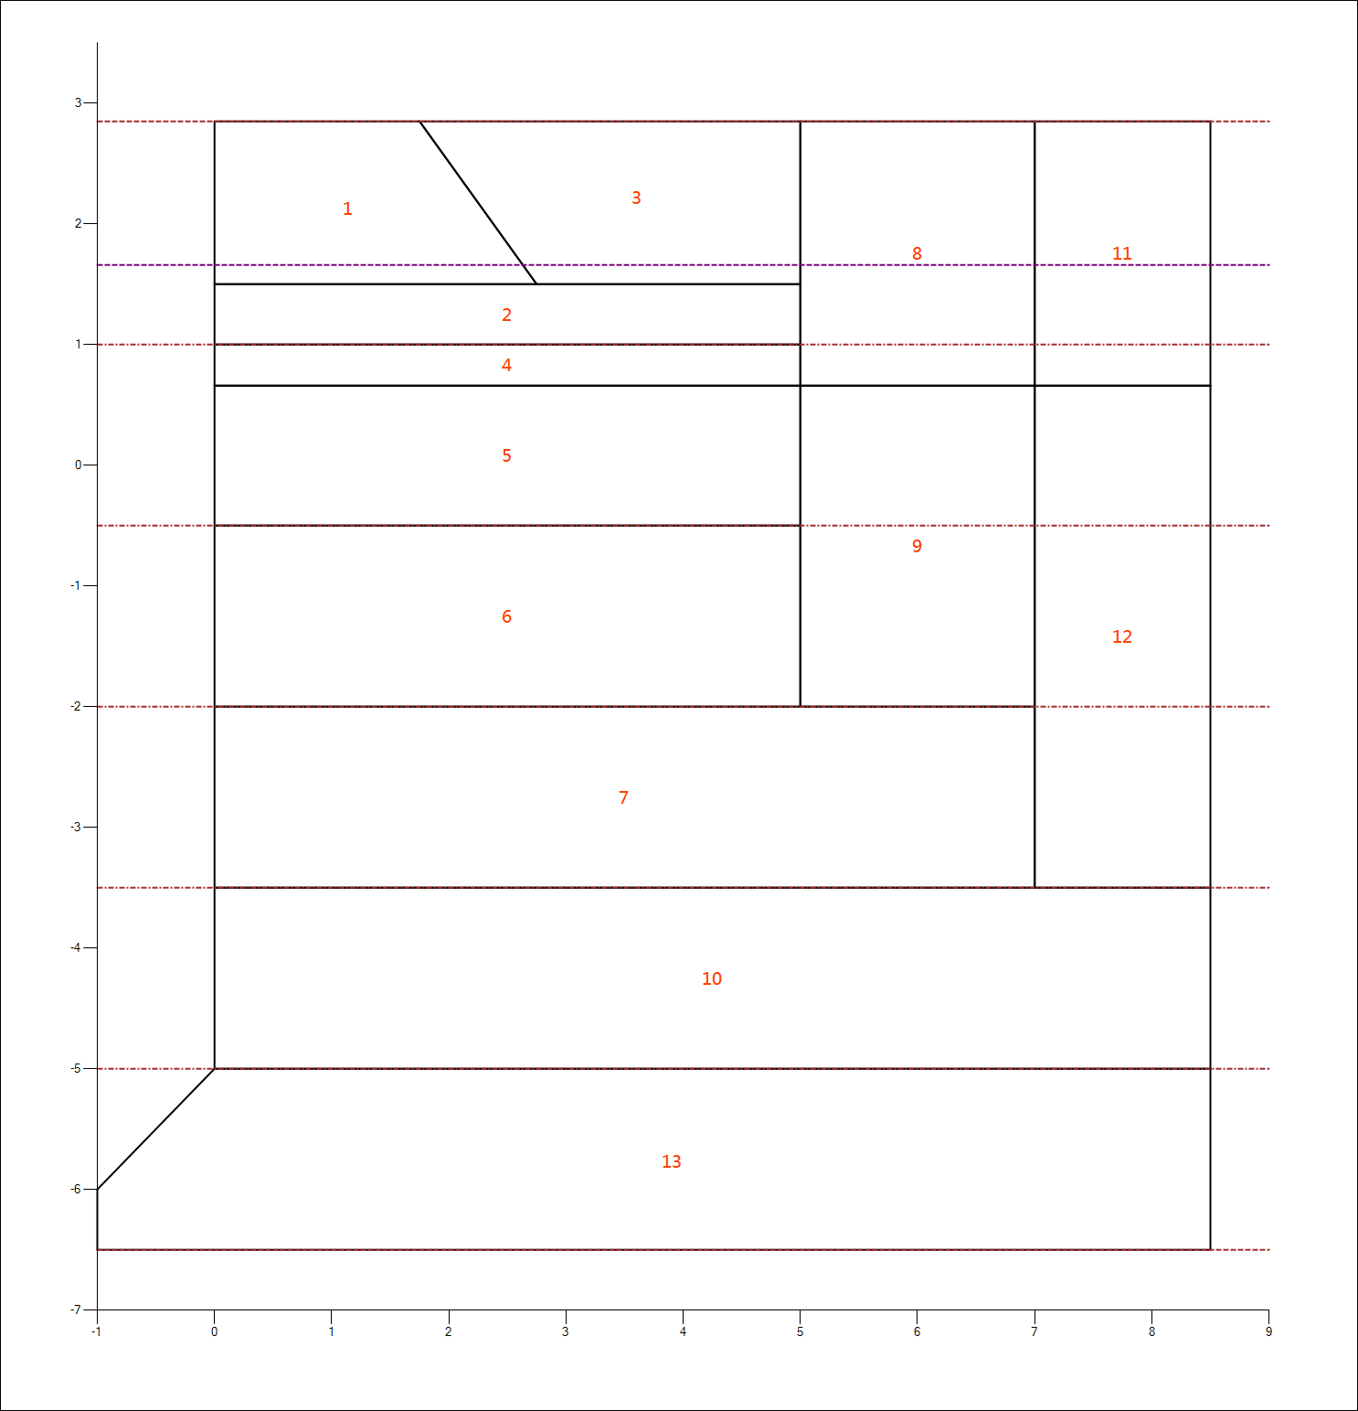

1. 地震力及傾倒彎矩

地震力 

設計震度*k*

傾倒彎矩

|  |  |  |  |  |  |  |
| --- | --- | --- | --- | --- | --- | --- |
| 檢討面  Sec. | 分區 | 面積  A(*m*2) | 單位體重 | 地震力 | 力臂 | 傾倒彎矩 |
| I | 1 | 3.04 | 2.30 | 1.12 | 1.13 | 1.26 |
|  | 2 | 2.50 | 2.30 | 0.92 | 0.25 | 0.23 |
|  | 3 | 3.71 | 1.80 | 1.07 | 1.22 | 1.30 |
| EL+1 | 計 |  |  | 3.11 | 0.90 | 2.79 |
|  |  |  |  | 3.11 | 2.40 | 7.45 |
| II | 4 | 1.70 | 1.25 | 0.34 | 1.33 | 0.45 |
|  | 5 | 5.80 | 1.25 | 1.16 | 0.58 | 0.67 |
| EL-0.5 | 計 |  |  | 4.61 | 1.86 | 8.57 |
|  |  |  |  | 4.61 | 3.36 | 15.48 |
| III | 6 | 7.50 | 1.25 | 1.50 | 0.75 | 1.13 |
| EL-2 | 計 |  |  | 6.11 | 2.72 | 16.61 |
|  |  |  |  | 6.11 | 4.22 | 25.77 |
| IV | 7 | 10.50 | 2.30 | 3.86 | 0.75 | 2.90 |
|  | 8 | 4.38 | 1.80 | 1.26 | 5.26 | 6.63 |
|  | 9 | 5.32 | 1.80 | 1.53 | 2.83 | 4.34 |
| EL-3.5 | 計 |  |  | 12.76 | 3.10 | 39.63 |
|  |  |  |  | 12.76 | 4.60 | 58.78 |
| V | 10 | 12.75 | 2.30 | 4.69 | 0.75 | 3.52 |
|  | 11 | 3.29 | 1.80 | 0.95 | 6.76 | 6.39 |
|  | 12 | 6.24 | 1.80 | 1.80 | 3.58 | 6.43 |
| EL-5 | 計 |  |  | 20.20 | 3.72 | 75.12 |
|  |  |  |  | 20.20 | 5.22 | 105.42 |
| VI | 13 | 13.75 | 2.30 | 5.06 | 0.73 | 3.72 |
| EL-6.5 | 計 |  |  | 25.26 | 4.32 | 109.14 |

1. 土壓水平分力及傾倒彎矩

**(一)土壓強度：**

1. 平時

|  |  |
| --- | --- |
| 設計震度 | 0 |
| 土壓係數 | 0.22 |

1. 地震時

陸上：

|  |  |
| --- | --- |
| 設計震度 | 0.16 |
| 土壓係數 | 0.31 |

水中

|  |  |
| --- | --- |
| 設計震度 | 0.32 |
| 土壓係數 | 0.44 |

**(二)土壓水平力及傾倒彎矩：**

|  |  |
| --- | --- |
| 水平分力 |  |
| 傾倒彎矩 |  |

|  |  |  |  |  |  |  |  |
| --- | --- | --- | --- | --- | --- | --- | --- |
| 檢討面 | 分區 | 平 |  | 時 | 地 | 震 | 時 |
|  |  | 水平分力 | 力臂 | 傾倒彎矩 | 水平分力 | 力臂 | 傾倒彎矩 |
| I |  | 1.04 | 0.73 | 0.76 | 1.21 | 0.69 | 0.83 |
| EL+1 | 計 | 1.04 | 0.73 | 0.76 | 1.21 | 0.69 | 0.83 |
|  |  | 1.04 | 2.23 | 2.33 | 1.21 | 2.19 | 2.64 |
| II |  | 1.69 | 0.71 | 1.20 | 2.92 | 0.67 | 1.95 |
| EL-0.5 | 計 | 2.73 | 1.29 | 3.53 | 4.13 | 1.11 | 4.60 |
|  |  | 2.73 | 2.79 | 7.62 | 4.13 | 2.61 | 10.79 |
| III |  | 2.17 | 0.72 | 1.57 | 4.08 | 0.72 | 2.94 |
| EL-2 | 計 | 4.90 | 1.87 | 9.20 | 8.21 | 1.67 | 13.73 |
|  |  | 4.90 | 3.37 | 16.55 | 8.21 | 3.17 | 26.05 |
| IV |  | 2.65 | 0.73 | 1.93 | 5.05 | 0.73 | 3.67 |
| EL-3.5 | 計 | 7.55 | 2.45 | 18.48 | 13.26 | 2.24 | 29.72 |
|  |  | 7.55 | 3.95 | 29.81 | 13.26 | 3.74 | 49.62 |
| V |  | 3.13 | 0.73 | 2.28 | 6.01 | 0.73 | 4.39 |
| EL-5 | 計 | 10.68 | 3.01 | 32.10 | 19.28 | 2.80 | 54.01 |
|  |  | 10.68 | 4.51 | 48.12 | 19.28 | 4.30 | 82.92 |
| VI |  | 3.60 | 0.73 | 2.64 | 6.98 | 0.73 | 5.11 |
| EL-6.5 | 計 | 14.28 | 3.55 | 50.76 | 26.26 | 3.35 | 88.04 |

1. 土壓垂直分力及抵抗彎矩

|  |  |
| --- | --- |
| 垂直分力 |  |
| 抵抗彎矩 |  |

|  |  |  |  |  |  |  |
| --- | --- | --- | --- | --- | --- | --- |
| 檢討面 | 平 |  | 時 | 地 | 震 | 時 |
|  | 垂直分力 | 力臂 | 抵抗彎矩 | 垂直分力 | 力臂 | 抵抗彎矩 |
| I | 0.28 | 5.00 | 1.40 | 0.32 | 5.00 | 1.62 |
| II | 0.73 | 5.00 | 3.66 | 1.11 | 5.00 | 5.53 |
| III | 1.31 | 5.00 | 6.57 | 2.20 | 5.00 | 11.00 |
| IV | 2.02 | 7.00 | 14.17 | 3.55 | 7.00 | 24.88 |
| V | 2.86 | 8.50 | 24.32 | 5.17 | 8.50 | 43.91 |
| VI | 3.83 | 9.50 | 36.35 | 7.04 | 9.50 | 66.84 |

1. 殘留水壓及傾倒彎矩

|  |
| --- |
| (1)平時與地震時之殘留水壓力相同 |
| (2)殘留水壓力強度 |
| (3)傾倒彎矩 |

|  |  |  |  |  |
| --- | --- | --- | --- | --- |
| 檢討面 | 分區 | 殘留水壓 | 力臂 | 傾倒彎矩 |
| I |  |  |  |  |
| II |  | 0.47 | 0.47 | 0.22 |
| EL-0.5 | 計 | 0.47 | 0.47 | 0.22 |
|  |  | 0.47 | 1.97 | 0.92 |
| III |  | 0.77 | 0.75 | 0.58 |
| EL-2 | 計 | 1.24 | 1.21 | 1.50 |
|  |  | 1.24 | 2.71 | 3.36 |
| IV |  | 0.77 | 0.75 | 0.58 |
| EL-3.5 | 計 | 2.01 | 1.96 | 3.94 |
|  |  | 2.01 | 3.46 | 6.96 |
| V |  | 0.77 | 0.75 | 0.58 |
| EL-5 | 計 | 2.79 | 2.71 | 7.54 |
|  |  | 2.79 | 4.21 | 11.72 |
| VI |  | 0.77 | 0.75 | 0.58 |
| EL-6.5 | 計 | 3.56 | 3.46 | 12.30 |

1. 地震時之動水壓及傾倒彎矩

|  |  |
| --- | --- |
| (1)設計震度 $k_{d}$ | 0.32 |
| (2)動水壓力 $F_{d}$ | $$\frac{7}{12}×k_{d}×r_{w}×h_{w}^{2}$$ |
| (3)作用力矩 $Y_{d}$ | $$\frac{2}{5}×h_{w}$$ |
| (4)傾倒彎矩 |  |

|  |  |  |  |
| --- | --- | --- | --- |
| 檢討面 | 動水壓合力 $$F_{d} t/m$$ | 力矩 $$Y_{d} (m)$$ | 傾倒彎矩 $$M_{d} (t-m/m)$$ |
| I |  |  |  |
| II | 0.13 | 0.46 | 0.06 |
| III | 0.68 | 1.06 | 0.72 |
| IV | 1.66 | 1.66 | 2.77 |
| V | 3.08 | 2.26 | 6.97 |
| VI | 4.93 | 2.86 | 14.11 |

1. 船舶牽引力及傾倒彎矩

|  |  |
| --- | --- |
| (1)船舶牽引力 | 2.5 |
| (2)繫船柱突出高度 | 0.25 |
| (3)作用力矩 |  |
| (4)傾倒彎矩 |  |

|  |  |  |  |
| --- | --- | --- | --- |
| 檢討面 | 船舶牽引力 | 力臂 | 傾倒彎矩 |
| I | 2.5 | 2.10 | 5.25 |
| II | 2.5 | 3.60 | 9.00 |
| III | 2.5 | 5.10 | 12.75 |
| IV | 2.5 | 6.60 | 16.50 |
| V | 2.5 | 8.10 | 20.25 |
| VI | 2.5 | 9.60 | 24.00 |

1. 垂直力及抵抗彎矩 總和表

(1)平時

|  |  |  |  |  |  |  |
| --- | --- | --- | --- | --- | --- | --- |
| 檢討面 | 垂直力 | | | 抵抗彎矩 | | |
|  | 壁體自重 | 垂直土壓 | 計 | 壁體自重 | 垂直土壓 | 計 |
| I | 19.42 | 0.28 | 19.70 | 46.49 | 1.40 | 47.88 |
| II | 25.60 | 0.73 | 26.34 | 61.95 | 3.66 | 65.61 |
| III | 30.85 | 1.31 | 32.17 | 75.07 | 6.57 | 81.65 |
| IV | 57.39 | 2.02 | 59.42 | 200.97 | 14.17 | 215.14 |
| V | 85.74 | 2.86 | 88.60 | 363.97 | 24.32 | 388.30 |
| VI | 103.20 | 3.83 | 107.03 | 535.46 | 36.35 | 571.82 |

(2)地震時

|  |  |  |  |  |  |  |
| --- | --- | --- | --- | --- | --- | --- |
| 檢討面 | 垂直力 | | | 抵抗彎矩 | | |
|  | 壁體自重 | 垂直土壓 | 計 | 壁體自重 | 垂直土壓 | 計 |
| I | 19.42 | 0.32 | 19.74 | 46.49 | 1.62 | 48.10 |
| II | 25.60 | 1.11 | 26.71 | 61.95 | 5.53 | 67.48 |
| III | 30.85 | 2.20 | 33.05 | 75.07 | 11.00 | 86.08 |
| IV | 57.39 | 3.55 | 60.95 | 200.97 | 24.88 | 225.85 |
| V | 85.74 | 5.17 | 90.90 | 363.97 | 43.91 | 407.88 |
| VI | 103.20 | 7.04 | 110.24 | 535.46 | 66.84 | 602.30 |

1. 水平力及傾倒彎矩 總和表
2. 平時

|  |  |  |  |  |  |  |  |  |
| --- | --- | --- | --- | --- | --- | --- | --- | --- |
| 檢討面 | 水平力 | | | | 傾倒彎矩 | | | |
|  | 土壓 | 殘留水壓 | 牽引力 | 計 | 土壓 | 殘留水壓 | 牽引力 | 計 |
| I | 1.04 | 0.00 | 2.5 | 3.54 | 0.76 | 0.00 | 5.25 | 6.01 |
| II | 2.73 | 0.47 | 2.5 | 5.70 | 3.53 | 0.22 | 9.00 | 12.75 |
| III | 4.90 | 1.24 | 2.5 | 8.65 | 9.20 | 1.50 | 12.75 | 23.45 |
| IV | 7.55 | 2.01 | 2.5 | 12.07 | 18.48 | 3.94 | 16.50 | 38.92 |
| V | 10.68 | 2.79 | 2.5 | 15.97 | 32.10 | 7.54 | 20.25 | 59.89 |
| VI | 14.28 | 3.56 | 2.5 | 20.34 | 50.76 | 12.30 | 24.00 | 87.06 |

1. 地震時

|  |  |  |  |  |  |  |  |  |
| --- | --- | --- | --- | --- | --- | --- | --- | --- |
| 檢討面 | 水平力 | | | | 傾倒彎矩 | | | |
|  | 土壓 | 殘留水壓 | 地震力 | 計 | 土壓 | 殘留水壓 | 地震力 | 計 |
| I | 1.21 | 0.00 | 3.11 | 4.31 | 0.83 | 0.00 | 2.79 | 3.62 |
| II | 4.13 | 0.47 | 4.61 | 9.20 | 4.60 | 0.22 | 8.57 | 13.39 |
| III | 8.21 | 1.24 | 6.11 | 15.56 | 13.73 | 1.50 | 16.61 | 31.84 |
| IV | 13.26 | 2.01 | 12.76 | 28.04 | 29.72 | 3.94 | 39.63 | 73.29 |
| V | 19.28 | 2.79 | 20.20 | 42.26 | 54.01 | 7.54 | 75.12 | 136.67 |
| VI | 26.26 | 3.56 | 25.26 | 55.07 | 88.04 | 12.30 | 109.14 | 209.48 |

1. 壁體安全檢核

**(1)滑動及傾倒安定檢核**

|  |  |
| --- | --- |
| 滑動安全係數 |  |
| 傾倒安全係數 |  |

|  |  |  |  |  |  |
| --- | --- | --- | --- | --- | --- |
| 檢討面 | 區分 | 平 | 時 | 地 震 | 時 |
| -- | -- | 安全係數 | 判定 | 安全係數 | 判定 |
| I | 滑動 | 3.34 | OK | 2.75 | OK |
|  | 傾倒 | 7.96 | OK | 13.30 | NG |
| II | 滑動 | 2.31 | OK | 1.45 | OK |
|  | 傾倒 | 5.15 | OK | 5.04 | NG |
| III | 滑動 | 1.86 | OK | 1.06 | OK |
|  | 傾倒 | 3.48 | OK | 2.70 | NG |
| IV | 滑動 | 2.46 | OK | 1.09 | OK |
|  | 傾倒 | 5.53 | OK | 3.08 | NG |
| V | 滑動 | 3.33 | OK | 1.29 | OK |
|  | 傾倒 | 6.48 | OK | 2.98 | NG |
| VI | 滑動 | 3.16 | OK | 1.20 | OK |
|  | 傾倒 | 6.57 | OK | 2.88 | NG |

**(2)地盤承載力檢核**

A.壁體底部反力計算

|  |  |  |
| --- | --- | --- |
| 區分 | 平時 | 地震時 |
| 合力作用點*X* | 4.53 | 3.56 |
| 壁體底部寬 | 9.50 | 9.50 |
| 偏心量*e* | 0.22 | 1.19 |
| *e*與之關係 | e<=(b/6) | e<=(b/6) |
| 壁體底部反力及分布寬()  ：最大反力  ：最小反力    當時：      ，  當時：  ，  ， | 最大反力P1=  12.84(t/m^2) | 最大反力P1=  20.30(t/m^2) |
| 最小反力P2=  9.70(t/m^2) | 最小反力P2=  2.91(t/m^2) |
| 壁體底部反力分佈寬=  9.50(m) | 壁體底部反力分佈寬=  9.50(m) |

B.基礎拋石底面容許承載力計算

|  |  |  |
| --- | --- | --- |
| 區分 | 平時 | 地震時 |
| 偏心傾斜荷重傾斜角 | 10.76° | 26.55° |
| 基礎拋石底面反力分佈寬 | b''=10.11(m) | b''=10.29(m) |
| 基礎拋石底面反力及  最大反力  最小反力 | R1= 12.57(t/m^2)  R2= 9.61(t/m^2) | R1= 19.25(t/m^2)  R2= 3.19(t/m^2) |
| 地盤之極限承載力      基礎地盤之容許承載力 | Qu=48.27(t/m^2)  qa=20.81(t/m^2) | Qu=48.90(t/m^2)  qa=34.10(t/m^2) |
| 判定 | OK | OK |