1. 填表資訊

|  |  |
| --- | --- |
| 填表員工編號 | Andy |
| 填表員工姓名 | 123 |
| 填表時間 | 2017/09/22 11:21 |

1. 設計條件

|  |  |
| --- | --- |
| 設計潮位高(*HWL*) | 1.8 |
| 設計潮位低(*LWL*) | 0 |
| 殘留水位(*RWL*) | 0.6 |
| 平時上載荷重(*Q*) | 1 |
| 地震時上載荷重() | 0.5 |
| 船舶牽引力() | 0 |
| 陸上設計震度(*k*) | 0.1 |
| 水中設計震度(*k’*) | 0.2 |
| 水單位重() | 1.03 |
| 繫船柱突出高度 | 0 |
| 背填料內摩擦角() | 40 |
| 背填料壁面摩擦角() | 15 |
| 背填料水平傾斜角() | 0 |
| 入土深度(*U*) | 0 |
| 拋石厚度(*D*) | 1 |
| 地盤基礎內摩擦角() | 33 |
| 土壤凝聚力(*C*) | 0 |
| Meyerhof土壤承載力係數 | 0 |
| Meyerhof土壤承載力係數 | 19 |
| Meyerhof土壤承載力係數 | 17 |
| 平時滑動安全係數 | 1.2 |
| 平時傾倒安全係數 | 1.2 |
| 平時地盤承載力安全係數 | 2.5 |
| 地震時滑動安全係數 | 1 |
| 地震時傾倒安全係數 | 1 |
| 地震時地盤承載力安全係數 | 2.5 |
| 土壤重(陸上) | 1.8 |
| 土壤重(水中) | 1 |

1. 壁體自重及抵抗彎矩

壁體自重 

抵抗彎矩 

|  |  |  |  |  |  |  |
| --- | --- | --- | --- | --- | --- | --- |
| 檢討面  Sec. | 分區 | 面積  A(*m*2) | 單位體重 | 壁體自重 | 力臂 | 抵抗彎矩 |
| I | B1 | 0.85 | 2.30 | 1.96 | 0.25 | 0.49 |
|  | B2 | 0.72 | 2.30 | 1.66 | 0.78 | 1.30 |
|  | B3 | 0.72 | 1.80 | 1.30 | 1.07 | 1.39 |
|  | B4 | 0.43 | 1.80 | 0.77 | 1.48 | 1.13 |
|  | B5 | 0.64 | 2.30 | 1.47 | 0.80 | 1.18 |
|  | B6 | 1.92 | 1.27 | 2.44 | 0.80 | 1.95 |
| EL-0.6 | 計 |  |  | 9.59 | 0.78 | 7.43 |
|  |  |  |  | 9.59 | 0.78 | 7.43 |
| II | B7 | 2.10 | 1.80 | 3.78 | 2.10 | 7.94 |
|  | B8 | 1.20 | 1.00 | 1.20 | 2.10 | 2.52 |
|  | B9 | 4.16 | 1.27 | 5.28 | 1.30 | 6.87 |
| EL-2.2 | 計 |  |  | 19.86 | 1.25 | 24.76 |
|  |  |  |  | 19.86 | 1.25 | 24.76 |
| III | B10 | 2.10 | 1.80 | 3.78 | 3.10 | 11.72 |
|  | B11 | 2.80 | 1.00 | 2.80 | 3.10 | 8.68 |
|  | B12 | 4.68 | 1.27 | 5.94 | 1.80 | 10.70 |
| EL-3.5 | 計 |  |  | 32.38 | 1.73 | 55.86 |

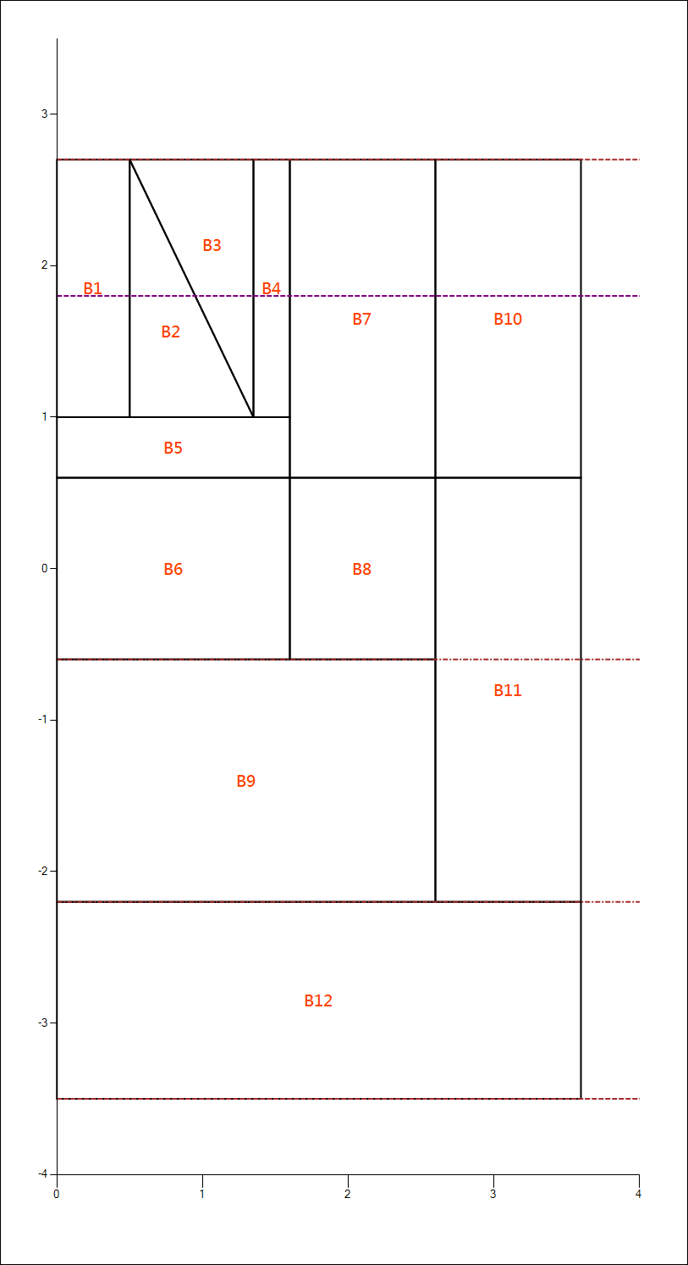

1. 地震力及傾倒彎矩

地震力 

設計震度

傾倒彎矩

|  |  |  |  |  |  |  |
| --- | --- | --- | --- | --- | --- | --- |
| 檢討面  Sec. | 分區 | 面積  A(*m*2) | 單位體重 | 地震力 | 力臂 | 傾倒彎矩 |
| I | B1 | 0.85 | 2.30 | 0.20 | 2.45 | 0.48 |
|  | B2 | 0.72 | 2.30 | 0.17 | 2.17 | 0.36 |
|  | B3 | 0.72 | 1.80 | 0.13 | 2.73 | 0.36 |
|  | B4 | 0.43 | 1.80 | 0.08 | 2.45 | 0.19 |
|  | B5 | 0.64 | 2.30 | 0.15 | 1.40 | 0.21 |
|  | B6 | 1.92 | 2.30 | 0.44 | 0.60 | 0.26 |
| EL-0.6 | 計 |  |  | 1.16 | 1.60 | 1.85 |
|  |  |  |  | 1.16 | 3.20 | 3.70 |
| II | B7 | 2.10 | 1.80 | 0.38 | 3.85 | 1.46 |
|  | B8 | 1.20 | 1.80 | 0.22 | 2.20 | 0.48 |
|  | B9 | 4.16 | 2.30 | 0.96 | 0.80 | 0.77 |
| EL-2.2 | 計 |  |  | 2.71 | 2.36 | 6.40 |
|  |  |  |  | 2.71 | 3.66 | 9.92 |
| III | B10 | 2.10 | 1.80 | 0.38 | 5.15 | 1.95 |
|  | B11 | 2.80 | 1.80 | 0.50 | 2.70 | 1.36 |
|  | B12 | 4.68 | 2.30 | 1.08 | 0.65 | 0.70 |
| EL-3.5 | 計 |  |  | 4.67 | 2.98 | 13.93 |

1. 土壓水平分力及傾倒彎矩

**(一)土壓強度：**

1. 平時

|  |  |
| --- | --- |
| 設計震度 | 0 |
| 土壓係數 | 0.20 |

1. 地震時

陸上：

|  |  |
| --- | --- |
| 設計震度 | 0.1 |
| 土壓係數 | 0.25 |

水中

|  |  |
| --- | --- |
| 設計震度 | 0.2 |
| 土壓係數 | 0.32 |

**(二)土壓水平力及傾倒彎矩：**

|  |  |
| --- | --- |
| 水平分力 |  |
| 傾倒彎矩 |  |

|  |  |  |  |  |  |  |  |
| --- | --- | --- | --- | --- | --- | --- | --- |
| 檢討面 | 分區 | 平 |  | 時 | 地 | 震 | 時 |
|  |  | 水平分力 | 力臂 | 傾倒彎矩 | 水平分力 | 力臂 | 傾倒彎矩 |
| I |  | 2.43 | 1.28 | 3.11 | 3.02 | 1.14 | 3.45 |
| EL-0.6 | 計 | 2.43 | 1.28 | 3.11 | 3.02 | 1.14 | 3.45 |
|  |  | 2.43 | 2.88 | 7.00 | 3.02 | 2.74 | 8.28 |
| II |  | 2.11 | 0.77 | 1.62 | 3.07 | 0.77 | 2.36 |
| EL-2.2 | 計 | 4.54 | 1.90 | 8.62 | 6.09 | 1.75 | 10.64 |
|  |  | 4.54 | 3.20 | 14.52 | 6.09 | 3.05 | 18.56 |
| III |  | 2.08 | 0.63 | 1.31 | 3.08 | 0.63 | 1.94 |
| EL-3.5 | 計 | 6.62 | 2.39 | 15.83 | 9.17 | 2.24 | 20.50 |

1. 土壓垂直分力及抵抗彎矩

|  |  |
| --- | --- |
| 垂直分力 |  |
| 抵抗彎矩 |  |

|  |  |  |  |  |  |  |
| --- | --- | --- | --- | --- | --- | --- |
| 檢討面 | 平 |  | 時 | 地 | 震 | 時 |
|  | 垂直分力 | 力臂 | 抵抗彎矩 | 垂直分力 | 力臂 | 抵抗彎矩 |
| I | 0.65 | 1.60 | 1.04 | 0.81 | 1.60 | 1.29 |
| II | 1.22 | 2.60 | 3.16 | 1.63 | 2.60 | 4.25 |
| III | 1.77 | 3.60 | 6.38 | 2.46 | 3.60 | 8.84 |

1. 殘留水壓及傾倒彎矩

|  |
| --- |
| (1)平時與地震時之殘留水壓力相同 |
| (2)殘留水壓力強度 |
| (3)傾倒彎矩 |

|  |  |  |  |  |
| --- | --- | --- | --- | --- |
| 檢討面 | 分區 | 殘留水壓 | 力臂 | 傾倒彎矩 |
| I |  | 0.56 | 0.47 | 0.26 |
|  | 計 | 0.56 | 2.07 | 1.15 |
| II |  | 0.99 | 0.80 | 0.79 |
| EL-2.2 | 計 | 1.55 | 1.26 | 1.94 |
|  |  | 1.55 | 2.56 | 3.95 |
| III |  | 0.80 | 0.65 | 0.52 |
| EL-3.5 | 計 | 2.35 | 1.90 | 4.47 |

1. 船舶牽引力及傾倒彎矩

|  |  |
| --- | --- |
| (1)船舶牽引力 | 0 |
| (2)繫船柱突出高度 | 0 |
| (3)作用力矩 |  |
| (4)傾倒彎矩 |  |

|  |  |  |  |
| --- | --- | --- | --- |
| 檢討面 | 船舶牽引力 | 力臂 | 傾倒彎矩 |
| I | 0 | 3.30 | 0.00 |
| II | 0 | 4.90 | 0.00 |
| III | 0 | 6.20 | 0.00 |

1. 垂直力及抵抗彎矩 總和表

(1)平時

|  |  |  |  |  |  |  |
| --- | --- | --- | --- | --- | --- | --- |
| 檢討面 | 垂直力 | | | 抵抗彎矩 | | |
|  | 壁體自重 | 垂直土壓 | 計 | 壁體自重 | 垂直土壓 | 計 |
| I | 9.59 | 0.65 | 10.24 | 7.43 | 1.04 | 8.48 |
| II | 19.86 | 1.22 | 21.07 | 24.76 | 3.16 | 27.92 |
| III | 32.38 | 1.77 | 34.15 | 55.86 | 6.38 | 62.24 |

(2)地震時

|  |  |  |  |  |  |  |
| --- | --- | --- | --- | --- | --- | --- |
| 檢討面 | 垂直力 | | | 抵抗彎矩 | | |
|  | 壁體自重 | 垂直土壓 | 計 | 壁體自重 | 垂直土壓 | 計 |
| I | 9.59 | 0.81 | 10.40 | 7.43 | 1.29 | 8.73 |
| II | 19.86 | 1.63 | 21.49 | 24.76 | 4.25 | 29.01 |
| III | 32.38 | 2.46 | 34.84 | 55.86 | 8.84 | 64.70 |

1. 水平力及傾倒彎矩 總和表
2. 平時

|  |  |  |  |  |  |  |  |  |
| --- | --- | --- | --- | --- | --- | --- | --- | --- |
| 檢討面 | 水平力 | | | | 傾倒彎矩 | | | |
|  | 土壓 | 殘留水壓 | 牽引力 | 計 | 土壓 | 殘留水壓 | 牽引力 | 計 |
| I | 2.43 | 0.56 | 0 | 2.99 | 3.11 | 0.26 | 0.00 | 3.37 |
| II | 4.54 | 1.55 | 0 | 6.08 | 8.62 | 1.94 | 0.00 | 10.56 |
| III | 6.62 | 2.35 | 0 | 8.97 | 15.83 | 4.47 | 0.00 | 20.30 |

1. 地震時

|  |  |  |  |  |  |  |  |  |
| --- | --- | --- | --- | --- | --- | --- | --- | --- |
| 檢討面 | 水平力 | | | | 傾倒彎矩 | | | |
|  | 土壓 | 殘留水壓 | 地震力 | 計 | 土壓 | 殘留水壓 | 地震力 | 計 |
| I | 3.02 | 0.56 | 1.16 | 4.73 | 3.45 | 0.26 | 1.85 | 5.56 |
| II | 6.09 | 1.55 | 2.71 | 10.35 | 10.64 | 1.94 | 6.40 | 18.98 |
| III | 9.17 | 2.35 | 4.67 | 16.18 | 20.50 | 4.47 | 13.93 | 38.90 |

1. 壁體安全檢核

**(1)滑動及傾倒安定檢核**

|  |  |
| --- | --- |
| 滑動安全係數 |  |
| 傾倒安全係數 |  |

|  |  |  |  |  |  |
| --- | --- | --- | --- | --- | --- |
| 檢討面 | 區分 | 平 | 時 | 地 震 | 時 |
| -- | -- | 安全係數 | 判定 | 安全係數 | 判定 |
| I | 滑動 | 1.71 | OK | 1.10 | OK |
|  | 傾倒 | 2.52 | OK | 1.57 | OK |
| II | 滑動 | 1.73 | OK | 1.04 | OK |
|  | 傾倒 | 2.64 | OK | 1.53 | OK |
| III | 滑動 | 2.29 | OK | 1.29 | OK |
|  | 傾倒 | 3.07 | OK | 1.66 | OK |

**(2)地盤承載力檢核**

A.壁體底部反力計算

|  |  |  |
| --- | --- | --- |
| 區分 | 平時 | 地震時 |
| 合力作用點*X* | 1.23 | 0.74 |
| 壁體底部寬 | 3.60 | 3.60 |
| 偏心量*e* | 0.57 | 1.06 |
| *e*與之關係 | e<=(b/6) | e>(b/6) |
| 壁體底部反力及分布寬()  ：最大反力  ：最小反力    當時：      ，  當時：  ，  ， | 最大反力P1=  18.53(t/m^2) | 最大反力P1=  31.36(t/m^2) |
| 最小反力P2=  0.44(t/m^2) | 最小反力P2=  0.00(t/m^2) |
| 壁體底部反力分佈寬=  3.60(m) | 壁體底部反力分佈寬=  2.22(m) |

B.基礎拋石底面容許承載力計算

|  |  |  |
| --- | --- | --- |
| 區分 | 平時 | 地震時 |
| 偏心傾斜荷重傾斜角 | 14.71° | 24.92° |
| 基礎拋石底面反力分佈寬 | b''=4.86(m) | b''=3.73(m) |
| 基礎拋石底面反力及  最大反力  最小反力 | R1= 14.72(t/m^2)  R2= 1.33(t/m^2) | R1= 19.66(t/m^2)  R2= 1.00(t/m^2) |
| 地盤之極限承載力      基礎地盤之容許承載力 | Qu=60.34(t/m^2)  qa=25.14(t/m^2) | Qu=50.74(t/m^2)  qa=21.30(t/m^2) |
| 判定 | OK | OK |