一、填表資訊

|  |  |
| --- | --- |
| 填表員工編號 | 123456 |
| 填表員工姓名 | 游祥麟 |
| 填表時間 | 2016/05/26 16:33 |

二、設計條件

|  |  |
| --- | --- |
| 深海波波向(16方位) | ES |
| 海側方向(左/右) | 右 |
| 深海波波高(m) | 7.1 |
| 深海波週期(sec) | 11.2 |
| 設計潮位(m) | 6.63 |
| 海床波度 | 0.04 |
| 折射係數 | 1 |
| 淺化係數 | 1.001 |
| 繞射係數 | 0.42 |
| 波力折減係數 | 0.95 |
| 入射波與堤體法線之垂向夾角(未修正) | 30 |
| 入射波與堤體法線之垂向夾角(修正後) | 15 |
| 地面線(m) | -4.5 |
| 消波塊高程(m) | 7.2 |

三、外力計算

1. 水深條件

|  |  |
| --- | --- |
| (m) | 11.13 |
| (m) | 10.63 |
| (m) | 3.37 |
| (m) | 0.00 |

2. 有義波高及最大波高

|  |  |
| --- | --- |
|  | 195.69 |
|  | 2.98 |
|  | 110.04 |
|  | 0.06 |

|  |  |  |  |  |  |
| --- | --- | --- | --- | --- | --- |
| 概算係數 | | | 概算係數 | | |
|  |  |  |  |  |  |
| 0.16 | 0.62 | 1.19 | 0.30 | 0.73 | 1.96 |

|  |  |
| --- | --- |
| 有義波高(m) | 2.98 |
|  | 0.04 |
|  | 11.73 |
| 最大波高(m) | 5.37 |

3. 波壓強度係數

|  |  |
| --- | --- |
|  | 0.90 |
|  | 0.00 |
|  | 0.84 |

4. 液壓作用高度

|  |  |
| --- | --- |
|  | 7.53 |
|  | 3.37 |

5. 波壓力計算

|  |  |
| --- | --- |
|  | 4.65 |
|  | 3.85 |
|  | 3.88 |
|  | 2.57 |

|  |  |  |  |  |
| --- | --- | --- | --- | --- |
| 分區 | 波壓強度  P(t/m2) | 波壓  FP(t/m2) | 力矩  Y(m) | 傾倒彎矩  Mp(t-m/m) |
| EL +10 | 2.57 | 12.16 | 12.32 | 149.74 |
| EL +6.63 | 4.65 | 45.34 | 5.32 | 240.99 |
| EL -4 | 3.88 | 0.00 | 0.00 | 0.00 |
| 合計 | ---- | 0.00 | ---- | 390.73 |

6. 揚壓力計算

|  |  |
| --- | --- |
|  | 3.88 |
|  | 23.29 |
|  | 186.33 |

7. 堤體自重及抵抗彎矩

堤體自重

抵抗彎矩

|  |  |  |  |  |  |  |
| --- | --- | --- | --- | --- | --- | --- |
| 分區 | 型塊名稱 | A  (m2) | Y  (t/m3) | W  (t/m) | X  (m) | Mw  (t-m/m) |
|  | 1 | 4.90 | 2.30 | 11.27 | 11.13 | 125.38 |
| EL +6.63 | 2 | 5.89 | 2.30 | 13.55 | 6.70 | 90.76 |
|  | 3 | 19.56 | 2.30 | 44.99 | 6.00 | 269.93 |
| EL -4 | 4 | 108.00 | 2.30 | 248.40 | 6.00 | 1490.40 |
| 合計 | --- | --- | --- | 318.21 | --- | 1976.47 |

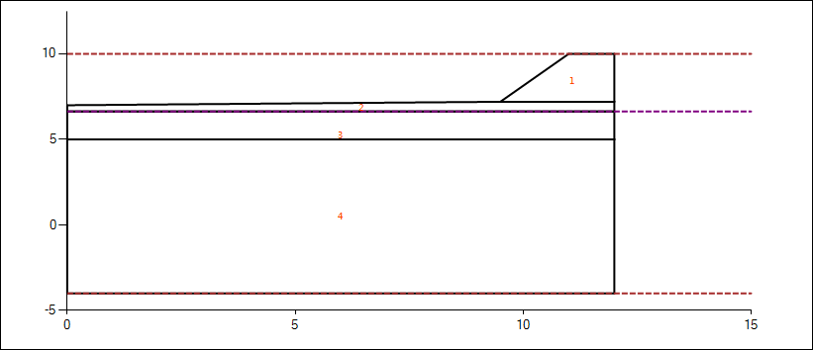

四、堤體安定檢查

|  |  |  |
| --- | --- | --- |
| 1. 滑動 | 3.08 | >=1.2...OK |
| 2. 傾倒 | 4.58 | >=1.2...OK |

五、消波工重量計算

1. 堤身段(港外側)

|  |  |
| --- | --- |
| 消波形塊安定係數 | 7 |
| 消波塊單位體積重量 | 2.3 |
| 消波塊斜坡面與水平面之夾角 | 33.7 |
| W1(ton) | 3.11 |

2. 堤頭部加強

|  |  |
| --- | --- |
| 消波形塊安定係數 | 7 |
| 消波塊單位體積重量 | 2.3 |
| 消波塊斜坡面與水平面之夾角 | 33.7 |
| W2(ton) | 4.66 |

3. 堤身段(航道側)

|  |  |
| --- | --- |
| 消波型塊安定係數 |  |
| 消波塊單位體積重量 |  |
| 消波塊斜坡面與水平面之夾角 |  |
| 波高傳遞率 |  |
|  |  |
|  |  |
|  |  |
|  |  |
| W3(ton) |  |

六、胸牆部安定檢核

1. 滑動SF檢核

|  |  |
| --- | --- |
| 滑動SF | 0.71  <1.2...NG |
| 混凝土容許應力 | 42.02 |
|  | 66.94 |
| 採用 | 60 |
| 胸牆EL值(以上) | 5 |

2. 傾倒SF檢核

|  |  |  |
| --- | --- | --- |
| 傾倒SF | 2.34 | >=1.2...OK |