Using Machine Theory of Mind to Learn Agent Social Network Structures from Observed Interactive Behaviors with Targets

Yun-Shiuan Chuang, Hsin-Yi Hung, Edwinn Gamborino, Joshua O.S. Goh, Tsung-Ren Huang, Yu-Ling Chang, Su-Ling Yeh, Li-Chen Fu, *Member, IEEE*

*Abstract*— Human social interactions are laden with behavioral preferences that stem from hidden social network representations. In this study, we trained a neural network (NN) to learn and predict human social preferences based on implicit information from the way agents and social targets behaviorally interact with each other. Our findings have implications for machine applications that seek to infer hidden information structures solely from third-person observation of behaviors.

# INTRODUCTION

# The use of artificial intelligent machines that dynamically interact with people is proliferating across many aspects of human life such as in interactive live service platforms [] and socially assistive robots []. Nevertheless, the efficacy of such social machines is limited by the naturalness of their interactions with people. Specifically, human-machine interactions are typically hampered because the interactive actions engaged by machines are often contextually aberrant and do not fit human social behavioral norms []. Thus, learning algorithms that help social machines display more human-like contextually relevant interactive behaviors should enhance their intended functionality.

*This research was supported in part by the Ministry of Science and Technology of Taiwan (MOST 107-2634-F-002-018), National Taiwan University, Center for Artificial Intelligence & Advanced Robotics, and Joint Research Center for AI Technology and All Vista Healthcare.

Y.-S. Chuang is with the Graduate Institute of Brain and Mind Sciences, National Taiwan University, Taipei, Taiwan (e-mail: yunshiuan.chuang@gmail.com).

H.-Y. Hung is with the Graduate Institute of Brain and Mind Sciences and the Center for Artificial Intelligence and Advanced Robotics, National Taiwan University, Taipei, Taiwan (e-mail: r05454001@ntu.edu.tw).

E. Gamborino is with the Center for Artificial Intelligence and Advanced Robotics, National Taiwan University, Taipei, Taiwan. (phone: +886 958 376 105; e-mail: gamborino@ntu.edu.tw).

J.O.S. Goh is with the Graduate Institute of Brain and Mind Sciences, Department of Psychology, Neurobiology and Cognitive Science Center, and the Center for Artificial Intelligence and Advanced Robotics, National Taiwan University, Taipei, Taiwan. (phone: +886 2 2312 3456 ext. 88022; e-mail: joshuagoh@ntu.edu.tw).

T.-R. Huang and Y.-L. Chang are with the Department of Psychology and the Center for Artificial Intelligence and Advanced Robotics, National Taiwan University, Taipei, Taiwan. (e-mail: [ychang, trhuang] @g.ntu.edu.tw).

S.-L. Yeh are with the Department of Psychology, the Graduate Institute of Brain and Mind Sciences and the Center for Artificial Intelligence and Advanced Robotics, National Taiwan University, Taipei, Taiwan. (e-mail: suling@g.ntu.edu.tw).

L.-C. Fu is with the Center for Artificial Intelligence and Advanced Robotics, the Department of Electrical Engineering and the Department of Computer Science and Information Engineering, National Taiwan University, Taipei, Taiwan (e-mail: lichen@ntu.edu.tw).

# One characteristic driving fluent human social interactions is access to information about the underlying social network of persons involved, which is often implicit []. For example, suggesting a friend call Bill Gates about a lunch appointment would be absurd unless one knew that he is a common acquaintance. Also, one might talk about sensitive matters with a sibling amongst other family members but avoid such topics with the sibling when amongst colleagues. In these above scenarios, knowledge of the collocutor’s social network is implicitly required to determine if a given interactive action would be contextually pertinent or not. Similarly, naturalistic human-machine social interactions would require machines to represent and leverage on information about the underlying social networks governing behavioral interactions between humans.

# Social networks, however, are abstract constructs in human minds that are hidden with respect to third-party observers such as another person or a machine. A social network exists only because the persons involved preferentially interact with each other in specific ways. As such, the nature of social connections between persons must be inferred from observations of their interactive behaviors. Critically, other work has shown that artificial neural networks implementing Theory of Mind (e.g. ToMnet []) can observe past social interaction outcomes between agents and targets (derived from predetermined interaction rewards) and form internal representations of agents’ hidden false beliefs.

# In this study, we adapted the work in [] to construct ToMnet+ and evaluated how its operation might represent hidden social networks underlying observed interactions between agents and targets. Such a demonstration has implications on how neural models might be engaged to infer deep relational structures in apparently disparate observations across various classes of data problems. In addition, as mentioned, an artificial neural network developed along these lines might also be integrated as a dynamic module in social software services or robots to enhance human-machine interactions across various functional contexts.

# Core to our approach in this work is simulating plausible social networks that constitute ground truth against which to assess performance of ToMnet+ (Fig. 1). These simulated social networks consisted of agents with different inter-personal connection weights to targets. Importantly, connection weights were based on the range of scores from the Social Support Questionnaire (SSQ) commonly used in Psychology to evaluate real human social dependencies on specific persons []. In general, people more readily approach and interact with persons in their network whom they perceive as providing them with greater social support [].

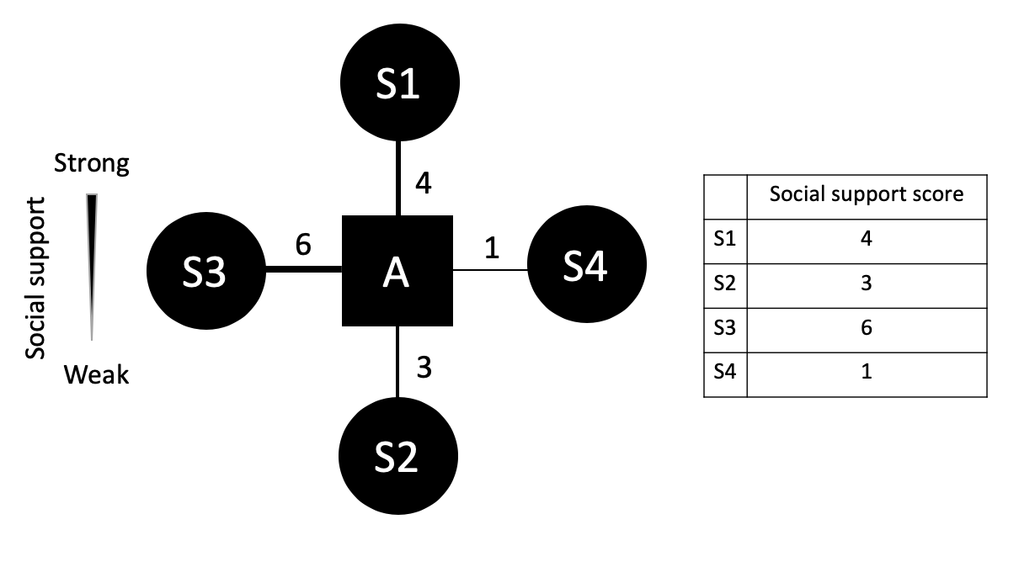

Fig. 1. An example simulated social support network of agent, *A*, and four targets, *S*. Connections between the agent and targets are modulated by the degree of social support the agent perceives receiving from each target.

# Simulated social support networks were thus used to generate sets of agent interactions with targets in different social contexts from which ToMnet+ learned. To test for a hidden social support network representation, we asked ToMnet+ which target an agent would preferentially interact with over various novel combinations of social contexts. We considered that the rank order of agent-target social support weights captures the base topology of our simple simulated social networks. As such, the goal is to determine if ToMnet+ judgment of agent-target social interaction preferences during test has a similar rank order as the social support weights.

# In the following, Section II expands on the notion of social support and its influence on human social interaction as well as considers relevant findings on machine learning of human social preferences. Section III covers our methodology regarding the SSQ, simulation generation, additional real human social interaction data acquisition for ecological validation, and ToMnet+ architecture and implementation. Section IV reports ToMnet+ performance results for the simulation data as well as human data. Section V discusses the findings and conclusion.

# Background and Related Works

## A. Social Support Networks

The role of social support networks in modulating human inter-personal interaction behaviors has been extensively studied. As we are aware, [] was the first study to use the term “network” and apply its concept on a small Norwegian community to characterize how pairs of persons were socially related to each other. Specifically, two persons in the social network might be friends, each with their own other sets of friends, some of which might know each other or not. Moreover, in order to achieve certain goals in the social network, each person interacts with specific sets of others, resulting in the formation of sub-classes of social function. Social networks are thus graphs with specific topologies [] that emerge from tracing out the paths of relationships between a given person and how that person socially interact with all other persons in the network.

Importantly, as mentioned, social network structure or topology also determines the sort of social interactions a person might engage in or not. Specifically, a person’s social network mediates the ease with which the person is able to obtain support from others for certain needs []. For instance, Interestingly, support may not always be sought out from persons close in the social network. Rather, persons in more distal networks or weak networks might at times be more favored for some life or psychological needs []. Thus, while a person might maintain several different types of social network, one of the most important of these is a person’s social support network. Critically, one’s social support network likely drives many everyday social interactions with different people. As such, there is a need to quantify a person’s social support network.

Several approaches have been implemented to characterize social support networks. Of these, Sarason’s Social Support Questionaire [] has been one of the most commonly used. The SSQ consists of 27 items. …

In this study, we simulated a social network of a virtual agent (A) with four social targets (s) based on the degree of social support the agent perceives about each target as in the SSQ [].

## B. Machine Theory of Mind

## C. Preference Learning

Both in the literature and in commercial applications, there are several instances of artificial intelligence being used to learn user preferences in order to provide personalized, or targeted, services from different types of data – visual, verbal, metadata – and with different machine learning approaches.

For instance, in the field of virtual agents, Recommender Systems are ubiquitous on web platforms and in our personal computing devices (smartphones and others). These artificial agents learn human preferences and adjust their service accordingly with the objective of maximizing the time the user spends using the platform, which often translates to increased profits from advertisements. These systems often rely on hard metrics (e.g. usage time, number of items consumed), content meta-data (e.g. tags, title, author) and user-generated data (e.g. ratings, engagement in social feedback systems) to train the learning structures that adjust the nature of the content feed shown to the user [14], [15]. Given the recent explosion of social media and ad-based media consumption platforms, data to train such systems is now abundant, but not often made publicly available. In contrast, the proposed system aims to learn the social network of the user from naturalistic observation of the users’ behavior around others in order to provide advice on how to deal with different social situations.

Socially Assistive Robotics is a discipline where a robot –defined as an embodied intelligent agent – provides a service to its user, either physical (e.g. rehabilitation therapy) or psychological (e.g. companionship, emotional support). Previous research [17] has indicated that autonomous cognitive and social profiling of the user are key to deploying social robots in environments outside of the laboratory (e.g. in hospitals, schools or at home). In order to perform this cognitive and social profiling, robots must interpret the behavior of their users through implicit cues in their facial expression and body gestures to infer mental states, personalities and emotions and, using this information, use a decision making process to determine how to best interact with a specific user.

For instance, in [16] a platform for robot-assisted photo reminiscence for the elderly was introduced. Reminiscence Therapy is an intervention commonly used in patients with Mild Cognitive Impairment to prevent brain deterioration. It most often relies on the evocation of memories from the users’ lifetime through discussion of personal effects such as photographs. The authors implemented a variety of deep neural networks and a knowledge based inference process to generate questions that are directly related to the visual content of each photograph. Results showed that the participants felt more engaged when the robot asked questions related to the photograph and their speech than when not.

In [18], the authors presented a method to promote trust between humans and robots. Their approach is based on Natural Language Understanding techniques where, when the user discloses their vulnerability to the robot, the system could infer the underlying feelings and desires of the user in order to provide relevant and effective emotional support.

Finally, in [19], [20], the authors discuss the importance of learning the preference of the user through interactions with an emotional support robot for children. The system they presented could perform a variety of actions (e.g. play videos, tell jokes), and learn the user preferences by assessing their emotional reactions from their facial expressions with a n Interactive Reinforcement Learning algorithm. Their results showed that subjects gave more positive feedback to the robot and showed more willingness to interact with the robot after several sessions when it learned their preferences.

In the proposed system

# Methodology

## A. System Overview

We simulated a social network of a virtual agent (*A*) with four social targets (*s*) based on the degree of social support the agent perceives about each target []. We then placed agents and selected targets in locations in a grid world randomly generated with barriers (Fig. 2). Using these social agent parameters, we simulated agent movement behaviors to targets by contrasting the physical distances, $d_{s}$, which is the number of steps between agent and targets, and attraction, $u_{s}$, which is calculated as,

$$u_{s}=U\left(‖\hat{α_{s}}‖,‖ \hat{β_{s}}‖\right)=\frac{\sqrt{{(\tilde{β_{1,s}}}^{2}+ {\tilde{β_{2,s}}}^{2}+{\tilde{β_{3,s}}}^{2} )}}{\sqrt{({\tilde{α_{1,s}}}^{2}+ {\tilde{α_{2,s}}}^{2}+{\tilde{α_{3,s}}}^{2} )}}$$

Where $s=1,2,3,4$, and $α_{n,s}$ and $β_{n,s}$ are the nth personal and associative parameters of target s, respectively. Then,

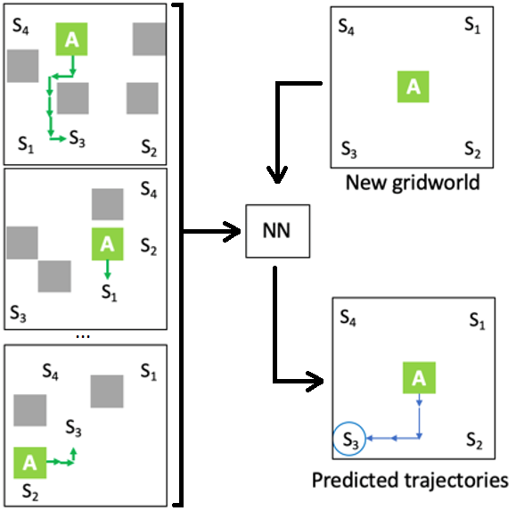

Figure 2. A depiction of the simulated social network of agent, A, and targets, s. Agent and targets are socially associated with connections modulated by social distances (line thickness), social support (node color), and nature of relationship (shape) as well as personal interaction biases for power distance, affiliation, and interpersonal reactivity (not shown in figure) (see Method).

$$\tilde{P_{s}}=(-\tilde{u_{s}}ln\tilde{u_{s}})-(-\tilde{d_{s}}ln\tilde{d_{s}})$$

such that the agent was set to move toward the social target with largest $\tilde{\left(P_{s}\right)}$, constituting a grid world trajectory instance (green arrows in Fig. 2). We simulated 10,000 grid world trajectories in total. In addition, a real human participant also indicated four friends (targets) with social parameter information obtained using questionnaires [3][4][5]. The participant was then placed in randomly generated grid world scenarios and was tasked to reach one of the targets with minimal moves, yielding 9,830 real human trajectory data. We then applied a modified ToMnet consisting of a deep-learning architecture with a character network and a prediction network. The character network consumes the agent’s past grid world trajectories to summarize the acting agent’s “character”. The prediction network then consumes the 8-dimensional character vector and, with a given new grid world state, predicts which target the agent will approach. The character and prediction networks consist of a residual network (resnet) and a long-short term memory network (LSTM) meta-layers that summarize the agent’s spatiotemporal grid world movement behaviors. The model was applied using a 8:1:1 training, validation, and testing split on simulated and human data separately using Tensorflow [6]. The trained model was used to infer the underlying preference of the simulated/human agents by feeding the model with start grid world states with four targets equidistant from agents. The probability of approaching each target output using softmax function were agents preference scores for each target.

## B. ToMnet+

The ToMnet+ is inspired by the ToMnet [8]. ToMnet+ is composed of a character network and a prediction network. The character network consists a residual network (resnet) [] with 5 layers followed by an average pooling layer and then a single-layer long-short term memory network (LSTM) []. The input of the character network is a batch of trajectories, Each trajectory is a 4d tensor of size 10×12×12×11, where 10 is the number of consecutive steps in the trajectory, 12 is the width and height of the grid world. 11 is the number of features. Trajectories that have more than 10 steps are truncated such that the last 10 steps are preserved, whereas the ones with less than 10 steps are padded with zeros (padded before the first step). The 11 features include 4 actions (up, down, left, right), the positions of 4 targets, the position of the obstacles, and the initial position of the agent. xxxxxx

# Experimental results

## A. Simulation Data

Figure X. Accuracy in the test set as a function of the standard deviation (SD) of social support values across 4 targets in the training set for simulated data. Each red round dot is the average model test accuracy in test set (averaged across all the simulated data with the same SD). The blue triangle is the average random rate which should be the baseline to compared with. Random rate for each model is derived for each subject by dividing 100% by the average number of targets in the trajectories. The error bars represent the standard errors.

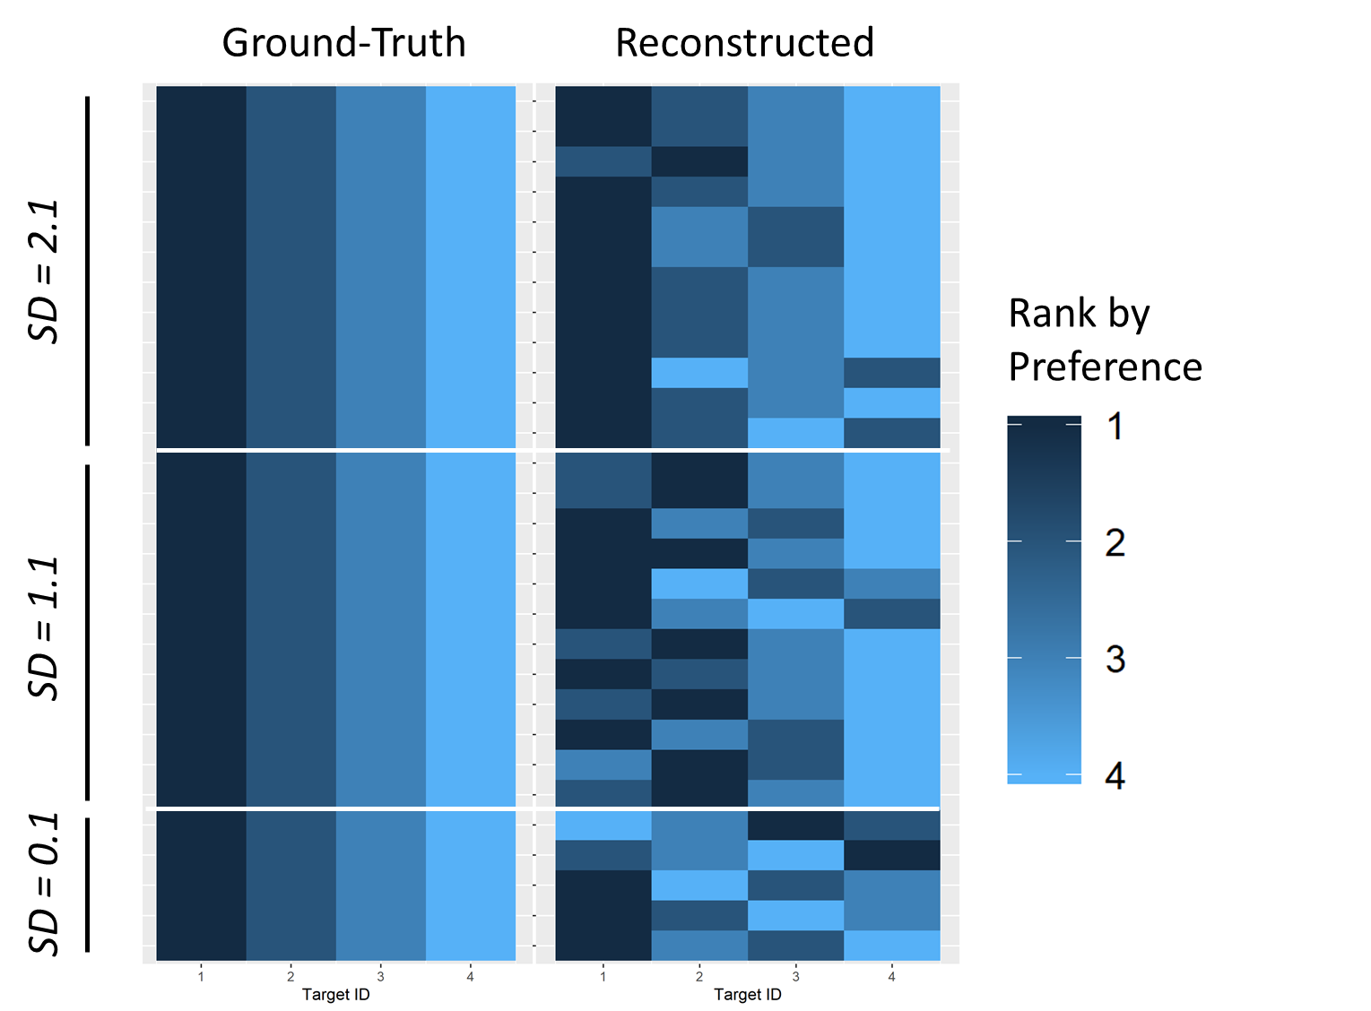

Figure Simulation-preference-matrix. The ground-truth preference matrix and the reconstructed preference matrix for simulated data. Each row is a subject and each column is a target that the subject interacts with. The color of the cell_ij encodes the subject_i’s ranked preference (1-4; 1 being the favorite target and 4 being the less favorite one) for target_j. If there are tie(s) in the preference rank among targets (e.g., two or more targets share the same preference score), the targets with ties are assigned the average rank value (two targets share the second place in the preference score will have the rank value of 2.5). The ground-truth preference matrix is constructed by the rank-transformed simulated social support value of each target. The reconstructed preference matrix is constructed by the rank-transformed predicted preference score inferred by ToMnet+. The labels on the left are the standard deviations of the ground-truth preference scores (before rank-transformation) between the 4 targets.



Performance of the trained models in predicting the agents’ final targets from test grid world start states is shown in Table 1 for both simulated and human data. Model performances as measured by the accuracy in predicting the agent’s final target given test start states in grid world. S1~S4 are 4 potential targets across the grid world instances, each with different personal and associative social parameter values constituting their underlying social network structures. Preference scores are normalized prediction probabilities (see Methods).

Because there were 4 potential targets in the test grid worlds, the chance prediction was 25%. Critically, the models which observed nothing more than the agents’ grid world behaviors were capable of inferring the agents’ underlying preference rankings.

## B. Human Data

Figure X Accuracy in the test set as a function of the number of trajectories in the training set for human data set. Each red round dot is the model accuracy in test set for each human subject. The blue triangle is the random rate, which should be the baseline to compared with. Random rates are derived for each subject by dividing 100% by the average number of targets in the trajectories. The x-axis is log-transformed for clearer illustration. The label besides each red dot is the subject ID.

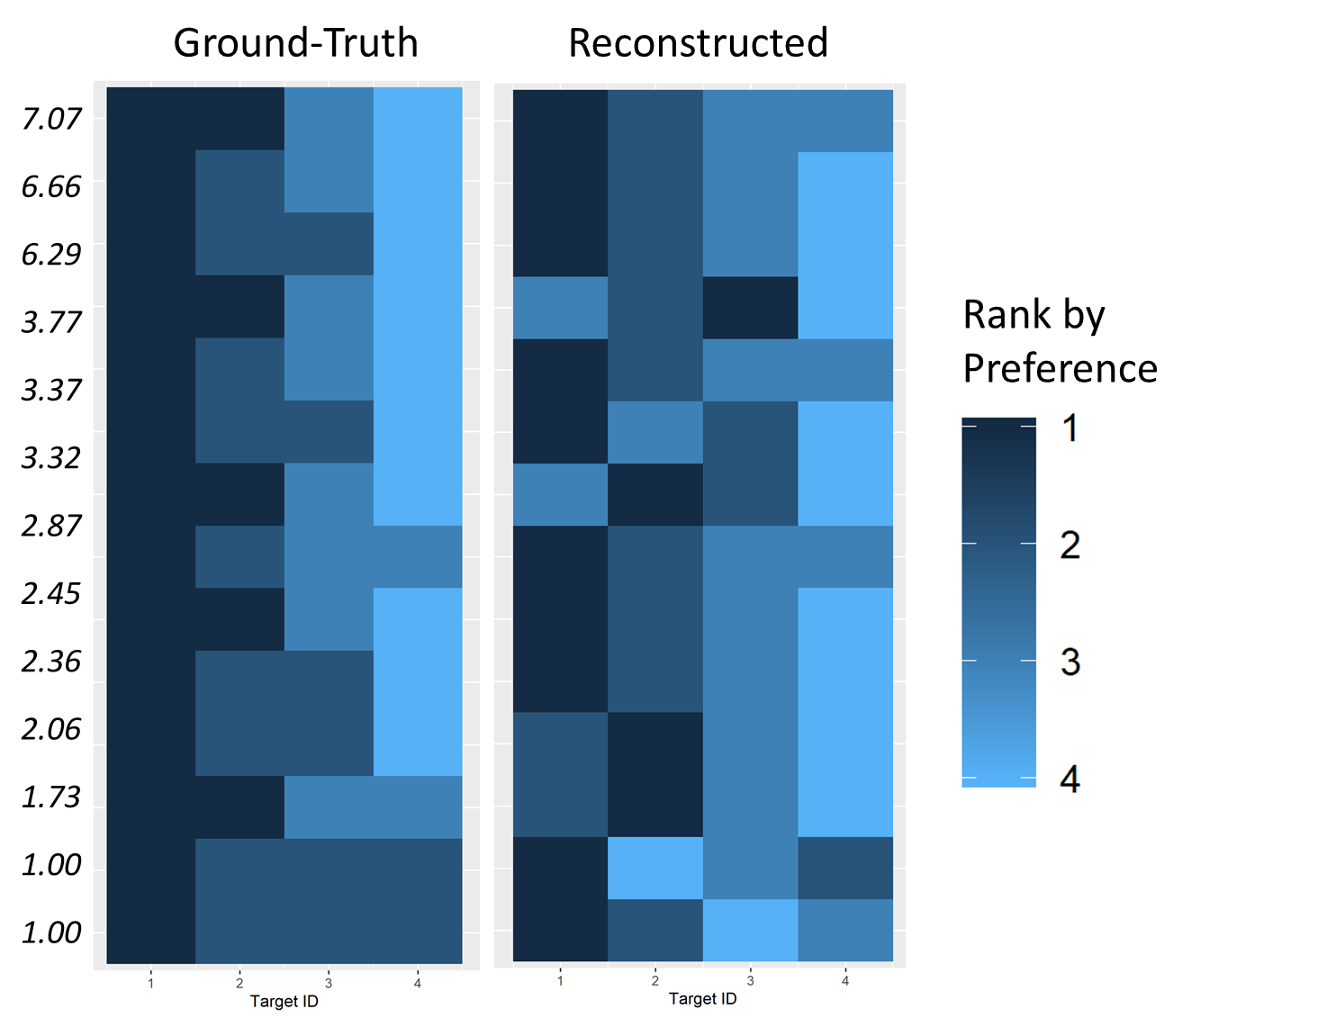

Figure Simulation-preference-matrix. The ground-truth preference matrix and the reconstructed preference matrix for simulated data. Each row is a subject and each column is a target that the subject interacts with. The color of the cell_ij encodes the subject_i’s ranked preference (1-4; 1 being the favorite target and 4 being the less favorite one) for target_j. If there are tie(s) in the preference rank among targets (e.g., two or more targets share the same preference score), the targets with ties are assigned the average rank value (two targets share the second place in the preference score will have the rank value of 2.5). The ground-truth preference matrix is constructed by the rank-transformed simulated social support value of each target. The reconstructed preference matrix is constructed by the rank-transformed predicted preference score inferred by ToMnet+. The labels on the left are the standard deviations of the ground-truth preference scores (before rank-transformation) between the 4 targets.

# Conclusions

Our findings highlight the potential of machine applications that infer implicit human preferences from third-person behavioral observation data. This is distinct from most current applications that are focused on dissociating explicit signals (e.g. recognizing emotional categories from facial expressions). This is also distinct from the previous study, which used ToMnet to extract preference from simulated agents without hidden associative structures [2]. We demonstrate that a NN such as ToMnet can also model real hidden social networks reflected in human social preferences. Aside from artificial intelligence and robotics applications, our findings also have implications in neuropsychological research. In principle, the human brain is also a neural network, albeit more complex, that operates by integrating observations of how other humans behaviorally interact to generate an internal hypothesis about real social networks [7]. As such, it is intriguing to consider such model implementations of learning and behavior as formal theory about the information mechanisms at work in human brains. With this initial platform, future work expanding on different formats of behavioral information and NN architectures can then be used to better understand how the human mind grasps reality.

References

1. G. Sinha, R. Shahi, and M. Shankar, “Human Computer Interaction,” in *2010 3rd International Conference on Emerging Trends in Engineering and Technology*, 2010, pp. 1–4.
2. J. C. Pulido, C. Suarez-Mejias, J. C. Gonzalez, A. Duenas Ruiz, P. Ferrand Ferri, M. E. Martinez Sahuquillo, C. E. Ruiz De Vargas, P. Infante-Cossio, C. L. Parra Calderon, and F. Fernandez, “A Socially Assistive Robotic Platform for Upper-Limb Rehabilitation: A Longitudinal Study With Pediatric Patients,” *IEEE Robot. Automat. Mag.*, vol. 26, no. 2, pp. 24–39, Jun. 2019.
3. H.-L. Cao, P. G. Esteban, M. Bartlett, P. Baxter, T. Belpaeme, E. Billing, H. Cai, M. Coeckelbergh, C. Costescu, D. David, A. De Beir, D. Hernandez, J. Kennedy, H. Liu, S. Matu, A. Mazel, A. Pandey, K. Richardson, E. Senft, S. Thill, G. Van de Perre, B. Vanderborght, D. Vernon, K. Wakanuma, H. Yu, X. Zhou, and T. Ziemke, “Robot-Enhanced Therapy: Development and Validation of Supervised Autonomous Robotic System for Autism Spectrum Disorders Therapy,” *IEEE Robot. Automat. Mag.*, vol. 26, no. 2, pp. 49–58, Jun. 2019.
4. H. Javed and C. H. Park, “Interactions with an empathetic agent: regulating emotions and improving engagement in autism,” *IEEE Robot. Automat. Mag.*, vol. 26, no. 2, pp. 40–48, Jun. 2019.
5. A. Ostrowski, D. DiPaola, E. Partridge, H. W. Park, and C. Breazeal, “Older Adults Living With Social Robots: Promoting Social Connectedness in Long-Term Communities,” *IEEE Robot. Automat. Mag.*, pp. 1–1, 2019.
6. A. Howard, A. Tapus, and I. Kajitani, “Socially assistive robots [from the guest editors],” *IEEE Robot. Automat. Mag.*, vol. 26, no. 2, pp. 10–110, Jun. 2019.
7. A. Tapus, C. Tapus, and M. J. Mataric, “The use of socially assistive robots in the design of intelligent cognitive therapies for people with dementia,” in *2009 IEEE International Conference on Rehabilitation Robotics*, 2009, pp. 924–929.
8. N. C. Rabinowitz, F. Perbet, H. F. Song, C. Zhang, S. M. Eslami and M. Botvinick, “Machine Theory of Mind”, arXiv: 1802.07740. Retrieved from <https://arxiv.org/abs/1802.07740>, 2018.
9. J. S. Wiggins, “A Psychological Taxonomy of Trait-Descriptive Terms: The Interpersonal Domain” in Journal of Personality and Social Psychology, 37, 3, pp. 395-412, 1979.
10. M. H. Davis, “A Multidimensional Approach to Individual Differences in Empathy” in JSAS Catalog of Selected Documents in Psychology, 10, 85, 1980.
11. I. G. Sarason, H. M Levine, R. B. Basham et al. “Asserting Social Support: The Social Support Questionnaire” in Journal of Personality and Social Psychology, 44, 127-139. 1983.
12. M. Abadi, P. Barham, J. Chen, Z. Chen, A. Davis, J. Dean, et al., “Tensorflow: A System for Large-Scale Machine Learning” in Proceedings of the 12th USENIX Conference on Operating Systems Design and Implementation (OSDI’16). USENIX Association, Berkeley, USA, 265-283. 2016.
13. J. O. S. Goh, H.-Y. Hung, Y-S. Su, “A Conceptual Consideration of the Free Energy Principle in Cognitive Maps: How Cognitive Maps Help Reduce Surprise” in Journal of Psychology, Learning and Motivation, 69, pp. 205-240. 2018.
14. Z. Zhao, H. Lu, D. Cai, X. He and Y. Zhuang, “User Preference Learning for Online Social Recommendation," in IEEE Transactions on Knowledge and Data Engineering, vol. 28, no. 9, pp. 2522-2534, 1 Sept. 2016.doi: 10.1109/TKDE.2016.2569096
15. A. Bellogin, I. Cantador, P. Castells and A. Ortigosa, “Discovering Relevant Preferences in a Personalized Recommender System using Machine Learning Techniques”, in Proceedings of the ECML-PKDD 2008 Worskhop on Preference Learning, 2008.
16. Y. Wu, E. Gamborino and L. Fu, "Interactive Question-Posing System for Robot-Assisted Reminiscence from Personal Photos," in IEEE Transactions on Cognitive and Developmental Systems. doi: 10.1109/TCDS.2019.2917030
17. H. Gunes, O. Celiktutan and E. Sariyanidi, “Live human-robot interactive public demonstrations with automatic emotion and personality prediction.”. In Phil. Trans. R. Soc. B 374: 20180026, 2019.
18. X. Guo, Y. Huang, E. Gamborino, S. Tseng, L. Fu, S. Yeh, “Inferring Human Feelings and Desires for Human-Robot Trust Promotion” Proceedings of the 21st HCI International Conference, HCII 2019, 2019. DOI: 10.1007/978-3-030-22577-3_26
19. E. Gamborino and L. Fu, "Interactive Reinforcement Learning based Assistive Robot for the Emotional Support of Children," 2018 18th International Conference on Control, Automation and Systems (ICCAS), Daegwallyeong, 2018, pp. 708-713.
20. E. Gamborino, H. Yueh, W. Lin, S. Yeh and L. Fu, "Mood Estimation as a Social Profile Predictor in an Autonomous, Multi-Session, Emotional Support Robot for Children," 2019 28th IEEE International Conference on Robot and Human Interactive Communication (RO-MAN), New Delhi, India, 2019, pp. 1-6. doi: 10.1109/RO-MAN46459.2019.8956460