Design Patterns Team 2: Term Project

System Architecture:

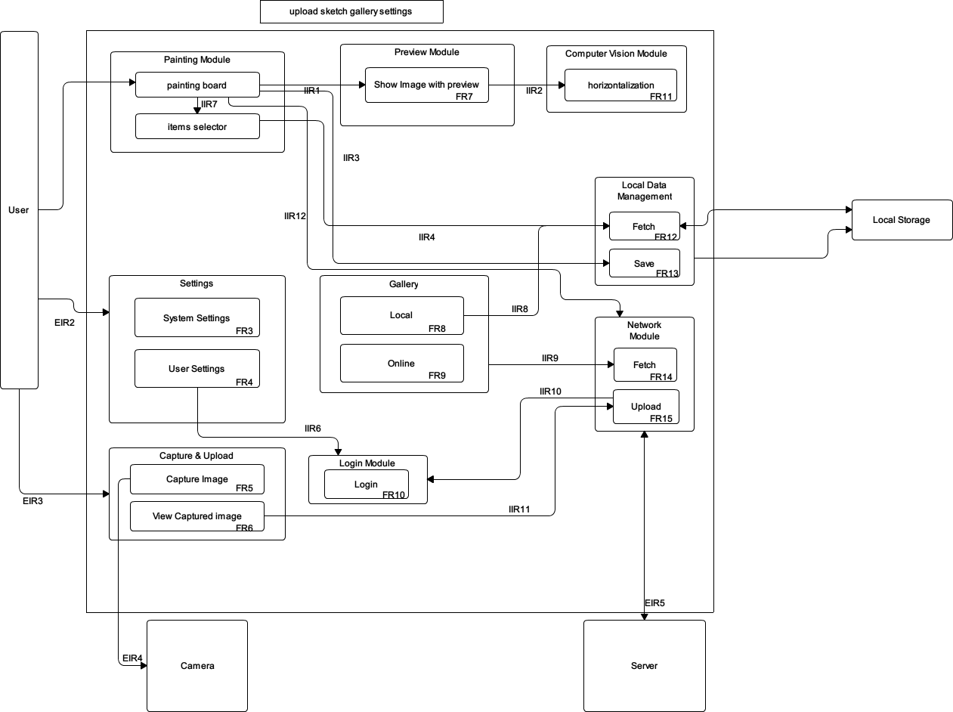

Requirements:

* EIR1:  User can design what pattern to draw. User can pick items from pre-defined pics or from gallery.
* EIR2: User can configure some parameters of the app.
* EIR3: User captures drawn image and decides whether to upload or not.
* EIR4: Capture image by camera.
* EIR5: Need a place to store data, and you should be able to retrieve them. Image objects are sent between server and network module, and objects should contain key-value pair only.
* EIR6: Store images and auxiliary data.
* EIR7: get specific data from local storage.
* IIR1: Painter can send the final painting file to the preview.
* IIR2: The computer vision module gets necessary data(image) from the preview module. After computing, the computer vision module returns the result, i.e. the relative orientation between the device and the paper, back to the preview module.
* IIR3: The painting module transfer the painted image to the local data management module, in order to save it.
* IIR4: Seletor can get elements from local storage services. After the image is done, you can save it to the local storage.
* IIR6: User settings and Login**.** By setting up a partner for the default account, automatic login this account every time we open the application. And you can withdraw from the account to log in.
* IIR7: User would jump from painter to selector after he/she click on the "add" button. Selector would inform the painter which element user has selected.
* IIR8: The gallery module requests the local data management for images stored in the local storage.
* IIR9:Gallery and Fetch**.** In the case of a network connection, can get photo from the Internet, and then display in a local program.
* IIR10: Network module get user information from login module.
* IIR11: An image to be upload should be provided and network module will then upload it to the server.
* IIR12: Merged image can be uploaded to the server.
* FR1:The painter can add elements to the sketch. The painter can change the relative position and size of the elements. After finishing, the painter can produce a final sketch containing all the elements  that the user want to paint.
* FR2:The item selector can show all elements available on local device. In item selector, user can choose which element he/she want to use.
* FR3: System settings. 1.To setup the theme, background or background color. 2.Can set language, namely the switch in both Chinese and English.
* FR4: User settings: 1. To set up with a partner's account to log in.
* FR5: User can capture a drawn image.
* FR6: After user has captured an image, he/she can choose to retake another image or upload current captured image.
* FR7: The camera preview is on the screen. If the paint region is detected on the preview, the image to draw is shown on the screen at the right position and orientation. If the user rotates or moves the device, the image should move consistently. The image can be zoomed in/out, moved, rotated by the user on the screen.
* FR8: Open the local photo albums, showing the local photo album for users to browse and select the picture
* FR9: In the case of a network connection, to download and display the cloud pictures online, for users to browse and choose
* FR10:  If not logged in, ask user to log in through Facebook. If logged in, return user info.
* FR11: This function calculates the current relative orientation between the device and the paper.
* FR12: This function fetches data from the local storage, according to some input constraints.
* FR13: This function stores input data into the local storage.
* FR14: When called, make query to the server and get images. Additional filter may be specified, such as category.
* FR15: Given an image to be upload, create thumbnail for the image and upload both original image and thumbnail, with some information about the image( user, category,...etc) to the server. If the user hasn't logged in, he/she will be asked to log in first.