**Sumo Digital TechVarsity Challenge 2017 – XML File Format Specification**

Both the input for the test case and the route output from your implementation are held in a simple XML formatted text file.

The supplied test case is all held in an element called **TestCase**.

Fred’s starting position is in an Element within **TestCase** called **StartPoint**.

Fred’s ship position is in an Element within **TestCase** called **EndPoint**.

An element called **IslandPoints** within **TestCase** holds a sequence of **Point** elements that describe the n-gon of the navigable space around the island.

An element called **RoutePoints** within **TestCase** holds a sequence of Point elements that describe the route from Fred’s starting position to his ship. The starting and ending points should be included at the start and end of the sequence.

Each point element contains two floating point values, the first indicates how far the point is from the left side of the map (the X coordinate) and the second indicates how far the point is from the top of the map (the Y coordinate). Values are in the range 0.00 to 100.00 and the two values are separated by a single space.

XML files supplied as test cases will contain a **StartPoint**, **Endpoint** and **IslandPoints** elements. Your generated output must contain a **RoutePoints** element, but you can choose to include a copy of the input elements or not, whichever makes most sense for your implementation.

A sample test case and an example possible route for Fred is shown below. A visualisation of the data shows the starting point as a red cross, the ship endpoint as a red cross, the island limits as a yellow line around a green n-gon and a suggested route as a purple dotted line.

<TestCase>

<StartPoint>5.00 50.00</StartPoint>

<EndPoint>95.00 50.00</EndPoint>

<IslandPoints>

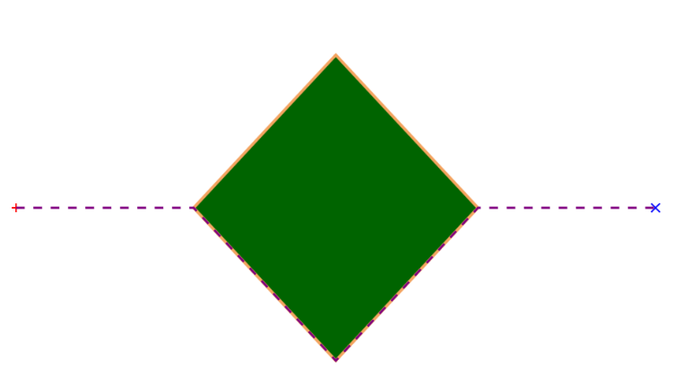 <Point>30.00 50.00</Point>

<Point>50.00 20.00</Point>

<Point>70.00 50.00</Point>

<Point>50.00 80.00</Point>

</IslandPoints>

<RoutePoints>

<Point>5.00 50.00</Point>

<Point>30.00 50.00</Point>

<Point>50.00 80.00</Point>

<Point>70.00 50.00</Point>

<Point>95.00 50.00</Point>

</RoutePoints>

</TestCase>