Prerequisite:

Stm32:

Mbed-os 5.15.0

Wifi-ism43362

Mbed-os-example-ble-GattServer

Rpi:

os

time

socket

threading

requests

Install Dependencies:

webserver:

Execution:

Rpi-side:

cd final

python3 merge.py

webserver:

做法

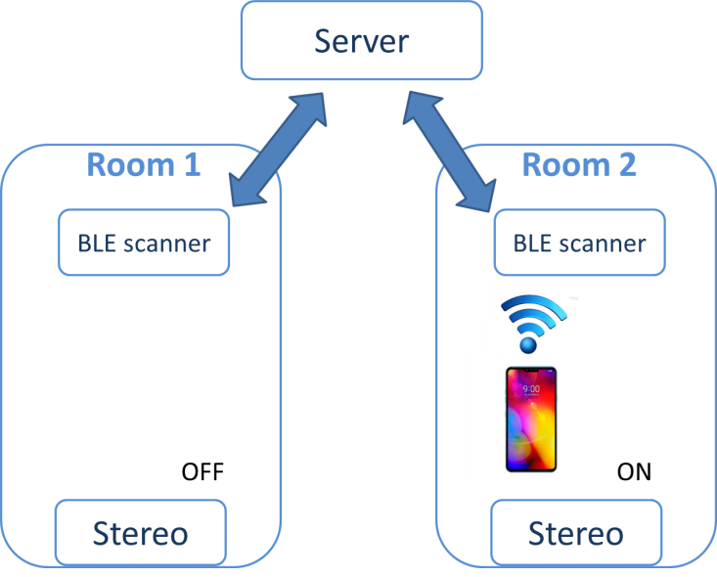

Our system aims to develop a smart audio player with capability of detecting which room the user is in and playing songs in that room. In our demo, we show that we can control the Bluetooth speaker remotely from the laptop and when the user leaves the room (the ble connection breaks up), the player will stop the music.

There are five components in our components, **web app, system controller, bluetooth speaker, ble scanner, smartphone.**

1. web app provides a user interface to control the Bluetooth speaker.
2. System controller integrates the signal from web server and ble scanner and directly controls the Bluetooth speaker.
3. Smartphone indicate the location of the user
4. Ble scanner scan the signal broadcasts from the smartphone
5. Bluetooth speaker play songs and is able to control volume

Web app is executed on the laptop. The app indicates the user’s location and to control the songs to play. React js is used for frontend development and python’s flask is used for backend.

A multi thread system controller is built on rpi. It connects to the web server and the ble scanner to decide which song to play, whether to pause the song and directly control the speaker. Python are used to develop the system.

STM board plays the role of ble scanner. While the STM receives ble signal from the user, it will send signals to system controller (rpi) via tcp connection.

難處

1. To setup the connection between rpi and the speaker, we faced some difficulties. The audio driver alsa doesn’t support the ble connection. **=>** After trials, we found that there are another driver called bluealsa can bind the alsa and ble together
2. When dealing with the stm board, we found that there are no available examples using both tcp and ble => we integrate the two examples together